Dear Parents and Guardians,
I hope everyone is making the most of this fantastic weather we are having!
Please find attached work to complete for English Learning Support groups (Monday 02nd June – 05th June)
These groups include Senior Infants and 4th Class English groups.
If you have any questions or queries regarding the work, please email horeswoodmrstaffordset@gmail.com and I will get back to you as soon as I can.
Please continue to use the Seesaw platform as you deem necessary.
Please stay safe and mind yourselves.

Kind regards,
Mr Stafford.

Mr Stafford’s Senior Infant English Group
Dates | Activity | Dolch Word List  Remember: Look, sound, read  Put into a silly sentence and a normal sentence each night.
Monday
01/06/2020
Tuesday  02/06/2020 | - ff, ss, ll and zz words  - Complete two pages of activities | Dolch words to revise (Dolch list below)  Big, went, are, come, if
Wednesday  03/06/2020 | - Add the correct final letter activity  - Add the correct first letter activity  - Choose the correct vowel activity | Dolch words to learn (Dolch list below)  Now, long, no, came, ask
Thursday  04/06/2020 | I have included additional worksheets and revision sheets on the magic ‘e’ sound so please complete as you deem appropriate. | Dolch words to revise (Dolch list below)  Now, long, no, came, ask

Please also revise Dolch list 1-4 as you deem appropriate.

Mr Stafford
English Support Group 4th Class Pupils
Dates | Activity | Additional notes
Monday
01/06/2020
Tuesday  02/06/2020 | Idioms readings and matching task
Wednesday  03/06/2020 | Reading comprehension and questions: Over the Moon  Underline all of the idioms you can see in the story
Thursday  04/06/2020 | Reading comprehension and questions  ‘’One last barbeque’’  Trick: Spell a new word trick: Read and try it out!

Senior Infants
Dolch list 1 and 2
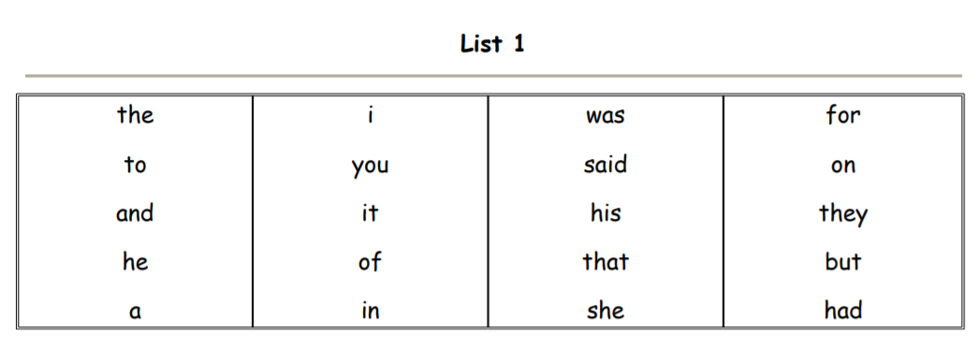

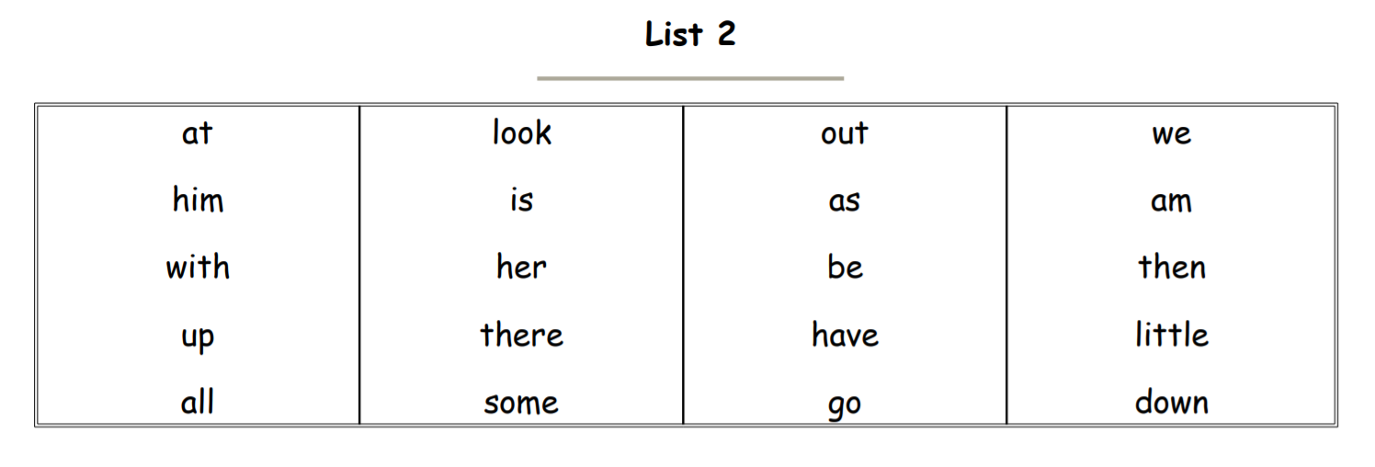

List 3
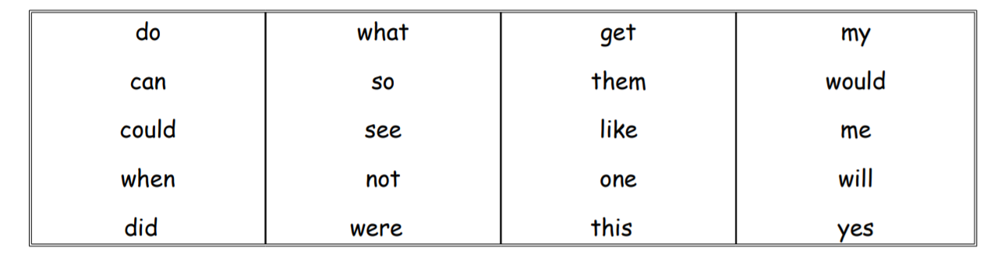

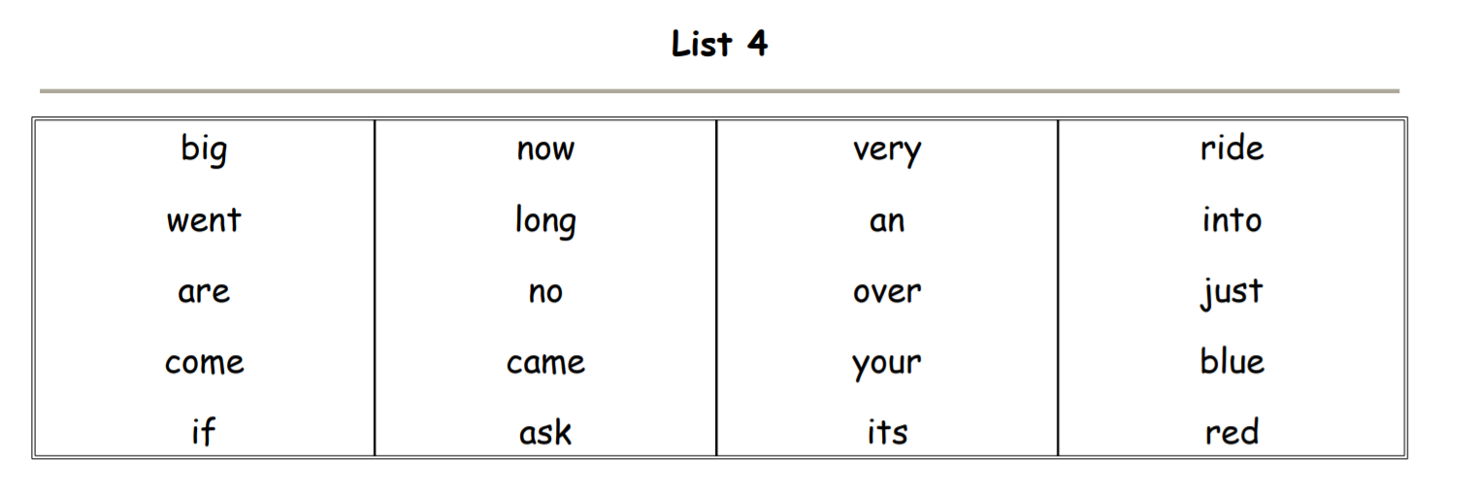
M

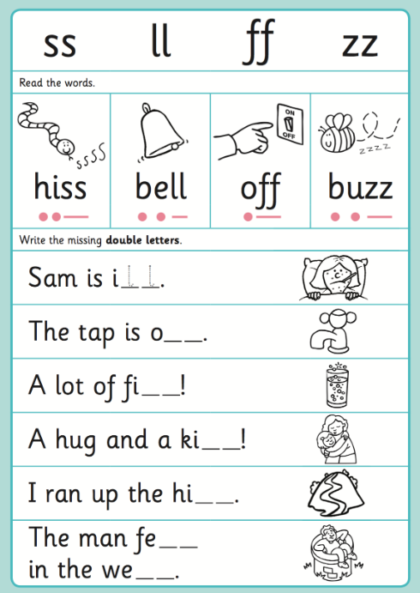

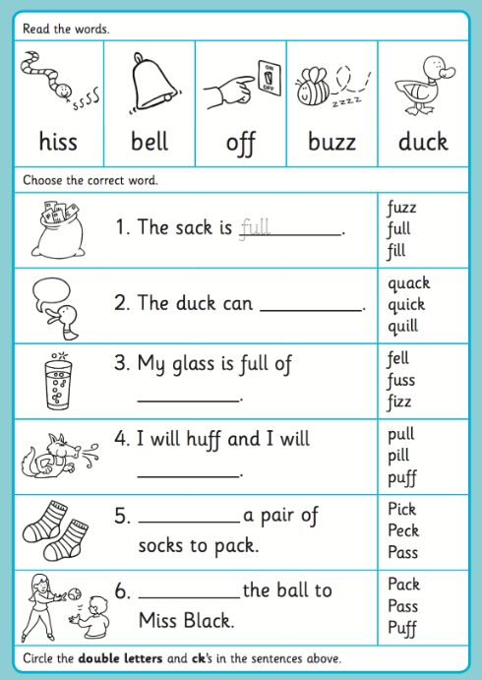

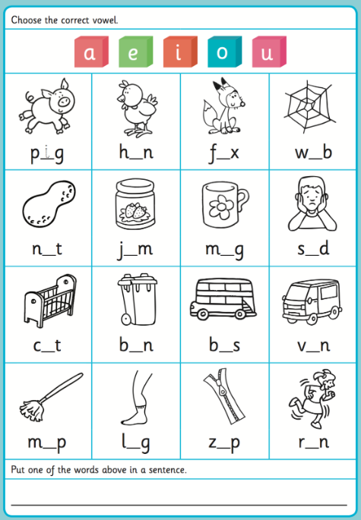

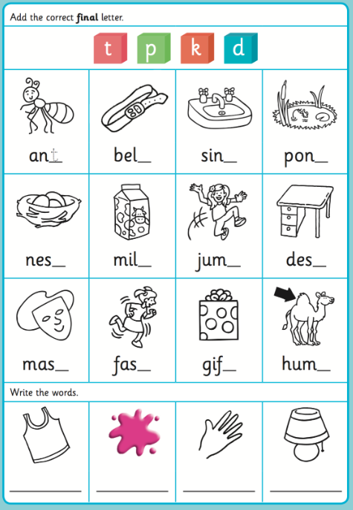

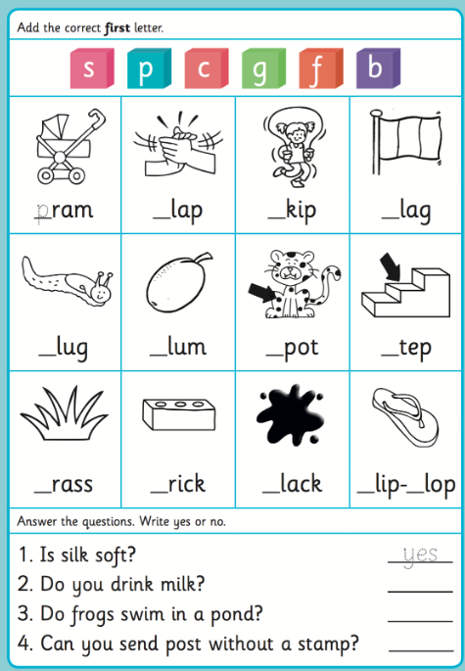

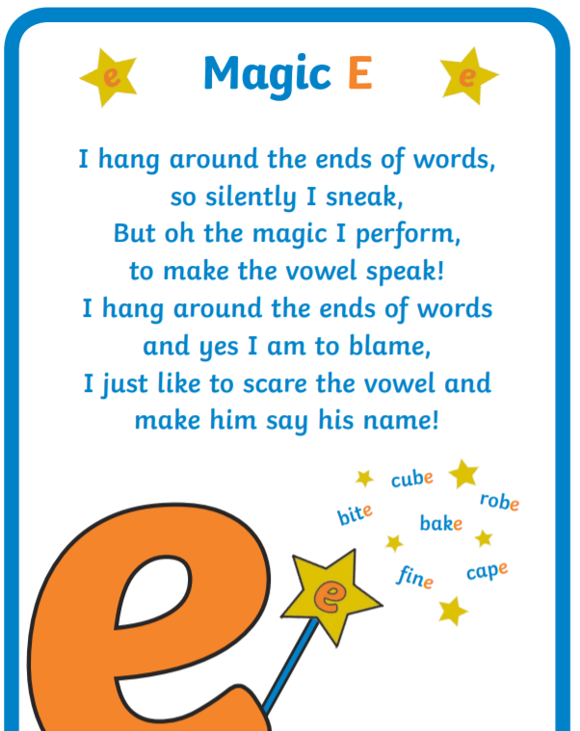

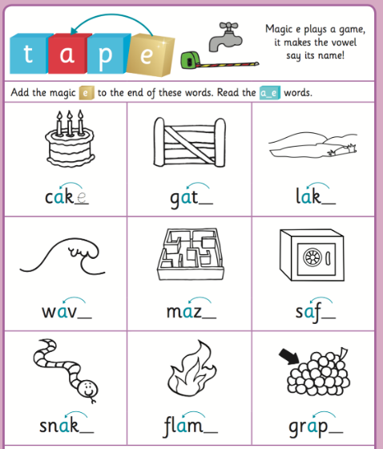

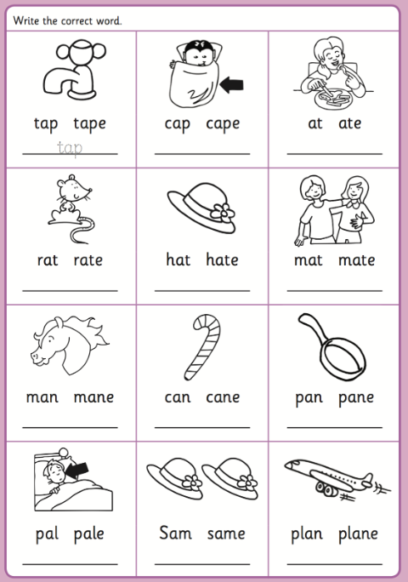

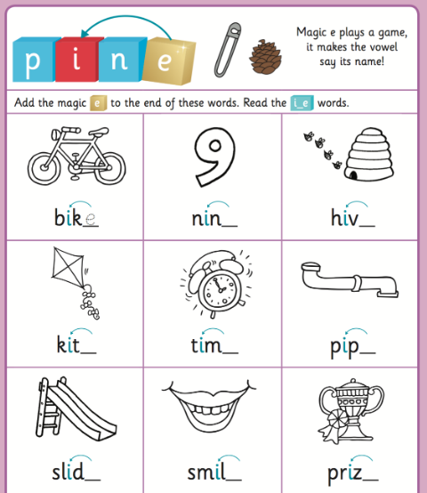

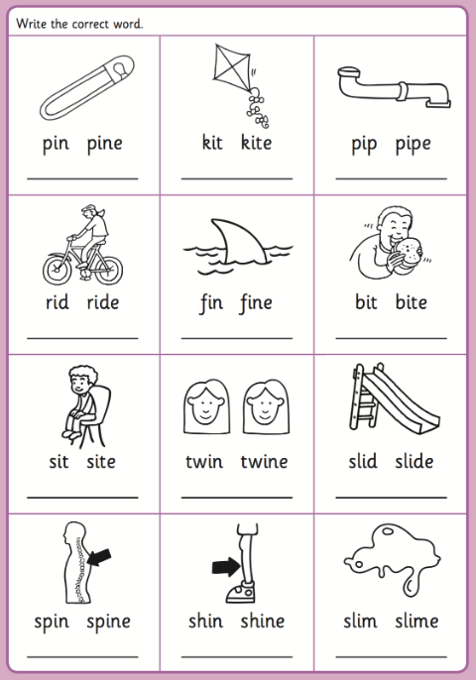

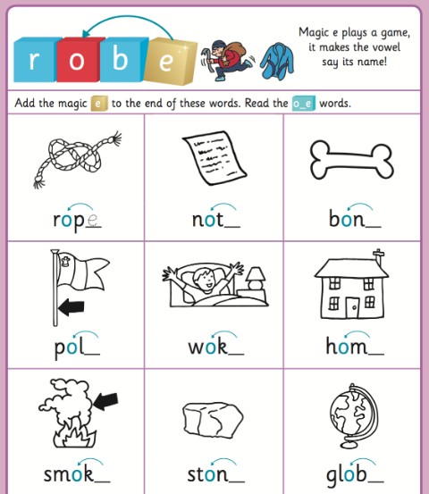

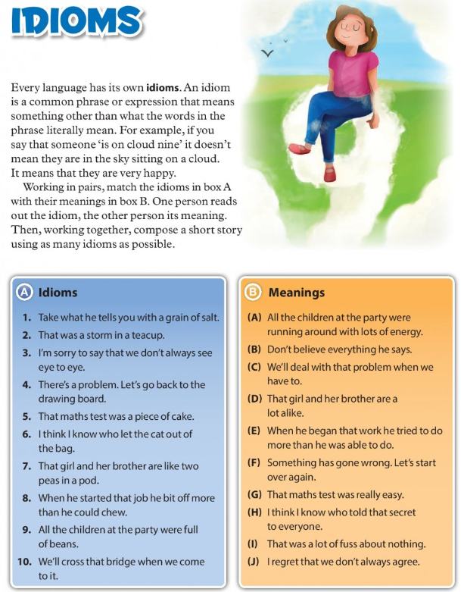

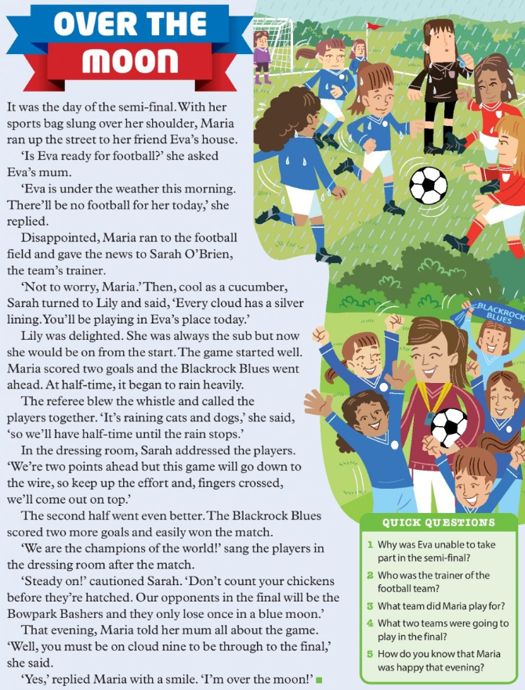

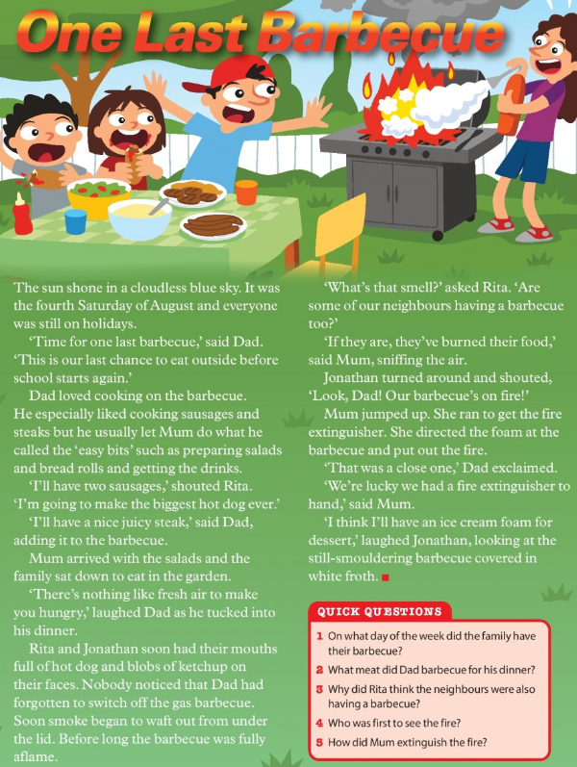

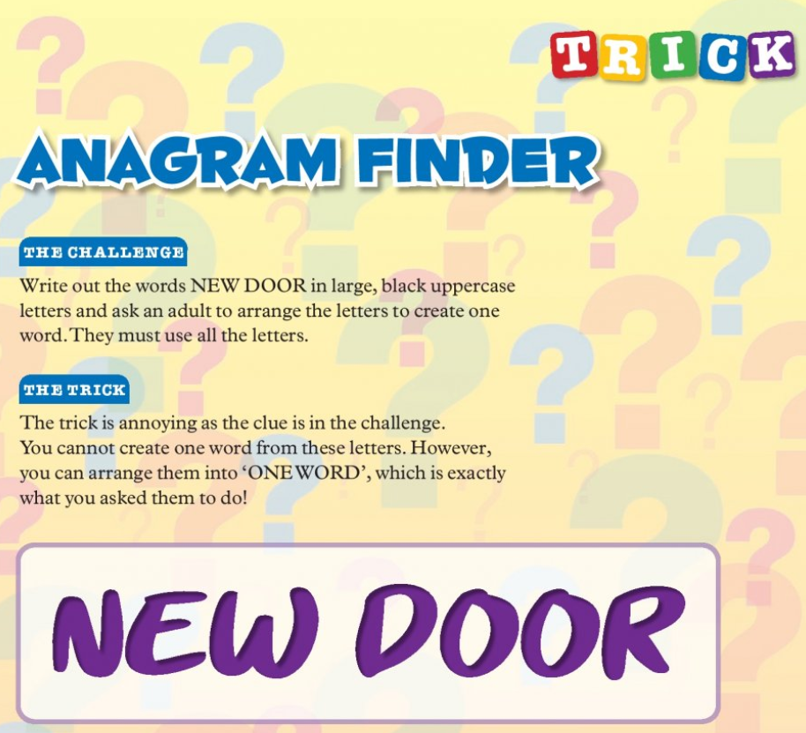
Read it and try it out at home!

