Twenty Hours of Outdoors Ideas

- Homemade Bug motel/bee home/bird feeder/bird bath – get creative and make one at home with your family. (encouraging birds into your family)
- Upstyling old furniture/DIY crafts/paint stone art for your garden (design stones with paints and leave them somewhere for someone else to take one)
- Taking photographs of wildlife/nature around you
- Go for a cycle /scoot
- Have a picnic
- Build a camp/tent/den
- Bug hunt
- Have a mini sports day with egg and spoon races/three legged race
- Help out in the garden
- Fly a kite
- Have a treasure hunt
- Get arty with chalk on the ground
- Wash the car
- Play hopscotch
- Make lemonade and set up a lemonade stall
- Try some skipping and learn some skipping chants
- Make a scarecrow
- Make sandcastles if you are on a trip to the beach
- Blow some bubbles
- Hunt for animal tracks
- Make sun shadows
- Make a nature collage
- Read outside
- Make a treasure map for someone and see if they can find the treasure.

20 Hours Outside Challenge
This week’s challenge is to spend as much time outside as you can.
Record the time you spend outside on the grid below. You could be reading, walking, cycling, playing, farming, gardening, doing some of the Green School activities or some of the Active Schools week activities. Once you are outside, then it counts.
For each hour spent outside, colour one of the circles.

In case it is raining, remember  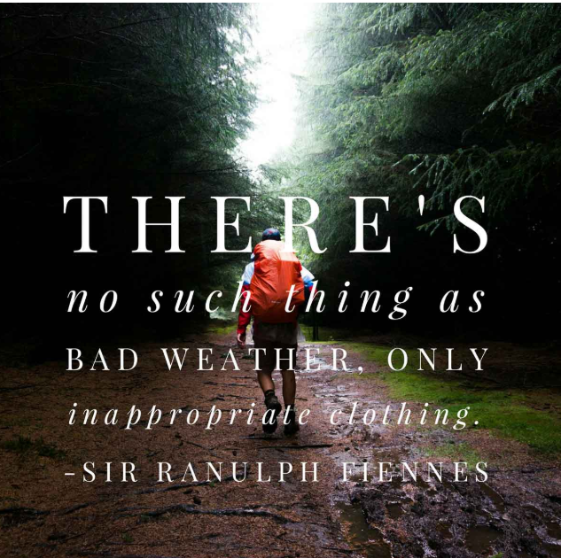 | Name: _______________  Class: _______________
Why stop at 20? See how many circles you can fill in.

