Dear Parents and Guardians,
Please find attached work to complete for English Learning Support groups (Tuesday 05th May – Friday 15th May).
These groups include Senior Infants and 4th Class English groups.
All worksheets and resources are included in this document. This is work to be completed as deemed appropriate alongside the class work allocated by the classroom teacher. Please do not feel under any pressure to get all the work complete. Some days, you might read the comprehensions and activities without answering the questions. Other times, you might answer the questions orally. Read as often as you can and try read for enjoyment too.
I have now set up an email that will be monitored for the purpose of a parent/guardian needing to contact me regarding work. If you have any questions or queries regarding the work, please email horeswoodmrstaffordset@gmail.com I will be online Monday to Friday 9:20 a.m. to 11:20 a.m. and endeavour to get back to you as soon as I can.
I have set up an online account for my students on an app/ website called Seesaw. I would like to use this website for reviewing and correcting work with 4th class. Senior infants may also find this a useful way of receiving feedback for their work. There is no requirement to upload all or any of your work here but it may be beneficial if I can give feedback on some of your work through comments. To access the online site each child will have a unique password to log in. I will e-mail you this code to log in to seesaw as a student. It is very easy and simple for the children to use. Please send an e-mail to horeswoodmrstaffordset@gmail.com if you would like to set this up.
Please stay safe and mind yourselves.

Kind regards,
Mr Stafford.

Mr Stafford
Senior Infant English Group
Dates | Activity | Dolch Word List  Remember: Look, sound, read  Put into a silly sentence and a normal sentence each night.
Tuesday  05/05/2020 | - Match the beginning sound to the picture  - Write the correct words (All on sheet 1)  - Read and match the sentence to the picture | Dolch words to revise (Dolch list below)  The, to, and, he, a  ***Please see note below on Dolch list words.
Wednesday  06/05/2020 | - Read the sentence and circle yes or no activity | Dolch words to learn (Dolch list below)  I, you, it, of, in
Thursday  07/05/2020 | - Animal word trail worksheet | Dolch words to revise (Dolch list below)  Was, said, is, that she,
Friday  08/05/2020 | - Colour the giraffe activity | Dolch words  For, on, they, but, had

***It may be beneficial to revise and reinforce the Dolch word list 1 and list 2 over this fortnight.
I have also attached Dolch list 3 so please feel free to progress to Dolch list 3 as appropriate.

Dates | Activity | Dolch Word List  Remember: Look, sound, read  Put into a silly sentence and a normal sentence each night.
Monday  11/05/2020 | - Magic e sound: ‘a’ words | Dolch words to learn (Dolch list below)  At, him ,with, up all  ***Please see note below on Dolch list words.
Tuesday  12/05/2020 | - Magic e sound: ‘i’ words | Dolch words to revise (Dolch list below)  Look, is, her, there, some
Wednesday  13/05/2020 | - Magic e sound: ‘o’ words | Dolch words to learn (Dolch list below)  Out, as, be, have, go
Thursday  14/05/2020 | - Revision words sheet 1  - Revise magic ‘e’ words orally | Dolch words to revise (Dolch list below)  We, am, then, little, down
Friday  15/05/2020 | Revision words sheet 2  Revise magic ‘e’ words orally | Dolch words revision of all words list 1 and list 2

***It may be beneficial to revise and reinforce the Dolch word list 1 and list 2 over this fortnight.
I have also attached Dolch list 3 so please feel free to progress to Dolch list 3 as appropriate.

Mr Stafford
English Support Group 4th Class Pupils
Dates | Activity | Additional notes
Tuesday  05/05/20 | - Reading comprehension and questions  ‘’The Clever Fox’’  - Writing activity: ‘’Excuses, Excuses!’’  - Create two of your own ‘wacky’ excuses explaining why you are late for school. | Remember, full sentences for your answers.
Wednesday  06/05/2020 | Reading comprehension and questions  ‘’Fractions for Homework’’
Thursday  07/05/2020 | English in Practice Day 65 and 66  Please complete both sides

Dates | Activity | Additional notes
Monday  11/05/2020 | Reading comprehension and Questions  ‘’The Giggler Treatment’’ (The biscuit tester) | Remember, full sentences for your answers.
Tuesday  12/05/20 | ‘’Opposites’’ activity | Complete on the worksheet
Wednesday  13/05/2020 | English in Practice Day 67 and 68  Please complete both sides | Complete on the worksheet
Thursday  14/05/2020 | Reading comprehension and questions  ‘’Learning the hard way’’
Senior Infants
Dolch list 1 and 2
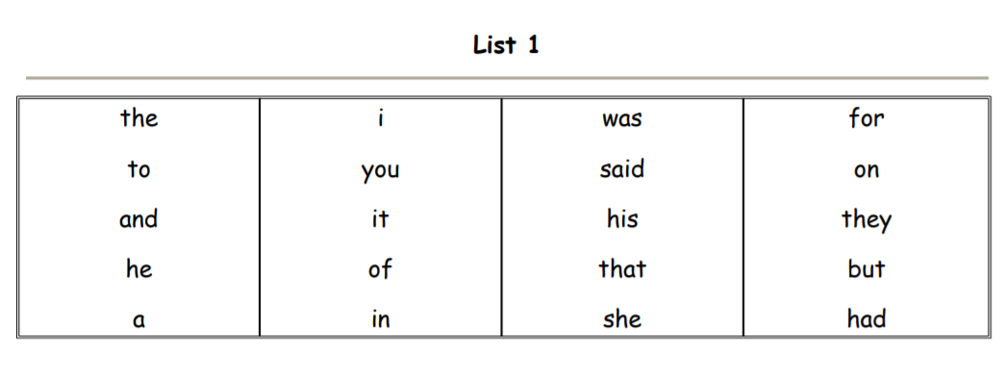

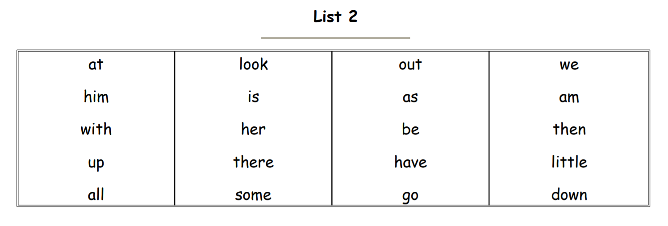

List 3
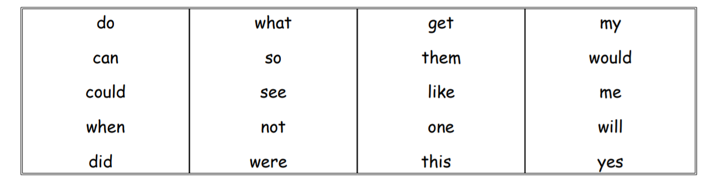

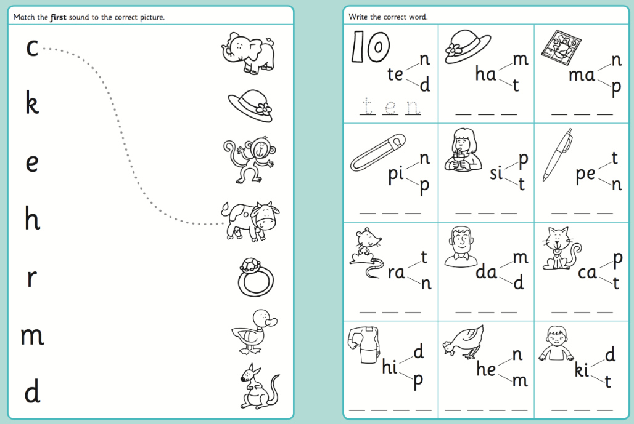

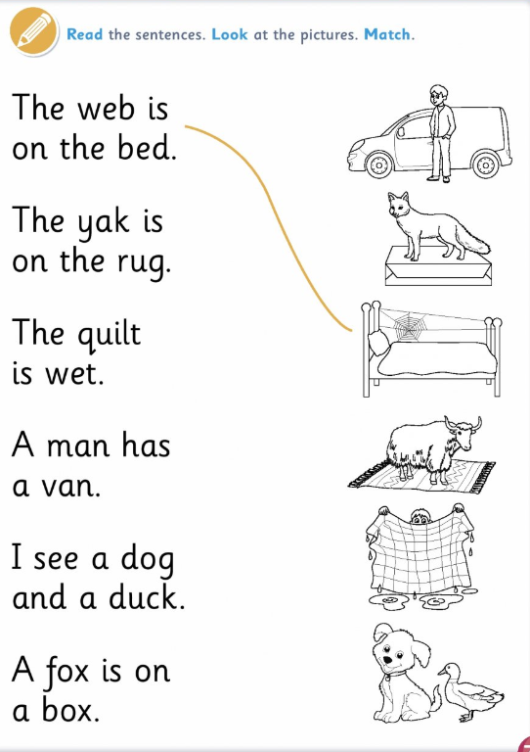
Read and match the sentence to the picture

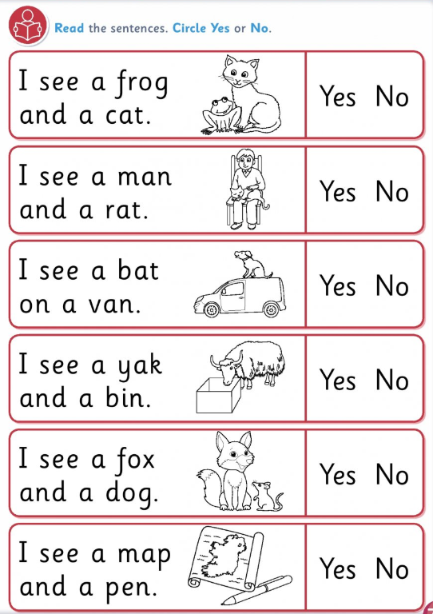
Read the sentence and circle yes or no.

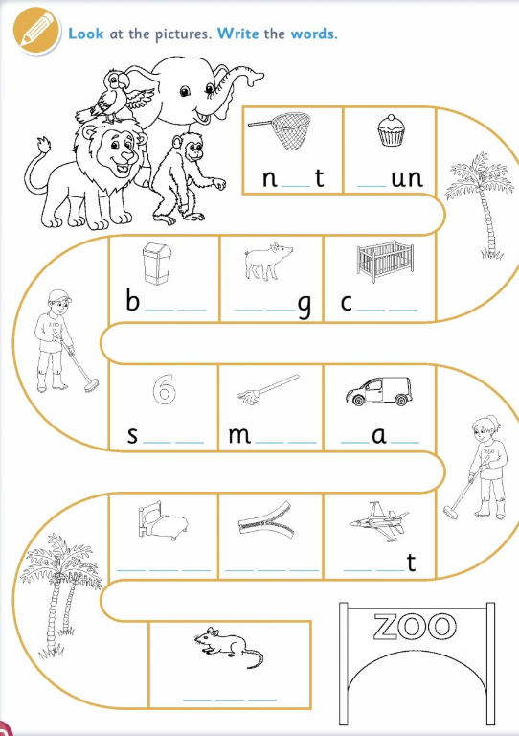
Animal word trail

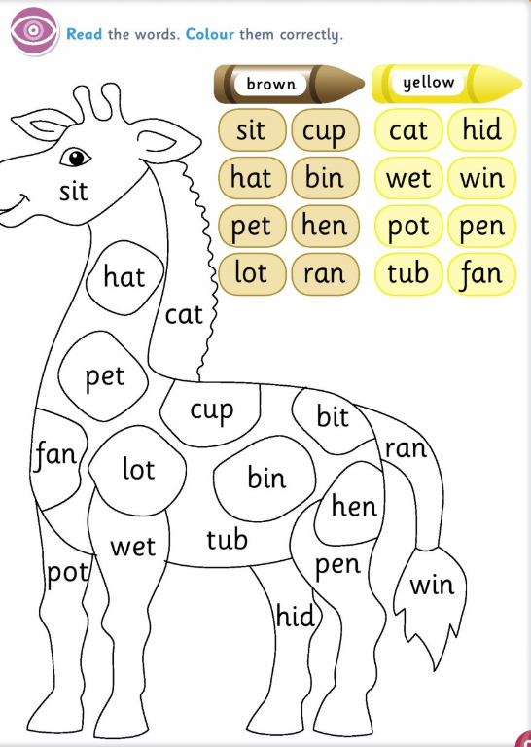
Colour the giraffe worksheet

Magic e sound: ‘’A’’ words
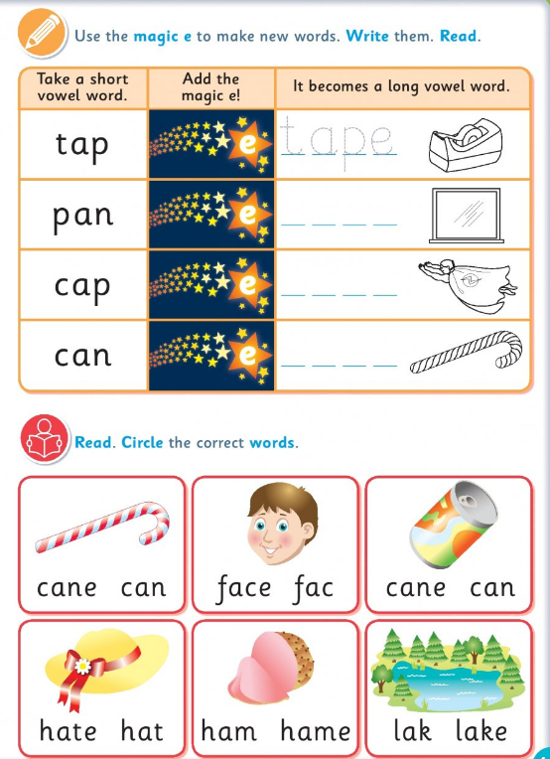

Magic e sound: ‘I’ words
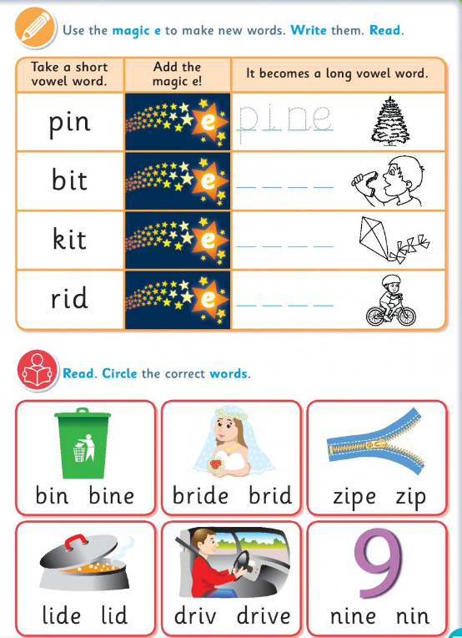

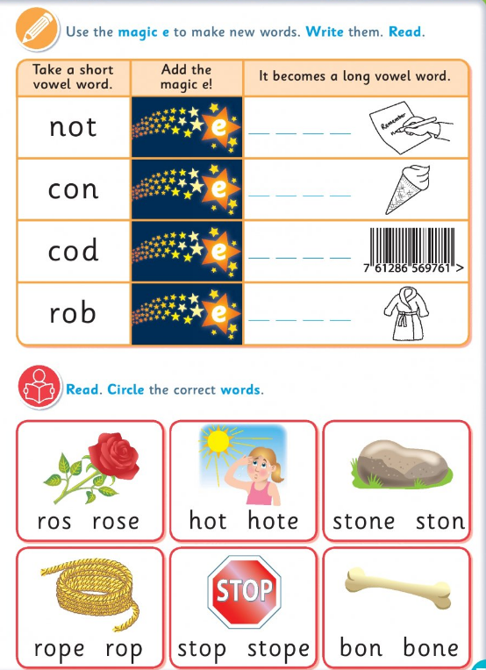
Magic e sound: ‘o’ words

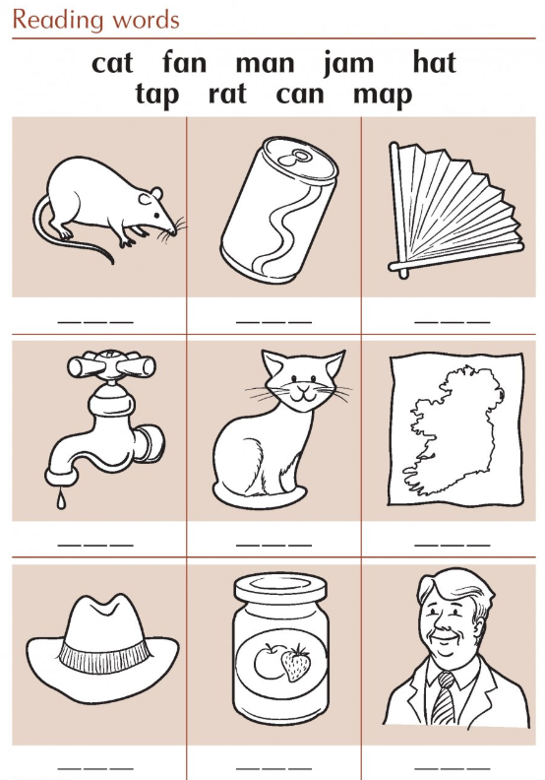
Revision words 1

Revision words 1

Revision words 2
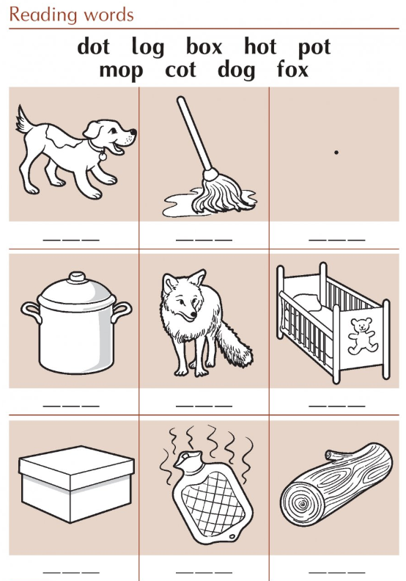

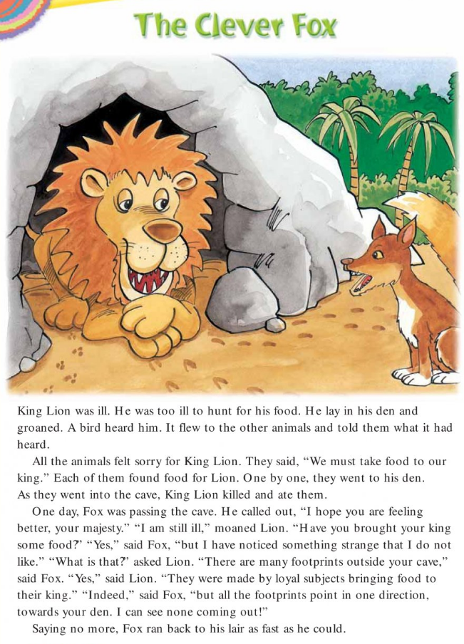
4th Class worksheet 1

The Clever Fox Questions
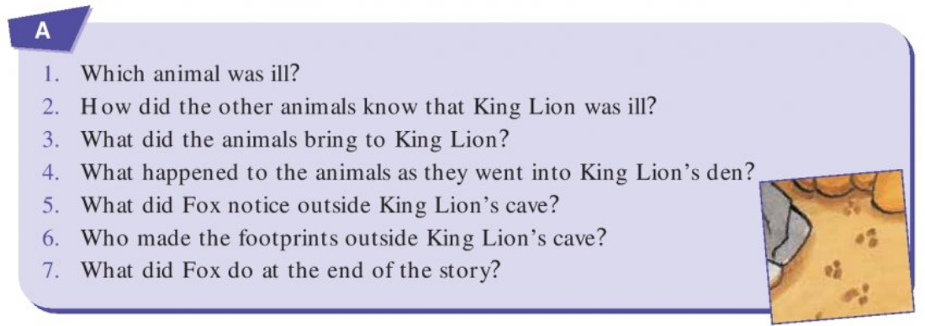

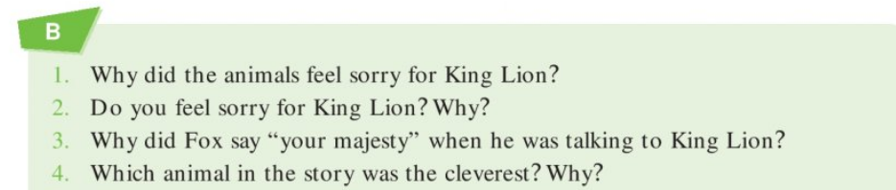

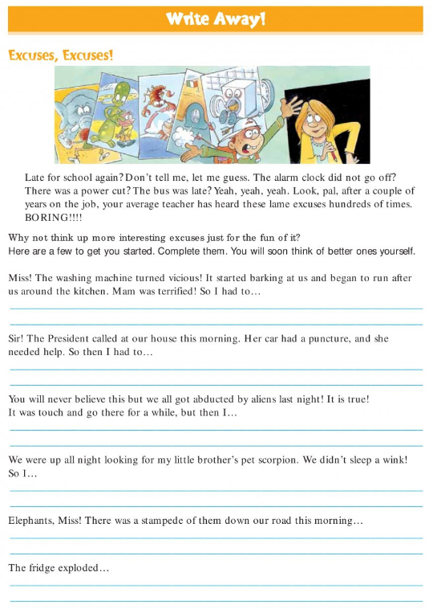

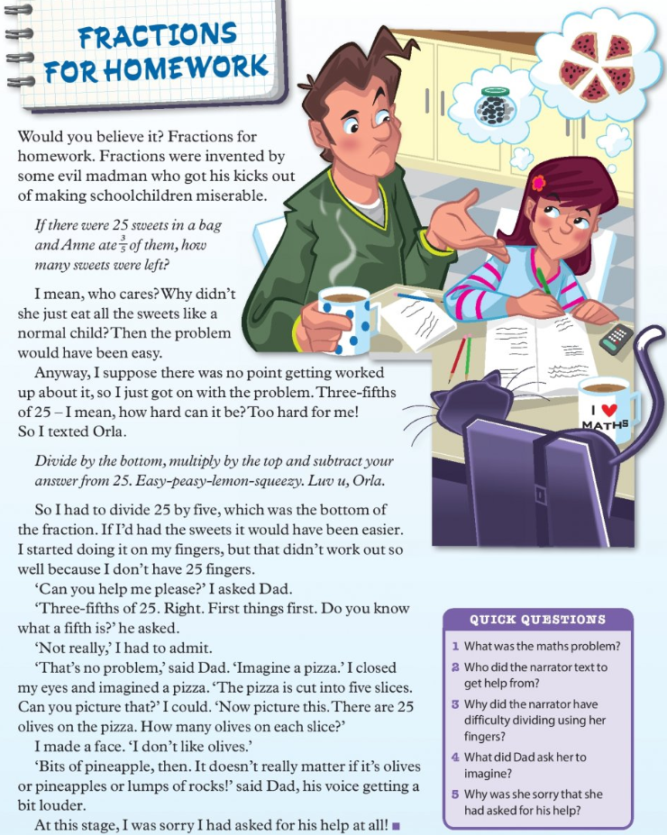

.

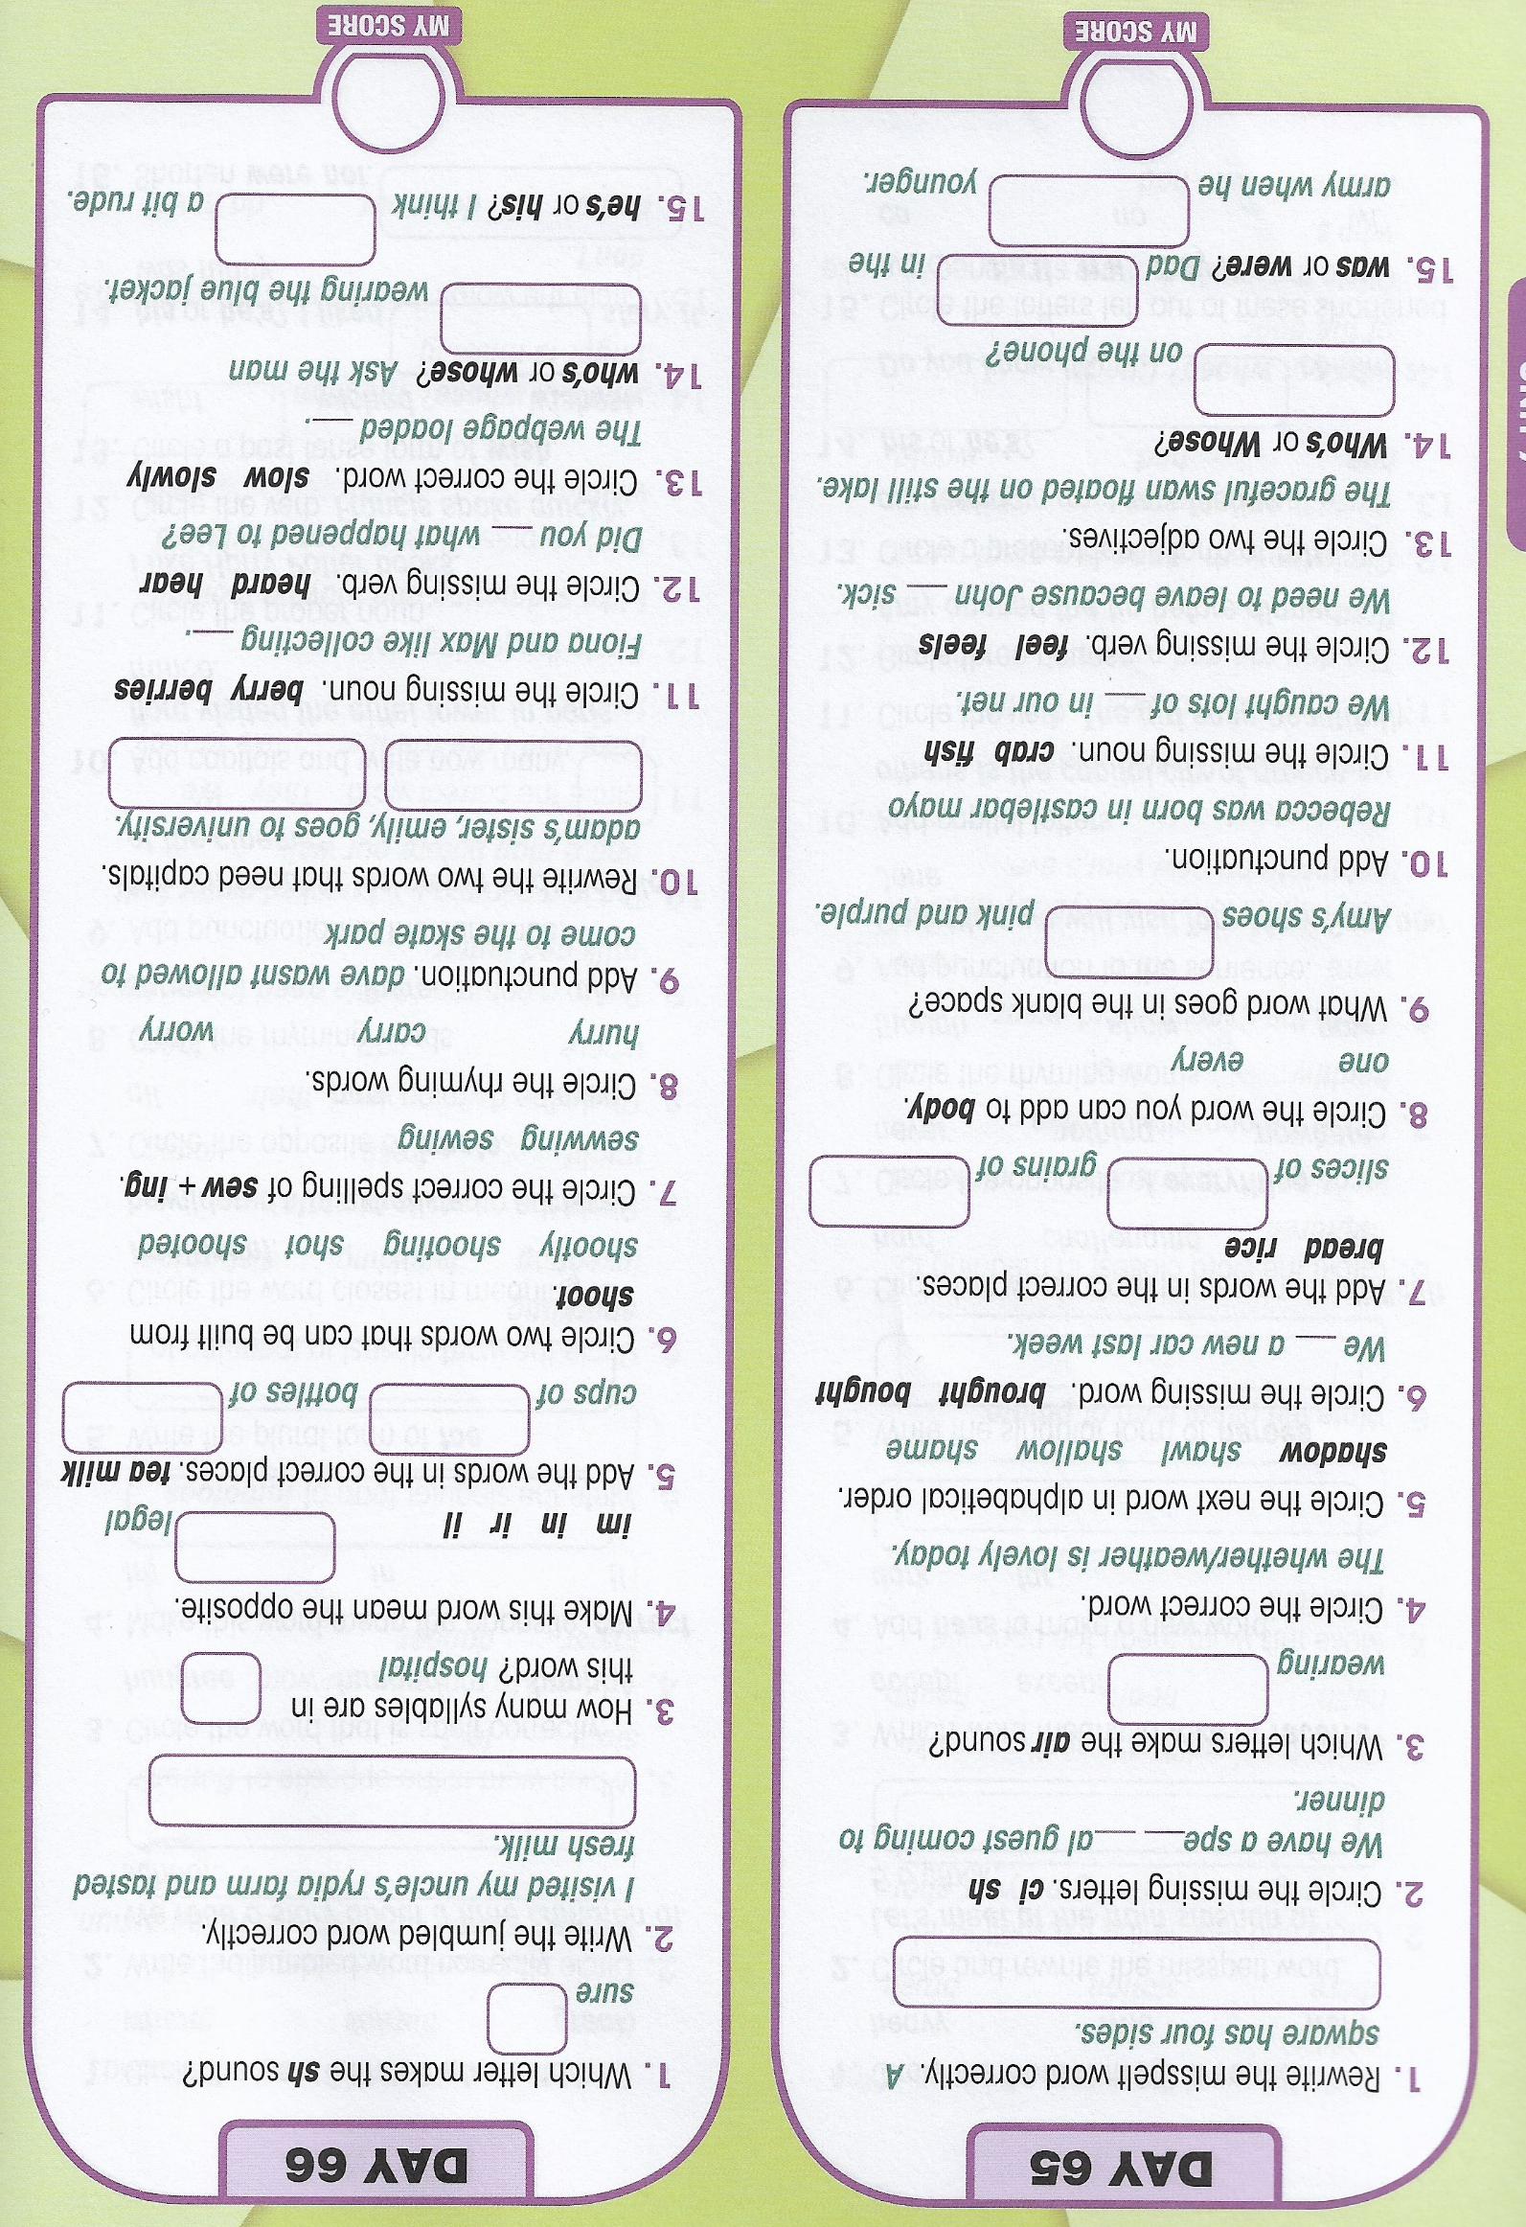

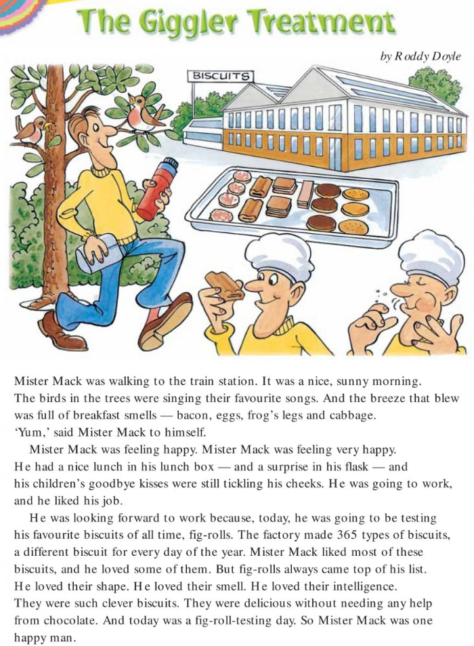

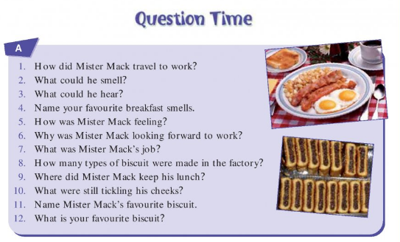

Extra questions
Would you like to be a biscuit tester? Why/ Why not?
Write a paragraph describing your dream future job!

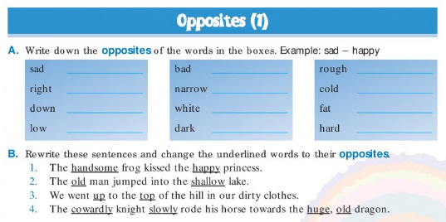
Opposites worksheet

