Dear Parents and Guardians,
Please find attached work to complete for English Learning Support groups (Monday 18th May – 29th May)
These groups include Senior Infants and 4th Class English groups.
All worksheets and resources are included in this document. This is work to be completed as deemed appropriate alongside the class work allocated by the classroom teacher. Please do not feel under any pressure to get all the work complete. Some days, you might read the comprehensions and activities without answering the questions. Other times, you might answer the questions orally. Read as often as you can and try read for enjoyment too.
If you have any questions or queries regarding the work, please email horeswoodmrstaffordset@gmail.com I will be online Monday to Friday 9:20 a.m. to 11:20 a.m. and endeavour to get back to you as soon as I can.
I have set up an online account for my students on an app/ website called Seesaw. I would like to use this website for reviewing and correcting work with 4th class. Senior infants may also find this a useful way of receiving feedback for their work. There is no requirement to upload all or any of your work here but it may be beneficial if I can give feedback on some of your work. It is very easy and simple for the children to use. Please send an e-mail to horeswoodmrstaffordset@gmail.com if you would like to set this up.
Please stay safe and mind yourselves.

Kind regards,
Mr Stafford.

Mr Stafford
Senior Infant English Group
Dates | Activity | Dolch Word List  Remember: Look, sound, read  Put into a silly sentence and a normal sentence each night.
Monday  18/05/2020 | - Rhyming words 1 | Dolch words to learn (Dolch list below)  List 3  Do, can ,could, when, did
Tuesday  19/05/2020 | - Rhyming words 2 | Dolch words to revise (Dolch list below)  Do, can ,could, when, did
Wednesday  20/05/2020 | Rhyming words 3 | Dolch words to learn (Dolch list below)  What, so, see, what, were
Thursday  21/05/2020 | - Add the final letter worksheet 1 and 2  (Please complete both pages) | Dolch words to revise (Dolch list below)  What, so, see, what, were
Friday  22/05/2020 | - Read the sentence: Write yes or no | Dolch words revision: Please use list 1,2 and 3 to revise words learned

I have also attached Dolch list 4 so please feel free to progress to Dolch list 4 as appropriate.

Dates | Activity | Dolch Word List  Remember: Look, sound, read  Put into a silly sentence and a normal sentence each night.
Monday  25/05/2020 | - Read and draw worksheet | Dolch words to learn (Dolch list below)  Get, them, like, one, this
Tuesday  26/05/2020 | - Read and circle the correct word | Dolch words to revise (Dolch list below)  Get, them, like, one, this
Wednesday  27/05/2020 | Colour the correct sound the word begins with activity | Dolch words to learn (Dolch list below)  My, would, me, will, yes
Thursday  28/05/2020 | Complete revision sheets as you deem appropriate | Dolch words to revise (Dolch list below)  My, would, me, will, yes
Friday  29/05/2020 | Complete revision sheets as you deem appropriate | Dolch words revision: Please use list 1,2 and 3 to revise words learned

I have also attached Dolch list 4 so please feel free to progress to Dolch list 4 as appropriate.

Mr Stafford
English Support Group 4th Class Pupils
Dates | Activity | Additional notes
Monday  18/05/2020 | Deliberate mistakes Part A and B  Draw an accurate picture of the story in your copy
Tuesday  19/05/20 | Reading comprehension and Questions  ‘’Speedwell Garage’’ | Please write full sentences in your English copy
Wednesday  20/05/2020 | Homophones activity  - There, their, they’re  - To, too, two
Thursday  21/05/2020 | English in Practice day 71 and 72  Please complete on the sheet

Dates | Activity | Additional notes
Monday  25/05/2020 | Reading comprehension and questions  ‘’The Future is Now’’ | Please write full sentences in your English copy
Tuesday  26/05/20 | English in Practice day 75 and 76  Please complete on the sheet
Wednesday  27/05/2020 | Responding to a poem: Poem: ‘’Gorilla’’  Answer the question in writing or orally | Your choice to complete the question in writing or orally
Thursday  28/05/2020 | Book Review activity  Please feel free to design your own book review in your copy. You can include the same headings and add in your own to suit your book! | This can be completed with a book you have read before  Or  Begin a new book from home today!

Senior Infants
Dolch list 1 and 2
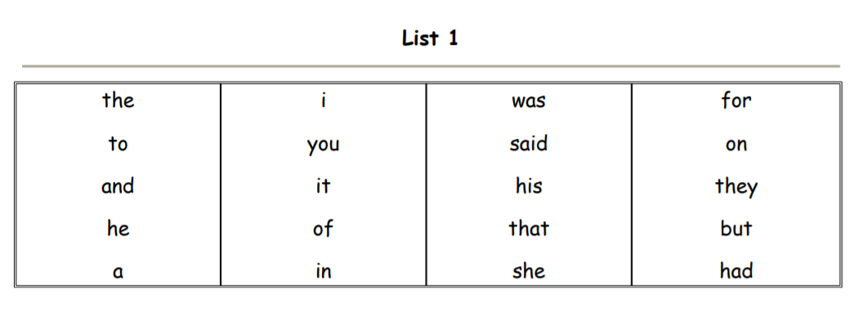

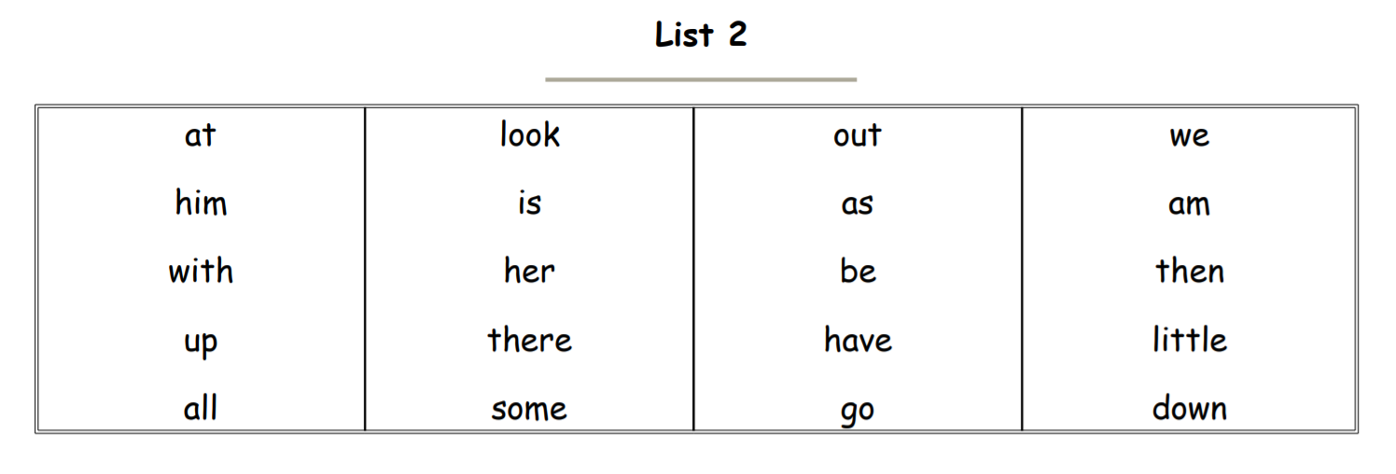

List 3
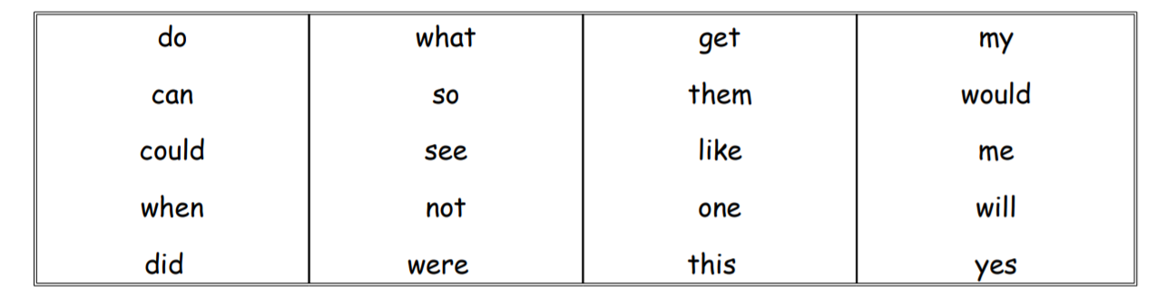

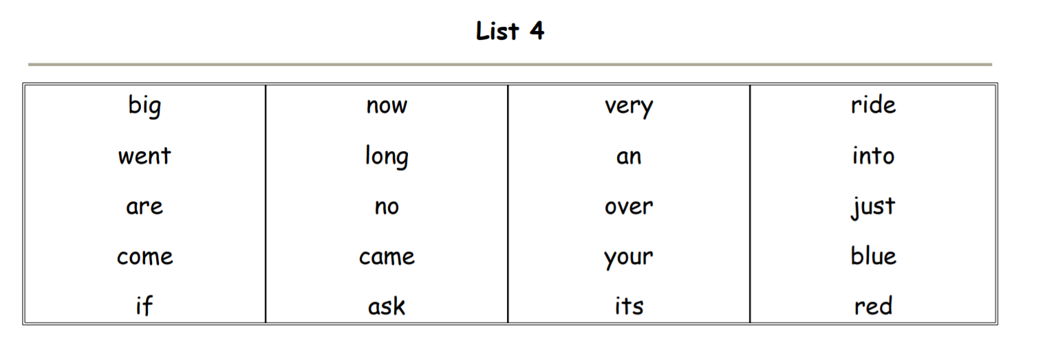
M

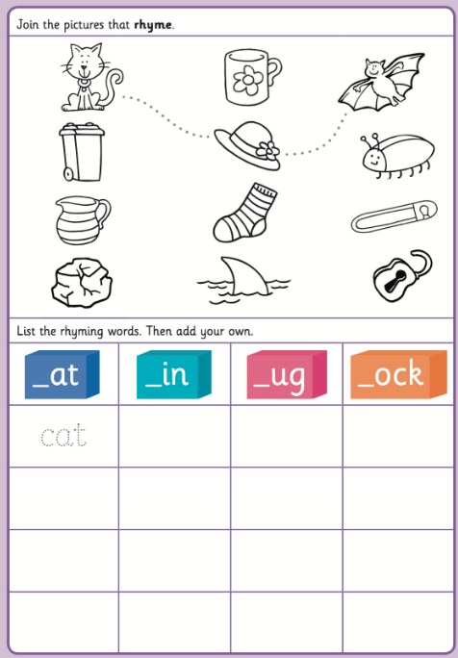
Rhyming words 1

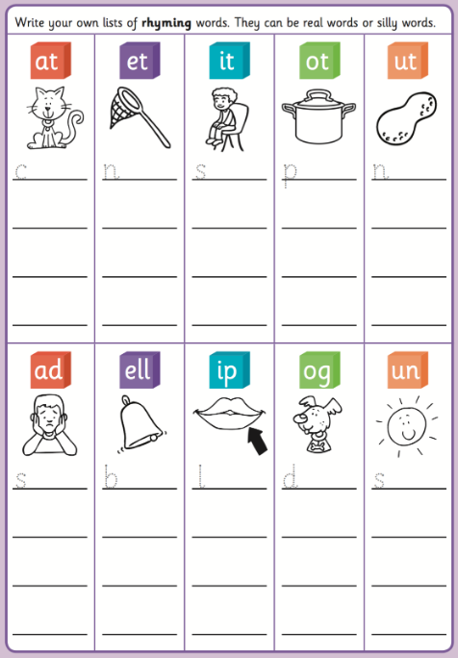
Rhyming words 2

Rhyming words 3
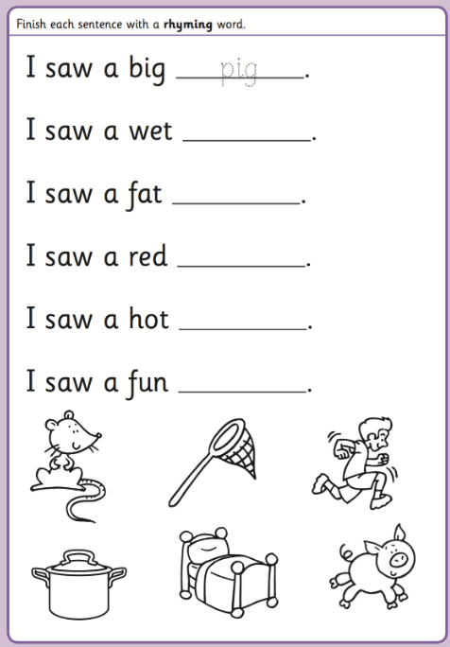
Use the pictures below to write a rhyming word at the end of each sentence.

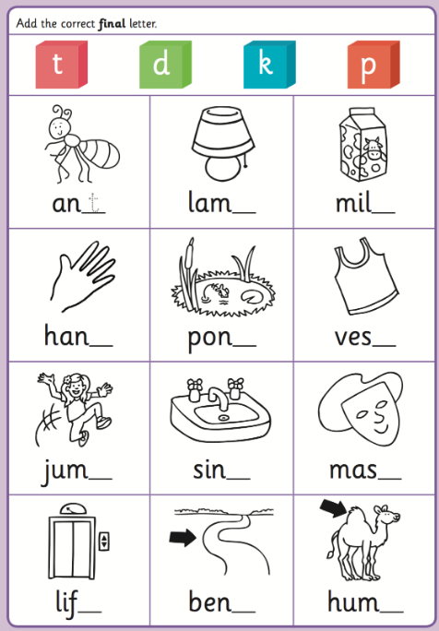
Add the final letter worksheet 1

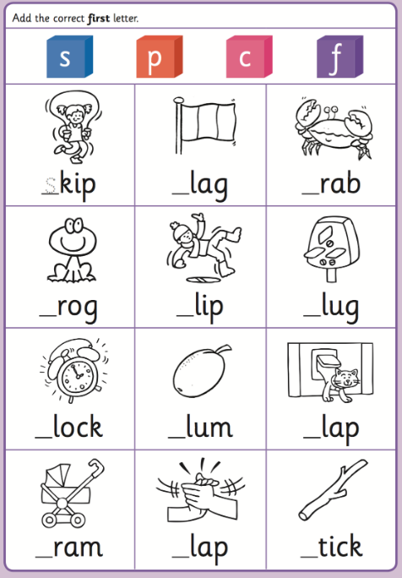
Add the first letter worksheet 2

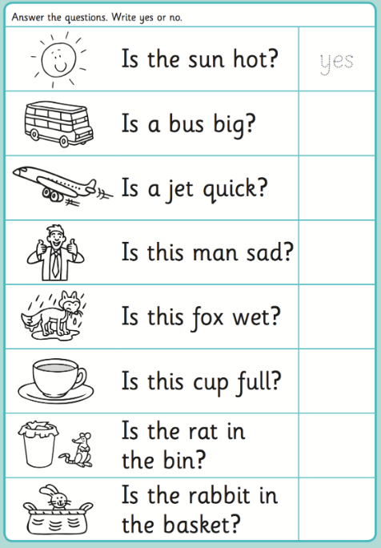
Read the sentence. Write yes or no to answer each question.

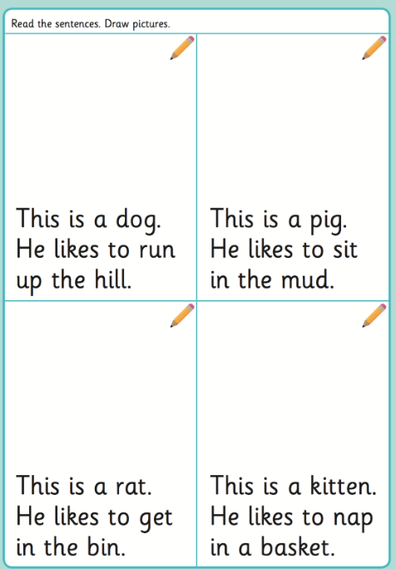
Read and draw worksheet

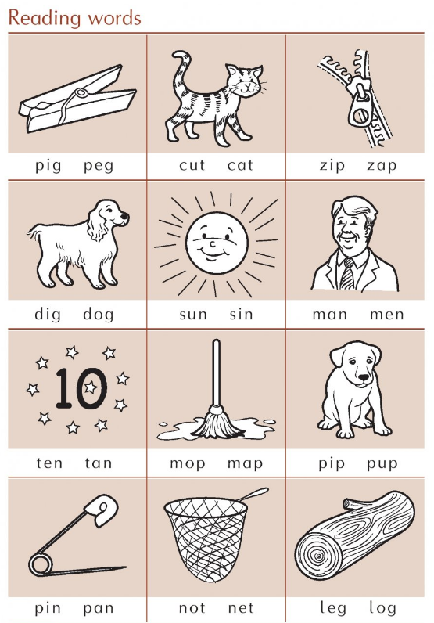
Read and circle the correct word
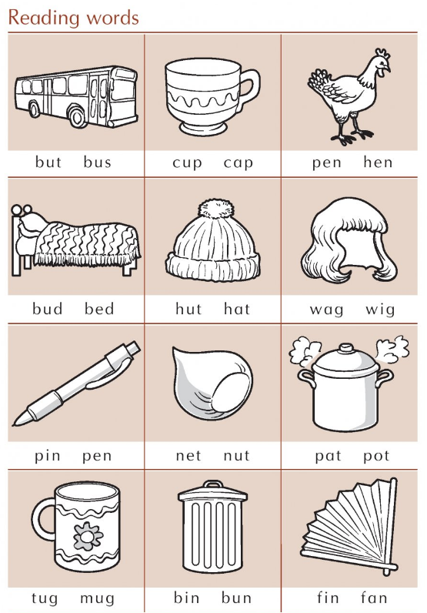

Colour the correct letters that the word begins with.
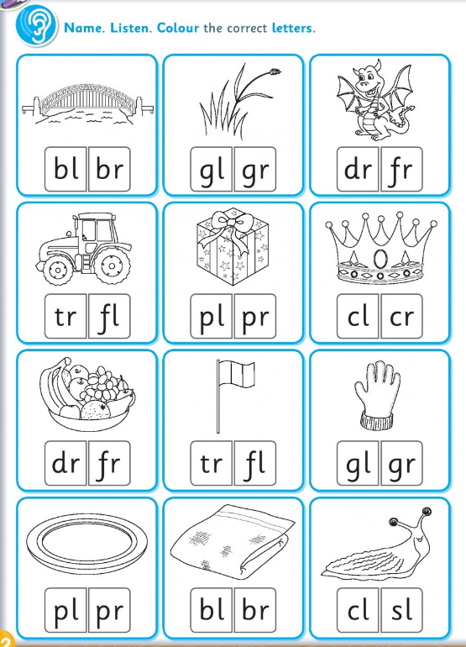

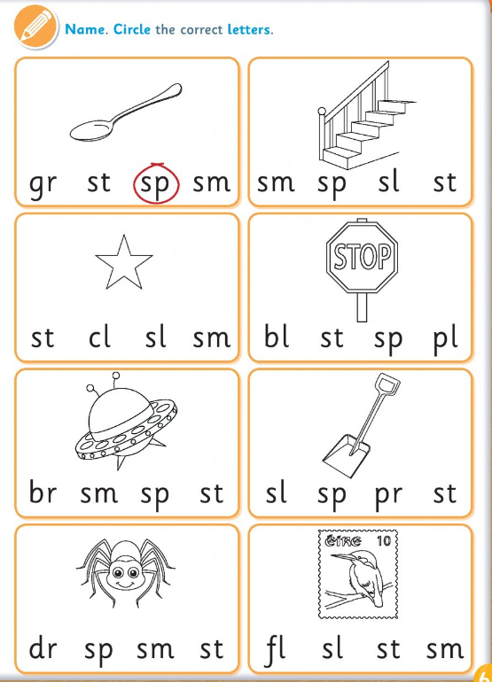
Circle the correct letter the word begins with

Revision sheet 1
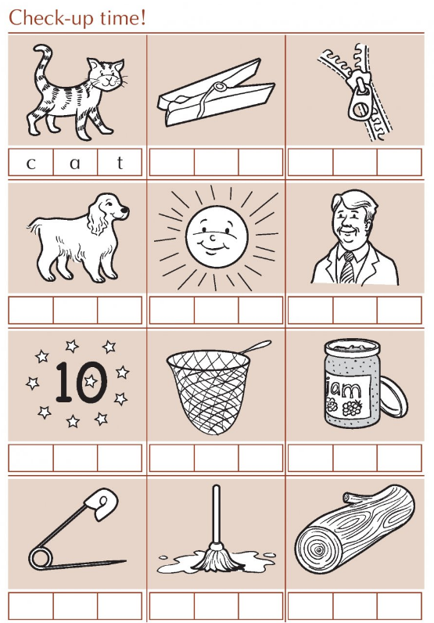

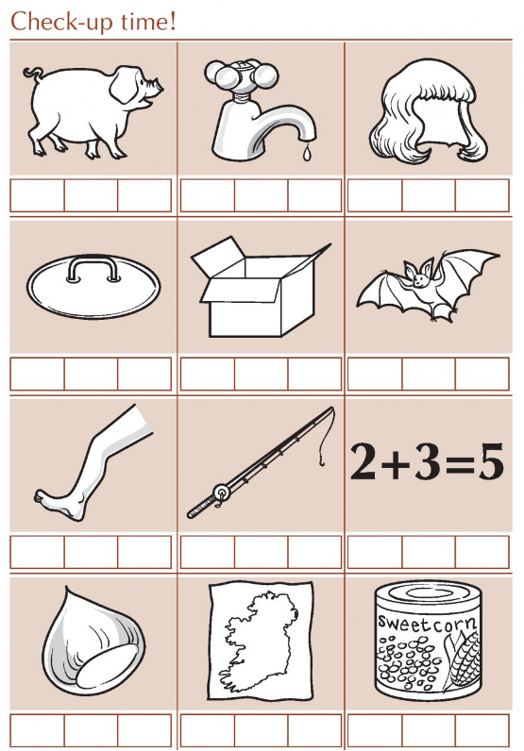
Revision sheet 2

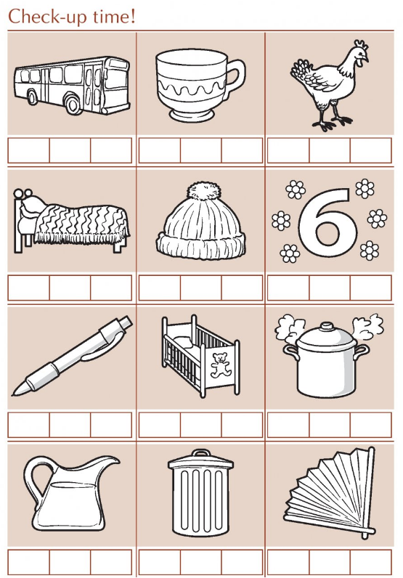
Revision sheet 3

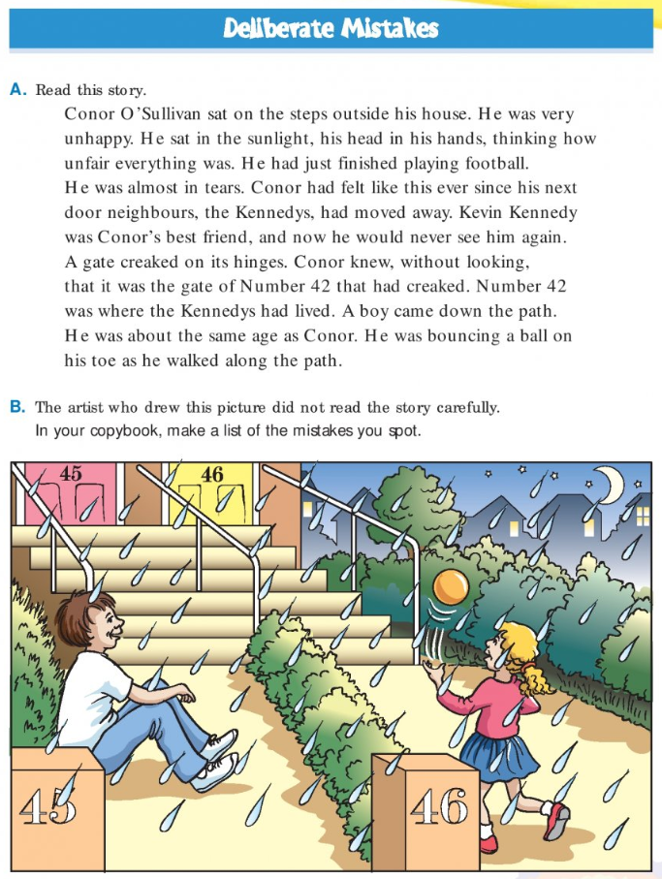
4th Class worksheets

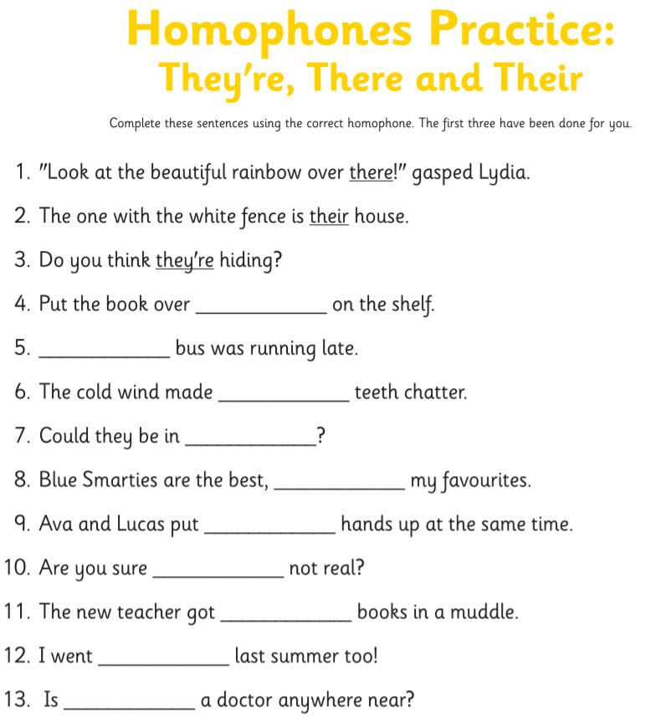

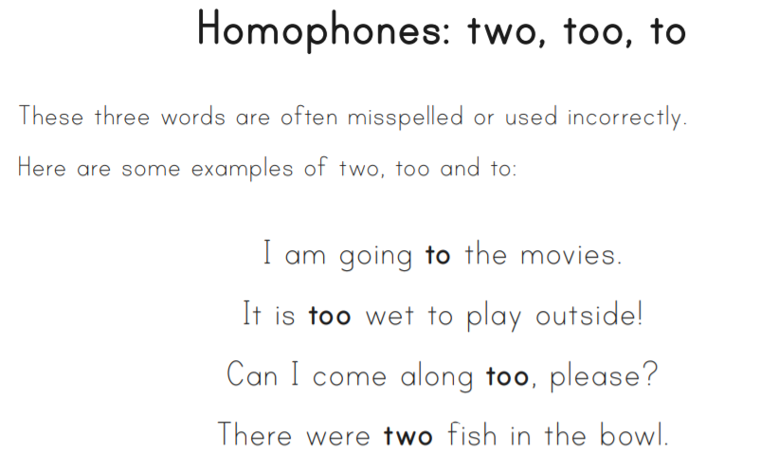

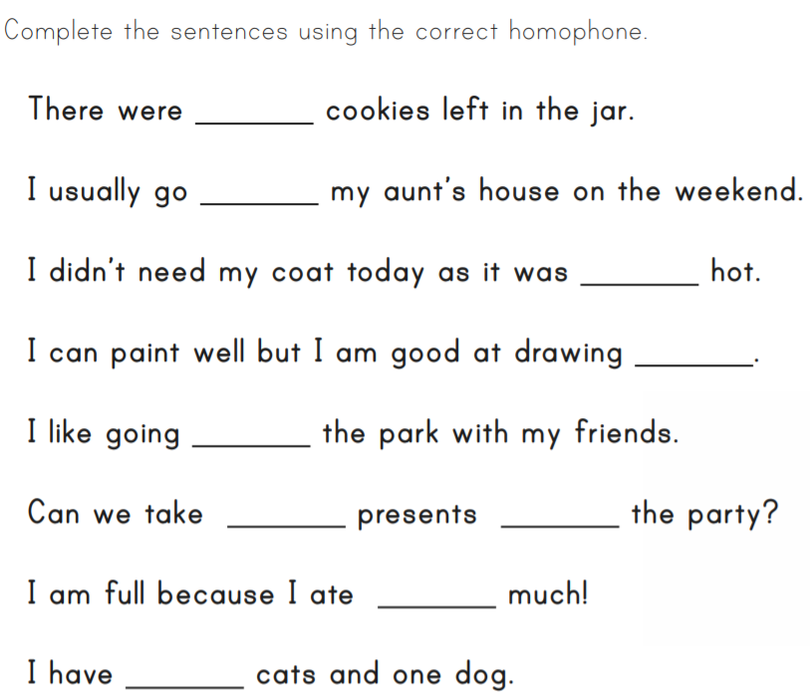

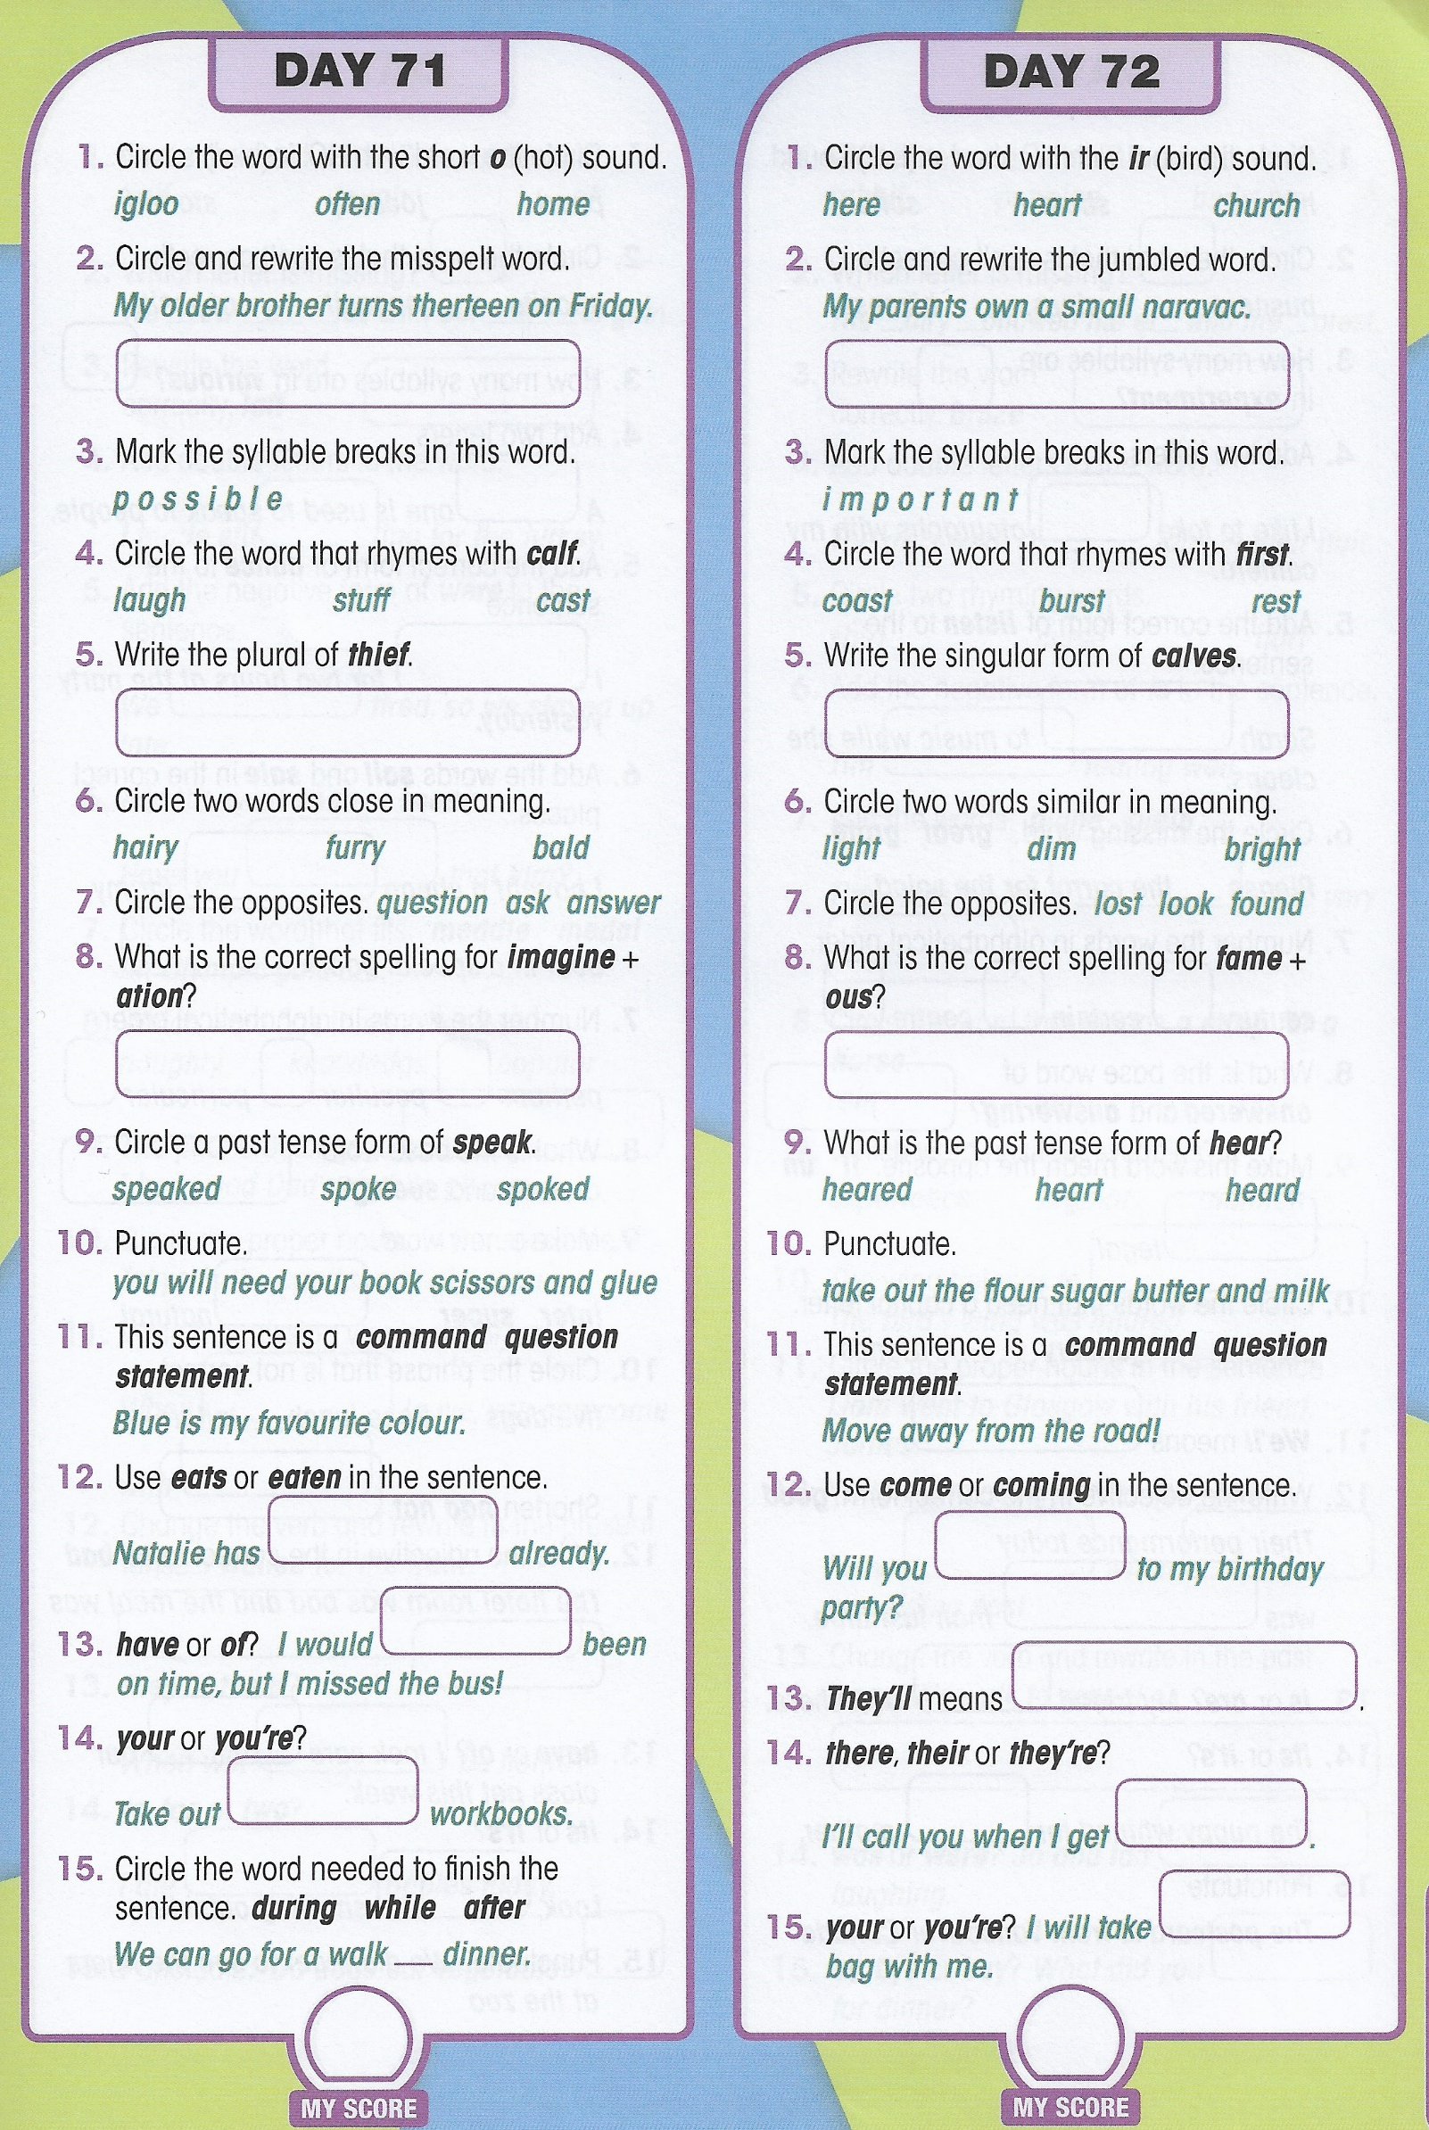

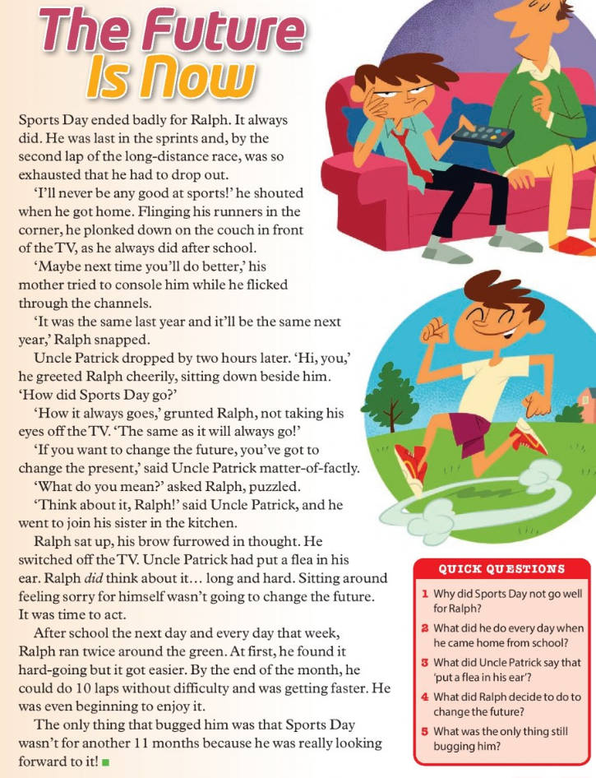

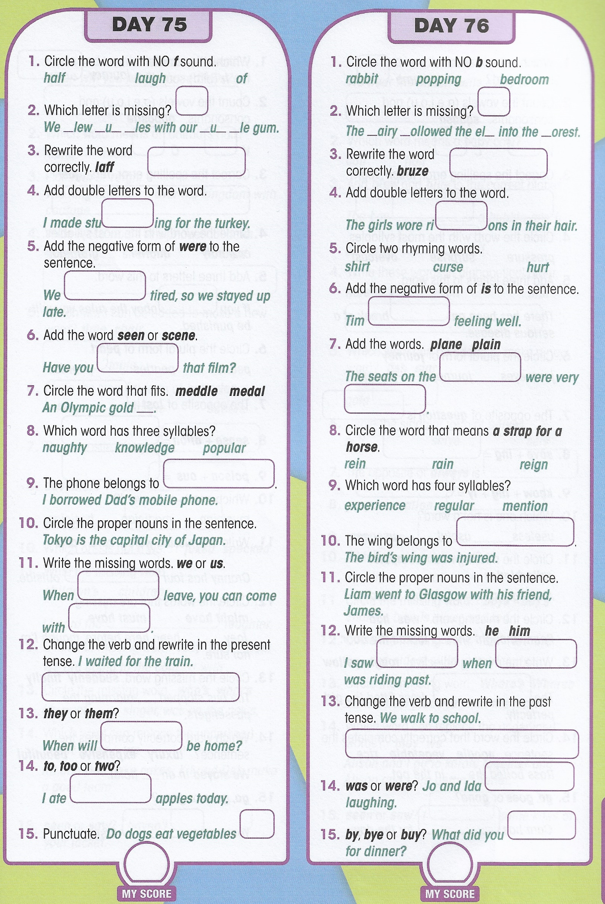

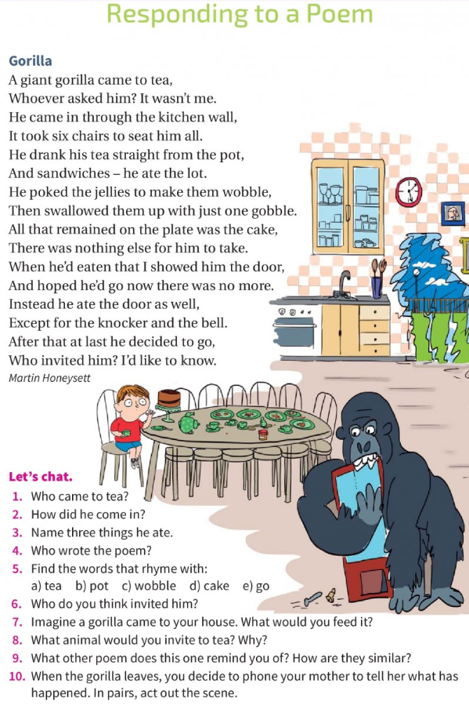

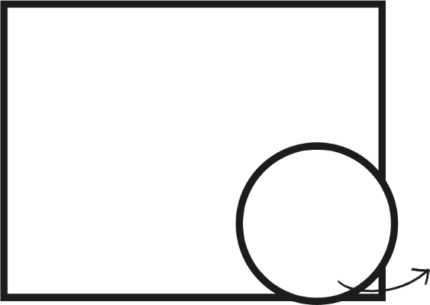
Would I recommend this book to my friend?
What happened?

Why did this happen?

Reasons why not
Reasons why
My Star Rating

Why I rated the book stars
This book made me feel
because

Name
Personality

Describe how the character looks

How I feel about this character and why

draw how you felt!

Picture of the setting
Character
Plot
Setting
My book cover
Author
Illustrator
Genre (tick as many as apply to your book)

O scary
O fairy tale
O adventure
O sports

O fiction
O non-fiction
O fantasy
O humour
O other
O animal story
O biography
O historical
O mystery

Book Title
Book Review

