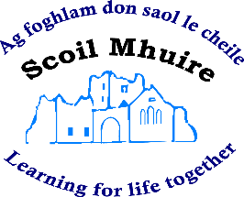

Teacher Email Contact Details

- Ms. A. O’Hanlon: horeswoodjuniorinfants@gmail.com

- Ms A. Doyle: horeswoodseniorinfants@gmail.com

- Ms K. O’Hanlon: horeswoodfirstclass@gmail.com

- Ms L. Cosgrove: horeswood2ndclass@gmail.com

- Ms. E. O’Connor: horeswoodsecondandthird@gmail.com

- Ms. A. Lawlor: 3rdclassteacherscoilmhuire@gmail.com

- Ms. L. Warner: horeswoodfourthclassmswarner@gmail.com

- Ms. A. O’Dwyer: horeswoodfourthclassmsodwyer@gmail.com

- Ms. G. Radford: horeswoodfifthclass@gmail.com

- Mr J. Mooney: horeswood5thand6th@gmail.com

- Mr D. Keating: horeswoodsixthclass@gmail.com

SEN Teachers:
- Mrs. B. O’Brien: horeswoodsenbob@gmail.com

- Mr. S. Stafford: horeswoodmrstaffordset@gmail.com

- Ms. F. Phelan: horeswoodfphelan@gmail.com

- Mr. S Donohue: horeswoodsen22@gmail@.com

