Dear Parents and Guardians,
Please find attached work to complete for English Learning Support groups (Monday 20th April – Friday 1st May).
These groups include Senior Infants and 4th Class English groups.
All worksheets and resources are included in this document. This is work to be completed as deemed appropriate alongside the class work allocated by the classroom teacher. Please do not feel under any pressure to get all the work complete. Some days, you might read the comprehensions and activities without answering the questions. At other times, you might answer the questions orally. Read as often as you can and try read for enjoyment too.
I have now set up an email that will be monitored for the purpose of a parent/guardian needing to contact me regarding work. If you have any questions or queries regarding the work, please email horeswoodmrstaffordset@gmail.com I will be online Monday to Friday 9:20 a.m. to 11:20 a.m. and endeavour to get back to you as soon as I can.
I have set up an online account for my students on an app/ website called Seesaw. I would like to use this website for reviewing and correcting work with 4th class. Senior infants may also find this a useful way of receiving feedback for their work. There is no requirement to upload all or any of your work here but it may be beneficial if I can give feedback on some of your work through comments. To access the online site each child will have a unique password to log in. I will e-mail you this code to log in to seesaw as a student. It is very easy and simple for the children to use. Please send an e-mail to horeswoodmrstaffordset@gmail.com if you would like to set this up.
For now, please stay safe and mind yourselves.

Kind regards,
Mr Stafford.

Mr Stafford
Senior Infant English Group
Dates | Activity | Dolch Word List 2  Remember: Look, sound, read  Put into a silly sentence and a normal sentence each night.
Monday  20/04/2020 | - Worksheet ‘at’ and ‘et’ words  - Copy work: Can you think of any more words ending in ‘at’ or ‘en’. Write and draw in your copy. | Dolch words to learn (Dolch list 2 below)  At, him, with, up all
Tuesday  21/04/20 | - Fill in the missing vowel worksheets  (Complete the two pages) | Dolch words to revise (Dolch list 2 below)  At, him, with, up all
Wednesday  22/04/2020 | - Read and colour worksheet  - Copy work: Can you spot any rhyming words with the real words? Write these in your copy. | Dolch words to learn (Dolch list 2 below)  Look, is, her, there, some
Thursday  23/04/2020 | - Missing middle letters worksheet 1  - Copy work: Can you think of any words that rhyme with these words? Write these in your copy. | Dolch words to revise (Dolch list 2 below)  Look, is, her, there, some
Friday  24/04/2020 | - Read and colour the correct picture worksheet 1 | Dolch words revision of all words learned this week

Dates | Activity | Dolch Word List 2  Remember: Look, sound, read  Put into a silly sentence and a normal sentence each night.
Monday  27/04/2020 | - Colour the correct letter and write the word worksheet 1 | Dolch words to learn (Dolch list 2 below)  Out, as, be, have, go
Tuesday  28/04/20 | - Missing middle letters worksheet 2 | Dolch words to revise (Dolch list 2 below)  Out, as, be, have, go
Wednesday  29/04/2020 | - Missing end letters worksheet | Dolch words to learn (Dolch list 2 below)  We, am, them, little, down
Thursday  30/04/2020 | - Missing consonants worksheet | Dolch words to revise (Dolch list 2 below)  We, am, them, little, down
Friday  01/05/2020 | Read and colour the correct picture worksheet | Dolch words revision of all words learned this week

Mr Stafford
English Support Group 4th Class Pupils
Dates | Activity | Additional notes
Monday  20/04/2020 | ‘’Your very own alligator’’ reading comprehension  Answer all Questions in part A  Answer any ‘’Think and Talk’’ question in your English copy | Remember, full sentences for your answers.
Tuesday  21/03/20 | Homophones activity | Write full sentences in English copy
Wednesday  22/04/2020 | Poem: Mr Nobody  Answer Questions and ‘’Think and Talk’’ question | Write a couple of sentences to explain your ‘’think and talk’’ answer
Thursday  23/04/2020 | English in Practice Day 61 and 62  Please complete both sides

Dates | Activity | Additional notes
Monday  27/04/2020 | Trick: Guess the number trick: Try it out at home!  Poem: ‘’Because of number one’’ | Answer the poem questions in your English copy
Tuesday  28/03/20 | Trick: Speaking without using the letter ‘a’  Reading comprehension and question: A Long Shot | Answer all Part A  Answer any one question in ‘’Think and Talk’’
Wednesday  29/04/2020 | Synonyms Part A and B  Please answer in your English copy
Thursday  30/04/2020 | English in Practice Day 63 and 64  Please complete both sides

Senior Infants
Dolch list 2
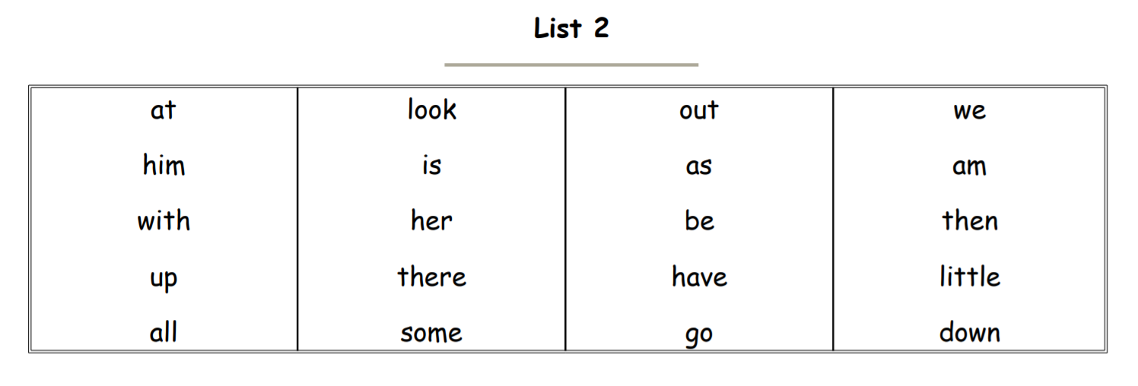

#

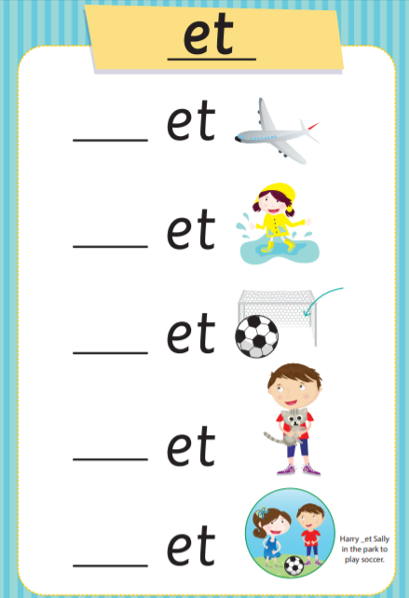
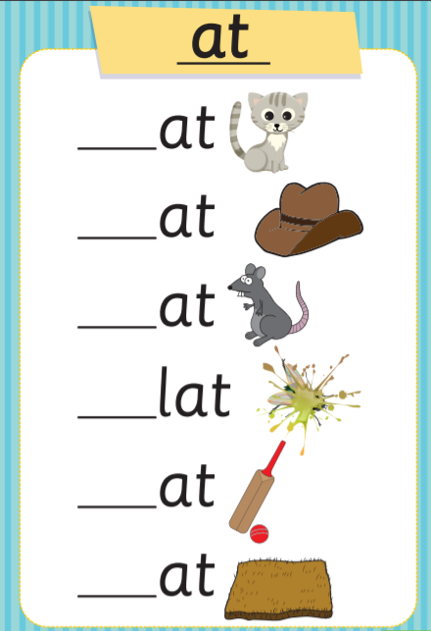

Fill in the missing vowel worksheet
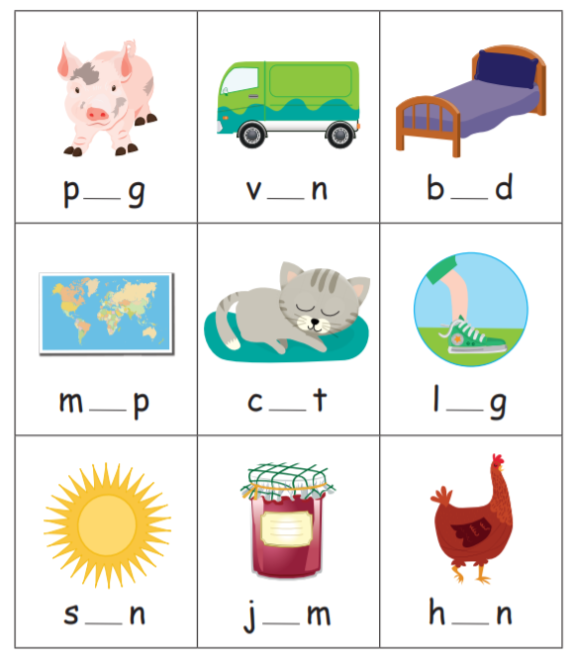

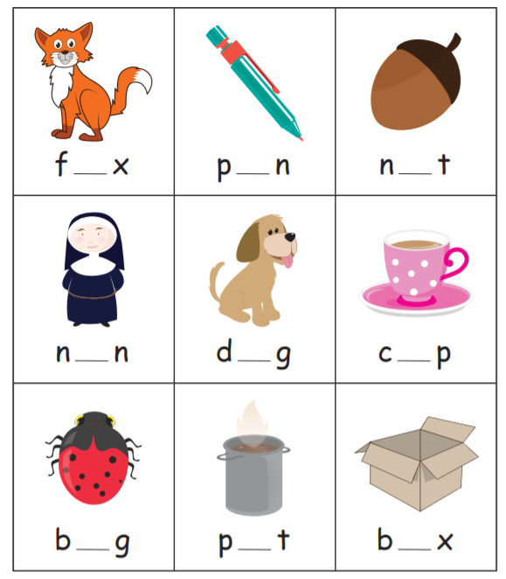
Worksheet 2 (continued)

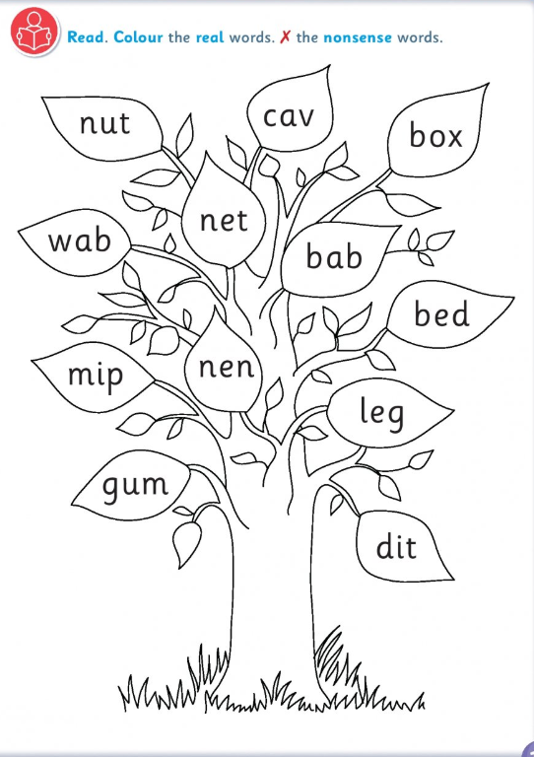
Read and colour worksheet

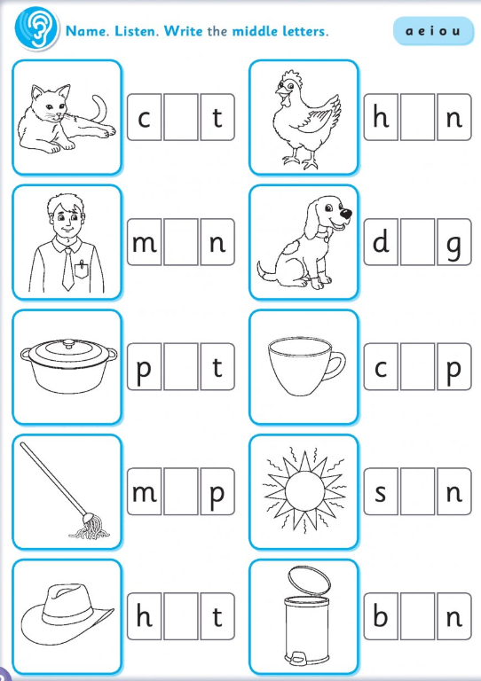
Missing middle letters worksheet 1

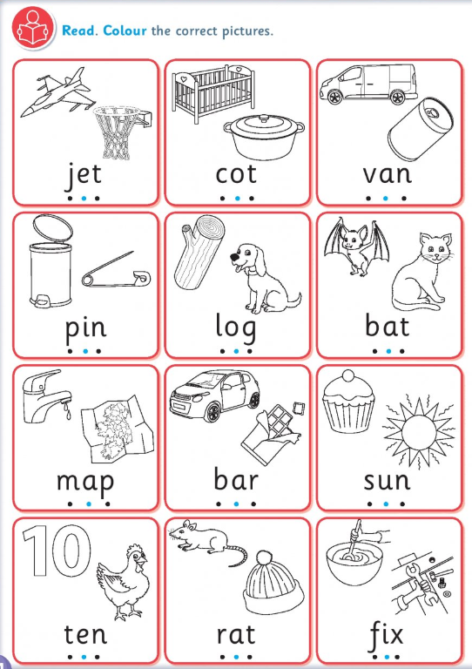
Read and colour the correct picture worksheet 1

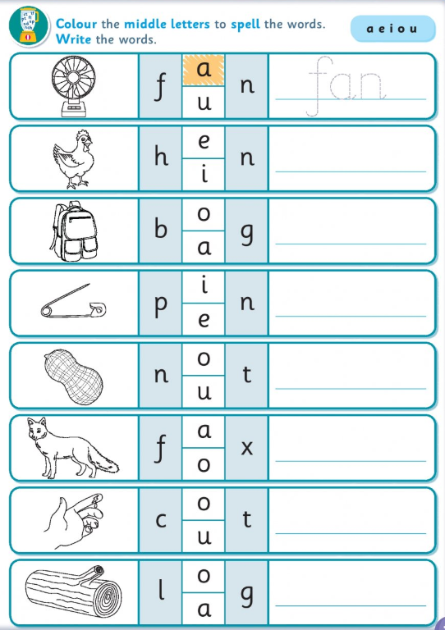
Colour the correct letter and write the word worksheet 1

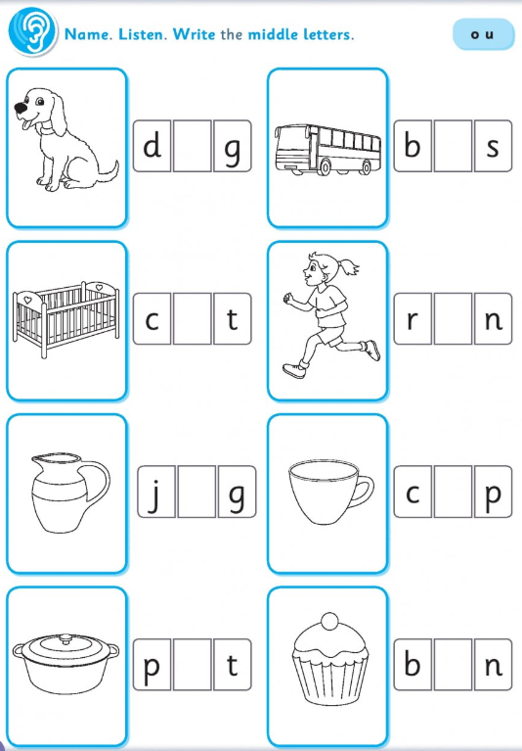
Missing middle letters worksheet 2

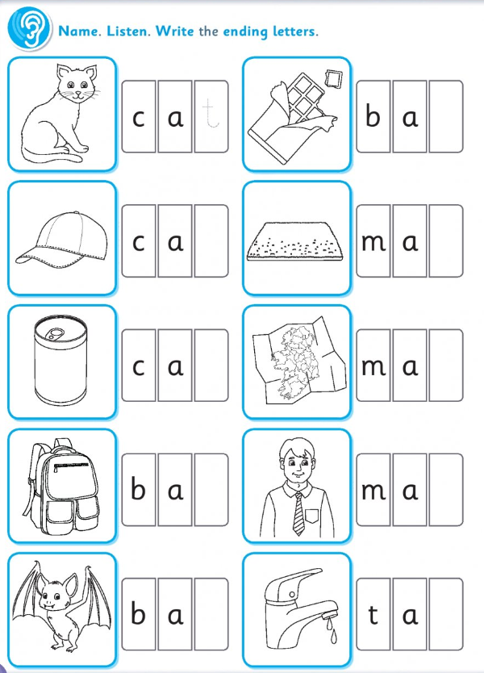
Missing end letters worksheet

Missing consonants worksheet 1
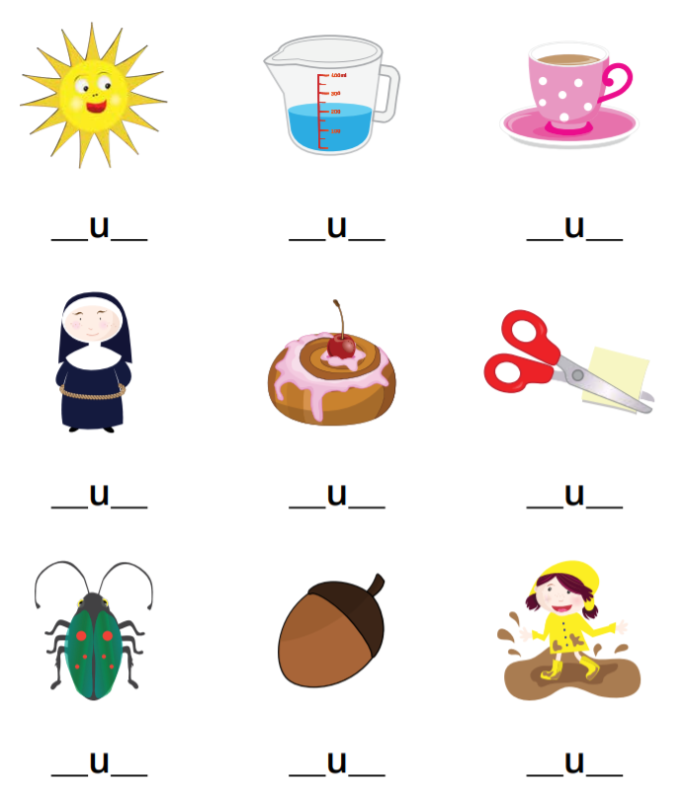

Read and colour the correct picture
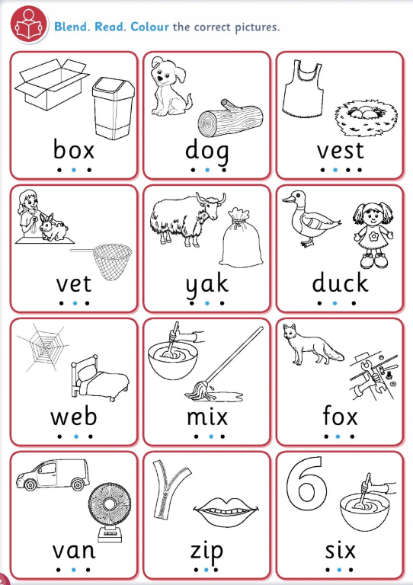

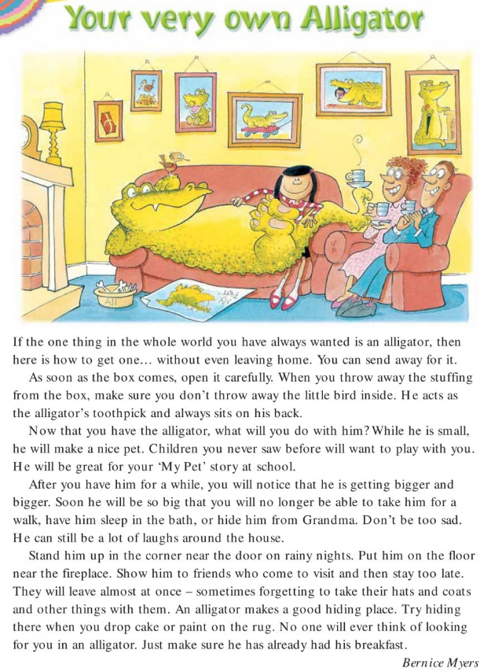
4th Class Worksheet 1

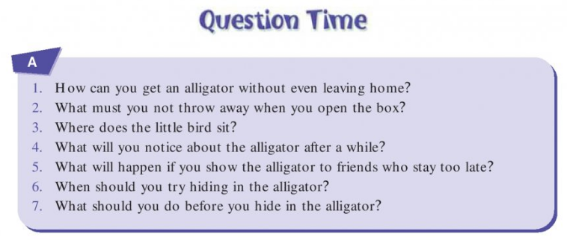
Your Very Own Alligator Questions

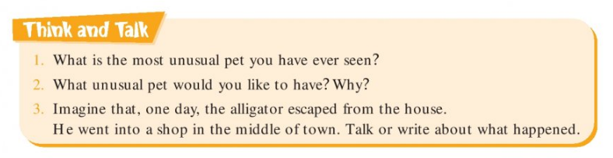

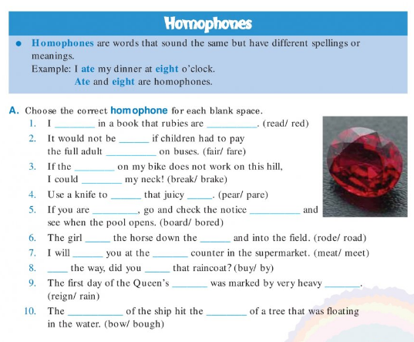
Homophones activity

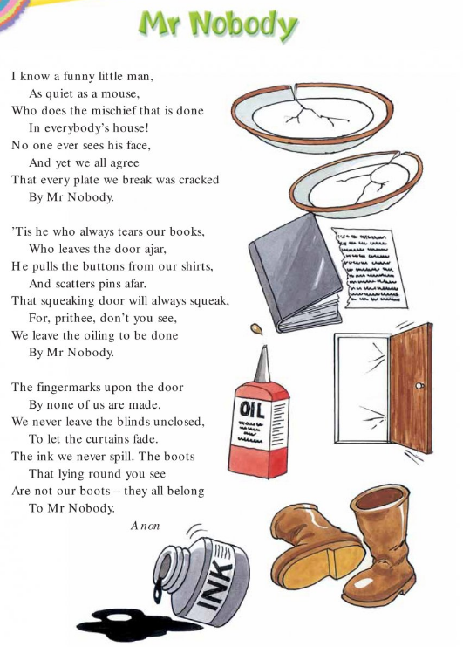

Poem: Mr Nobody Questions
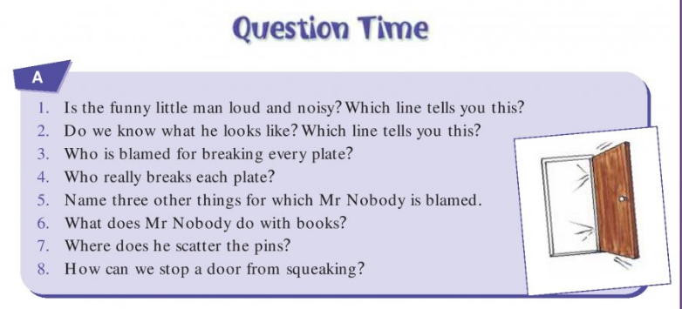

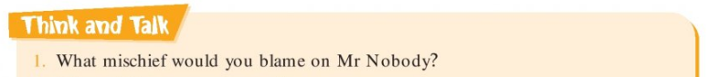

Write a couple of sentences explaining this.

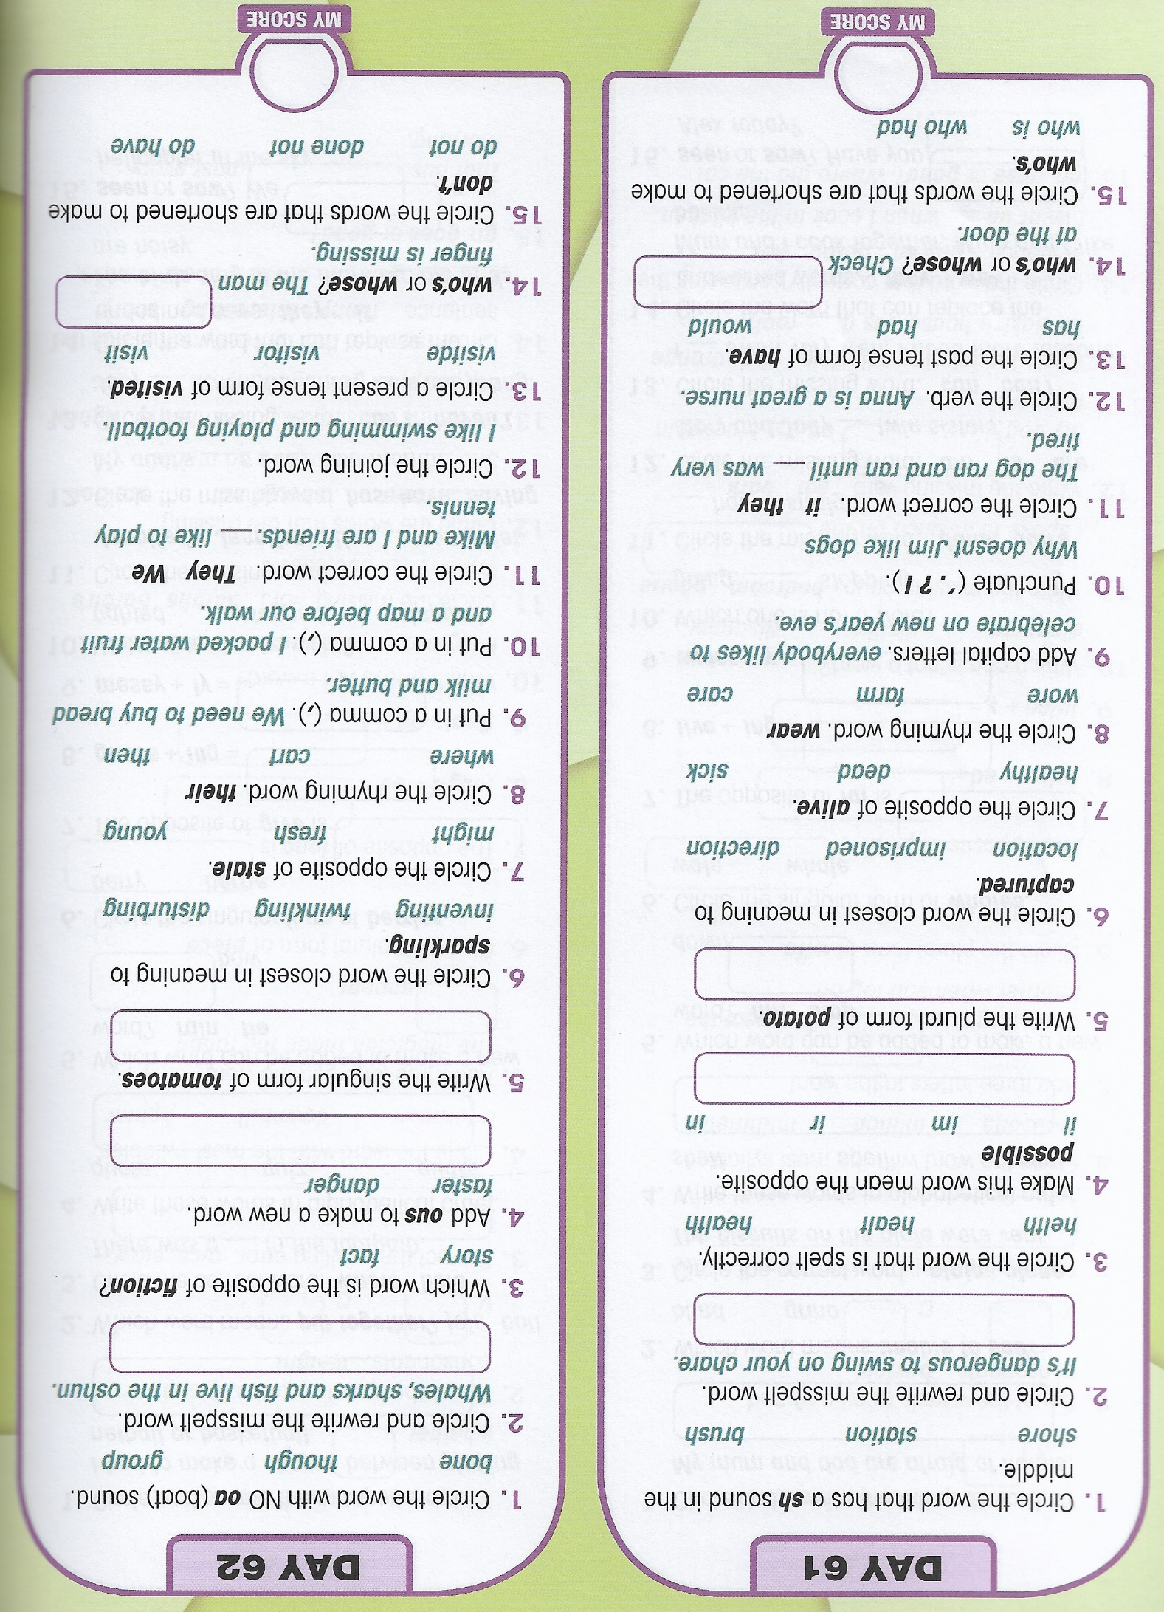

Read and try it out!
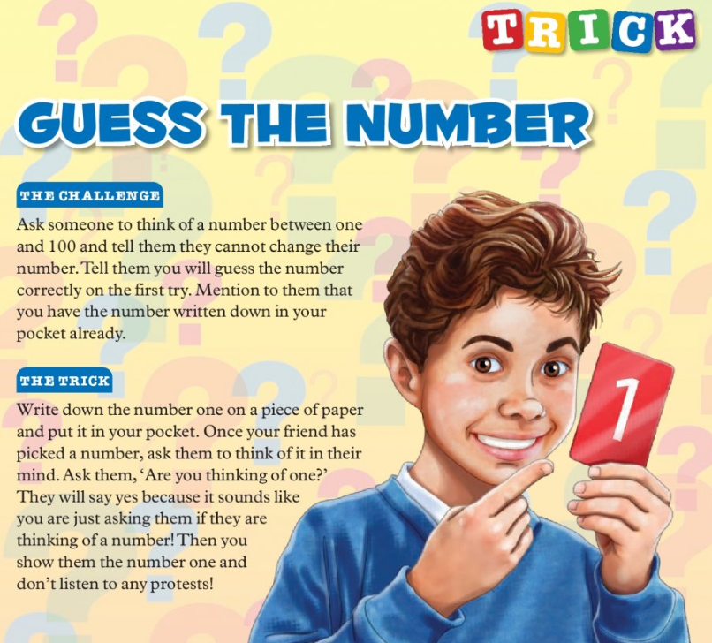

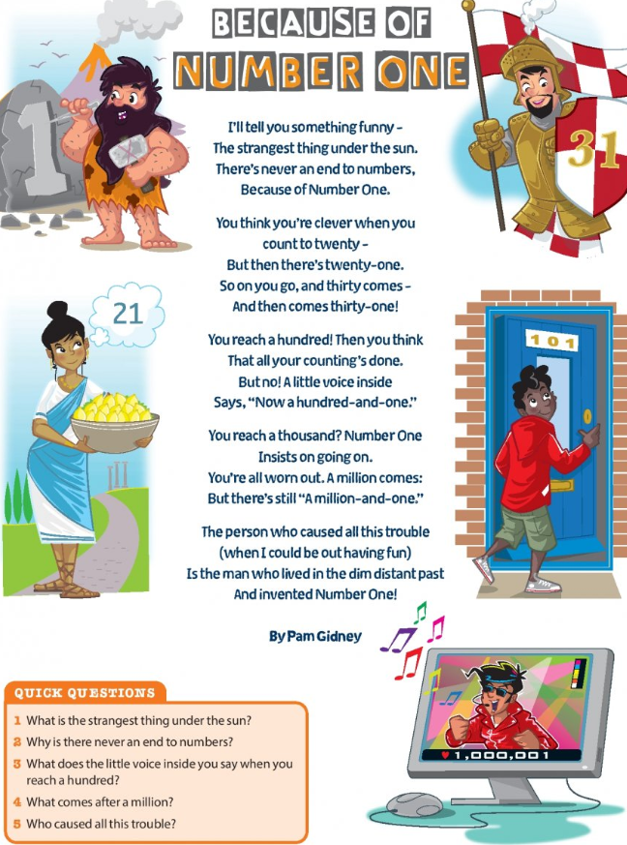

Read and try it out!
