Ms. Doyle’s Senior Infants
Monday 30th March – Friday 3rd April 2020

Monday 30th March 2020
Literacy
Reading & Oral Language - Look at the new words for the week (Dolch List 5, see list below). Children should look at the words and see if they can sound them out or read them. After they read all the words they should put them into silly and regular sentences.
from | good | any | about | around
want | don’t | how | know | right

Writing – Children should complete activity sheet (see attached) about the image on the page. The children should discuss the image with you and then answer the questions on the page – either on the page or in their copy. The children should invent a problem that can happen and invent a solution to the problem.
Gaeilge
Éadaí (‘a-d’) – clothes
Revise the words for clothes with the children by having them draw the items as you call them out by saying -
‘Tarraing (‘tar-ing’) _________’ Scíorta (skirt-a) – skirt
Bríste (‘brie-shh-ta’) – pants Gúna (goo-nah) – dress
Léine (lay-nah) – shirt Bróga (bro-ga) - shoes

t-léine (t lay-nah) – t-shirt Geansaí (gan-zee) – jumper

Then the children should colour the items in a given colour. Parents can call out the item of clothing and the colour
for the children to correctly identify by saying –
‘Cuir (colour) ar na (clothes)’ (qur ____ air nah _____)

Dearg (da-rog) …on the pants
Buí (b-we) …on the shirt
Glás (gloss) …on the t-shirt
Gorm (gu-rum) …on the jumper
Dubh (duh-v) …on the shoes
Bán Dearg (bawn da-rog) …on the dress
Bán (b-awn) …on the skirt
Maths
Length -
Compare 2 objects in the house in terms of length, which is longer, which is shorter? E.g. the fridge and the kitchen table, the couch and the T.V. – use a pencil case, shoe or any other object to measure (we don’t use rulers in Senior Infants). Do this with 3 sets of items and write the answers that you get in your blue copy.
Item | Estimate/Guess | Actual Count | Longest Item
Fridge and Table | 9 shoes and 6 shoes

Please create a Folens Account online to access the children’s maths book, Planet Maths https://www.folensonline.ie/registration/?r=t – there are games and resources linked to the topics that you can access for free by registering as a Teacher and using the special code for Roll Number: Prim20

Tuesday 31st March 2020
Literacy
Revise new words – read and put them into sentences orally
Reading – Read the story with the children and ask them questions throughout and ask them to recap at the end. The children should try to make up a new ending for the story once you are finished discussing it. Pause the book on YouTube on each page to allow the children to read it by themselves before listening to the story.
Where’s my Teddy? - https://www.youtube.com/watch?v=yP7CKlk2iKc
Gaeilge
An Choirp (on corp) – Body
Revise the words for body parts with the children by playing Simon Says
Deir O Grádaigh (der oh gra-de) cuir do lámh ar do (qur duh law-va air duh) _______
Shúile (sue-la) – eyes Lámha (law-va) - hands
Chluasa (clue-sa) - ears Bholg (bull-ugg) - stomach
Bhéal (Bail) – mouth Shrón (shh-row-n)

Maths
Sizing -
In their blue copy, children should draw the following shapes and follow the instructions below:
Item | Draw the same item but show it as | New Items
 | Big and small
 | Small and smaller
 | Big and bigger
 | Small and smaller
 | Big, bigger, biggest
 | Small, smaller, smallest

Wednesday 1st April 2020
Literacy
Revise new words – read and put them into written sentences (spellings do not have to be 100% correct but encourage the children to write them independently).
Capital Letters – Q
https://www.google.com/search?q=writing+a+capital+Q&oq=writing+a+capital+Q&aqs=chrome..69i57j33l7.7582j0j7&sourceid=chrome&ie=UTF-8#kpvalbx=_Q0N6Xu6bOdiM1fAP072moA424
Children should look at the letter video and then discuss the shape of the letter with you. Practise writing the letter in their air using their ‘magic finger’, then use their finger to write the letter on the table, on their leg, on your back etc.
If you have playdough, ask the children to make the letter using the playdough or Lego or other non-writing materials.
Practise writing the letter Q in their blue copy, ensure the children use a tripod grip on their pencil. 2 lines of practise then write the words Queen, Quick and Quack – the children can also draw pictures of these words.
Gaeilge
Practise the numbers up to 10 with the children, ask the children to line up items and count them as Gaeilge https://www.youtube.com/watch?v=heA91pd0fVs
- a haon
- a dó
- a trí
- a ceathair
- a cúig
- a sé
- a seacht
- a hocht
- a naoi
- a deich
Children should also watch Garfield as Gaeilge - https://www.youtube.com/watch?v=2hG0wNdWvUQ
Maths
Data – make a list of all the things that are in your room (have at least 4 different items) – count them and check which item has the biggest and smallest number e.g.
Item (Write the name or draw a picture) | Number | Which has the most/least?
Pillow | 2 | Least
Teddy Bears | 6 | Most
Toy cars | 5

Thursday 2nd April 2020
Literacy
Revise your new sight words – can you try to spell them without looking at them today?
Oral Language – Describing an image (The Farm) using as much detail as possible – see image attached (there is also some suggested questions for you to ask your child).
Play Eye Spy with things in the house or in your own garden – do this with letters or sounds e.g. I spy with my little eye a words beginning with ____ or I spy with my little eye a word that has the sound ‘ue’ in it (use the Jolly Phonics song to help with sounds if you are unsure).

Gaeilge
Revise the names of animals as Gaeilge – ask the children to draw the animals as you call them out –
Bó (bow) – Cow Madra (mod-ra)– Dog
Caora (quara) – Sheep Cat (cot) – Cat
Muc (muck) – Pig Coinín (quinn-een) – Rabbit
Cearc (ke-arc) – Hen Eilifint – Elephant
Sioráf – Giraffe Moncaí – Monkey
Tíogar (Tea-grr) – Tiger Cangarú – Kangaroo

Maths
Number Bonds to 10 children should revise their addition with answers equalling 10 using Rainbow to 10 method. The children should do this in their Blue Copy.
Each colour represents 2 sums that adds to 10 e.g. red: 0+10=10 and 10+0=10
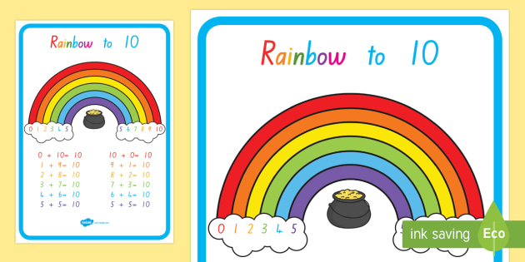

Friday 3rd April 2020
Literacy
Jolly Phonics – Please practise the children’s phonics sounds with them, with the songs and actions https://www.youtube.com/watch?v=26uXtUYssuo&t=581s
We also use this song in school to help the children learn the letter names as well as the sounds - https://www.youtube.com/watch?v=s64SblHofVE
Call out a sound for the children, ask them to think of a word beginning with that sound and say it in a sentence (silly or regular) – pick about 20 (at least 1 from each group) different sounds today –

- s, a, t, p, i, n,
- c, k, e, h, r, m, d
- g, o, u, l, f, b
- ai, j, oa, ie, ee, or
- z, w, ng, v, oo, oo
- y, x, ch, sh, th, th
- qu, ou, oi, ue, er, ar

Audio Books by Beatrix Potter – The Tale of Peter Rabbit - https://stories.audible.com/pdp/B00IZMHQSE?ref=adbl_ent_anon_ds_pdp_pc_cntr-0-2
Listen to Chapter 1 of the story and then write about the bits that you liked, disliked and why. Children should also write what they think will happen next. Children should draw a picture of what they think Peter Rabbit looks like and describe it to you.

Gaeilge
Revise all the words from the week with games such as draw a picture of a ____, find a ____ around the house etc. Play ‘I spy’ as Gaeilge with the words from the week – Feicim le mo shúilín beag (fek-im le muh sue-linn be-ug) __________

Maths
Patterns – children should finish the following patterns and create 3 of their own patterns in their Blue Copy.

Practise counting up to 20 and backwards to 0
Additional Subjects – these can be done on days that you choose

Reading
Children should read books from your own collection whenever possible. Ask the children questions about the books and stories (about the author, illustrator, what they think will happen, why they think that, what will happen next etc.). The children can write a few sentences on their own about the story after they have read it and draw a picture. When writing, remind the children to have ‘sharp fingers’, to write on the line, to use finger-spaces and full-stops. Also remind the children to use the space on the lines appropriately when writing (do not squish words onto a line if they won’t fit and don’t move to the next line for a word if there is a lot of space).
Religion
Practise saying the Hail Mary & Our Father
The Last Supper story - https://www.youtube.com/watch?v=2359k2zAJmA

History
Read the story of ‘Hansel and Gretel’ – https://www.twinkl.ie/resource/t-t-166-hansel-and-gretel-story-sequencing
As you are reading, ask the children questions such as what just happened, what do you think will happen next, why etc.
After reading, ask the children to sequence the story in their own words using the language of first, then, next, finally

Geography
In your copy or on a page that you have at home, draw as simple map from your house to a relatives or friends house, marking any big features that you pass on the journey (church, shop, school, parks etc.). This map should be very simple and while discussing the map with your child ask them to say what jobs or things happen in certain places e.g. In the shop people work with money, food and people, some people bake bread there etc.

Science
Naming the parts of a flower (see attached) and colouring – if you can’t print the page, doing it on a sheet/copy, cereal box you have at home is fine
If you have a garden, go outside and make a list (or draw a picture) of any plants/flowers/trees that you can see. Try to find the names of these using the app Flora Incognita (this is a free app).

P.E.
Jumping, hopping and catching – play leap frog, practise jumping and landing on one foot, landing on 2 feet, play hopscotch if you have chalk at home, throw a ball and catch it in one hand, throw a ball and clap your hands before catching it, what other tricks can you do? Have lots of fun
You could make an obstacle course for you and your parents/siblings to play with – challenge each other to see who can do it the fastest/slowest etc.
Do some dancing and stretching – put on your favourite song and make up a dance to it. Add in some stretches to warm you up –
- Pencil stretch
- Lunges
- Reaching your toes without bending your knees

Music
Learn the words for Hakuna Matata from The Lion and sing it. Practise clapping/marching to the beat while you sing - https://www.youtube.com/watch?v=BGI1DnMEpv8 - why not sing this song with everyone in your house to spread some cheer at this time? You can make up a dance together if you want

Drama
Go on an adventure around your house/garden where you are either Hansel or Gretel. You can set a ‘breadcrumb’ trail for your parents or siblings to follow. Use toys, sticks etc. for the trail – why do you think using breadcrumbs outside wouldn’t be a good idea?

Art
Children should make an Easter character using materials that can be recycled at home, colours (paint, crayons, pencils – whatever you have at home) and decorations (recyclable materials e.g. toilet roll insides, cereal boxes etc., paper, stickers, cotton wool, tinfoil, again whatever materials you already have at home).
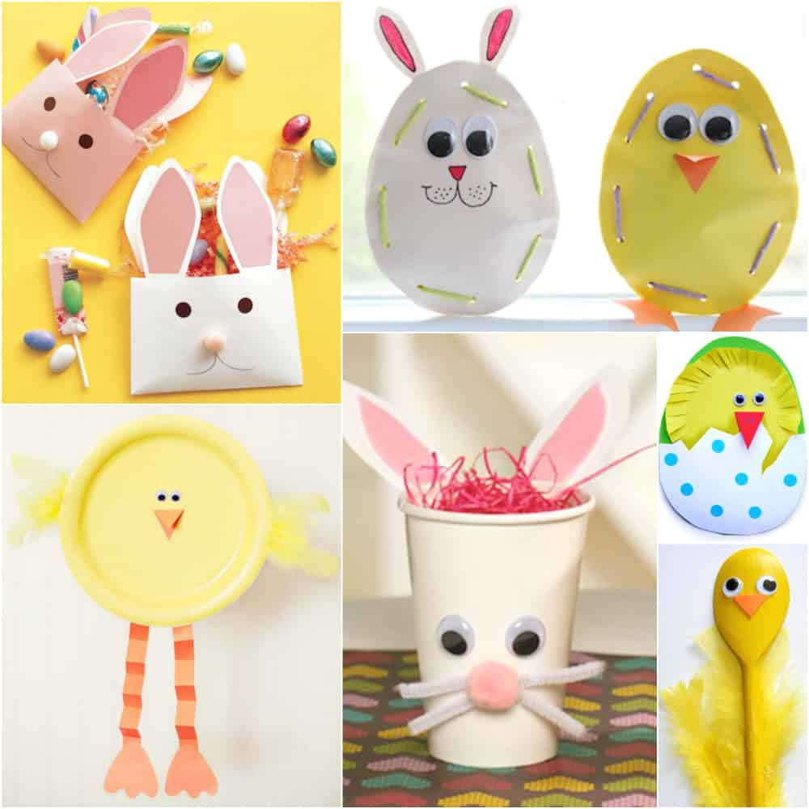
Here are some examples (you can make something different if you like, it just needs to be Easter Themed)

S.P.H.E.
Family tree – children should make a simple family tree back to look at links in the family – this should go back to their grandparents (or further if they want to) – this can be done using images, drawn pictures – any format that the children would like to present it in.

Hello everyone,
I hope everyone is keeping well and minding themselves. Try your best to do the work that’s in this document – if you have any problems you can email me for help -horeswoodseniorinfants@gmail.com
I will be monitoring the emails from 10-11 and 2-3 each day if you need any help
I hope you are all helping as much as you can around the house and having fun playing with your parents, brothers and sisters. Remember it’s important to have fun and play at home too. I hope that we will all see each other again soon.

Stay Safe and Healthy Everyone

