School work for school closure days 4th class Ms.Warner

Novel:

Read a novel/book of your choice. If you finish a novel or two please fill in a book review for completed novels/books.

Recount Writing:

In your hardback write a recount of our day with Gillian from the Marine Institute last Friday. Remember high five sentences, capitals, finger spaces, clever spelling, makes sense and full stops.

News Report:

Pretend you are a news reporter. Write a news report into your hardback copy explaining why schools are closed. Include information on important tips and guidelines for people in the community to follow. Remember high five sentences, capitals, finger spaces, clever spelling, makes sense and full stops.

Word Wizard:

Unit 13 on Butterflies (p74, 75, 76, 77 & 78)

Maths:

Tables: Revise 6, 7 and 8 multiplication and division tables.
Tables Champion: Complete next week in Tables Champion.
Master your Maths: weeks 23 and 24 including Friday tests (p50, p51, p88, p52, p53 & p89)
Figure it out: p66 (all)

Music:

Practice song for assembly.

PE:

Try to do some of the following exercises when you are at home. Pick one every few hours!
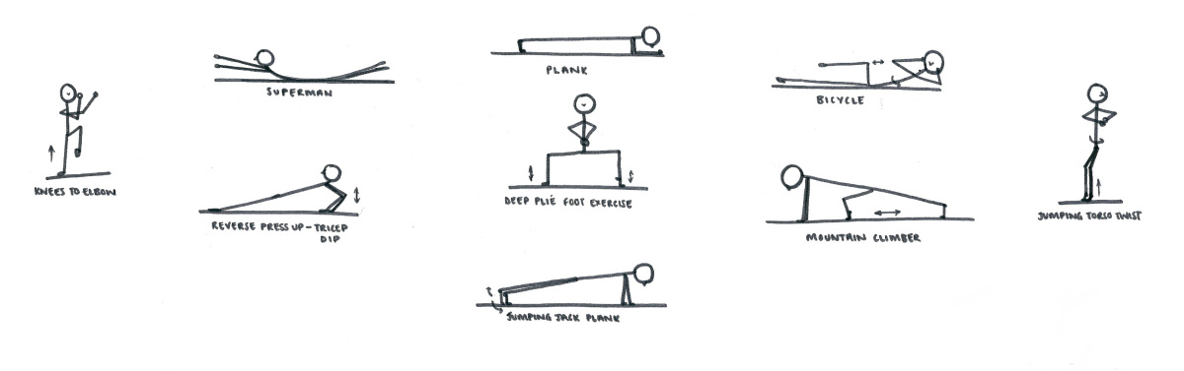

Optional Tasks:

- If children like they can think about any additional props/costumes they would like for our performance at the school assembly and make these i.e.: make themselves a bee costume etc.
- Children can choose a topic of their choice (possibly; a country, sports star, time in history i.e. the Celts, festival, etc.) and research this. Children can present their findings in; poster, booklet or powerpoint form.

