School work for school closure days 4th class Ms. O’ Dwyer

English
Novel/Reading:
- Read a novel/book of your choice. If you finish a novel or two please fill in a book review for completed novels/books.
*If you’re a member of the library you can access e books online*

News Report:

- Pretend you are a news reporter. Write a news report into your homework copy explaining why schools are closed. Include information on important tips and guidelines for people in the community to follow. Remember CUPS: Capital letters, Understanding-will people understand what I’ve written, Punctuation, Spelling

Word Wizard:

- Unit 13 on Butterflies (p74, 75, 76, 77 & 78). All to be done in your homework copy.

Maths
- Tables: Revise ALL tables
- Tables Champion: Complete next week in Tables Champion.
- Master your Maths: weeks 25 and 26 and Friday tests (p54, p55, p89, p56, p57 & p90)
Gaeilge
- Watch Cúla 4 ar TG4
- Go online to the Cúla 4 website and play some game
- Practice saying some Irish at home using the phrases sheet you have or indeed practice what you know already.

SPHE
- Tidy your room/spring clean the house
- Don’t forget to do/say something kind everyday
- Try and not let your mind stay too long in that Busy Bee level, try and ‘spend’ some time at Flower Level using the techniques we learned.
- Design a poster that goes with your news report that shows people how to prevent the spread of infection of Covid 19

PE:

- Try to do some of the following exercises when you are at home. Pick one every few hours!
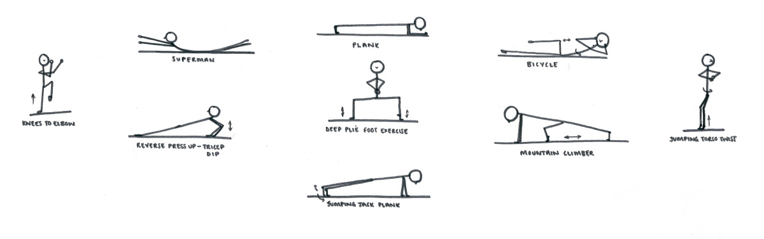
- Keep active! Look up dances online and learn them e.g. Go Noodle, Just Dance; Operation transformation 10@10.
SESE
- Pick a country of our choice and do a research project on it: include capital/main cities; food and drink; major rivers and mountains; language; flag; currency; culture/pastimes; tourist attractions; how children’s lives there compare/differ than yours and any other interesting facts you find.
- If possible go outside to your garden and plant some seeds/flowers and do some weeding (remember Save the Bees)

Other information
- There are many websites online that provide online learning/games to make learning fun and engaging for children.
https://www.padlet.com/ciarareillymarino/primarydistancelearning has a great list of them

Also Twinkl (excellent website with powerpoints/worksheets etc. ) are providing a month’s free subscription. Use the code: IRLTWINKLHELPS

