Ms. Doyle’s Senior Infants
Wednesday 19th – Friday 27th March 2020

Paired Reading
The children have 3 readers in their school bag. Please read these for 2 nights each as normal
Book 1 – Wednesday 18th, Thursday 19th
Book 2 – Monday 23rd, Tuesday 24th
Book 3 – Wednesday 25th, Thursday 26th
Please ask your children question about the books that they are reading e.g. –
What do you think this book will be about?
Who is the author/illustrator?
What do you think will happen next? Why?
What does the picture tell you before we read?
Can you remember what happened in the story?

Please encourage your child to read books they have at home as well, especially if they were not in school to get new books.

Literacy & Maths
Children have sheets in their Homework Folders (see 6 pages attached). Please complete the sheets as follows -
Wednesday 18th –
- Maths Sheet (Wednesday)

- Jolly Phonics – Please practise the children’s phonics sounds with them, with the songs and actions https://www.youtube.com/watch?v=26uXtUYssuo&t=581s
We also use this song in school to help the children learn the letter names as well as the sounds - https://www.youtube.com/watch?v=s64SblHofVE
Call out a sound for the children, ask them to think of a word beginning with that sound and say it in a sentence (silly or regular) – pick about 20 (at least 1 from each group) different sounds today –

- s, a, t, p, i, n,
- c, k, e, h, r, m, d
- g, o, u, l, f, b
- ai, j, oa, ie, ee, or
- z, w, ng, v, oo, oo
- y, x, ch, sh, th, th
- qu, ou, oi, ue, er, ar

Thursday 19th –

- Maths Sheet (Thursday)

- Phonics – Please practise adding ‘Magic e’ to words with the children. This is the silent ‘e’ that changes the vowel sounds to their letter name. We use this song and story to help the children in school - https://www.youtube.com/watch?v=bZhl6YcrxZQ (song) and https://www.youtube.com/watch?v=c3oA4wfUBak&t=23s (story).

Ask the children to add a ‘magic e’ to the words at the end of the song, the children should say the word with and without the magic e sound to practise the change in the vowel sound.

Friday 20th –

- Handwriting Sheet (h, o, l, b) – on the back of the sheet, write about the story, ‘The Princess and the Frog’ using the sentence starters - first, then, next, last
e.g.
First the girl went to…..
Then the boy….
Next they went….
Last they went to….
Encourage the children to use capital letters (where appropriate) finger spaces and full-stops.

- Maths – Number Bonds
0+6=
1+5=
2+4=
3+3=
4+2=
0+7=
1+6=
2+5=
3+4=
4+3=
5+2=
6+1=
7+0=

Monday 23rd –
- Maths Sheet (Monday)

- Dictation (in Blue Homework Copy) – encourage the children to sound all the words out themselves, remind them to stretch the words out to help them. Please do not spell the words for the children, let them try by themselves.

- I saw a dog.
- She went to the park.
- He got a new ball.
- We look at the books.

Tuesday 24th –
- Maths Sheet (Tuesday)

- Dictation (in Blue Homework Copy) - encourage the children to sound all the words out themselves, remind them to stretch the words out to help them.

      - I got a new toy.
      - Dad went to the shop.
      - When is it time for dinner?
      - I will go to the beach with my cat.

Wednesday 24th –
- Handwriting Sheet (u, f, j, v) - write sentences 3 on the back with sentence starters such as I went, I saw, I got

- Maths - Number Bonds –

0+8=
1+7=
2+6=
3+5=
4+4=
5+3=
6+2=
7+1=
8+0=
0+9=
1+8=
2+7=
3+6=
4+5=
5+4=
6+3=
7+2=
8+1=
0+9=

Thursday 25th –
- Writing Genre Sheet – Children complete the plan for their news on the sheet and should then write their News in their Homework copy, children should write 4 sentences about their News.

- Maths – Children should make patterns (using 3 or more objects) out of objects that have at home, toys, and cutlery, anything that they have easy asses to. Children can line the items up on the table/floor etc. and tell you what their pattern is.

Examples –
Fork, knife, spoon, fork, knife, spoon,
Red Lego, yellow Lego, blue Lego, red Lego, yellow Lego, blue Lego
Teddy, doll, car, teddy, doll, car

Friday 27th –
- Children should write (in their Blue copy) an ‘About Me Report’ about themselves – My name is, I am___ years old, I have ___ hair and ___ eyes, their likes/dislikes and favourite food etc.

- Maths –
Ask your child to tell you about the different coins that they know in money (we only work with 1c- 20c in Senior Infants) – ask them if they can draw the coins, in their copy or on a sheet. Ask them to draw different ways of making different values up to the value of 10c.

Toy Shop Money Game - https://www.topmarks.co.uk/money/toy-shop-money
Please change the currency to Euro and play games 1 and 2

Letter & Number Formation (in Blue Homework Copy)
Children should also practise their number formation from 1 – 10 when possible.
Children should practise all of their letter formations for lower case letters a-z, and upper case letters, A, B, C, D, E, F, H, I, J, K, L, M, N, O, P, S, T, U, V, W, X, Z when possible.

Word Wallet
Children should continue to practise reading the words in their word wallet – putting them into silly and normal sentences each day. When you come across new words in your child’s reader, encourage them to put them into sentences to help them remember the new words.

Fine/Gross Motor Skills
Children should try to play games at home to help support their fine and gross motor skills development. These games can include some of the following –
- Jigsaws
- Lego/Building blocks
- Playdough
- Threading activities
- Arts and crafts activities including cutting, gluing, colouring
- Playing with a ball
- Skipping, hopping, jumping
- Drawing pictures using pencil first then colouring
- Board games

Games & Activities the children like to play in school
- Hangman
- I spy – with words or items
- Odd one out/Spot the difference
- Simon Says
- Animal Exercises – walk/act like a bear, dog, cat, lion, rabbit, giraffe, bunny, crab etc.
- GoNoodle (free website with dances and exercises on them)
- Just Dance (children’s versions of songs, Disney songs etc. available on YouTube)

Stay Safe and Healthy Everyone
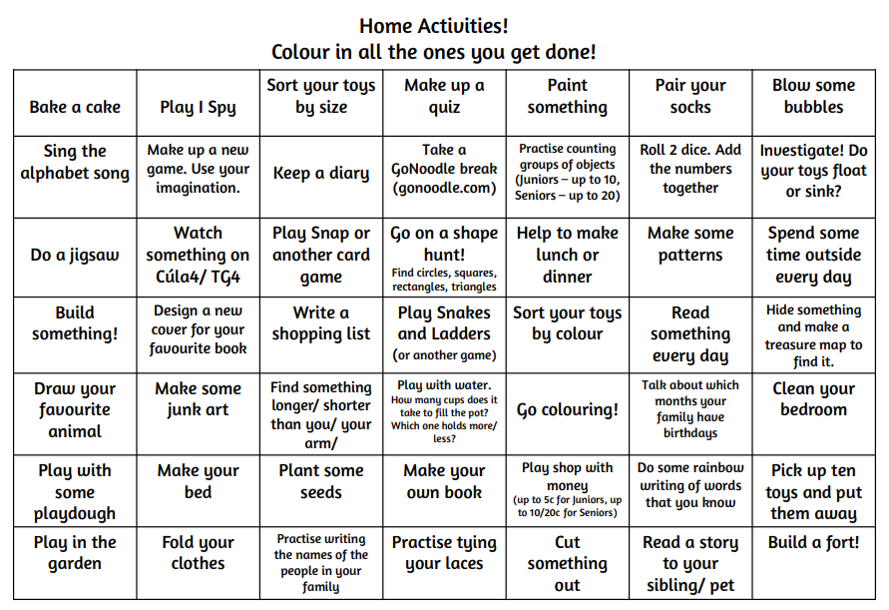
Suggestions for Activities at Home

