Dates | Maths Activities  - See notes | Tables Champion | Gaeilge  - See notes | Jolly Grammar | Hand-writing | Movement Breaks | SESE Project
Wed  18/03/20 | - MyM Wk. 23 -Mon  - Revision 1 | TC WK 22 - Mon | F&F pg. 48  - Activity A & B  - 1 sentence in copy | JG pg. 48  - Activities in the book  - 1st word into a sentence in copy | Page 31 | Cosmic Kids Yoga (YouTube)  1000 hrs outdoor challenge | Week 1 -Find out 5 facts about a famous scientist or engineer e.g. Henry Ford, Leonardo Da Vinci.  Write the facts in your copy.  See how tall you can make a giraffe that stands with newspaper and tape. Measure it and record the height in your copy. Maybe you would like to take a picture of it and ask someone to e-mail it to louisecosgrove@scoilmhuirecampile.com
Thurs  19/03/20 | - MyM Wk. 23 - Tues  - Measure 5 items under a metre long  - Revision 2 | TC WK 22 - Tues | F&F pg. 48  - Activity C&D  - 1 sentence | JG pg. 48  - Next 3 words into sentences | Page 32 | Try a Go Noodle activity  1000 hrs outdoor Ch.
Fri  20/03/20 | - MyM Wk. 23 - Wed  - Maths Trail 1 | TC WK 22 - Wed | F&F pg. 48  - Activity E&F  - 1 sentence | JG pg. 48  - Next 3 words into sentences | Page 33 | RTE jr. 10@10  1000 hrs outdoor ch.
Mon  23/03/20 | - MyM Wk. 23 - Thurs  - Revision 3 | TC WK 22 - Thurs | F&F pg. 48  - Activity G  - 1 sentence | JG pg. 48  - Next 3 words into sentences | Page 34 | Just Dance (YouTube)  1000 hrs outdoor Ch. | Week 2 - Animal that lives in the sea – see notes below.
Tues  24/03/20 | - MyM Wk. 24 – Mon  - Revision 4 | TC WK 23 – Mon | F&F pg. 49  - Activity A & B  - 1 sentence | JG pg. 50  - Activities in the book  - 1st word into a sentence in copy | Page 35 | Cosmic Kids Yoga (YouTube)  1000 hrs outdoor Ch.
Wed  25/03/20 | - MyM Wk. 24 – Tues  - Revision 5 | TC WK 23 - Tues | F&F pg. 49  - Activity C&D  - 1 sentence | JG pg. 50  - Next 3 words into sentences | Page 36 | Try a Go Noodle activity  1000 hrs outdoor Ch.
Thurs  26/03/20 | - MyM Wk. 24 – Wed  - Revision 6 | TC WK 23 - Wed | F&F pg. 49  - Activity E&F  - 1 sentence | JG pg. 50  - Next 3 words into sentences | Page 37 | RTE jr. 10@10  1000 hrs outdoor ch.
Fri  27/03/20 | - MyM Wk. 24 – Thurs  - Maths Trail 2 | TC WK 23 - Thurs | F&F pg. 49  - Activity G  - 1 sentence | JG pg. 50  - Next 3 words into sentences | Page 38 | Just Dance (YouTube)  1000 hrs outdoor Ch.
Notes:
Religion | Please make sure you know all of the following prayers for the First Penance (all on page 64 of Grow in Love) – Act of Sorrow, Prayer for forgiveness, Prayer after forgiveness, Confiteor (Penitential Act A).  The children also got their lines for the drama or readings or hymns for the First Penance. Please go over these during the school closure.
Reading | Lots of opportunity over the break to read, read and read. Don’t forget to record all your books onto your reading record and if this gets full write them down in your homework copy. I hope Grace and I will be busy, busy giving out merits and raffle tickets on the first day back. Maybe we’ll have to make another goal because we’ll reach our class target of 450 before Easter, well before the summer holidays .
Maths | Revision | Revision – Please do these in your homework copy.  Revision 1 Revision 2 Revision 3 Revision 4  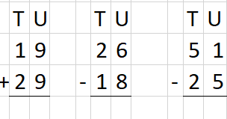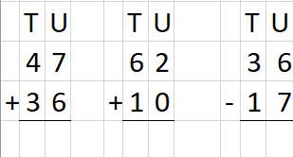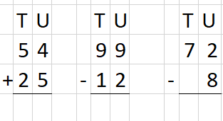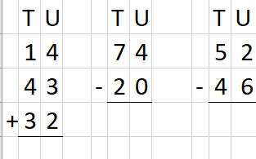  Revision 5  In your copy. Give each letter of the alphabet a number.  - Add them to see how much your name scores.  - Can you find out the value of other people’s names in the class.  Revision 6  - Spring, Summer, Autumn, Winter  Number the seasons of the year from your favourite (1) to least favourite (4).  - I have 5 coins in my pocket. Only two coins are the same. How much could I have? Draw out the possible combinations in your copy.
 | Maths Trail | Look around your house and find the items below. Write them down in your homework copy.  Maths Trial 1  - Find 3 examples of right angles  - List 3 items that measure less than a metre  - Estimate how long it would take to walk from your bedroom to the kitchen. Now test to see how close you were.  Maths Trial 2  - Find 3 cylinders in your house  - Find 3 cuboids in your house  - Can you find a cone or a pyramid in your house?
Gaeilge | Each day write one sentence in your homework copy using one of the words. Try your best. Remember your verbs from the classroom.  Bhí mé – I was, Chuir mé – I put, Chuaigh mé – I went. Cheannaigh mé – I bought.  Aonad 23  Ith – to eat Ag ithe - eating Dath bán – colour white Thit sé – He fell  D’ith mé – I ate Ag rith - running Áthas - happy Thug sí – She gave  Aonad 24  Úll - apple Milseáin - sweets Deoch - drink Páipéar - paper  Cón - cone Barra - bar Criospaí - crisps Páipéar grin - comic
SESE | Animal that lives in the sea.  Background information – read pages 58 – 60 of Feena’s Book of facts to get you thinking.  Think of your fabulous panda reports. I’d like you to write a report about a sea animal of your choice. Remember all the information that Gillian from the Marine Institute gave us and look at the report in Word Wizard about the Polar Bear (pg. 50)  Headings:  - Introduction – is it a mammal or a fish? Is it the smallest, biggest creature in the ocean etc.  - What does it look like?  - Where does it live? (What part of the ocean, warm waters or cold water etc.)  - What do they eat?  - Did you know? (Interesting facts)  Remember how we made notes first under all these headings first and then wrote the report. Check your English copy. You can write the report in your English copy, you can do it on a sheet or if you like you can type it up. Don’t forget to include pictures of the creature – you can draw it or take a picture from the internet. Remember the labelled diagram for the panda, you could do one of these also.  Art – please make a 3d structure of your creature to go along with your report. You can use anything you have at home – e.g. toilet rolls, stones from your walk on the beach, paper plates, newspaper for paper mâché or how about building your sea creature from LEGO or knitting! You don’t need to buy anything, just put on those thinking caps. Here are a few examples I found.  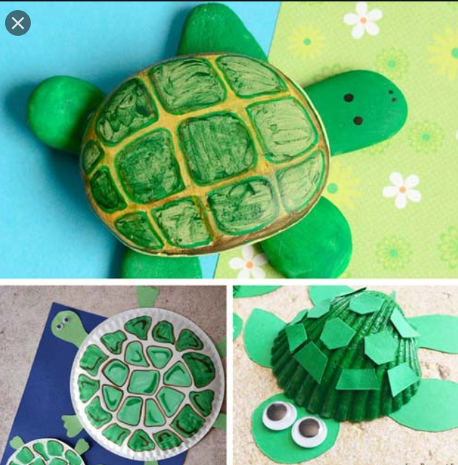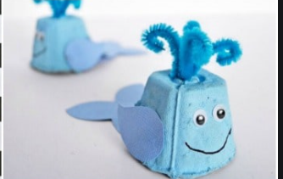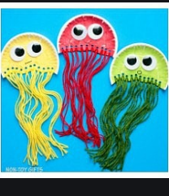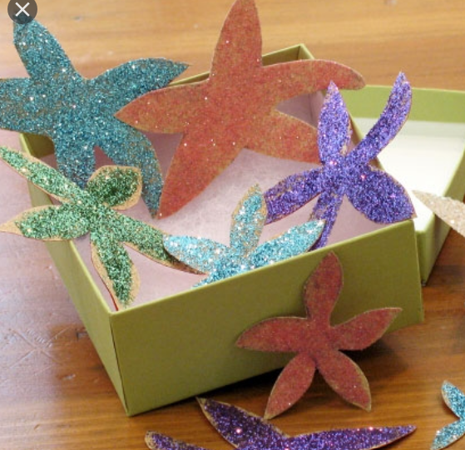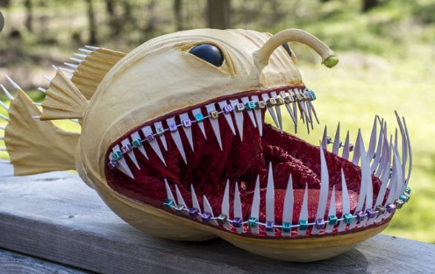
Useful websites:

IXL – https://ie.ixl.com/math/class-2 Great for practicing maths activities
Topmarks – https://www.topmarks.co.uk/maths-games/daily10
Hit the button - https://www.topmarks.co.uk/maths-games/hit-the-button
Balloon pop - https://www.theschoolhub.ie/sample.php
Mathletics: https://www.mathletics.com/uk/for-home/ Free home trial for maths

eBook library: https://www.oxfordowl.co.uk/for-home/find-a-book/library-page/
BorrowBox app – free resource from the library. Use the barcode from the back of your library card to log in. You can access eBooks and also audio books. Super resource for children and adults at this time!

Twinkl – A really useful website with lots of resources for free that they have make accessible to everyone at this time. Use the code IRLTWINKLHELPS to get free access to all resources for a month. Would be helpful for the engineer and scientist facts above or the ocean animal project.

Art PowerPoints – step by step instructions: www.mrsbrown.art/drive
LEGO Stamping: https://frugalfun4boys.com/lego-stamping-its-art-with-bricks/

Lightbot - https://lightbot.com/hour-of-code.html Coding website

Duolingo – www.duolingo.com or as a free app on the phone. Great opportunity to practice Gaeilge in a fun, interactive way.
Cula: www.cula4.com/en/

GoNoodle: www.gonoodle.com
Yoga: https://www.youtube.com/user/CosmicKidsYoga

