School work for school closure days 5th and 6th class Mr. Mooney
Novel:
Read Pg 22- 68 – Chapters Three - Six
Vocabulary: Use your dictionary to find the meaning of the words in the word box.

Word Box

acknowledge complement considerate conviction customary

decidedly distinctly exasperation inscription insistent

insolent significance torture

As you read your novel use your dictionary to find the meaning of any other words you may not understand.

Questions

A good idea is to do the questions at the end of reading each individual chapter.

Chapter 3
1. Describe Gretel, Bruno's sister.
2. How well do Bruno and Gretel get on? Use three adjectives (describing words) to describe their relationship.
3. What is the name of their new house? From what you have read so far describe the difference between Bruno's old house and new house.
4. Why is Gretel surprised when she looks out of the window?

ACTIVITIES
Chapter 4
1. Describe the view from Bruno's window.
2. Where does Gretel think they are? Explain your answer.
3. Describe the people in the camp.
4. How are the children on the other side of the fence treated by the soldiers?
5. How does Gretel react to the children on the other side of the fence?

Activity
Draw a picture of the view of the camp and the people that Bruno sees from his window.

Chapter 5
1. Was Bruno's mother happy to leave Berlin? Explain.
2. Describe Bruno's father.
3. Why does Bruno go in to his father's study?
4. How does Bruno's father react to his son's desire to go home?
5. What is really going on in the story, that Bruno is not aware of?
Chapter 6
1. How well is Bruno settling in to his new home?
2. Describe Maria, the family's maid.
3. Does Bruno have a lot of respect for his father? Explain.
4. 'Bruno and Gretel treat Maria differently.' Explain this statement.
5. How do Bruno and Gretel treat their father differently?

Discussion

How would you describe Bruno's relationship with his father? Do you think that the Commandant is a good father?

'Ah, those people,' said Father, nodding his head and smiling slightly. 'Those people...well, they're not people at all, Bruno.' (page 55)
What do you think Bruno's father means when he says that the people on the other side of the fence are not people at all?

Please feel free to continue to read the novel beyond chapter six for enjoyment and to ensure you continue reading regularly.

Regular reading of other texts.

Spellbound:

Unit 23

Learn words in Unit 23 on Page 48 of book.

Complete activities A-H based on the words in the unit.

Look up any meanings of words that you are unsure of in your dictionary (you do not need to write out the definitions).

Write a sentence for each word in unit 23. (English copy)

News Report:

Pretend you are a news reporter. Write a news report into your English copy explaining why schools are closed. Include information on important tips and guidelines for people in the community to follow.

Please remember to put a title, date and page number on your work.

Maths:
Tables
Regularly revise 6, 7, 8, 9, 11 and 12 multiplication and division tables.

6th Class only - Busy at Maths – Directed Numbers Page 120 to 124
A positive number is greater than zero.
A negative number is less than zero.
Page 120 – Qs 1 – 7
Page 121 – Qs 1 -13
Page 122 – Qs 1 – 4
Page 123 – Qs 1 – 4
Page 124 – Qs 1 – 6

Page 91 - A quick look back 5
Page 131 – A quick look back 7

5th Class only Busy at Maths – Directed Numbers Page 125 to 128
A positive number is greater than zero.
A negative number is less than zero.
Page 125 – Qs 1 – 3
Page 126 – answer the following questions based on page 126
- Write 10 degrees celsius.
- What is our average body temperature?
- What is the freezing point of water?
- What is 15 degrees below freezing point?
- Write minus 20 degrees celcius.
- What is 25 degrees above freezing point?
Page 126 – Q 2
Page 127 – Qs 1 – 16
Page 128 – Qs 1 – 5
5th class continued:
Page 93 - A quick look back 5
Page 119 – A quick look back 6

Maths Problems: (5th and 6th class)
Answer the following problems.
- Benny cycled 6 $\frac{3}{4}$ km on Monday, 7 $\frac{2}{5}$ km on Tuesday and 8 $\frac{66}{100}$ km on Wednesday. How far did he cycle over the three days?
- Change these fractions to decimals

$$\frac{1}{8} \frac{2}{6} \frac{3}{5} \frac{17}{20} \frac{1}{20} \frac{7}{10} \frac{1}{12} \frac{99}{100} \frac{3}{25}$$

- Try multiplying these decimals. Remember to estimate first!

- €43.69 X 4
- €6.72 X 24
- 35.37cm X 48
- €61.92 X 7
- 52.89m X 57

- A box of pears weighs 28.749kg. What is the total weight of 27 boxes of pears?
- The distance around one circuit of a Formula 1 race track is 8.638km. How far would a car travel if it went 19 times around the circuit?
- A foam fire extinguisher holds 6.228 litres in the medium size and 8.936 litres in the large size. What is the total amount of foam in six of the medium and nine of the large size?

- Complete these long division sums. There may be remainders!

- 239 ÷ 19
- 416 ÷ 27
- 442 ÷ 34
- 1776 ÷ 48
- 2067 ÷ 39

All Maths to be completed in Maths copy. Please give a title, date and page number. Please number each question correctly.
SESE:
- Choose a country of your choice and complete a project on the chosen country. Remember Japan and Australia have already been researched and cannot be chosen. Below is a list of ideas or topics which you should research and include in your project.
(The project can be completed on the large sheet included in your study pack. It can be hand written or typed. You can draw images or copy and paste from the internet with a parent’s supervision)
- Where in the world is the country, example what continent, part of the world?
- Culture, history, traditions, population, currency, food.
- Climate, time difference, seasons.
- Capital city and other major cities. Famous landmarks.
- Celebrities and famous people.
- Economy / President / Political parties.
- Sports and education.
- Nature and animals.
- Any natural disasters that may have occurred in the country.

Research:
- Find out three facts about concentration camps during World War 2

- Bruno's father has taught him how to do the Hitler salute, adapted by the Nazi Party as a sign of loyalty to its leader, Adolph Hitler. The salute is accompanied by the exclamation of the words Heil Hitler! said in a firm and usually loud voice. Do some research to find out about the origin (beginning) of this salute and how it was used in Hitler's Germany.

- Air raid shelters, also known as bomb shelters, were created to protect people during bomb attacks from the enemy air craft during World War Two. For domestic use, there were three types of air-raid shelters - Anderson shelters, Brick-built shelters and Morrison shelters. Carry out some research on the different types of Air Raid Shelters. Design and build your own Anderson Shelter based on what you find out about the real ones used in World War Two.

These shelters were half buried in the ground with earth heaped on top to protect them from bomb blasts.

There are some examples of Anderson Shelter models attached on the last page.

Gaeilge:
Fuaimeanna agus Focail, Aonad 23. Leathanach 70.
Use your dictionary to look up the meanings of any words you do not understand. Learn the spellings.
Complete activities A-H.
Dean cur síos ar do seachtaine sa bhaile. (leathanach amháin)
(Describe your week at home)

PE:
Try to do some of the following exercises when you are at home. Pick one every few hours!
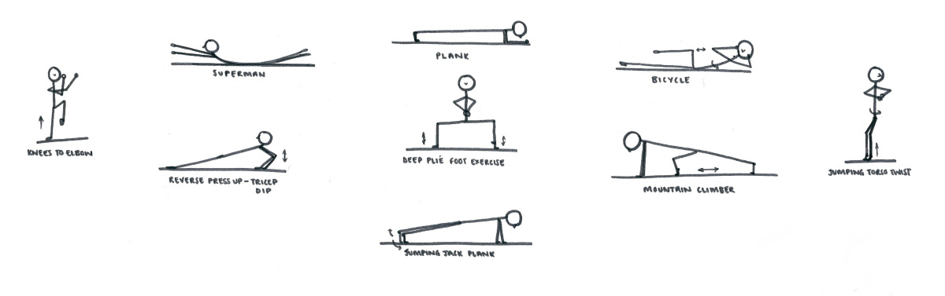

I hope you are all keeping well and not missing school too much! I’m sure you are all being very helpful around the house for your parents whicle you are off. Hopefully the above activities will keep you busy and entertained during this period of no school. The bridges you constructed during engineering week showed what great engineers we have in the class. People put in great effort and produced some wonderful inventions. I have set you a new challenge now in the ‘Anderson Shelters,’ which is perhaps an even greater challenge this time. I am excited to see what designs you will produce. Make sure you get parents permission before carrying out any of your research. I look forward to when we are reunited in the classroom and hearing all your news and views on what is an extraordinary and perhaps never seen before period in living memory, which is currently happening around the world. We said in history at the beginning of the year that history is every day life as much as significant moments from the past and we are truly in a moment of history that will be remembered for many years to come. In the meantime 5th and 6th class please take care and I will see you all soon.
Regards
Mr. Mooney.
Examples of Anderson Shelters:
