Dear Parents and Guardians,
Please find attached work to complete for English Learning Support groups (Monday 30th March – Friday 3rd April).
These groups include Senior Infants and 4th Class English groups.
All worksheets and resources are included in this document. This is work to be completed as deemed appropriate alongside the class work allocated by the classroom teacher. Please do not feel under any pressure to get all the work complete. Some days, you might read the comprehensions and activities without answering the questions. Other times, you might answer the questions orally. Read as often as you can and try read for enjoyment too.
I have now set up an email that will be monitored for the purpose of a parent/guardian needing to contact me regarding work. If you have any questions or queries regarding the work, please email horeswoodmrstaffordset@gmail.com I will be online Monday to Friday 9:20 a.m. to 11:20 a.m. and endeavour to get back to you as soon as I can.
I have set up an online account for my students on an app/ website called Seesaw. I would like to use this website for reviewing and correcting work with 4th class. Senior infants may also find this a useful way of receiving feedback for their work. There is no requirement to upload all or any of your work here but it may be beneficial if I can give feedback on some of your work through comments. To access the online site each child will have a unique password to log in. I will e-mail you this code to log in to seesaw as a student. It is very easy and simple for the children to use. Please send an e-mail to horeswoodmrstaffordset@gmail.com if you would like to set this up.
I’m looking forward to hearing all of your news when we return to school.
For now, please stay safe and mind yourselves.

Kind regards,
Mr Stafford.
Mr Stafford
Senior Infant English Group
Dates | Activity | Dolch Word List  Remember: Look, sound, read  Put into a silly sentence and a normal sentence each night.
Monday  30/03/2020 | - Revise vowel sound ‘a’.  - Worksheet 1 (below) ‘’Letter A words’’  - Copy work: Write a rhyming word and draw the picture for any three pictures shown. | Dolch words to learn (Dolch list 1 below)  Was, said, his, that she
Tuesday  31/03/20 | - Revise vowel sound ‘e’.  - Worksheet 1 (below) ‘’Letter E words’’  - Copy work: Write a rhyming word and draw a picture for any three pictures shown. | Dolch words to revise (Dolch list 1 below)  Was, said, his, that she
Wednesday  01/04/2020 | - Revise vowel sound ‘o’.  - Worksheet 1 (below) ‘’Letter O words’’  - Copy work: Write a rhyming word and draw a picture for any three pictures shown. | Dolch words to learn (Dolch list 1 below)  For, on, they, but, had
Thursday  02/04/2020 | - Revise vowel sound ‘u’.  - Worksheet 1 (below) ‘’Letter U words’’  - Copy work: Write a rhyming word and draw a picture for any three pictures shown. | Dolch words to revise (Dolch list 1 below)  For, on, they, but, had
Friday  03/04/2020 | - Worksheet 5 Phonics Read and write / Read and draw activity | Dolch words revision of all 10 words learned this week

Mr Stafford
English Support Group
4th Class Pupils
Dates | Activity | Additional notes
Monday  30/03/2020 | - Complete worksheet 1 on homophones (Part A and B).  Remember to write full sentences in your English copy | Remember how we changed the letters in there, their and they’re to use as clues.
Tuesday  31/03/20 | - Comprehension and questions: ‘’Bedtime to be decided by children, not parents’’. | Remember to write full sentences for your answers.
Wednesday  01/04/2020 | - Synonyms and antonyms worksheet 1 and 2  - Twenty English questions worksheet to answer in English copy. | Synonym and antonym worksheet instructions: Look at the word in the middle. Then write a synonym and antonym for that word.  Synonyms: words of similar meaning  Antonyms: words of opposite meaning
Thursday  02/04/2020 | - Cloze writing: ‘’Pre-show Jitters’’. Write out in full to fill in the blanks in your English copy.  - Sell the impossible: Create one ‘wacky’ item to sell to an audience. | Remember to include: a name, a detailed description, why I should buy this, a cost price and a drawing.

Senior Infants
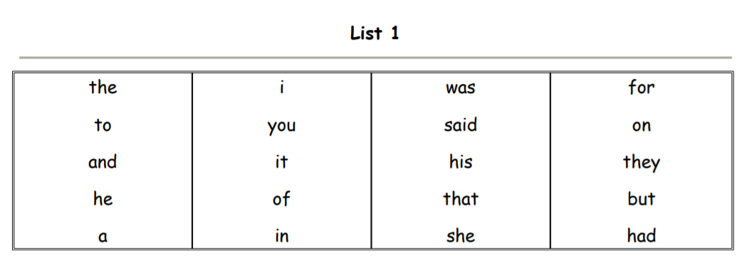
Dolch list 1

#

Senior Infants worksheet 1

Beginning and Ending Sounds Letter A

Directions: Say the name of each picture. Fill in the missing letters.

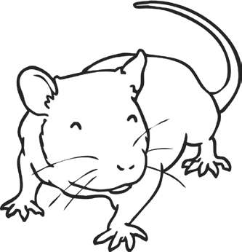
a

a

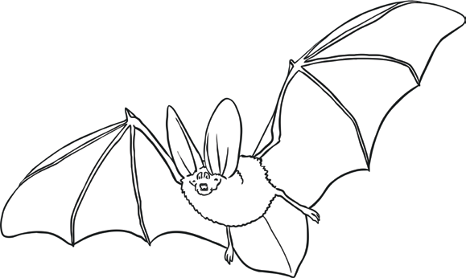
a

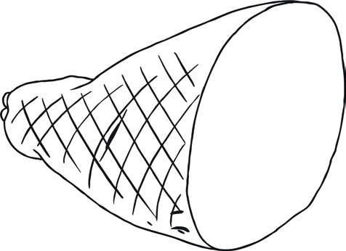
a

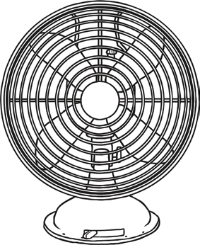
a
a

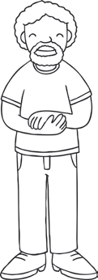
a

a

Senior Infants Worksheet 2
Say the name of each picture. Fill in the missing letter sounds.

10
e
e

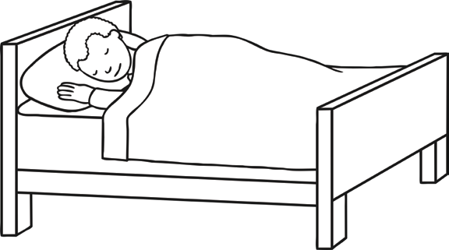
e

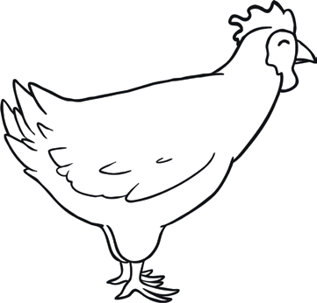
e

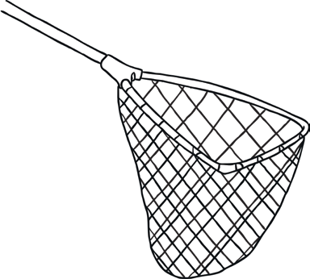
e
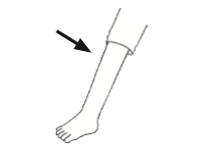
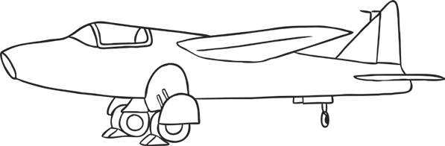
e

e

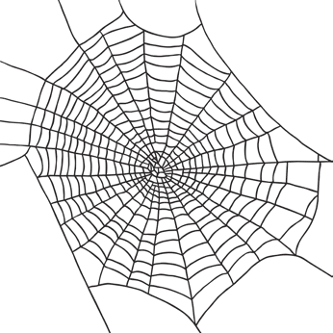
e

Senior Infants Worksheet 3
Say the name of each picture. Fill in the missing letter sounds.

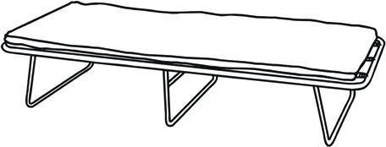
o
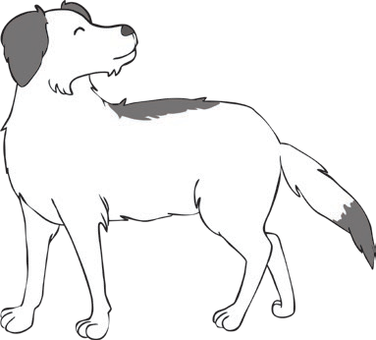
o

o

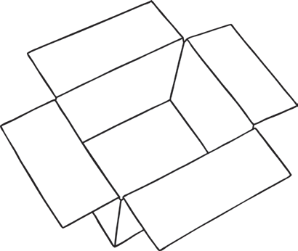
o

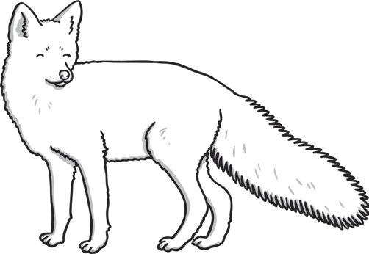
o
o
o

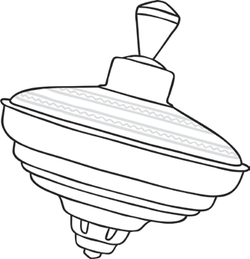
o

Senior Infants Worksheet 4
Say the name of each picture. Fill in the missing letter sounds.

u
u

u

u

u
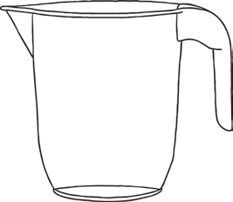
u

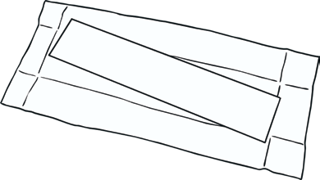
u

u

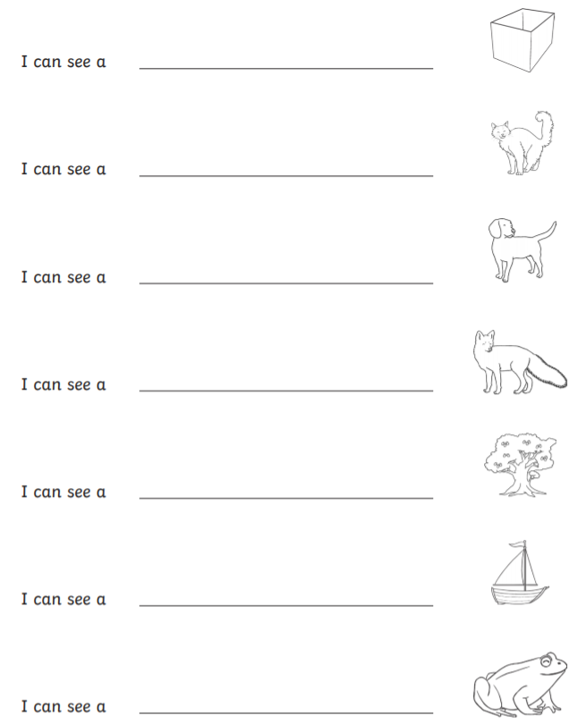
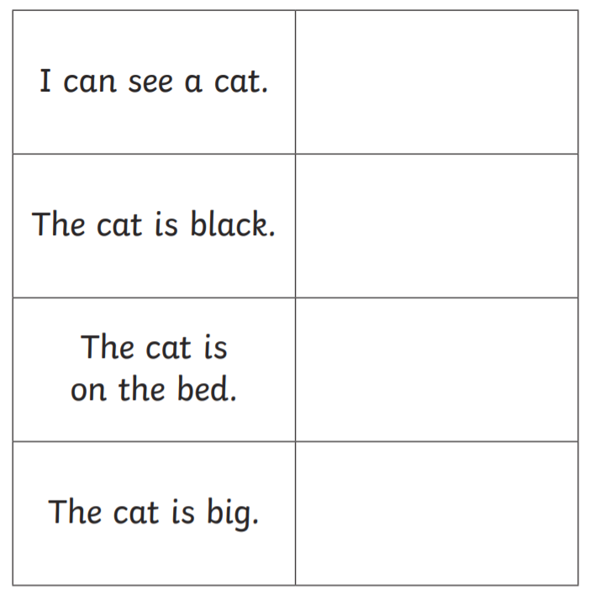
Worksheet 5 Phonics read and draw / read and write activity

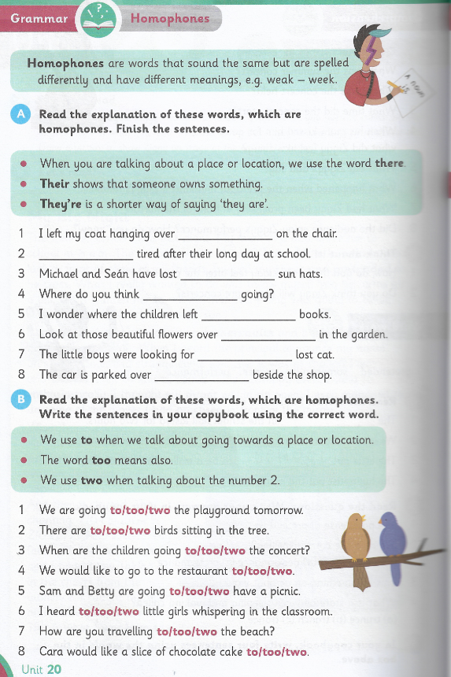
4th Class Worksheet 1

4th Class Comprehension task
Bedtime to be decided by children, not parents.
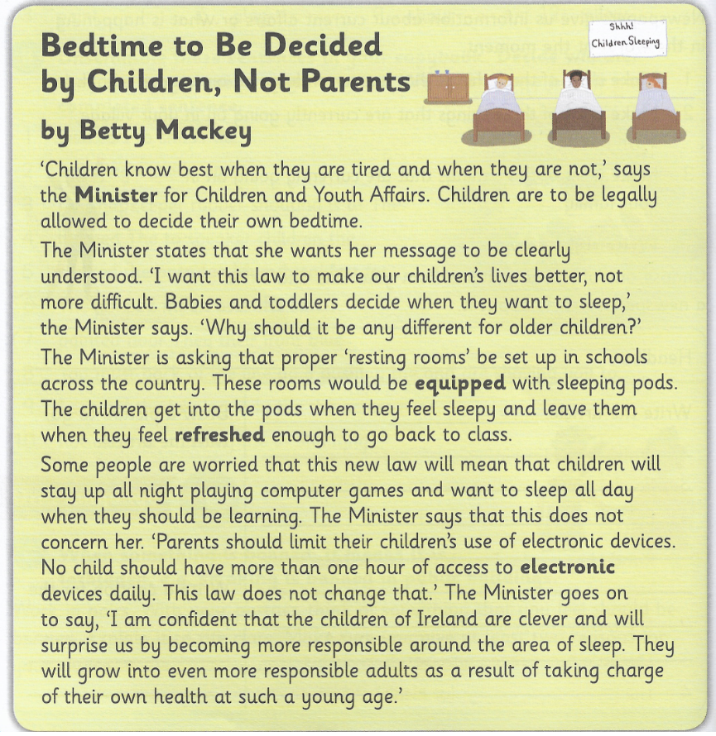

4th Class Comprehension questions
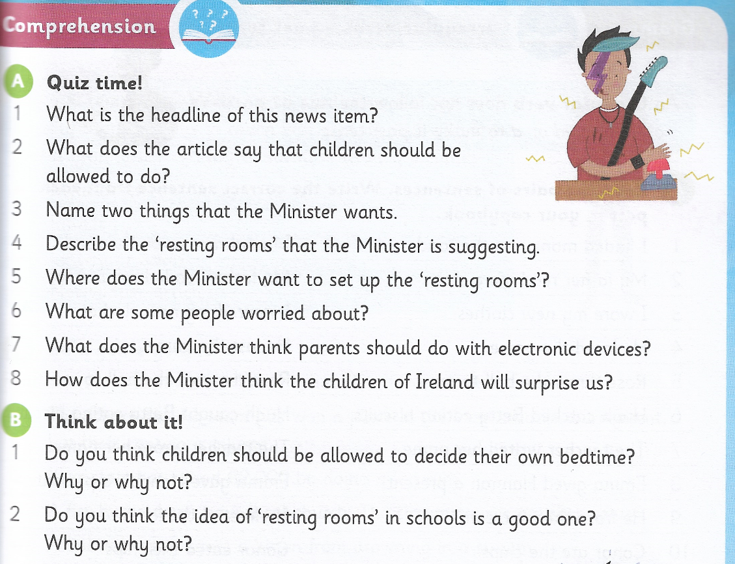
Bedtime to be decided by children, not parents.

4th Class
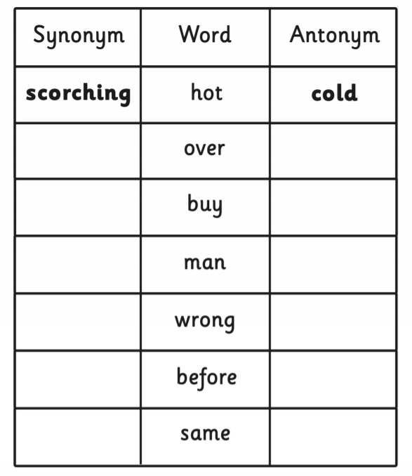
Synonyms and antonyms worksheet 1 and 2

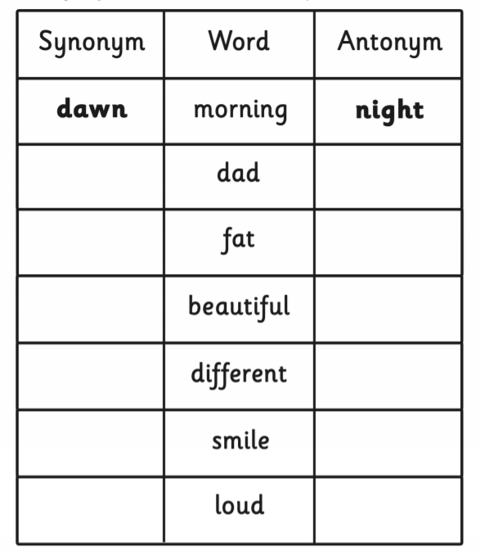

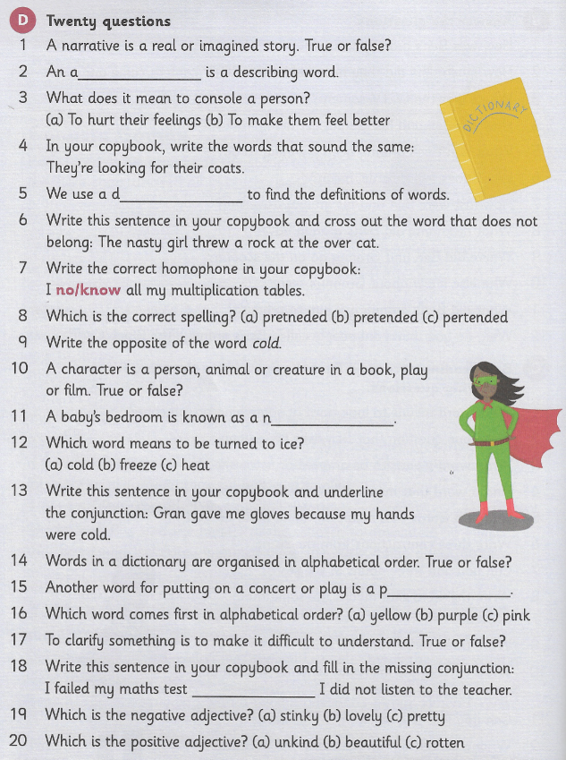
4th Class Twenty English questions worksheet

#
4th Class Cloze Writing
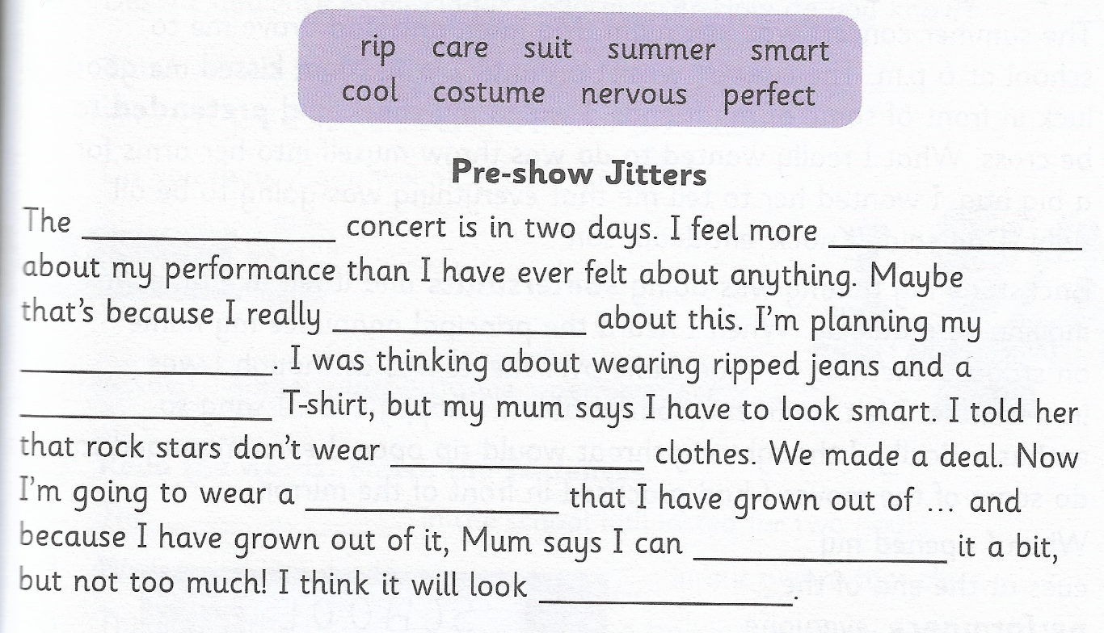
‘’Pre-show Jitters’’

