Dear Parents,
I hope you and your families are all keeping well during this difficult and unprecedented period. It is a challenging time for the children as they must undertake their school work at home but I hope they have embraced the challenge.
Due to the extended closure of the school there will now be additional work uploaded for the children to cover the week 30th March to April 3rd. I now also have a new email set up at which you can contact me at any time with queries, questions or comments in relation to your children’s work. The new email address that you can contact is horeswood5thand6th@gmail.com. I will regularly monitor this email address but particularly between the times of 11-12pm and 2-3pm each day. However feel free to email any time and I will do my best to reply as soon as I can. If you could forward me the best email address to contact you at that would be great.
At the end of this document I have attached answers relating to some of the work the children have already undertaken to date. The children can self correct this particular work using these answers. Children can also upload the work they have completed by way of pictures or by typing in Microsoft Word and sending an attachment. They can also forward pictures of their projects if they wish, project on chosen country and Anderson Shelters.
I appreciate that children may be starting to get a little restless at this point due to the social distancing and been unable to visit their friends and relatives. Hopefully the work uploaded will give them a focus and something to occupy them over the next week. I have tried to include some fun activities for the children to do in their spare time such as researching a new project, a simple science experiment (children have been asked to seek parent’s permission before carrying out same. Also if no vinegar is available at home do not worry about the experiment), some fun optical illusions, PE exercises (notes for exercises attached) and drama games (can be played with siblings or all the family).
In relation to the work I have uploaded, while it may seem there is a high quantity of pages attached, some of the pages relate to explanations and guidance for the children in order to give them the best support in carrying out the activities and tasks at home. For example, there is one whole page giving them prompts and guidance on their project. There are three pages explaining their science experiment. There are eight pages relating to optical illusions. The children could view these on the computer to save printing. Finally there is one page explaining PE exercises. There is also eleven pages relating to answers divided between 5th and 6th class.
In order to give some structure to the children’s week I have broken down the work by each day of the week. However this is only a guideline. Some children may like to stick to the daily routine while others might like to work ahead. There might be a day also when children are unable to do the work for whatever reason and may look to catch up the next day. I also appreciate that every household is different and if you feel that your child is feeling under pressure to complete the work, please feel free to drop me an email to discuss. Please ensure the children do not feel under pressure and if they are finding something very difficult they should move on.
Equally if your child is starting to feel the boredom and would like additional work or challenges to be set for them (you never know!!!) please also feel free to contact me via email and I can forward additional work.
For SESE activities there is an excellent website which I would recommend children to use especially for their SESE project. It is www.worldbookonline.com and it is free during school closures. Once you sign in, click on kids and there are many different options to explore. They provide a generic username and password for everyone to use as follows:
Username: wbsupport
Password: distancelearn
National Geographic for kids is another useful website for their project.
Finally, I would like to take this opportunity to thank you for your continued support during this difficult time. I hope that you and your families remain safe and healthy and I wish you all a very Happy Easter.

Kind Regards
Joe Mooney
5th and 6th class teacher.

Dear 5th and 6th class,
I hope you are all keeping well during this difficult and strange time in the world around us. Little did any of us know when we returned after Christmas that this is how term two would unfold. I’m sure you are all fully aware of the importance of following the guidelines and advice that have been put in place by the HSE and the Government in order to combat covid19.
I can only imagine how difficult social distancing is for you all, having to stay away from your friends and relations, but I hope you know by doing so, you are playing your part to help the country in its fight against the coronavirus. So I would like to say a big well done to you all. Also remember regular washing of hands with plenty of soap (practice your favourite song while washing – my go to song is Happy Birthday or ‘Dance Monkey’ – what’s yours? and sneezing or coughing into a tissue (then dispose of your tissue) or your sleeve (if you’ve no tissue on you) are also really important.
It is important that you are getting plenty of fresh air in your garden, now that the weather is starting to improve and plenty of exercise, in terms of walks, riding your bike or playing sport with your family.
I don’t know about you but I am really missing school and I can’t wait to return. I am missing our daily conversations and discussions. I have taken up gardening in the last week so hopefully my gardening skills will have improved by the end of the school closure!! I go for a run once a day and a visit to Tesco once a week and otherwise I am at home with my family all day everyday just like you. Maybe some of you have taken up a new hobby? It is an excellent opportunity to practice improving existing hobbies also such as your hurling, camogie, music, art and all your other pastimes.
I hope you are meeting the challenge of doing your school work at home head on. It is good preparation for secondary school, where you will become even more independent. Your parents have been provided with an email address at which they can contact me if you have any queries or questions about last week’s work or this week’s new work. I have also provided your parents with answers to the work from last week (Maths, Spellbound and Fuaimeanna agus Focail). You should use this to self-correct where possible. Ask an older sibling or parent if you made a mistake or got something wrong. This is very important. You can also ask your parents to forward me pictures of your projects (country project and Anderson Shelters) and other work completed. I’m really looking forward to seeing them. Did you find the Anderson Shelters challenging or difficult?
I would recommend www.worldbookonline.com for your new SESE project. Your parents have been given the login details. There are many different options you can explore but the world of animals section would be really useful for your new project. National Geographic for kids is another useful website for this project.
This week’s work has been laid out day by day. You can work ahead if you wish. That decision is up to you. There are some fun activities including researching a new project, a science experiment and some optical illusions (you’ll think your eyes are playing tricks on you!). Make sure you seek permission from a parent prior to carrying out any research on the internet or carrying out your experiment. If you find a particular area of your work very difficult or get very stuck, then move on.
I would also encourage you to take a moment and say a prayer of your choice every day in the morning or evening, or both, for all the people around the world during this difficult period and for the amazing doctors and nurses who are at the forefront of this fight against covid19.
I look forward to when school can resume and when I see you all back in the classroom. Let’s all pray that it will be sooner rather than later. Keep up the great work you have been doing and make sure you are doing plenty of jobs around the house for your mum and dad. I hope you all spoiled your mother for mother’s day! Please stay safe 5th and 6th and enjoy some downtime with your family. I hope you all have a wonderful Easter and try not to eat too many Easter eggs!!!!!

Happy Easter to you all.
Mr Mooney.

Monday 30th March:
English:
Novel
The Boy in the Striped Pyjamas
Chapter Six, Seven
Vocabulary: Draw a line from each word on the left to its definition on the right. Then use the numbered words to fill in the blanks in the sentences below.
Use your dictionary to help you.
1. enforced a. reckless adventure or prank
2. reverberated b. dislike
3. engaged c. caused to be carried out
4. incredulous d. showing a lack of belief
5. escapade e. easily annoyed
6. distaste f. echoed
7. irritable g. took park

1. Most people are __________________________ when they hear stories about flying saucers.

2. After the rain spoiled her plans, my sister was __________________________ for the entire day.

3. After reading the book, the students’ ___________________ engaged in a lively discussion about the characters.

4. The police officer ______________________ the law against speeding by giving the driver a ticket.

5. My little brother's latest _____________________ ended with a ball breaking a bedroom window.

6. The guide's call _______________________ in the cave.

7. Many people have a(n) ________________________ for snakes.

Read chapter 7 and answer the following questions.
Questions
Chapter 7
- Describe the one person Bruno knew to be mad.
- What does Bruno do to entertain himself?
- What is Bruno's opinion of Lieutenant Kotler?
- How does Gretel act around Lieutenant Kotler?
- What causes both Bruno and Gretel to feel uncomfortable with Lieutenant Kotler?
- How does Pavel help Bruno after his accident?
- Why is Bruno surprised to find out that Pavel is a doctor?

Discussion
- What do you think Pavel means when he tells Bruno that he thinks he has always been at Out-With?
- Why does Bruno's mother take credit for cleaning Bruno up after his fall? What does this suggest about her?

Dictionary Work
Look up the following words in the dictionary and explain what they mean -
inequality, racism, prejudice.

Letter writing:
As a class we are going to write a letter to a resident in a nursing home. Sadly, they cannot have any visitors at this time so I think our letters to them will really cheer them up. If your parent/guardian would prefer you didn’t send a letter that’s ok too, you can just complete it in your copy and we won’t send it. If you can type your letter and email it to the address above that would be great if not just write it in your copy, take a picture and send the picture to the email and I’ll type it. Thank you.
Today, just make a draft – what are you going to include in your letter – some ideas include, your name, your school, your hobbies, how you feel about being out of school, what you want to be when you grow up, what school is like for you today (remember, it will be very different from their time in school) and try make it as friendly as possible.

Maths:
We are moving on to Area this week – it’s Chapter 24 (P.125) Sixth Class and it’s Chapter 21 (P.112) Fifth Class in your Busy @ maths book
Remember, Area is the space covered by a 2-D shape (length x width = AREA)
Perimetre is the distance around a 2-D shape (Add all sides = PERIMETRE)
6th Class
In your copy complete Q 1 a-d, Q 2 a-i & Q 3 (i) and (ii) for each shape
5th Class
In your copy complete Q 1 a-j, Q2. a-f.
5th and 6th Class
Try solve the following problems too:
- A square field has sides that are 100 metres long. What is the field's perimeter? ____________mts.

- The perimeter of a rectangular price tag is 26 centimetres. The price tag is 10 centimetres wide. How tall is it? ________cm.

- The perimeter of a film screen is 66 metres. It is 23 metres wide. How tall is it? _________ mts.

- A square newspaper ad has sides that are 8 centimetres long. What is the newspaper ad's perimeter? _________ cms.

- A rectangular red sticker is 14 millimetres wide and 8 millimetres tall. What is its perimeter? _______ mms.

Tip: Draw out each shape to help you figure out the answer.

Gaeilge:
Try use Gaeilge neamhfhoirmiúil (Informal Irish) or just a cúpla focail around the house. Teach your family the verb/sentence game and get them to play along with you, play feicim le mo shúilín beag (I spy).
Fuaimeanna agus Focail, Aonad 24. Leathanach 73.
- Use your dictionary to look up the meanings of any words you do not understand. Learn the spellings for box 1 and put these words into sentences. Make sure to use different verbs in your sentences.
- Complete activities A & B
- Finish the sentences below using the 3 options in the box and translate the sentences:
- Chonaic an seanfhear timpiste agus ____________________________________.

- Bhí luch sa chistin agus ___________________________________.

- Ní dhearna mé an obair bhaile agus ___________________________________.

bhí an múinteoir feargach ghlaoigh sé ar na gardaí

thosaigh Mamó ag béicigh

PE:
It’s important to be staying active even if you are just at home. If possible youtube ‘the body coach classroom workouts’. These are really good and you can exercise along to your favourite music too! Ensure you’re getting at least 60 minutes exercise each day – if you don’t have access to the workouts – go for a walk or cycle, play football in the garden, use the trampoline or just follow the exercises attached at the end of this work – see: Notes!

Religion:
Imagine you were there, witnessing Jesus’ crucifixion. What would you have done? Would you have been standing at the foot of the cross with Mary or would you have run away? Why?
Write about this and then draw an illustration of what you think it was like to be there when Jesus was crucified.
Did you know: The name Jesus literally means ‘God saves’. Jesus freely gave up his life to make up for the sins of all the people.

SESE: Geography & Science:

Research an animal of your choice based on the following wide range of suggestions:
- An animal native to Japan (as you have already researched this country).
- An animal native to Australia (as you have already researched this country).
- An animal native to the country you chose for your Geography project last week.
- Any animal that is in danger of becoming extinct.
- Reptiles
- Water mammals
- Safari animals.
- Prehistoric animals.

Once you have gathered the information do a project / report on the animal.

Before you start think about:
- Why would you like to learn about this animal?
- List four things that you know already about this animal.
- List four things that you would like to learn about your animal?
Questions to help with your research:
- What is my animal's scientific name?
- What family does it belong to?
- What does my animal look like?
- What is my animal's height/length, weight, wingspan (only if bird)?
- What does my animal eat?
- Is my animal a predator? If so, what does it hunt?
- Where does / where did my animal live? (habitat)
- How long does my animal live (lifespan)?
- What does my animal's home look like?
- Who are my animal's enemies?
- How does my animal move? (swim, run, fly, hop, etc.)
- How fast can my animal move?
- How many babies can my animal have?
- How does my animal care for its young?
- Is my animal extinct or endangered?
- How can my animal be saved?
- What is or what was cool and unique about my animal?
- What did I learn from doing this report?
Tuesday 31st March:
English:
Phonics, Punctuation & Grammar:
- Circle the correct spelling – vicious or vitious
- Circle the correct spelling – protien or protein
- Add the silent letter – dou__t
- Circle the correct spelling – adoreable or adorable
- A synonym for achieve is – sneeze, gain or ache
- Circle the 2 words which can take the suffix ‘ness’ – bitter, attract, happy
- The contraction of might not is - _____________
- Circle the correct homophone- The film starts at half past/passed nine.
- Circle the word with the fewest syllables – celestial or martial
- Rewrite each word with ing added – carry ____________, die _________, ride ___________
- Add one comma to this sentence – At the side of the road the child sat crying.
- Enclose the additional information in commas – Julie a champion skater is my sister’s friend.
- Add commas to the sentence – The children’s menu gave a choice: chicken nuggets pizza and fish all served with French fries mash or salad.
- Write the missing pronoun – When Mum cooks dinner, _______ asks me to help.
- Write the missing pronoun – When my parents have finished dinner, ______ go for a walk.
- Circle the noun that the pronoun refers to – I stay with my sister and she helps me complete my homework.
- Write the missing pronoun – When ____ comes home, my brother plays cards with me.
- Add the present tense of the verb ‘to play’ – Mam is very competitive and she always ________ to win.
- Add the past tense of the verb ‘to teach’ – Martin’s father _________ him lots of different skills. (be careful with the homophone here!)
- Add the correct part of the verb ‘to play’ - __________ cards is a great way to have fun with friends and family.

Spellbound:
Spelling: Unit 24, page 50, commonly misspelled words. Read the words in box 1. Use your dictionary to look up the meaning of the word (You do not need to write out the definition).
Put the 4 words into sentences.
Complete activities A and B on page 50.

Letter writing:
All good letters have an introduction, a middle and an end. Make sure you are following the correct format when writing a letter, think back to the letter that was written for Ryan Tubridy- it had an address, it said Dear Ryan, it concluded with yours sincerely/ slán/ Kind regards and then your name. Don’t put your home address on the letters instead use the address of the school Reminder, If you can type your letter and email it to the address above that would be great if not just write it in your copy, take a picture and send the picture to the email and I’ll type it. Thank you.
Today, start your letter – This is the introduction – write the addresses in the correct place, the date and Dear _____, (leave this blank as the nursing home will fill in a name) and then tell them all about you, don’t have it too long as the main part of your letter will go in the middle section tomorrow!

Maths:
Area: Chapter 24 (P.126) Sixth Class and Area and perimeter: Chapter 21 (P.113) Fifth Class in your Busy @ maths book
6th Class
Finding the area of ‘trickier’ or irregular shapes!!
Remember, Area is the space covered by a 2-D shape (length x width = AREA)
Before you start look at the four steps at the top of P.126 to help you
- Divide the irregular shape into regular rectangles or squares.
- Calculate the measurements of any missing sides using the information you already have – you may need these measurements!
- Calculate the area of each regular rectangle/square inside the shape. (L x W)
- Add the areas together to find the total area.
In your copy complete Q 1 a-e and if possible complete the challenge too!
5th Class
Remember, Area is the space covered by a 2-D shape.
Perimeter is the distance around the 2-D shape.

In your copy complete Q 1
To calculate the area count the squares
To calculate the perimeter count the outside of the squares. See the example I have done for you below. The black lines show the outside of the each square relating to the count. There are 16 lines. The perimeter is 16cm.
Body Part | Area | Perimeter
Head | Example: 12cm² | Example: 16cm
Eye
Body
Tail |  | Example: 8cm
Leg (x2)
Whole dog

In your copy complete Q 2 a-f, Q3 a-e and Q4 a and b (i – v)

5th and 6th Class
Try solve the following problems too:
- A square coffee shop has sides that are 7 metres long. What is the coffee shop's area? _______ m2.

- A rectangular ink pad is 8 centimetres wide and 6 centimetres tall. What is its area? _______ cm2.

- A square painting has a perimeter of 8 metres. How long is each side? _____m.

- A square name tag has sides that are 10 centimetres long. What is the name tag's area? _______ cm2.

A rectangular shop in the mall is 7 metres wide and 10 metres long. What is its area? _____ m2

Gaeilge:
Try use Gaeilge neamhfhoirmiúil (Informal Irish) or just a cúpla focail around the house. Teach your family our verb/sentence game and get them to play along with you, play feicim le mo shúilín beag (I spy).
Fuaimeanna agus Focail, Aonad 24. Leathanach 73.
- Use your dictionary to look up the meanings of any words you do not understand. Learn the spellings for box 2 and put these words into sentences – Make sure to use different verbs in your sentences.
- Complete activities C & D
- Finish the sentences below using the 3 options in the box and translate the sentences:
- Bhí buataisí orm inné mar ________________________________.

- Bhí bindealán ar a ceann ag Aoife mar ______________________________.

- Cheannaigh sí a lán ag an margadh mar ______________________________.
bhí sé ag stealladh báistí, bhí rudaí deasa ar na stallaí, shleamhnaigh sí sa chlós

Religion:
Stations of the cross:
Write the station and Draw an image with colour for each station of the cross – There are 14 in total, we will do 4 today, 4 tomorrow, 3 Thursday and 3 Friday.
First station: Jesus is Condemned to death.
Second station: Jesus is given his cross.
Third station: Jesus falls the first time.
Fourth station: Jesus meets his mother.

SPHE: Being expressive
- Think about ‘body language’ – how is yours now? What types of expressions/body language would you expect to see when you’re happy/confident? What types of expression/body language would you expect to see when you’re down or in a low mood?
- Write these down in two different lists
- Now look at the emojis attached – I want you to choose two of your choice, explain them and draw a time you felt like this and explain why.

Music:
- Think of your favourite song right now, why is it your favourite?
- Listen to the song – sing along if you know the words
- What instruments can you hear?
- What is the tempo? (fast or slow)
- What are the dynamics? (Is it loud, medium or soft? Does it change?)
- Draw an image for the music you heard- what do you think of?

Wednesday 1st April:
English:
Novel
Chapters Eight - Ten
Vocabulary: Use the context to help you determine the meaning of the underlined word in each of the following sentences. Use your dictionary to help you.

Our class president dominated every meeting, not letting anyone else express an opinion.
Definition:_________________________________________________________________

Since our birthdays coincide, we can have one party for both of us.
Definition:_________________________________________________________________

I want to devise a way to make money this summer.
Definition:_________________________________________________________________

Having come from a country where we could not worship, we are now tolerant of all religious practices.
Definition:__________________________________________________________________

My mother was happy when she retrieved her lost purse.
Definition:__________________________________________________________________

The sinister storm clouds made the picnickers run for cover.
Definition:__________________________________________________________________

He rummaged through three drawers before he found his keys.
Definition:___________________________________________________________________

There is nothing sadder than the sight of a forlorn, lost child.
Definition:____________________________________________________________________
After receiving a poor grade, the student made a resolution to work harder.
Definition:_______________________________________________________________________

Read chapter 8 and answer the questions.
Chapter 8
- Describe Bruno's grandparents.
- How did his grandmother spend time with the children?
- Why did the last play Bruno and Gretel performed with grandmother end in a disaster?
- Why was Bruno's grandmother disappointed when Bruno's father became Commandant? Use quotation in your answer (a line from the novel to support your answer).

Letter writing:
Today, continue your letter – work on the middle– this is the main section of your letter, so maybe you can talk about your life, what school is like, what class you’re in, where you’re going to school next year, what you want to be when you grow up, how you feel about our current situation with Co-Vid 19 and any other relevant information.
We will then conclude our letters tomorrow
Spellbound:
Spelling: Unit 24, page 50, commonly misspelled words. Read the words in box 2. Use your dictionary to look up the meaning of the word (You do not need to write out the definition).
Put the 4 words into sentences.
Complete activities C and D on page 50.

Maths:
Area: Chapter 24 (P.127) Sixth Class and Area and perimeter: Chapter 21 (P.114) Fifth Class in your Busy @ maths book

6th Class
Finding the surface area of 3-D shapes

Before you start on P.127 I will add some steps to help you solve the problems
For Q 1, 2 & 3 when finding the total surface area of a CUBE you do the following:
- Count the number of faces it has = 6
- Find the area of each face – so for Q 1 the area of each face = 9cm²
- Multiply the area of each face (9cm²) by the number of faces your shape has (6) = 6 x 9cm² = 54cm²
That is how you work out each question for Q1, 2 & 3
Give them a go in your copy, remember to label your work clearly! (Page number and Question)
For Q 4, 5 & 6 it’s a little trickier as we are finding the total surface area of a cuboid.
I will go through Q 4 with you here then you can give it a go along with Q 5 & Q 6
- Count the number of faces you have on the cuboid – 6
- Find the area of the blue faces (the two ends) – L x W = 3 x 2 = 6cm²
- Find the area of the yellow faces (the top and bottom ) – L X W = 5 x 3 = 15cm²
- Find the area of the green faces (the two sides) – L X W = 5 x 2 = 10cm²
- Total area of all 6 faces (remember, there are 2 blue faces, 2 yellow faces & 2 green faces- so, I have 12cm² + 30cm² + 20cm² = 62cm²
When you’ve completed Q 4, 5 & 6 – Try this challenge- find a cuboid in your home and measure the surface area of it- follow the steps above – I’m looking forward to seeing what you find!
5th Class
Area – Rectangular shapes Length = 3cm
3cm Width = 2cm
There are 3 rows of 2cm².
That makes a total of 6cm²
Area = 6cm²
2cm

Use the example above and on page 114 to complete Q1 a-e

Complete Q2 a-f in your copy.

Complete Q3 a-d.

Remember: Area = length x width OR width x length

Add all sides = PERIMETRE

In your copy complete Q1 a-d - Page 115.

Gaeilge:
Try use Gaeilge neamhfhoirmiúil (Informal Irish) or just a cúpla focail around the house. Teach your family our verb/sentence game and get them to play along with you, play feicim le mo shúilín beag (I spy).
Fuaimeanna agus Focail, Aonad 24. Leathanach 73.
- Use your dictionary to look up the meanings of any words you do not understand. Learn the spellings for box 3 and put these words into sentences – make sure to use different verbs in your sentences.
- Complete activities E & F
- Finish the sentences below using the 3 options in the box and translate the sentences:
- Ní raibh Daidí sásta mar _______________________________________.

- Fuair mé airgead ó mo Mhamó mar _________________________________.

- An Nollaig a bhí ann agus ________________________________________.
bhí sceitimíní ar na páistí, bhris mé an fhuinneog, mo bhreithlá a bhí ann,

Religion:
Stations of the Cross:
Continue on with the next 4 stations, keep them with the other 4 in your copy!
Fifth station: Simon of Cyrene helps Jesus carry his cross.
Sixth station: Veronica wipes the face of Jesus.
Seventh station: Jesus falls the second time.
Eighth station: Jesus comforts the women of Jerusalem.
SESE: Science Experiment

The Statue of Liberty
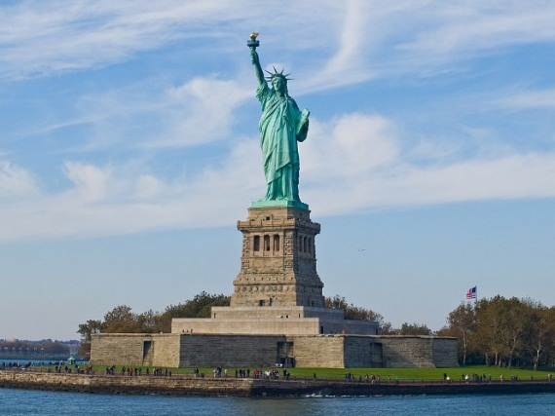
The Statue of Liberty is one of the most famous and recognisable sculptures in the world. It is located on Liberty Island in New York Harbour in New York, in the United States. The copper statue was a gift from the people of France to the people of the United States. The word 'Liberty' means free and the statue is a universal symbol of freedom.
The definition of Liberty - "the state of being free within society from oppressive restrictions imposed by authority on one's way of life, behaviour, or political views.
The amount of copper in the Statue of Liberty could make 30 million pennies! When the statue was originally assembled, it was a dull brown colour, reflecting the natural colour of its copper plates, just like the colour of pennies. Over the next 30 years, though, it slowly turned to the green colour you see today. What happened?
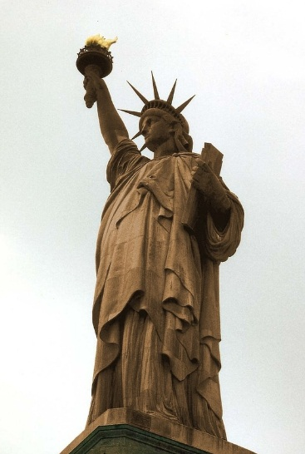 Original Colour
The change is due to a chemical reaction. To find out what happened let’s do an experiment. (Please ask parents’ for permission before carrying out the experiment).

Chemical Reactions: Make a Penny Turn Green

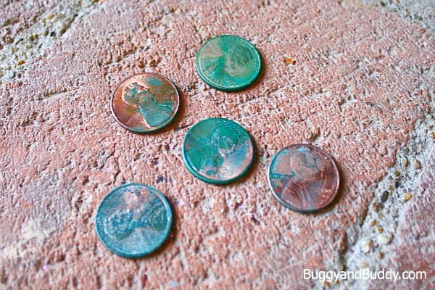

Materials for Turning a Penny Green
- Copper pennies
- White vinegar
- Dish or bowl
- Paper towel

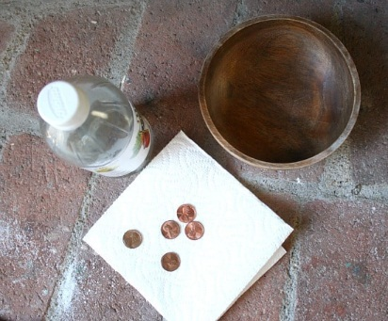 Materials

Procedure for Penny Chemical Reaction
1. Fold a paper towel so that it fits inside your dish.
2. Place the pennies on top of the paper towel.
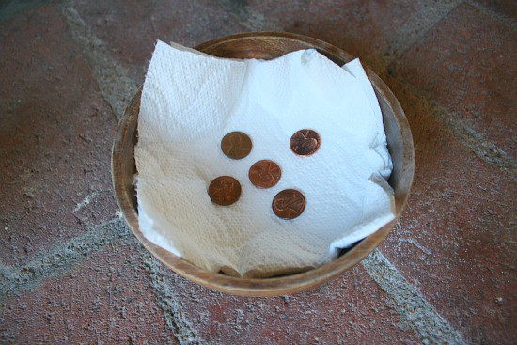 Setup – The pennies placed on the paper towel
3. Pour vinegar over the pennies so that the paper towel is fully saturated.
4. Observe the pennies over the next few hours and days. You can record your observations at the start of the experiment, after 4 hours, after one day, after two days.

Tips
I left this experiment out for a few days, adding more vinegar as the paper towel began to dry out and flipping the pennies over occasionally. The longer I waited, the more green they became!

Question to Spark Curiosity & Critical Thinking
What happened to the pennies over time? What is your theory as to why this happened?
Can you think of any other chemical reactions you’ve seen in everyday life?

What’s Going On
A chemical reaction has occurred! (A chemical reaction is the combination of two reactants to form something entirely new.) A penny is made of copper. The vinegar on the paper towel helps the copper in the penny easily react with the oxygen in the air to form a blue-green coloured compound called malachite.
This is similar to why the Statue of Liberty (which is covered with a layer of copper) has turned greenish-blue. The statue would naturally turn greenish-blue due to exposure to the oxygen in the air. However, because some rain has acid from pollution in it, the rain speeds up the reaction (just as the vinegar caused the reaction with the penny).

Did you know?
The Corona virus pandemic has lead to a huge drop in air pollution around the world. As countries all over the world go into lockdown to try fight the virus, the reduction in nitrogen dioxide produced from car engines, power plants and other industrial processes is temporarily slashing air pollution.

Thursday 2nd April:
English: Phonics, Punctuation & Grammar:
Phonics, Punctuation & Grammar:
- Circle the correct spelling – precious or pretious
- Circle the correct spelling – sieze or seize
- Add the silent letter – lam__
- Circle the correct spelling – changeable or changable
- A synonym for blend is – disappear, bless, mix - _________
- Which word can mean to make an offer of marriage to someone- (Propose, pronoun, project) _______________
- The contraction of would not is - _____________
- Circle the correct homophone – Dad guessed/guest the surprise for his birthday.
- Write the word with fewer syllables _________ (essential, special)
- Rewrite each word with ing added- hit ______________ & tie ____________
- Add one comma- Before the clock struck midnight the princess disappeared.
- Enclose the additional information in commas- Arthur rode his bike a Peugeot 531 to school each day.
- Add commas to the sentence – The sports available were: swimming tennis or badminton netball or basketball and cricket or baseball.
- Write the missing pronoun – When Uncle Max sees his friends, ___ tells them jokes.
- Write the missing pronoun – When ___ visits him, my sister and I laugh at his jokes.
- Circle the noun that the pronoun refers to – My cousin Sam is like his Dad as he also tells jokes.
- Write the missing pronoun – Uncle Max and Sam are funny and ____ make us laugh.
- Add the present tense of the verb to visit – My sister and I ________ Uncle Max and Sam on Fridays.
- Add the past tense of the verb to go – Last Friday, we ______ to a playground.
- Add the correct part off the verb to swim – I had never _____ in an outdoor pool.

Letter writing:
Today, conclude your letter – This is the ending – you want to just go back over the main points of your letter, make sure you’ve thanked them for reading your letter and maybe you can suggest the possibility of another letter if they would like it. Don’t forget to sign off and then put your name under it.
Don’t put your home address on the letters instead use the address of the school Reminder, If you can type your letter and email it to the address above that would be great if not just write it in your copy, take a picture and send the picture to the email and I’ll type it. Thank you and well done, that’s a really nice thing you just did!

Spellbound:
Spelling: Unit 24, page 50, commonly misspelled words. Read the words in box 3. Use your dictionary to look up the meaning of the word (You do not need to write out the definition).
Put the 4 words into sentences.
Complete activities E and F on page 51.

Maths:
Area: Chapter 24 (P.128) Sixth Class and chapter 21 (page 115) Fifth Class in your Busy @ maths book
6th Class
Finding the perimeter and area of an adventure centre
Remember, Area is the space covered by a 2-D shape (length x width = AREA)
Perimeter is the distance around a 2-D shape (add all the sides = perimeter)

Before you start you have to remember there is a scale being used (so for every 1cm you measure with your ruler, that is actually 1m in real life - they want to know the real measurements (metres).
Remember the obstacle course zone is an irregular shape so you have to go back to what you did on Tuesday to find the area of that zone.
Q 3 involves multiplication
Q 4 think about what they’re asking do you need the area or the perimeter to replace the safety net around the zone. How much will it cost and don’t forget to add the price of labour (those builders don’t work for free!)
Q5 Again are they asking the area or perimeter of the climbing zone if the complete zone needs new soft tiles. How much will that cost?

In your copy complete Q 1 a-e and if possible complete the challenge too! (Page 129).

Try solve the following problems too:
- square coffee shop has sides that are 7 metres long. What is the coffee shop's area? _______ m2.

- A rectangular ink pad is 8 centimetres wide and 6 centimetres tall. What is its area? _______ cm2.

- A square painting has a perimeter of 8 metres. How long is each side? _____m.

- A square name tag has sides that are 10 centimetres long. What is the name tag's area? _______ cm2.

- A rectangular shop in the mall is 7 metres wide and 10 metres long. What is its area? _____ m2.

5th Class
Remember:
Length x width = AREA
Add all sides = PERIMETRE

In your copy complete Q2 a-d, Q3 a,b,c, Q4 a and b and Q5 a-d. (Page 115)

Complete Q1 a-h - Page 116

Gaeilge:
Try use Gaeilge neamhfhoirmiúil (Informal Irish) or just a cúpla focail around the house. Teach your family our verb/sentence game and get them to play along with you, play feicim le mo shúilín beag (I spy).
Fuaimeanna agus Focail, Aonad 24. Leathanach 73.
- Use your dictionary to look up the meanings of any words you do not understand. Learn the spellings for box 4 and put these words into sentences – think of the game we play to build sentences in school, this will help!
- Complete activities G & H
- Finish the sentences below using the 3 options in the box and translate the sentences:
- Bhí sceitimíní ar na páistí sa bhus mar _______________________________.

- Cheannaigh an buachaill óg bréagán agus _____________________________.

- D’oscail an múinteoir an cófra agus ________________________________.
Thug sé airgead don siopadóir, bhí said ag du lar thuras scoile, thóg sí amach na cóipleabhair

PE:
It’s important to be staying active even if you are just at home. If possible youtube ‘the body coach classroom workouts’. These are really good and you can exercise along to your favourite music too! Ensure you’re getting at least 60 minutes exercise each day – if you don’t have access to the workouts – go for a walk or cycle, play football in the garden, use the trampoline or just follow the exercises attached at the end of this work – see: Notes!

Religion:
Stations of the Cross:
Continue this activity from the previous two days.
Ninth station: Jesus falls the third time.
Tenth station: Jesus is stripped of his clothes.
Eleventh station: Jesus is nailed to the cross.

Drama: Play a game of charades, 20 Q’s or 2 truths and 1 lie with someone at home, (you tell them 3 things- 2 are true & 1 is a lie- they have to guess the lie).

Friday 3rd April: The holidays are near!!
English:
Letter writing:
Today, send me your letter if you haven’t already done so! If you can type it and attach it to an email super but if not just take a picture of it and send the picture so I can type it. Thank you.

Novel
Chapter 8 Discussion
- Find the meaning of the word 'patriot' in your dictionary. How do you think Bruno's father would define the word patriot? How might grandmother's definition of the word be different?
- A flashback is a scene in a film, novel, etc. set in a time earlier than the main story. What is the purpose of the flashback in chapter 8?
- A metaphor is a figure of speech in which a comparison between two unlike objects is suggested or implied. What is being compared in the following metaphor?
"I (grandmother) was merely the blank wall to whom you (grandfather) addressed your words.

Read chapter 9 and answer the questions.
Chapter 9
- Who is Herr Liszt? Describe him.
- Why does Herr Liszt dislike storybooks?
- What makes Bruno decide to go exploring?
- What does Bruno see happening in the camp?

Spellbound:
Spelling: Unit 24, page 50, commonly misspelled words. Read the words in box 3. Use your dictionary to look up the meaning of the word (You do not need to write out the definition).
Put the 4 words into sentences.
Complete activity G on page 51.
Friday Challenge: Ask a member of your family to ask you’re your week’s spellings. Write them out on a page and see how many you can spell correct.
Best of luck.

Maths:
Area: Chapter 24 (P.129 & P.130) Sixth Class and Chapter 21 (page 116 & 117) in your Busy @ maths book.

6th Class
Area in m2, ares and hectares
Note: I have never used ares outside of the classroom so please don’t get worried about it. Once you know the following you’ll be just fine:
100m² = 1 are & 100 ares = 1 hectare

Today on P. 129 I would like you to do Q 1 (A), Q 2 (A) & Q 3 (All)
Also on P.130 I would like you to do Q1 only you can skip Q’s 2 & 3

5th Class
Today on p.116 I would like you to do Q2 a-d, Q3 a-d and Q4 a-d.
You can skip Q5.

Area – Irregular shapes Page 117.
Q1 a-c use the information provided to calculate the lengths of side x and y in each shape.

Read the example shown in the middle of page 117. This shows how to calculate the perimeter and area of irregular shapes. You will need to use the example to help you answer Q2.
Step 1: Divide the shape into rectangles / squares.
Step 2: Calculate the length of any missing sides that you’ll need to get the area.
Step 3: Calculate the area of each rectangle/square.
Step 4: Add the areas to find the total.

Use the above steps to answer Q2 a-f

Gaeilge:
Try use Gaeilge neamhfhoirmiúil (Informal Irish) or just a cúpla focail around the house. Teach your family our verb/sentence game and get them to play along with you, play feicim le mo shúilín beag (I spy).
Fuaimeanna agus Focail.
- Go back through the previous weeks – finish two activities you may have missed or skipped.
- Friday Challenge – ask a family member to ask your this week’s spellings and see how many you can spell correctly - it’s all good practice
Best of luck
- Finish the sentences below using the 3 options in the box and translate the sentences:
1. Shuigh na páistí síos go ciúin mar __________________________________.
2. Chuaigh Mamaí ag siopadóireacht agus _______________________________.
3. Bhí an t-ollmhargadh gnóthach mar _________________________________.
bhí an Nollaig ag teacht, bhí clár maith ar an teilifís, chuir sí bia sa tralaí

PE:
It’s important to be staying active even if you are just at home. If possible youtube ‘the body coach classroom workouts’. These are really good and you can exercise along to your favourite music too! Ensure you’re getting at least 60 minutes exercise each day – if you don’t have access to the workouts – go for a walk or cycle, play football in the garden, use the trampoline or just follow the exercises attached at the end of this work – see: Notes!

Religion:
Stations of the Cross:
Finish this activity with the last 3 stations and think about them as we prepare for Easter.
Twelfth station: Jesus dies on the cross.
Thirteenth station: Jesus is taken down from the cross.
Fourteenth station: Jesus is laid in the tomb.

SESE: Science

Optical Illusions
What is an Optical Illusion?
Optical Illusions can use colour, light and patterns to create images that can be deceptive or misleading to our brains. The information gathered by the eye is processed by the brain, creating a perception (view or opinion) that in reality, does not match the true image. Perception refers to the interpretation of what we take in through our eyes. Optical illusions occur because our brain is trying to interpret what we see and make sense of the world around us. Optical illusions simply trick our brains into seeing things which may or may not be real.
Fun Activity
Try out some of these illusions and discover just how tricky it can be for your brain to accurately interpret the images from your eyes.

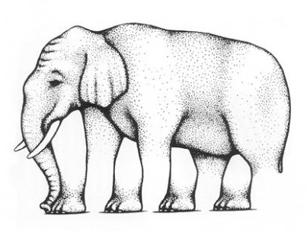

Elephant Legs

This elephant is missing a leg…or is it? The artist confuses his viewer by changing they way our brain is used to seeing things. It seems the more you look at the elephant, the more confusing it gets.
How many legs does the elephant have?

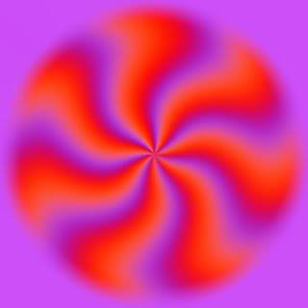
Whoa! Is that image spinning? Nope, not even a little bit. In fact, if you look away, it will seem to stop spinning. It’s all in your brain…. The repeated patterns and lines trick your brain into thinking that there is movement as it tries to make sense of the image. Pretty cool, huh?

Want to see the gears move?
Look at the dot and then move your head towards the screen and away from it.

This uses visual vibrations to create a cool effect. Try moving your head close to, and then away from the screen. The fuzzy dots appear to move.

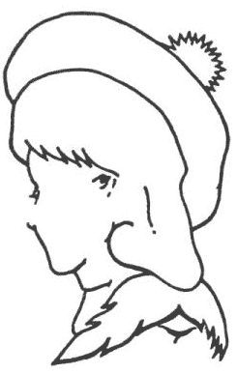
This simple line drawing is titled, “Mother, Father, and daughter” (Fisher, 1968) because it contains the faces of all three people in the title. How many faces can you find?

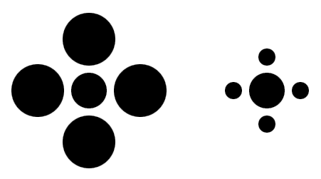
Look at the dots in the centre. Which one is bigger? Like many similar illusions, the dots are the same size…really! It can be hard to tell because your eye uses the other dots to make a comparison.

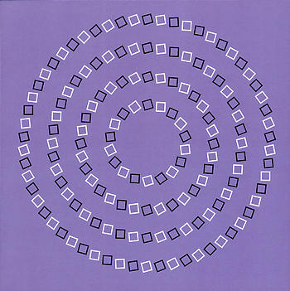
Check out the spiral…except it is not a spiral, just circles.
Don’t believe me? Use your finger to follow the fake spiral.
The tilt of the boxes fools your brain into believing it is a spiral.

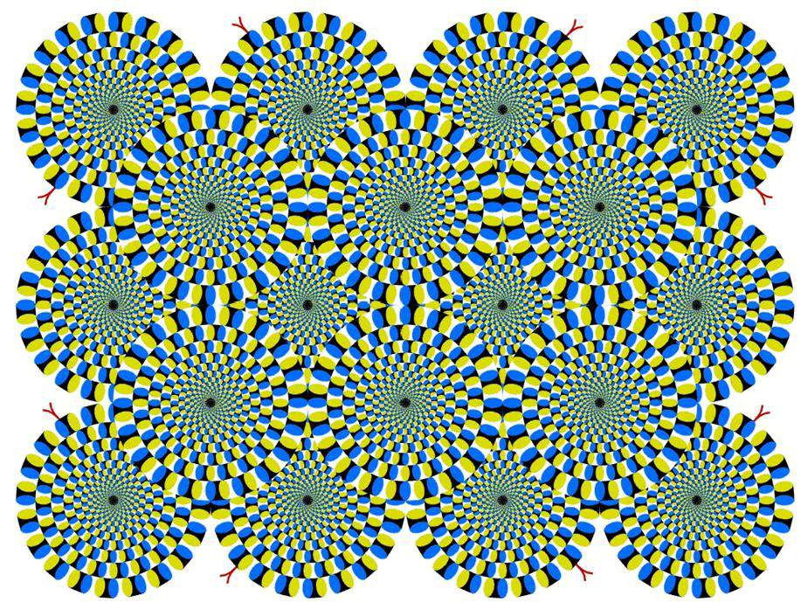

Hey, this is weird. Click on the image to make it bigger. It looks as though it’s moving, but it’s not. The shapes confuse the eye (really the brain) into believing that they are moving.

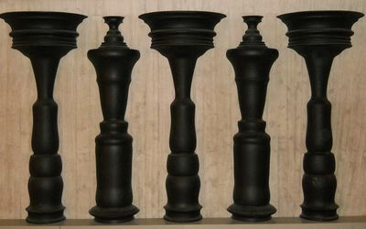
What do you see here?

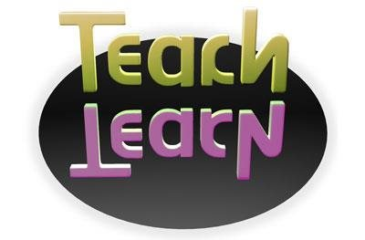

Teach
In this illusion you can see the word Teach and its reflection. Can you read the reflection too? What does it say?

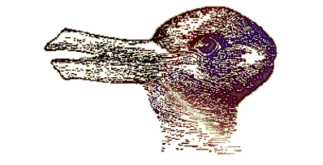

The Animal
How many animals do you see in the image?

Hermann Grid Illusion
Count all the black dots you can see

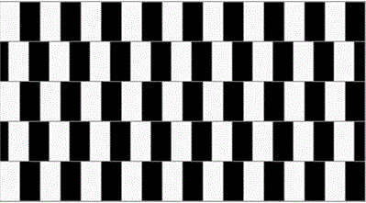

Horizontal Lines. Are the horizontal lines sloping or straight?

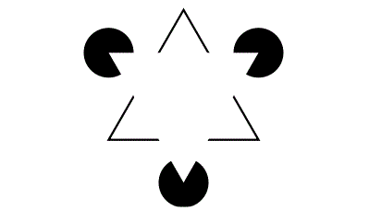

Kanizsa Triangle. How many triangles are present in the image?
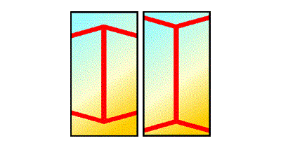

Muller-Lyer Illusion. Take a very close look at the 2 vertical lines. Do you think one line is longer than the other?

Notes-
PE Exercises:

1. Mountain Climbers
Get into a push-up position and then alternate bringing your knee to your elbow. You can do same side connections or crisscross. The idea is to move fast and work up a sweat!
2. Bear Crawls
Palms and feet flat on the floor, arch your back so that you look like a big bear. Race across the room.
3. Star Jumps
Stand tall and then explosively jump into the air, expanding your legs and your arms so that you look like a large “X” in the air.
4. Push Ups
Straightforward and to the point. Drop to the knee if you find this challenging!
5. Sit Ups
Another classic. Feel free to tuck your toes under the sofa or coffee table if you need a bit of support.
6. Burpees
Who is up for the challenge? Start with a jump up, then drop to a plank, add a push-up, and then jump back up. It should be one fluid motion and try to not pause between repetitions. Make it a bit easier by opting out of the push up if you need to.
7. Squats
To do this one, stand with your feet shoulder’s width apart, and do deep knee bends. Make sure keep your knees behind your toes and your arms out straight.
8. Leg Raises
Lay on your side or on your back and then lift your legs without bending at the knee. Try to hold at the top. This works your lower abdominals, but be careful to not let your lower back arch.
9. Lunges
Step forward and bend your front knee to a 90-degree angle. The goal is to have your back knee touch the ground without letting your front knee extend past your toes.
10. Planks
Elbows on the floor and balanced on your tiptoes. 30 seconds is considered the gold standard.
11. Butterfly Kicks
Lay flat on your back, and extend your legs straight out. Imagine a swimmer, and begin to flutter kick your legs without bending at the knee. Start with your feet high off of the floor, as the move gets more difficult the closer the action is to the floor.

6th Class Maths Answers:
Page 120
1. a) +4 b) +2 c) -1 d) -4 e) -6 f) -3
2. a) 3 b) 2 c) 2 d) 4 e) 6 f) 7 g) 5 h) 10
3. 4
4. 6
5. a) -2 b) +4 c) +3 d) -6 e) +1
6. -6, -5, -3. -2, +2, +3
7. a) 2 b) 2 c) 5 d) 4 e) 5 f) 8 g) 6

Page 121
- a) Miami b) Minneapolis
- Barcelona, Shanghai
- Chicago, Volgograd
- 5º C
- 7º C
- 11º C

- a) 2º C b) 6º
- a) Chicago b) 2º C
- a) Volgograd b) 8º C

- 24º C
- 25º C
- 37º C

- a) +20º -1º +6º +2º -6º b) +12º -9º -2º 0º -14º

c) +24º +3º +10º +6º -2º d) +7º -14º -7º -11º -19º

Page 122
- a) -20km b) +2km/h c) +5km/h
+10km -5km/h +10km/h
-5km +10km/h -5km/h

- a) Ronan b) Maria c) Ronan
- a) Ciara b) Ronan c) Maria

- a) +2 b) +4 c) -2 d) 0 e) +19 f) +11 g) -2 h) +4 i) -7 j) -3

Page 123
Q1. a) +6 b) -5 c) 0 d) -1 e) -4 f) +5 g) +2 h) -3 i) +1 j) 0

Q2. a) -1 b) +7 c) 0 d) -1 e) +6 f) -2 g) -2 h) +2 i) +6 j) -3

Q3. -12m
Q4. C) +10; +85 d) -30; +55 e) -50; +5 f) +25; +30
g) -40; -10 h) +20; +10 i) €10
j) Yes! Otherwise she would have been in the red (debt).

Page 124
Q1. a) Wheel invented b) World war 2
Q2. 476 years
Q3. a) 940 yrs b) 1,144 yrs c) 650 yrs d) 1,445 yrs
e) 3.456yrs
Q4. 5,439 yrs
Q5. a) -3,200 b) +80 c) +1,889 d) +1,659 e) -214
f) + 1,886 g) +1,173 h) -2,560

Q6. a) 1,806 yrs b) 230 yrs c) 2,346 yrs d) 640 yrs

Page 91 - A quick look back 5 Page 131 – A quick look back 7

- 300,000 1. 60
- 28,300 2. 27
- 15 3. 24
- 5:2 4. 12
- 2/9 5. €154
- 36 6. 48
- 7.059 7. 45
- 27 8. €4,50
- 8.970km 9. €30
- 42 10. €99
- 36 11. 49
- Yes 12. 6
- 81 13. 19ºC
- 12cm 14. 31
- 11 15. 110º
- 1.02 16. 64
- 9 17. 0.306
- 9cm 18. 1.255km
- 16.25km 19. 65km/h
- 1.55km 20. 468cm²

5th Class Maths Answers:
Page 125
Q1. a) 6 b) gold coins c) 4 d) solver bars e) watches
f) gold bars g) money bags h) silver coins i) treasure chest

Q3. a) 2 b) 2 c) 5 d) 2 e) 4 f) 6
g) 6 h) 6 i) 8 j) 10

Page 126
Q1. 10ºC Q2. 37ºC Q3. 0ºC Q4. -15ºC
Q5. -20ºC Q6. +25ºC

Q2. a) B b) E c) C
d) (i) +25º (ii) -20º (iii) +27º (iv) -30º (v) +45º (vi) -5º
(vii) +57º (viii) -12º

Challenge: 41ºC

Page 127
- Cape Town 2. Winnipeg 3. 8ºC 4. 1ºC
- 25ºC 6. 14ºC 7. 9ºC 8. Helsinki
9. Moscow 10. 6ºC 11. 7ºC 12. 22ºC
13. 7ºC 14. 4ºC 15. 41ºC

16.
Cork 6ºC New York Cape Town Oslo Helsinki
+11ºC +4ºC +32ºC -3ºC +3ºC
+3ºC -4ºC +24ºC -11ºC -5ºC
+21ºC +14ºC +42ºC +7ºC +13ºC
-7ºC -14ºC +14ºC -21ºC -15ºC

Hong Kong Winnipeg
+23ºC -9ºC
+15ºC -17ºC
+33ºC +1ºC
+5ºC -27ºC

Page 128
Q1. a) GD +15; pts 61 b) GD +5; pts 60
Q2 W 15; L 9
Q3. a) 6 b) 13
Q4. GD -16; pts: 33
Q5.
Barking Dogs: Position 11; pts 30
Proud Penguins: Position 10; GD -21
Clever Cats: Position 12; GD 26; pts 28
Skipping Kangaroos: Position 9; GD 18; pts 31

Page 93 - A quick look back 5 Page 119 – A quick look back 6

- 0.09 1. 8.7cm
- 93/100 2. 39m
- 3.791 3. 3,495 4. 76cm
- (5) 5. 0.25
- (3) 6. €8
- Complete yourself 7. 0.008
- Reflex 8. 26%
- €6 9. €27
- €12.50 10. 9/25
- 54/63 ÷ 9/9 = 6/7 11. €22
- 7.674 12. 150ml
- 1,638 13. 160
- 1,700kg 14. 2 hrs 52 mins
- €8,400 15. 17:20
- 42.084 litres 16. 16:52
- €960 17. 6cm²
- €24 18. 34cm
- 7/12 x 5/5 = 35/60 or 7/12 19. 93 mins
- 12 20. 0.42
- 36

Maths Problems Answer: (5th and 6th class)
Q1. 22.81km
Q2. 0.125 0.333 0.60 0.85 0.05 0.70
0.083 0.99 0.12

Q3. a) €174.76 b) €161.28 c) 1,697.76 d) €433.44
e) 3,014.73m

Q4. 776.223kg
Q5. 164.122kg
Q6. 117.792 litres
Q7. a) 12 R11 b) 15 R11 c) 13 d) 37 e) 53

Spellbound
Page 48 Page 49
C. Crossword E. Write the missing words.
Across
6. fingerprint 1. tablespoon
7. stepladder 2. homesick
3. handshake
Down 4. seashore
1. snowflake 5. fingerprint
2. footprint 6. loudspeaker
3. lifetime 7. wintertime
4. homesick 8. stepladder
5. handshake 9. daydreams; 10. handmade

F. Unscramble these words.
1. footprint
2. lifetime
3. seashore
4. stepladder
5. handshake
6. everybody
7. homesick
8. tablespoon
9. snowflake
10.background

G. Write the word list in alphabetical order.
1. background 2. daydreams 3. Everybody 4. fingerprint
5. footprint 6. handmade 7. handshake 8. homesick
9. lifetime 10. Loudspeaker 11. Seashore 12. snowflake
13. stepladder 14. Tablespoon 15. Thunderstorm 16. Wintertime

H. Match the letters.
1. tablespoon 7. seashore
2. loudspeaker 8. wintertime
3. fingerprint 9. handshake
4. homesick 10. snowflake
5. daydreams 11. lifetime
6. stepladder 12. Footprint

Fuaimeanna agus Focail
Leathanach 70
A.
mála = bag an-mhór = very big
mo mhála = my bag cé mhéad? = How much?
mo mhéara = my fingers mo mhuineál = my neck
mo lámha = my hands mo mháthair = my mother
maighdean mhara = mermaids ríomhaire = computer
an-mhaith = very good an-fómhar = autumn
moncaí = monkey an geimhreadh = winter
trí mhoncaí = three monkeys an samhradh = summer

B.
1. An samhradh a bhí ann. Bhí an aimsir go han-te ar fad.
It was summer. The weather was extremely hot.

2. Bhí fear an zú ag dul ó chás go cás le mála bia.
The zoo man (zookeeper) was going from cage to cage with a food bag.

3. Sciob moncaí dána an mála bia ón bhfear zú.
The naughty monkey snatched the bag of food from the zoo man (zookeeper).

4. "Chuir an moncaí a lámh amach agus ghoid sé mo mhála." a bheic an fear zú.
"The monkey put his hand out and stole my bag," shouted the zoo man (zookeeper).

5. "Nóiméad amháin bhí mo mhála i mo lámha agam agus ansin bhí sé imithe," a dúirt sé.
"One minute I had my bag in my hands and then it was gone," he said.

6. "Chuir sé a lámha timpeall ar mo mhuineál freisin."
"He put his hand around my neck also."

7. Lig an moncaí dána eilifint an-mhór amach as a chás.
The naughty monkey let the very big elephant out of his cage.

8. An lá ina dhiaidh sin bhí an scéal ar fad ar an ríomhaire.
The next day the whole story was on the computer.

C.
1. trí mhoncaí 2. mo lámha 3. mo mhéara 4. an-mhaith
5. ríomhaire 6. cé mhéad?

E.
1. D'fhan mé sa seomra ranga mar bhí mo chos gortaithe.
I stayed in the classroom because my leg was hurt.

2. Níl aon bhainne fágtha. Tá sé go leir ólta.
There is no milk left. It is all drank.

3. Bhí glúin Liam gearrtha agus bhí sí ag cur fola.
Liam’s knee was cut and it was bleeding.

4. Bhí an fuinneog briste ach tá sí deisithe anois.
The window was broken but it is now repaired.

5. Bhí mo chuid gruaige cíortha agam ar maidin.
I had my hair combed this morning.

6. Bhí mo sheomra suite maisithe go hálainn Lá Nollag seo caite.
My living room was beautifully decorated last Christmas.

7. Níl urlár mo sheomra ranga scuabtha fós.
My classroom floor has not been swept yet.

8. Bhí an scoil ciúin mar bhí na páistí go léir imithe abhaile.
The school was quiet as all the children has gone home.

F.
1. ríomhaire 2. Mála 3. maighdean mhara 4. an samhradh
5. mo mhuineál 6. mo mhéara

H.
Trasna
1. mo mháthair
3. an fomhar
6. mo lámha
8. an samhradh

Síos
2. mo mhála
3. an geimhreadh
4. an mhaith
5. mo mhéara
7. mála

