Dear boys, girls, parents and guardians,

I hope you are all feeling well and are staying safe. Hopefully, if we all adhere to social distancing instructions we can resume our daily routines soon. I am looking forward to hearing what you have all been up to, I’m sure you have been exercising a lot and helping at home. I am positive, that all your helping at home, with the supervision of adults is creating some wonderful cooks and bakers too.

Below I have outlined work for next week (30/03/2020 – 03/04/2020). It is broken down step-step and day-day, please do your best to complete the tasks as best you can. I have tried to keep the work as manageable as possible while trying to ensure skills are practiced and some progress is made. It can be difficult to focus at home and I know lots of adults are also working from home, therefore, please try to do as much as you can alone while remembering you can only do your honest best. I am aware that you currently do not have all books along with necessary photocopies at home. Therefore your parents have two options they can register online for free for an e copy of the books (information below) or I will also include a photograph of each page of any book you do not have at home with the work each day. t will therefore be necessary for parents/guardians to register on two online sites.

https://www.cjfallon.ie/ (for free) to access work. When registering you will be asked what class group your child is in and what titles you would like access to, please request access to the following; (Léigh sa Bhaile D, Small World History 4th, Small World Geography and Science 4th and Busy at Maths 4).

https://www.folensonline.ie/registration/ (for free)to access work. When registering you will be asked if you are a teacher or student, please select Teacher, choose a username and fill in your email address and choose a password. When asked for your school roll number please enter: Prim20. I have had my account with Folens for years so I cannot remember if they ask which books you would like access to at this point, if it asks you please select; Fuaimeanna agus Focail 4th class (purple book), Abair Liom F and Planet Maths 4th).

Your parents will need to e mail me at horeswoodfourthclassmswarner@gmail.com, if they can. I will add them to a mailing list where I will email answers to the previous day’s work so it can be easily self-checked and corrected if it suits your parents. If anyone has difficulty, would like something explained or would like me to check over work I can also contacted on this email address for guidance. I will monitor this mailbox between 11.00am – 1.00pm Monday to Friday and endeavour to get back to you as soon as possible.

I have included a notes section at the end of the weekly work. If you would like to take virtual tours, follow drawing lessons by a Marvel comic artist and much more you may like explore these suggestions at your discretion and with the consent and supervision of your parent/guardian. I hope all of you use this time to have fun with your families and explore your many talents. Take care of yourselves and others and remember to try to help your parents when you can. Hopefully we will all see each other soon.

Míle Buíochas,

Ms Warner

Ps. For children that go to Mr. Stafford and Ms. Phelan they should have information up on the website with their work and e mail addresses, please check it out.
Monday 30th March:
English:
- Jolly grammar 4 (week 23 ‘el’) learn first 6 words.
- Do all of Jolly Grammar phonic page (week 23 ‘el’).
- Please read a chapter or two in a novel, remember our reading challenge. New Ross Library has books available online if you would like something other than what is available at home.

Maths:
- Master your Maths: Week 25, P54 (Monday)
- We are moving on to Capacity this week – it’s Chapter 33 (beginning on P163) in your Busy at Maths book. You can find this page on the e book (if your parents managed to access it) or attached below.
Today please complete p163 in a maths copy if you have a spare one, or in your homework copy. Just remember to label your work and keep it neat so it is easy for you to locate questions when correcting.
Remember, there are 1,000ml in 1 litre. You can use a measuring jug and water to familiarise yourself with capacity measurements again.
Also don’t forget that 0.1= 1/10; 0.2= 2/10, 0.25=25/100, etc.
- Keep revising all tables. Perhaps test yourself if you can with a couple of online games such as Hit The Button or https://www.topmarks.co.uk/Search.aspx?q=tables
- Tables Champions: do Monday from the next week in Tables Champion

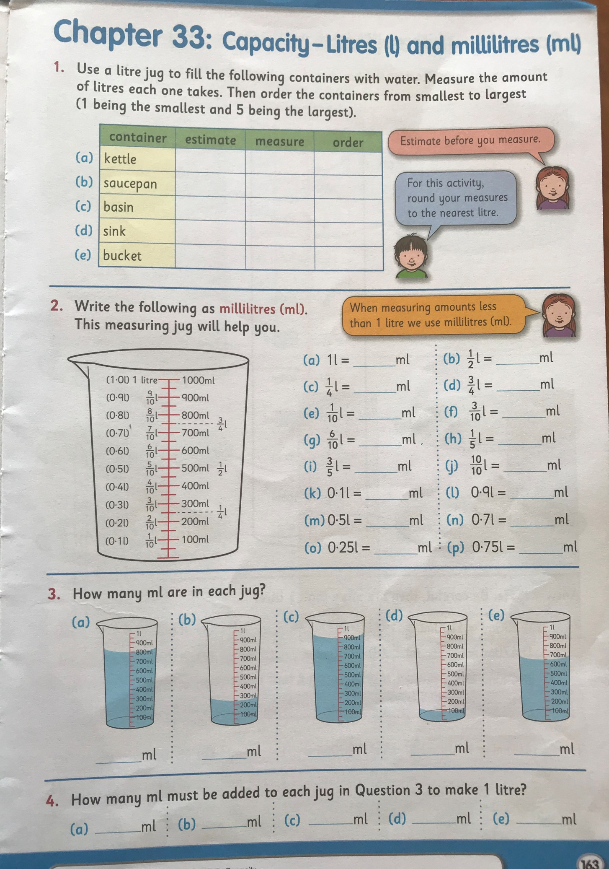

Gaeilge:
- Try use Gaeilge neamhfhoirmiúil (Informal Irish) or just a cúpla focail around the house. Example: Dún an fhuinneog, tá mé ag dul amach/isteach, tá mé amuigh/istigh, an bhfuil do obair críochnaithe? Agus mar sin dé/etc.
- Fuaimeanna agus Focail, Aonad 24, P73 – P75 learn the first three words and do A and B002E
- Léigh sa Bhaile, (available on cjfallon website once your parent has registered) p66 ‘Cóisir Chodlata’/ Sleepover party. Léigh an scéal agus freagair na céisteanna Q1, Q2 & Q3 (sa chóipleabhar).
- Use your dictionary to look up the meanings of any words you do not understand.
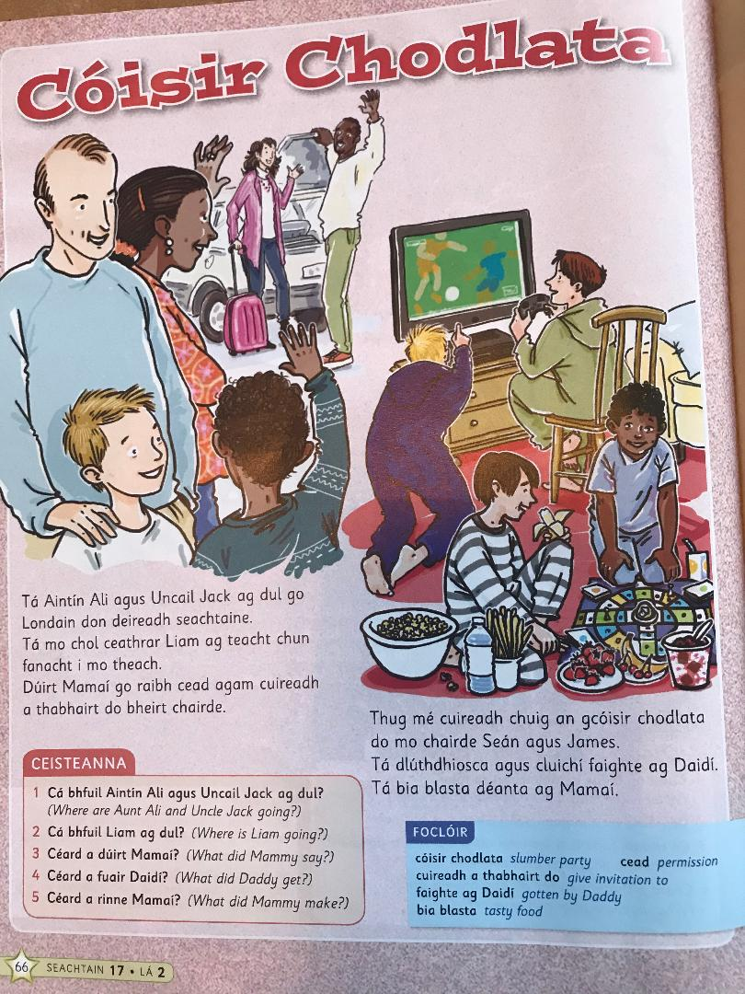

PE:
It’s important to be staying active even if you are just at home. If possible youtube ‘the body coach classroom workouts’ or google 10@10. These are really good and you can exercise along to your favourite music too! Ensure you’re getting at least 60 minutes exercise each day – if you don’t have access to the workouts – go for a walk or cycle, play football in the garden, use the trampoline or just follow the exercises attached at the end of this work – see: Notes!

SESE: Small world Geography & Science:
*Remember, this book is available for free on the CJFallon website once your parent/guardian has registered.
Unit 18: Materials and Change
- Read P105 & P106
- If possible carry out the experiment ‘investigate’ (orange box) on P106.
- Discuss and share your observations with someone at home: What did the cream look like when you put it in the container (was it a liquid/solid/gas)? Did you notice anything as you shook the container? When you take the lid off, have any changes occurred? Is there anything the same/different?
- Orally (you do not need to write) answer (A) and (B) on0020P106.

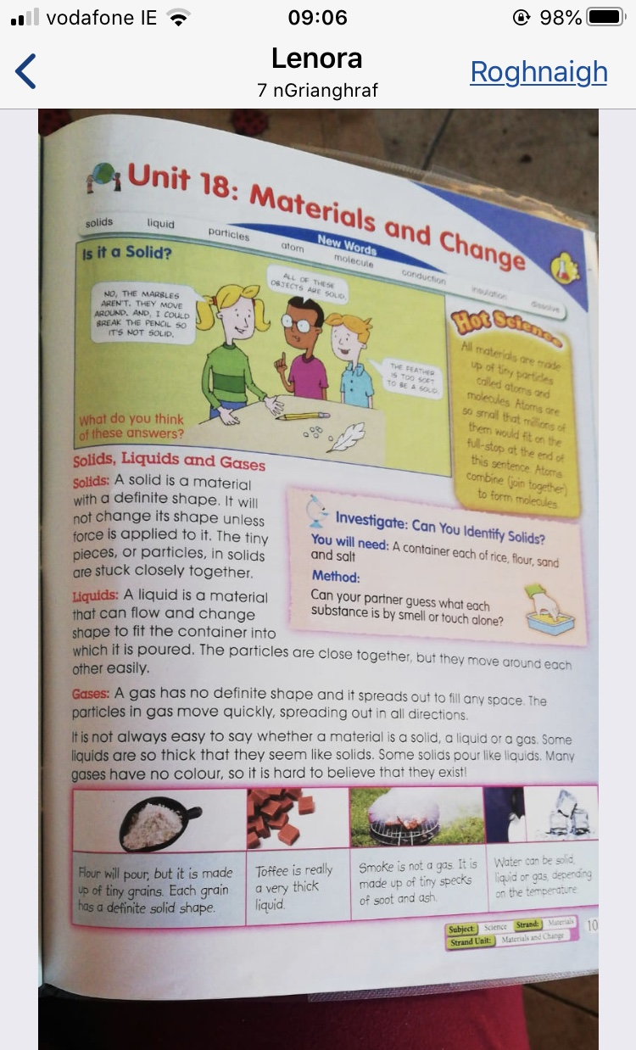
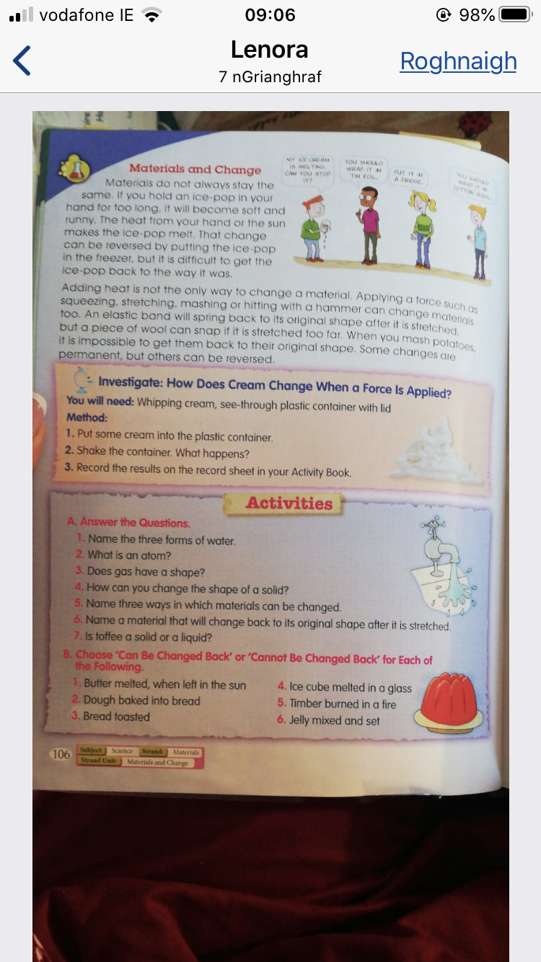

Tuesday 31st March:
English:
- Jolly grammar 4 (week 23 ‘el’) learn second set of 6 words.
- Do all of Jolly Grammar ‘grammar page’ (week 23 ‘Changing person 1st, 2nd and 3rd person’)
- Please read a chapter or two/or more in a novel. New Ross Library has books available online if you would like something other than what is available at home.
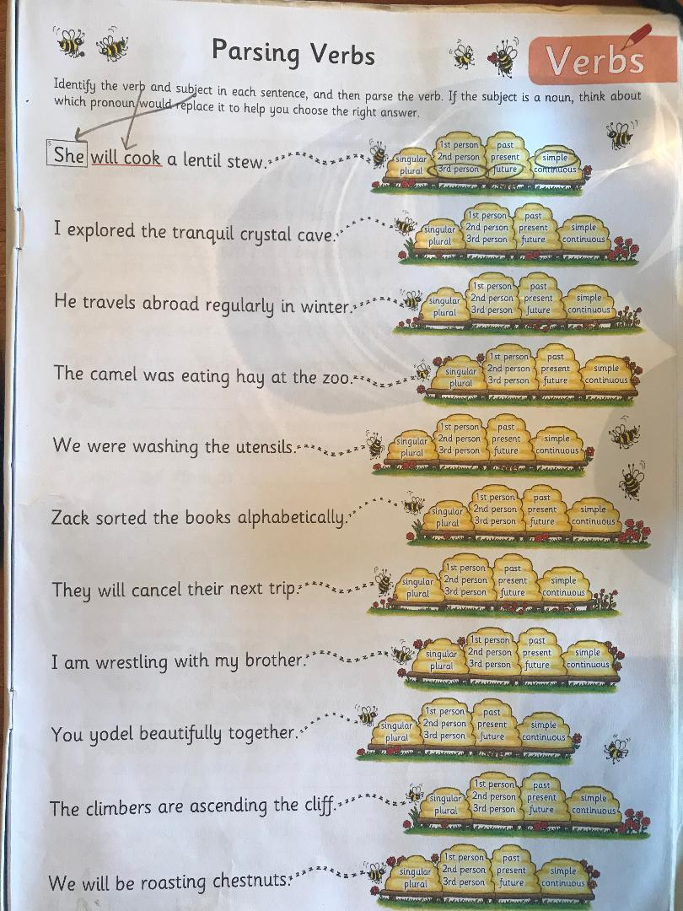

Maths:
- Master your Maths: Week 25, P54 (Tuesday)
- We are continuing to work on Capacity, Chapter 33 (p164) in your Busy At maths book. Today please complete p164 in a maths/homework copy (Q1, 2 & 3). Remember to label your work and keep it neat so it is easy for you to locate questions when correcting.
Remember, there are 1,000ml in each litre. To find one tenth of a litre you divide by ten. To find three tenths of a litre you divide 1,000ml (1L) by ten then multiply by three (divide by the bottom and multiply by the top). Similarly to find 18 one hundredths you divide by 100 (the bottom) and multiply by 18 (the top). You can use a measuring jug and water to familiarise yourself with capacity measurements again.
- Keep revising all tables. Perhaps test yourself if you can with a couple of online games such as Hit The Button or https://www.topmarks.co.uk/Search.aspx?q=tables
- Tables Champions: do Tuesday from the next week in Tables Champion

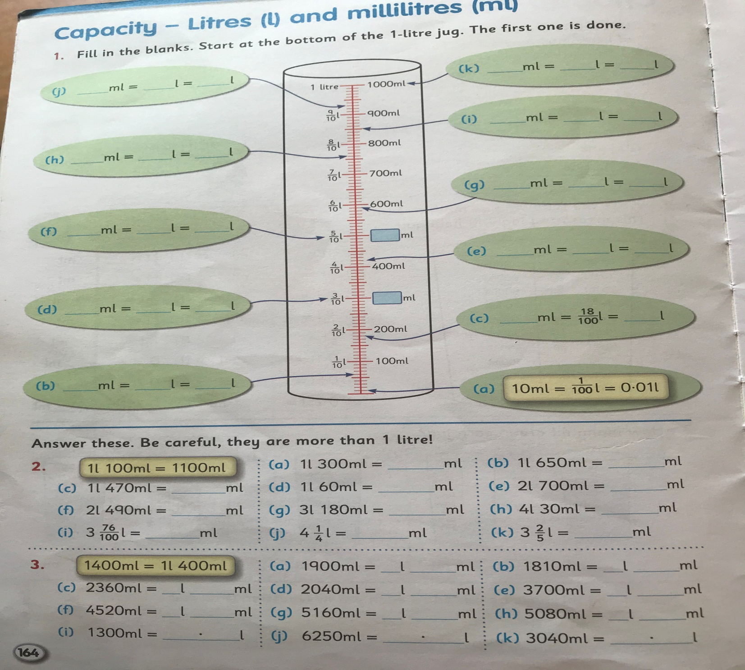
Gaeilge:
- Play feicim le mo shúilín (I spy) using items from around the house (as Gaeilge)
- Fuaimeanna agus Focail, Aonad 24, P73 – P75 learn the second three words and do C and D.
- Léigh sa Bhaile, p66 ‘Cóisir Chodlata’/ Sleepover party. Léigh an scéal arís agus freagair Q 4 & 5 (sa chóipleabhar).
- Use your dictionary to look up any words you don’t know the meaning of.

PE:
Do as you did yesterday, remember that you should try and get at least 60 minutes of physical exercise each day.

SESE: Small world Geography & Science:
*Remember, this book is available for free on the CJFallon website once your parent/guardian has registered.
Unit 18: Materials and Change (continued)
- Read P107 and P108
- If you can carry out the experiment ‘investigate’ (in the orange box) on p107.

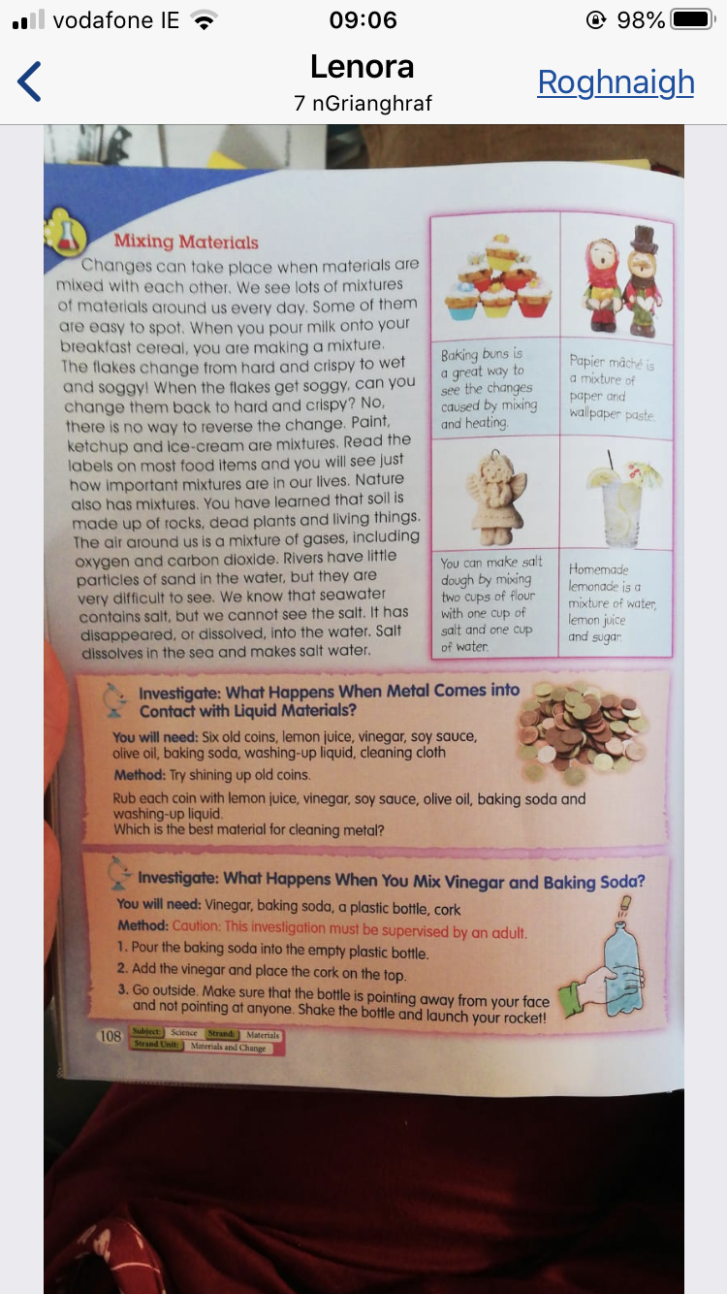

Music:
- Think of your favourite song right now, why is it your favourite?
- Listen to the song – sing along if you know the words
- What instruments can you hear?
- What is the tempo? (fast or slow)
- What are the dynamics? (Is it loud, or quiet? Does it change?)
- Draw an image for the music you heard- what do you think of?

Wednesday 1st April:
English:
- Jolly grammar 4 (week 23 ‘el’) learn third 6 words
- Word Wizard (Unit 14) begin on P79
Today we will be working on comprehension strategies; prediction, visualizing and determination of importance. For (A) write a sentence or two explaining how you believe rainbows are formed, remember this is not a test it’s part of the learning process. Draw a picture of what you visualise when you think of a rainbow (B).
- Next I want you to read P80 aloud to someone. When you come across a word you feel is important to use when describing rainbows and how they are formed underline it.
- Finally, pick the most significant of the five words you have underlined and record them in the stars on P79 (C) and explain to the person who listened to you read, why you chose these are important/significant words.
- It would be lovely if you could talk to someone at home about times when you have seen a rainbow. When was it? Where was it? Who else was there? What colours did you see? Do rainbows remind you of a particular day or something in particular?
Maths:
- Master your Maths: Week 27, P59 (Wednesday)
- Capacity, Chapter 33 (p165) in your Busy at Maths book.
Today: p165 in a maths copy (Q2. make the grid in your copy, Q3. Write out as follows; 720ml=72/100=0.72ml etc. and Q4. Please make out the grid as it is in the book and find at least two containers in your home which fall under each category).
If you would like to challenge yourself (I know you are all very capable), you can try the challenge at the end of the page
Remember, there are 1,000ml in each litre. You can use a measuring jug and water to familiarise yourself with capacity measurements again. Also remember 1/10(litre)= 100 ml and 1/100 (litre) = 10ml

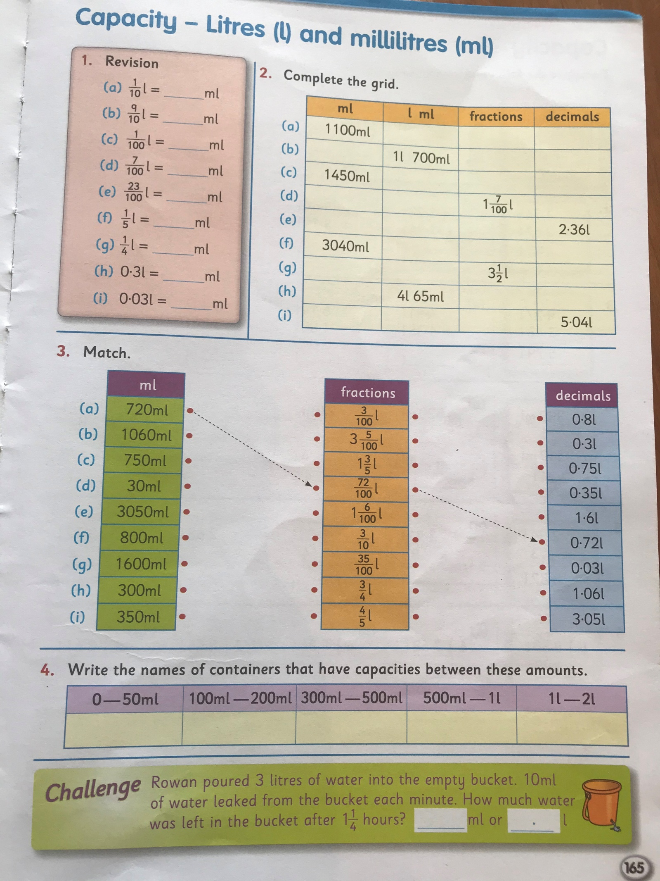
- Revision of all tables
- Tables Champion (Wednesday)
Gaeilge:
- Log on to Folens online and access ‘Abair Liom F’, choose ‘Resources’ , under lesson choose ‘Na Séasúir’ . There is a conversation ‘comhrá’ and poem ‘dán’ there which would be beneficial to listen to. I would love if you would try and join in with the poem/dán. The more you listen to and speak a language the more natural it will feel to you.
- Fuaimeanna agus Focail, Aonad 24, P73 – P75 learn the third three words and do E and F.
- Léigh sa Bhaile, (available on cjfallon website once your parent/guardian has registered) p71 ‘Ag Obair sa Ghairdín’ (working in the garden). Léigh an scéal agus freagair na céisteanna Q1, Q2 & Q3 (sa cóipleabhar).
- Use your dictionary to look up any words you don’t know the meaning of.
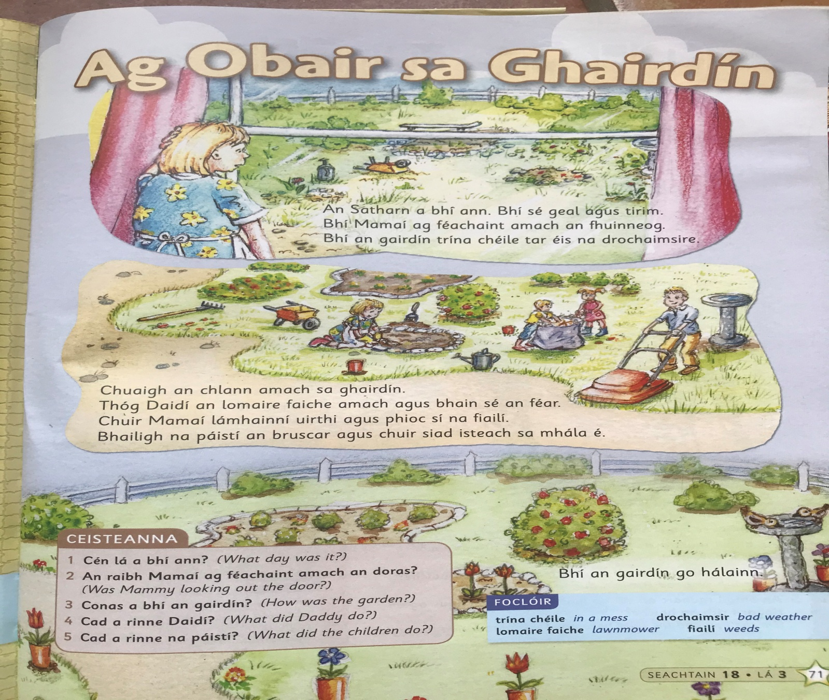

PE:
60 minutes at least of an activity you enjoy!

SESE
Try your own materials and change experiment.
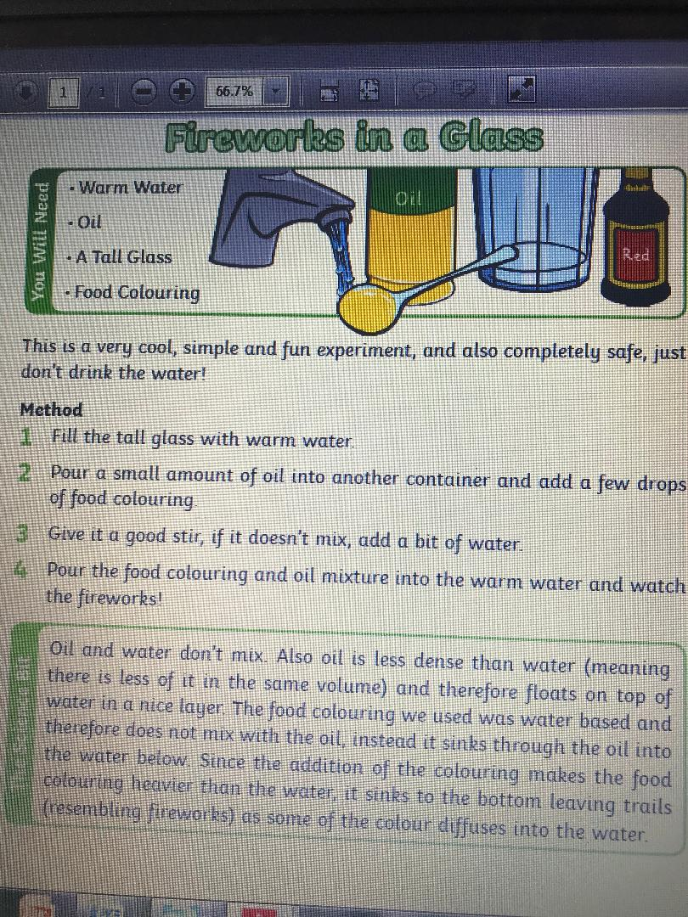

SPHE: Being expressive
- Think about ‘body language’ – how is yours now? What types of expressions/body language would you expect to see when you’re happy/confident? What types of expression/body language would you expect to see when you’re down or in a low mood?
- Write these down in two different lists
- Now look at the emojis – I want you to choose two of your choice, explain them and draw a time you felt like this and explain why.

Thursday 2nd April:
SPHE
Try some mindfulness to get that mind to ‘Flower Level’ this can be especially hard with the ongoing social isolation situation we are all in. Try using https://www.youtube.com/watch?v=neqwDPmn6yY to help you. Indeed try to do this everyday or several times a day, especially if you feel your mind is at ‘Busy Bee’ level.

English:
- Jolly grammar 4 (week 23 ‘el’) revise all spellings
- Word Wizard P80 and p81. Re-read page 80 and then do p 81: A and B in your copies (just answers) and C and D can be done in your books.
- Please read a chapter or two/or more in a novel. New Ross Library has books available online if you would like something other than what is available at home.
Maths:
- Master your Maths: Week 25, P55 (Thursday)
- Capacity, Chapter 33 (p166) Busy at maths book. Remember to label your work and keep it neat so it is easy for you to locate questions when correcting. Be careful of where you put the decimal point.
If you would like to challenge yourself attempt some of the challenges at the end of the page
Remember, there are 1,000ml in each litre. When representing litres and millilitres as a decimal be careful where you put the decimal point and use litres (L) rather than millilitres (L), example 1320ml = 1L 320ml or 1.320L = 1.32L.
- Tables Champions (Thursday)
- Revise all tables
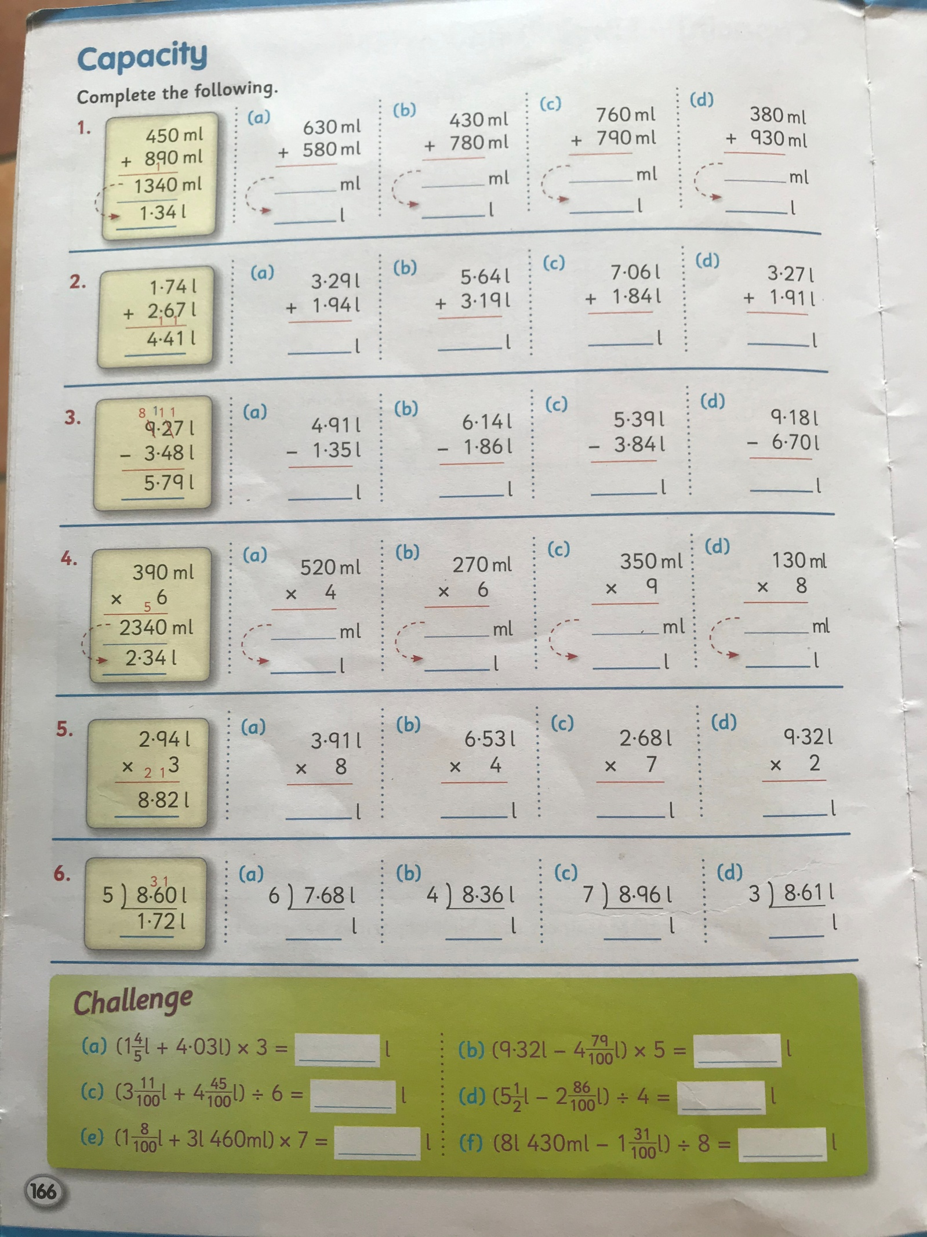

Gaeilge:
- Fuaimeanna agus Focail, Aonad 24, P73 – P75 learn the last three words and revise for Friday test and do G and H.
- Léigh sa Bhaile, p71 ‘Ag Obair sa Ghairdín’ Léigh an scéal agus freagair na céisteanna Q4 and Q5 (sa cóipleabhar).

PE:
It’s important to be staying active even if you are just at home. If possible register for GoNoodle and choose from a variety of activities from dance/athletics etc. Ensure you’re getting at least 60 minutes exercise each day – if you don’t have access to the workouts – go for a walk or cycle, play football in the garden, use the trampoline or just follow the exercises attached at the end of this work – see: Notes!

SESE: Small world Geography & Science:
SESE
Look up/think about a famous landmark e.g. Big Ben, Eiffel Tower, Statue of Liberty etc and design and build it using any materials you have around the house e.g. play-doh, lego, cardboard etc. If you like you can take a picture and send it to me by e mail.

Friday 3rd April: The holidays are near!!
English:
- Spellings: Ask an adult to call out spellings and do your best to spell it, treat the spelling test as you would as if you were in school and do the test in your text copy. When finished you can swap your copy for the book the adult is holding calling the words out for them to correct for you. Best of luck, remember, both your parents/guardians and I are always happy with your honest best effort
- Word Wizard (Unit 14) p. 82 in your copy
- Please do some reading of your choice. Perhaps a family member would enjoy listening to you reading from a novel/storybook/newspaper/internet article.
Maths:
- Master your Maths: Week 25, P55 (Friday)
- Capacity, Chapter 33 (p167) in your Busy at maths book.
Today: p167 in a maths/homework copy Q1, Q2, Q3, Q4
If you would like to challenge yourself attempt some of the challenges at the end of the page
Remember, there are 1,000ml in each litre therefore 330ml = 0.33L or 0.330L, 1.1L = 1L & 0.1L 100ml therefore 1.1L = 1100ml etc.
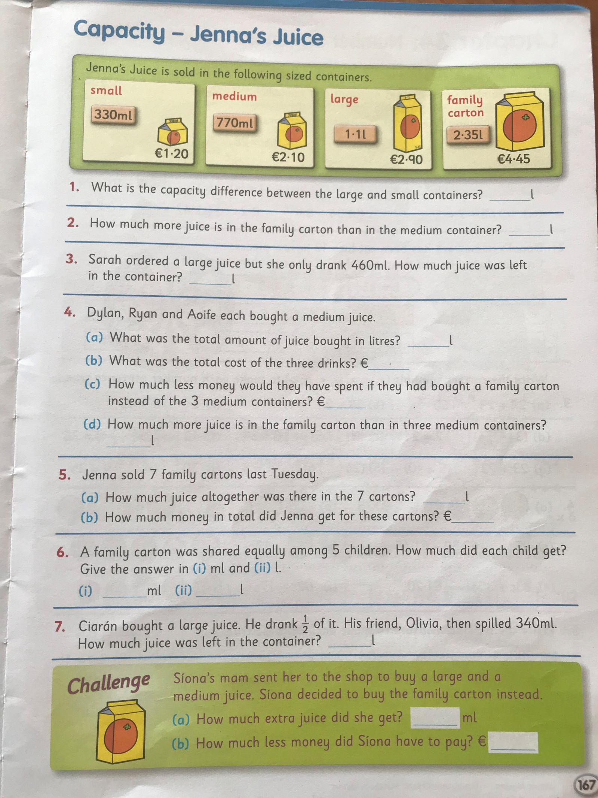

Gaeilge:
- Ask an adult to call out the words as Gaeilge for your spelling test, don’t forget to write the English beside the word. Next swap your test copy for the book and call out the words and spellings for someone else to correct, remember, just do your honest best.
- Léigh sa Bhaile, (available on cjfallon website once your parent/guardian has registered). Once your parent/guardian has emailed me at horeswoodfourthclassmswarner@gmail.com I can send out the answers for the comprehensions ‘Cóisir Chodalta’ agus ‘Ag Obair sa Ghairdín’ on Friday morning so you can correct your work. If you do not understand the answers you can look words up in your dictionary. Dictionary work is really important as it’s a skill you use and will continue to use throughout future studies and life.
- Log on to Folens online and access ‘Abair Liom F’, choose ‘Resources’ , under lesson choose ‘Na Séasúir’ . Listen to the comhrá, dán agus amhrán. Try your best to join in with the dán and amhrán.

PE:
It’s important to be staying active even if you are just at home. If possible youtube ‘the body coach classroom workouts’. These are really good and you can exercise along to your favourite music too! Ensure you’re getting at least 60 minutes exercise each day – if you don’t have access to the workouts – go for a walk or cycle, play football in the garden, use the trampoline or just follow the exercises attached at the end of this work – see: Notes!
SESE: Small world Geography & Science:
Unit 18: Materials and Change
This week we have been studying how change can occur i.e.: a substance can take many forms based on conditions, for example water (a liquid) can change to a vapour ‘steam’ when heated or can change to a solid ‘ice’ when cooled/frozen. OR when an acid such as lemon juice is added to the surface of a dirt coin can be cleaned.
- Discuss
Can you think of anything else which can change its form when a change occurs/is applied?
- If it is convenient for your parent/guardian to supervise you and you have permission to use cupboard contents you may like to plan and prepare a dish/cake/buns? While doing this notice how ingredients change when mixed and heated.
- If baking and using bicarbonate of soda/self-raising flour/baking powder why do you think these ingredients are needed? Hypothesize, what would happen if you left one of these special ingredients out? How do you think they work? When you have finished you can google to check your reasoning.

SPHE: Healthy eating – try not eat too many Easter eggs Happy Easter!
ART: Do some virtual tours of art galleries:
https://www.theguardian.com/travel/2020/mar/23/10-of-the-worlds-best-virtual-museum-and-art-gallery-tours

https://www.mentalfloss.com/article/75809/12-world-class-museums-you-can-visit-online

Notes

Virtual tours
https://www.theguardian.com/travel/2020/mar/23/10-of-the-worlds-best-virtual-museum-and-art-gallery-tours

Dublin Zoo.ie
(feeding time is roughly between 2-2.30)

https://www.mentalfloss.com/article/75809/12-world-class-museums-you-can-visit-online
Art
YouTube #wewilldraw by Will Sliney (Irish Marvel artist)

A Story a day (listening)
https://www.worldofdavidwalliams.com/elevenses/

P.E.
Urban Gym New Ross are on Facebook and will be doing some physical activities for kids on Tuesdays and Thursdays at 1.30pm. Parents who have Facebook might like to utilise this.

Fun Activities

*I gave every child a ‘Think like an Engineer’ booklet which they brought home. There are some really lovely activities which everyone at home could try out if you wish to do so.

PE Exercises:
1. Mountain Climbers
Get into a push-up position and then alternate bringing your knee to your elbow. You can do same side connections or crisscross. The idea is to move fast and work up a sweat!
2. Bear Crawls
Palms and feet flat on the floor, arch your back so that you look like a big bear. Race across the room.
3. Star Jumps
Stand tall and then explosively jump into the air, expanding your legs and your arms so that you look like a large “X” in the air.
4. Push Ups
Straightforward and to the point. Drop to the knee if you find this challenging!
5. Sit Ups
Another classic. Feel free to tuck your toes under the sofa or coffee table if you need a bit of support.
6. Burpees
Who is up for the challenge? Start with a jump up, then drop to a plank, add a push-up, and then jump back up. It should be one fluid motion and try to not pause between repetitions. Make it a bit easier by opting out of the push up if you need to.

7. Squats
To do this one, stand with your feet shoulder’s width apart, and do deep knee bends. Make sure keep your knees behind your toes and your arms out straight.
8. Leg Raises
Lay on your side or on your back and then lift your legs without bending at the knee. Try to hold at the top. This works your lower abdominals, but be careful to not let your lower back arch.
9. Lunges
Step forward and bend your front knee to a 90-degree angle. The goal is to have your back knee touch the ground without letting your front knee extend past your toes.
10. Planks
Elbows on the floor and balanced on your tiptoes. 30 seconds is considered the gold standard.
11. Butterfly Kicks
Lay flat on your back, and extend your legs straight out. Imagine a swimmer, and begin to flutter kick your legs without bending at the knee. Start with your feet high off of the floor, as the move gets more difficult the closer the action is to the floor.

