Dear boys and girls and parents

I hope you are all feeling well and are staying safe. Hopefully, if we all adhere to social distancing instructions we can resume our usual routines soon. I know it’s an unusual and perhaps stressful situation for you all and even though you thought you might never say it I bet you would much rather be in school! I know I would! I miss hearing all your news and stories and can’t wait to catch up with you all again. I’m sure you are finding lots to do at home, such as reading, exercising, playing outside in your garden, cooking, baking, art, hobbies, helping out and spending time with your family and pets.

Below I have outlined work for next week. It’s broken down step by step/day by day and I would love for you to get as much work done as you can but remember you can only do your best! It’s not easy to work at home. Your parents are very busy and have lots to do so try as much as you can on your own. No-one is to ever worry about the work. I have tried to keep the work as manageable as possible while trying to ensure we practice skills and make some progress. I am however aware that you currently do not have all books along with necessary photocopies at home. Therefore your parents have 2 options they can register online for free for an e copy of the books (information below) or I will also include a photograph of each page of any book you do not have at home with the work each day.

https://www.cjfallon.ie/ (for free) to access work. When registering you will be asked what class group your child is in and what titles you would like access to, please request access to the following; (Léigh sa Bhaile D, Small World History 4th, Small World Geography and Science 4th and Busy at Maths 4).

https://www.folensonline.ie/registration/ (for free)to access work. When registering you will be asked if you are a teacher or student, please select Teacher , choose a username and fill in your email address and choose a password. When asked for your school roll number please enter: Prim20. The books you will need are Fuaimeanna agus Focail 4th class (purple book) and Abair Liom F.

Your parents will need to e mail me at horeswoodfourthclassmsodwyer@gmail.com if they can. I will add them to a mailing list where I will email answers to the previous day’s work so it can be easily self-checked and corrected at home if it suits you or your parents. Of course if anyone has difficulty or would like something explained please do e mail me. It’s important to know boys and girls (and parents) that there is no pressure on you to do all of this and you can only do your best! I will monitor this mailbox between 10.00-11.00am and 2.00-3.00pm Monday to Friday and will get try to get back to you as soon as possible.

Take care of yourselves, be good for your parents, take this time to do some fun activities at home and try something different. Looking forward to hearing from you all.

Ms. O’ Dwyer

Ps. For children that go to Mr. Stafford and Ms. Phelan they should have information up on the website with their work and e mail addresses, please check it out.

Monday 30th March:
English:
- Jolly grammar il words:
Learn the first 6 words for spellings and put them into sentences in your copy
If you do not know the meanings of any of these words please look them up in a dictionary.
- Do all of Jolly Grammar page (below) in your copy.
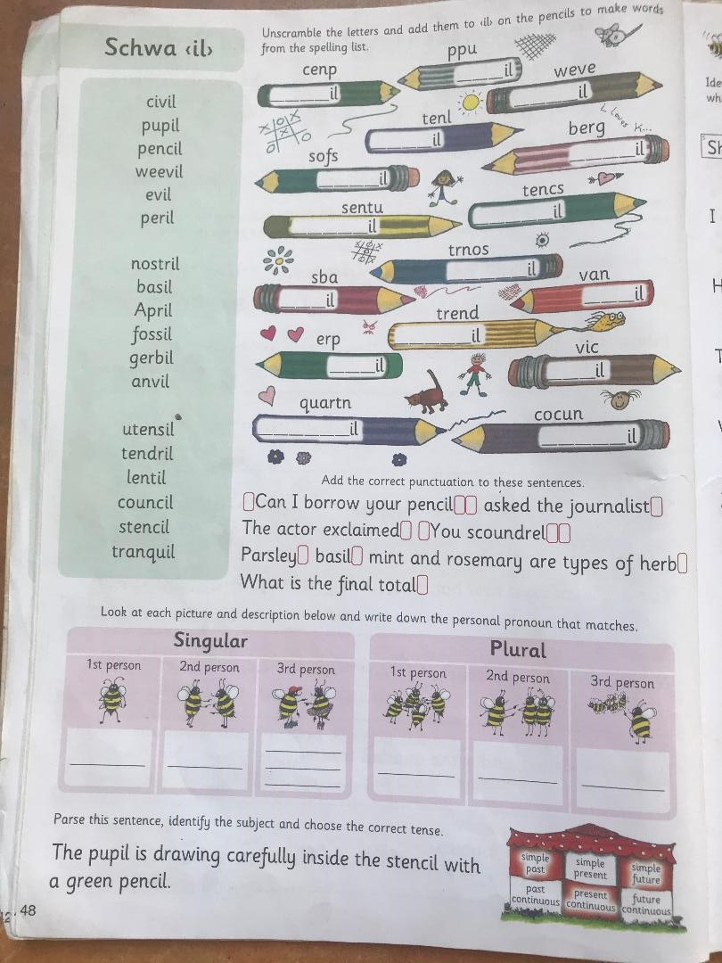
- Please read a chapter or two/or more in a novel. New Ross Library has books available online if you would like something other than what is available at home.
- If you can you can listen to David Walliams read online every day https://www.worldofdavidwalliams.com/elevenses/

Maths:
- Master your Maths: Week 27, P58 (Monday)
- We are moving on to Capacity this week – it’s Chapter 33 (beginning on P163) in your Busy at Maths book. You can find this page on the e book (if your parents managed to access it) or attached below.
Today please complete p163 in a maths copy if you have a spare one, or in your homework copy. Just remember to label your work and keep it neat so it is easy for you to locate questions when correcting.
Remember, there are 1,000ml in 1 litre. You can use a measuring jug and water to familiarise yourself with capacity measurements again.
Also don’t forget that 0.1= 1/10; 0.2= 2/10, 0.25=25/100, etc.
- Keep revising all tables. Perhaps test yourself if you can with a couple of online games such as Hit The Button or https://www.topmarks.co.uk/Search.aspx?q=tables
- Tables Champions: do Monday from the next week in Tables Champion

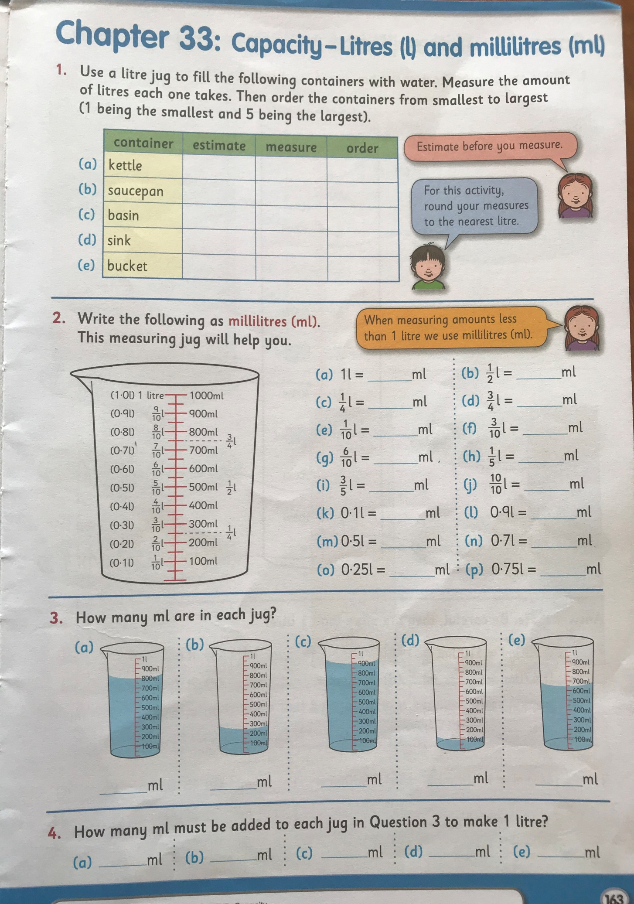
Gaeilge:
- Try use Gaeilge neamhfhoirmiúil (Informal Irish) or just a cúpla focail around the house.
- Fuaimeanna agus Focail, Aonad 23, P70 learn the first three words and do A and B in your copies (don’t forget to translate B)
- Léigh sa Bhaile, (available on cjfallon website once your parent has registered) p66 ‘Cóisir Chodlata’/ Sleepover party. Léigh an scéal agus freagair na céisteanna Q1, Q2 & Q3 (sa chóipleabhar).
- Use your dictionary to look up the meanings of any words you do not understand.
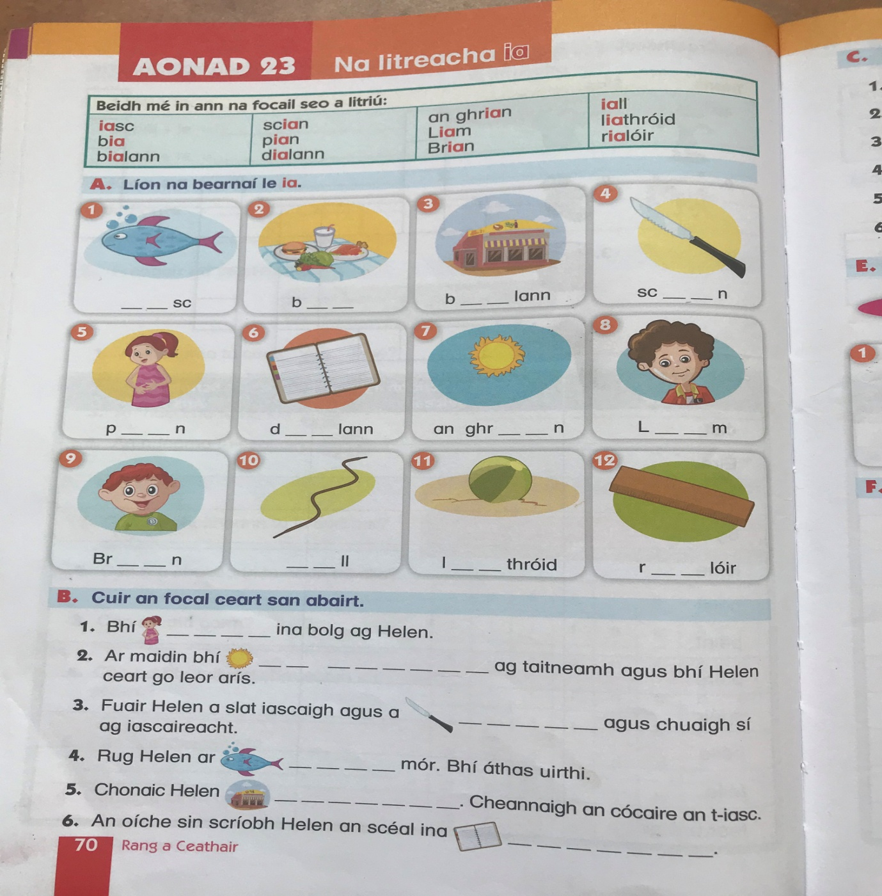

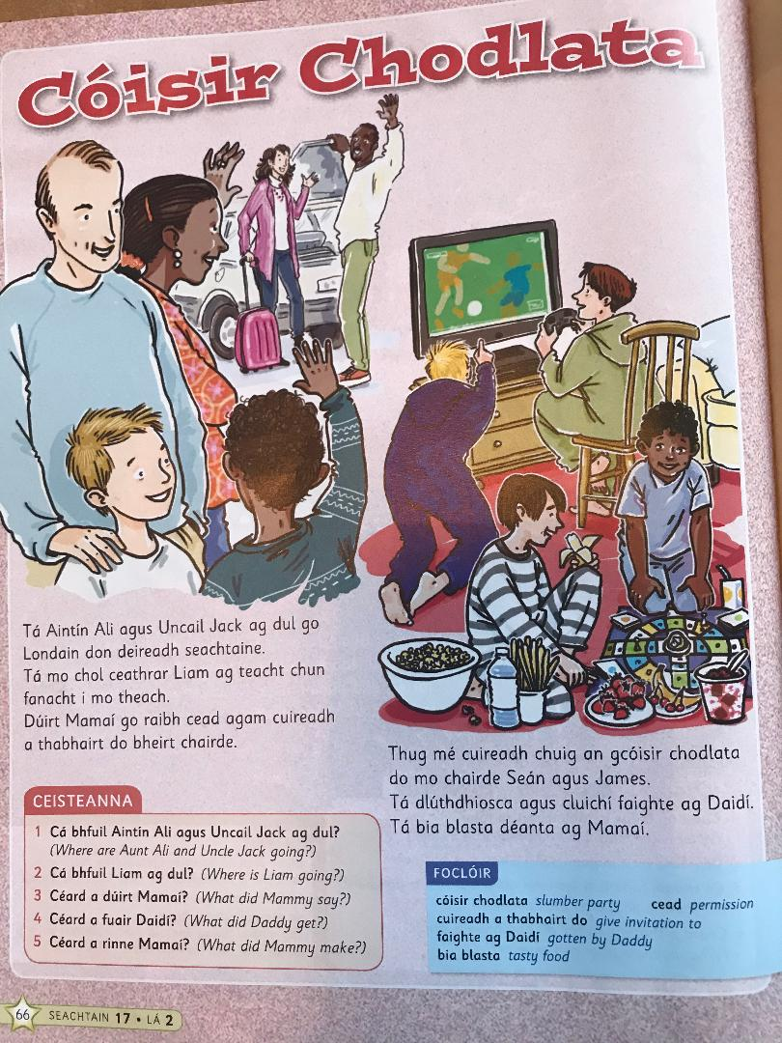

PE:
It’s important to be staying active even if you are just at home. If possible youtube ‘the body coach classroom workouts’ or google 10@10 or Go noodle. These are really good and you can exercise along to your favourite music too! Ensure you’re getting at least 60 minutes exercise each day. – if you don’t have access to the workouts – go for a walk or cycle, skip or play football in the garden.
SESE: Small world Geography & Science:
*Remember, this book is available for free on the CJFallon website once your parent/guardian has registered.
Unit 18: Materials and Change
- Read P105 & P106
- If possible carry out the experiment ‘investigate’ (orange box) on P106.
- Discuss and share your observations with someone at home: What did the cream look like when you put it in the container (was it a liquid/solid/gas)? Did you notice anything as you shook the container? When you take the lid off, have any changes occurred? Is there anything the same/different?
- Orally (you do not need to write) answer (A) and (B) on P106.

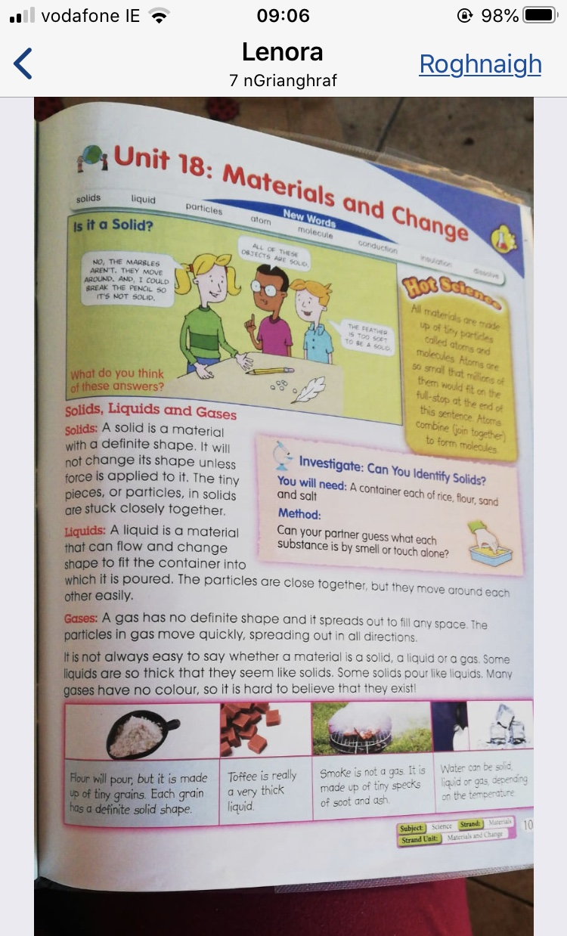
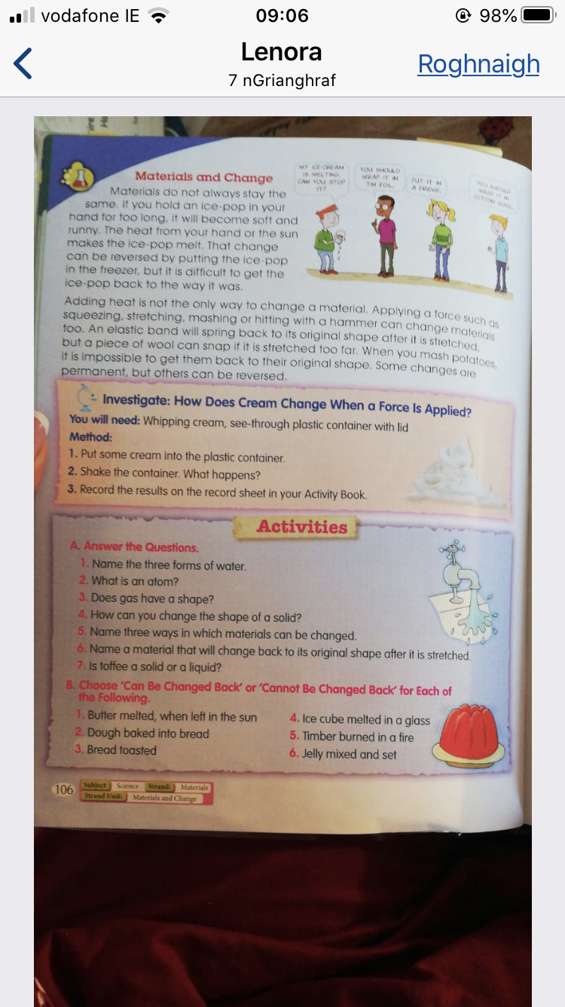

Tuesday 31st March:
English:
- Jolly grammar 4 learn second set of 6 words and put into sentences.
- Do all of Jolly Grammar grammar page p. 49
- Please read a chapter or two/or more in a novel. New Ross Library has books available online if you would like something other than what is available at home.
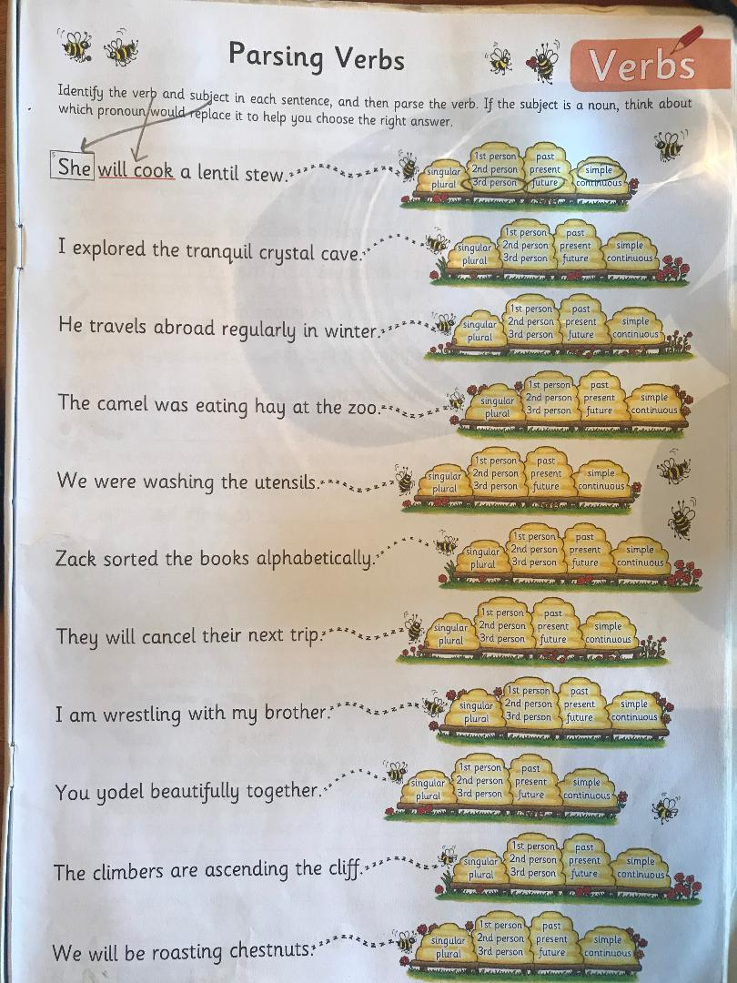

Maths:
- Master your Maths: Week 27, P58 (Tuesday)
- We are continuing to work on Capacity, Chapter 33 (p164) in your Busy At maths book. Today please complete p164 in a maths/homework copy (Q1,2 & 3). Remember to label your work and keep it neat so it is easy for you to locate questions when correcting.
Remember, there are 1,000ml in each litre. To find one tenth of a litre you divide by ten. To find three tenths of a litre you divide 1,000ml (1L) by ten then multiply by three (divide by the bottom and multiply by the top). Similarly to find 18 one hundredths you divide by 100 (the bottom) and multiply by 18 (the top). You can use a measuring jug and water to familiarise yourself with capacity measurements again.
- Keep revising all tables. Perhaps test yourself if you can with a couple of online games such as Hit The Button or https://www.topmarks.co.uk/Search.aspx?q=tables
- Tables Champions: do Tuesday from the next week in Tables Champion

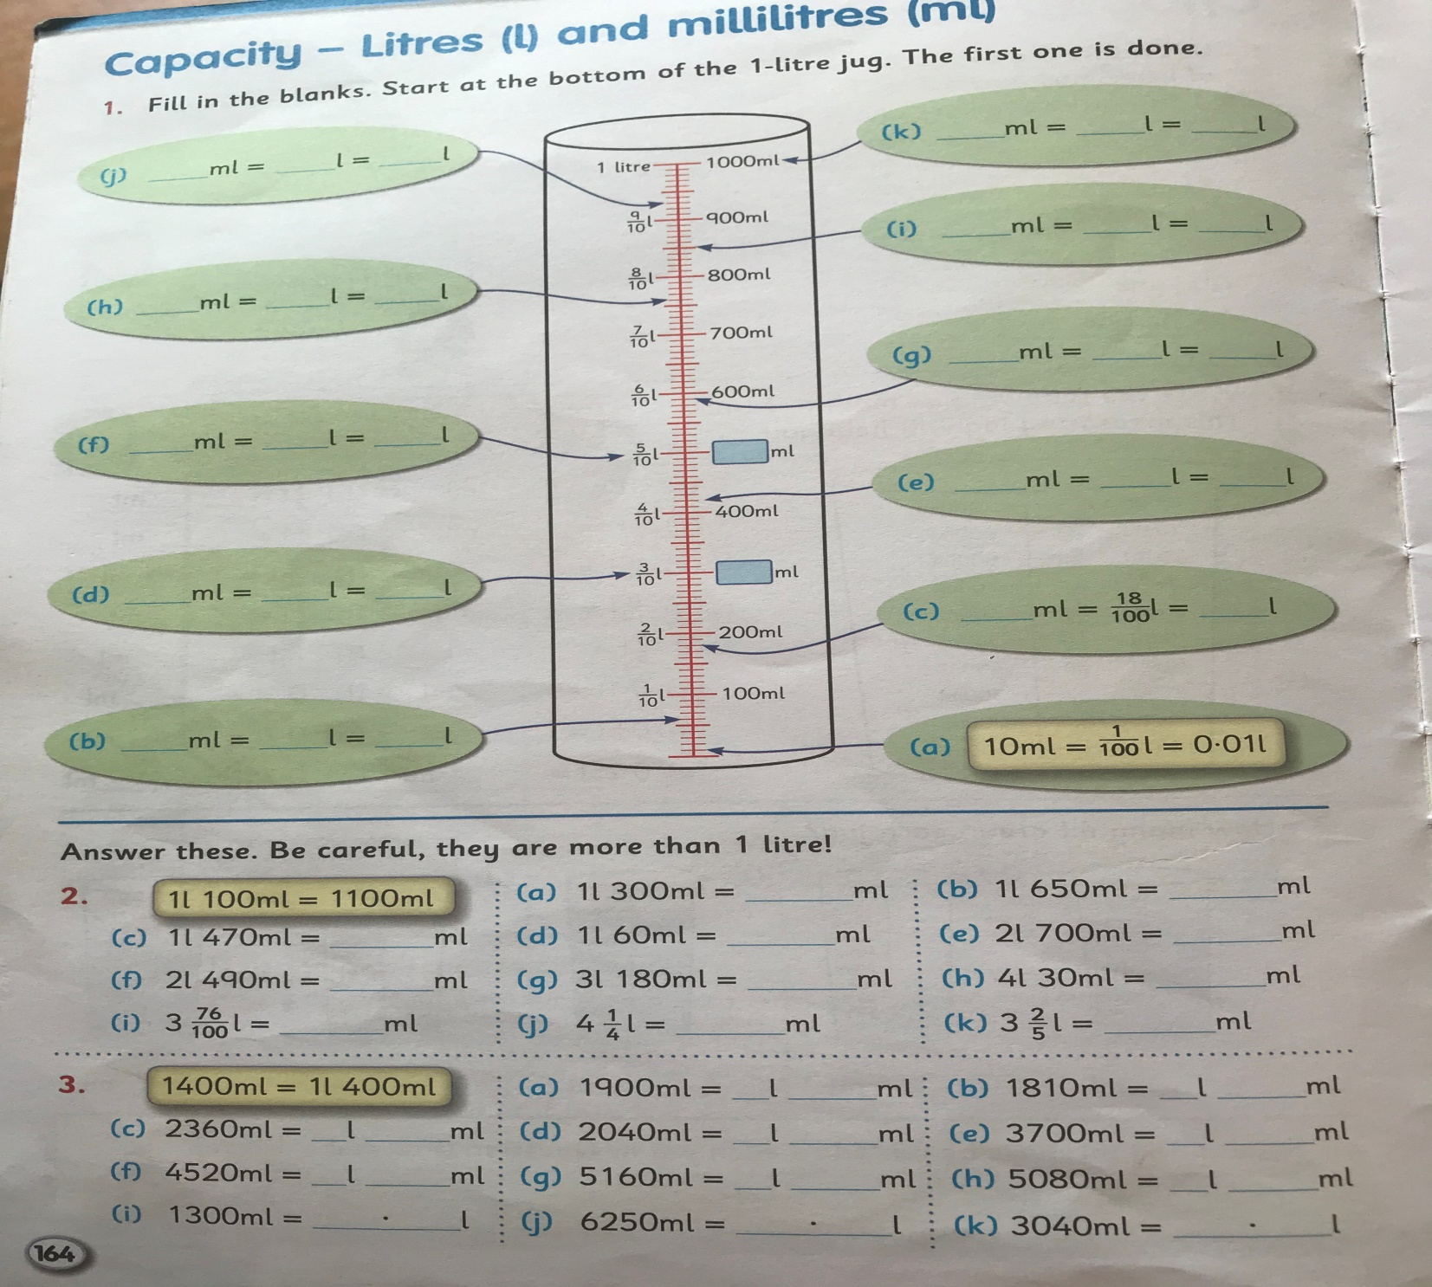
Gaeilge:
- Play feicim le mo shúilín (I spy) using items from around the house (as Gaeilge)
- Fuaimeanna agus Focail, Aonad 23, P71 learn the second three words and do C and D.
- Léigh sa Bhaile, p66 ‘Cóisir Chodlata’/ Sleepover party. Léigh an scéal arís agus freagair Q 4 & 5 (sa chóipleabhar).
- Use your dictionary to look up any words you don’t know the meaning of.
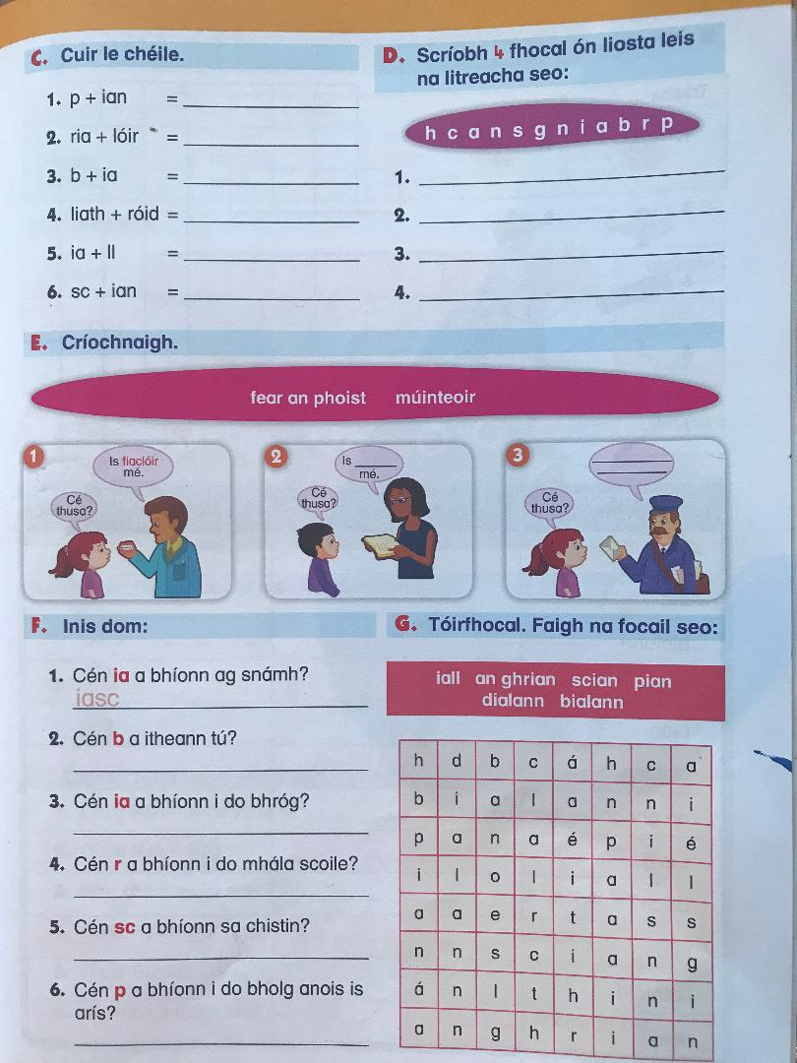
PE:
Do as you did yesterday, remember that you should try and get at least 60 minutes of physical exercise each day.
SESE: Small world Geography & Science:
*Remember, this book is available for free on the CJFallon website once your parent/guardian has registered.
Unit 18: Materials and Change (continued)
- Read P107
- If you can carry out the experiment ‘investigate’ (in the orange box) on p107.

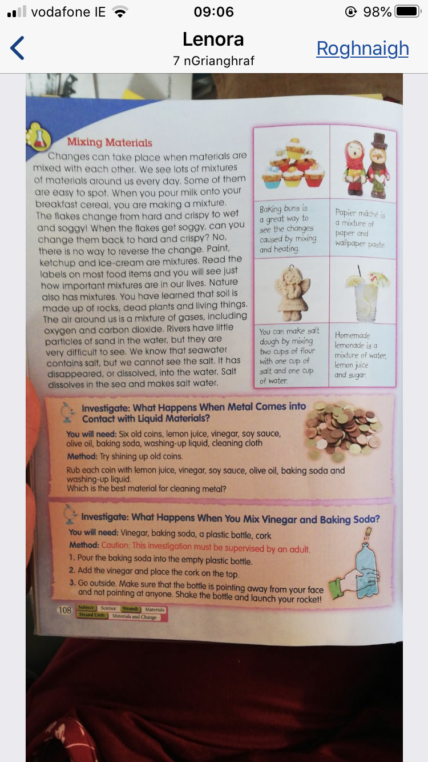

Music:
- Think of your favourite song right now, why is it your favourite?
- Listen to the song – sing along if you know the words
- What instruments can you hear?
- What is the tempo? (fast or slow)
- What are the dynamics? (Is it loud, or quiet? Does it change?)
- Draw an image for the music you heard- what do you think of?

Wednesday 1st April:
English:
- Jolly grammar 4 ‘1l’ learn third 6 words.
- Word Wizard (Unit 14) begin on P79
Today we will be working on comprehension strategies; prediction, visualizing and determination of importance. For (A) write a sentence or two explaining how you believe rainbows are formed, remember this is not a test it’s part of the learning process. Draw a picture of what you visualise when you think of a rainbow (B).
- Next I want you to read P80 aloud to someone. When you come across a word you feel is important to use when describing rainbows and how they are formed underline it.
- Finally, pick the most significant of the five words you have underlined and record them in the stars on P79 (C) and explain to the person who listened to you read, why you chose these are important/significant words.
- It would be lovely if you could talk to someone at home about times when you have seen a rainbow. When was it? Where was it? Who else was there? What colours did you see? Do rainbows remind you of a particular day or something in particular?
Maths:
- Master your Maths: Week 27, P59 (Wednesday)
- Capacity, Chapter 33 (p165) in your Busy at Maths book. (Q2. make the grid in your copy, Q3. Write out as follows; 720ml=72/100=0.72ml etc. and Q4. Please make out the grid as it is in the book and find at least two containers in your home which fall under each category).
If you would like to challenge yourself (I know you are all very capable), you can try the challenge at the end of the page
Remember, there are 1,000ml in each litre. You can use a measuring jug and water to familiarise yourself with capacity measurements again. Also remember 1/10(litre)= 100 ml and 1/100 (litre) = 10ml

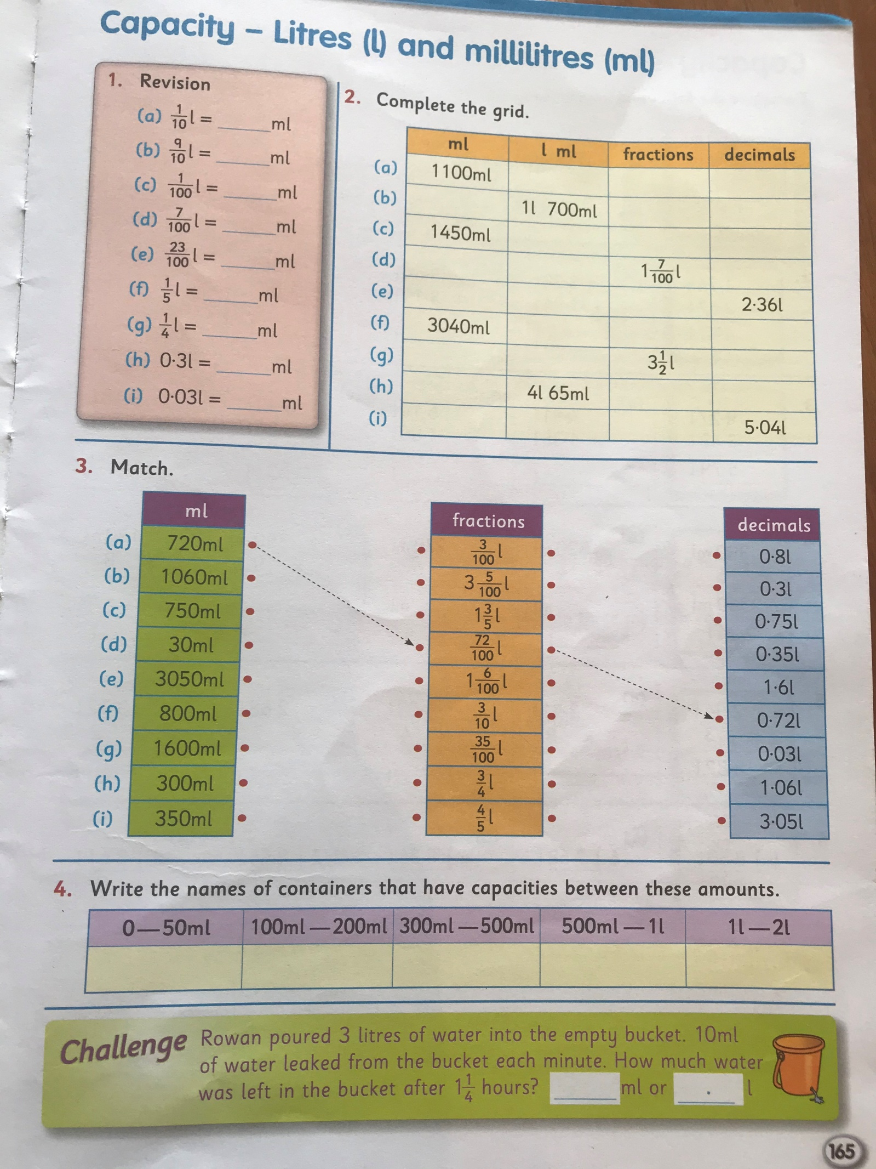
- Revision of all tables
- Tables Champion (Wednesday)
Gaeilge:
- Leadóg focal: pick a theme from the following (or make up your own) and see how many words/phrases you can list in 1 minute, try to beat your own time each day or play against someone else:
- Rudaí a bhíonn sa chistin
- Rudaí a bhíonn sa seomra suite
- Éadaí
- Bia
- Glasraí
- Torthaí
- Dathanna
- Spórt
- Fuaimeanna agus Focail, Aonad 23, P71 learn the third three words and do E and F sa chóipleabhar and don’t forget to translate F
- Léigh sa Bhaile, (available on cjfallon website once your parent/guardian has registered) p71 ‘Ag Obair sa Ghairdín’ (working in the garden). Léigh an scéal agus freagair na céisteanna Q1, Q2 & Q3 (sa cóipleabhar).
- Use your dictionary to look up any words you don’t know the meaning of.
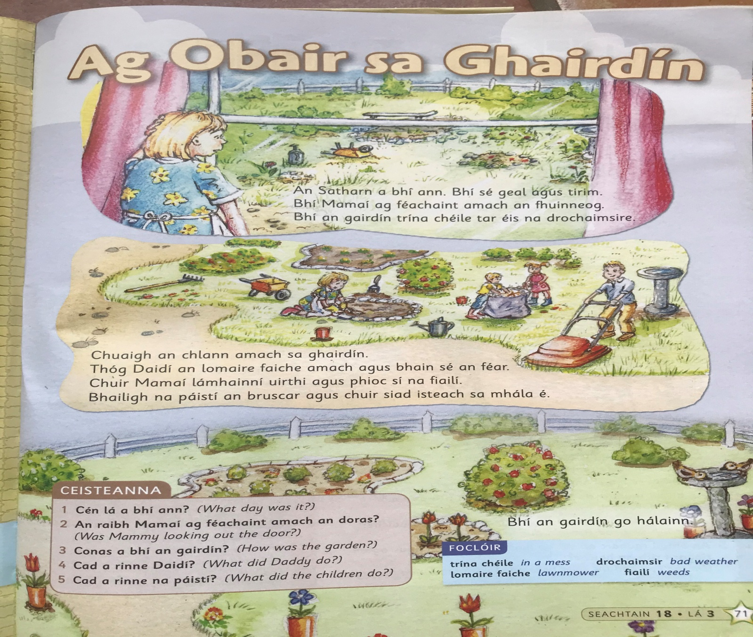

PE:
60 minutes at least of an activity you enjoy!
SESE
Try your own materials and change experiment.
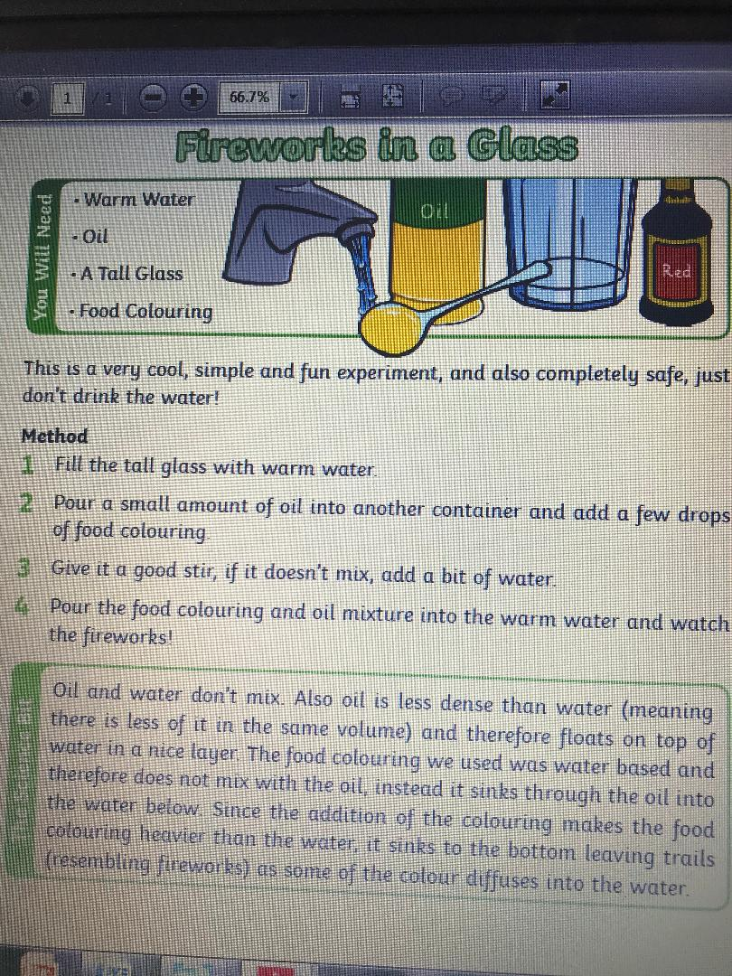

Thursday 2nd April:
SPHE
Try some mindfulness to get that mind to ‘Flower Level’ this can be especially hard with the ongoing social isolation situation we are all in. Try using https://www.youtube.com/watch?v=neqwDPmn6yY to help you. Indeed try to do this every day or several times a day, especially if you feel your mind is at ‘Busy Bee’ level.

English:
- Jolly grammar revise ALL spellings
- Word Wizard P80 and p81. Re-read page 80 and then do p 81: A and B in your copies (just answers) and C and D can be done in your books.
- Please read a chapter or two/or more in a novel. New Ross Library has books available online if you would like something other than what is available at home.
Maths:
- Master your Maths: Week 27 P59 (Thursday)
- Capacity, Chapter 33 (p166) Busy at maths book. Remember to label your work and keep it neat so it is easy for you to locate questions when correcting. Be careful of where you put the decimal point.
If you would like to challenge yourself attempt some of the challenges at the end of the page
Remember, there are 1,000ml in each litre. When representing litres and millilitres as a decimal be careful where you put the decimal point and use litres (L) rather than millilitres (L), example 1320ml = 1L 320ml or 1.320L = 1.32L.
- Tables Champions (Thursday)
- Revise all tables
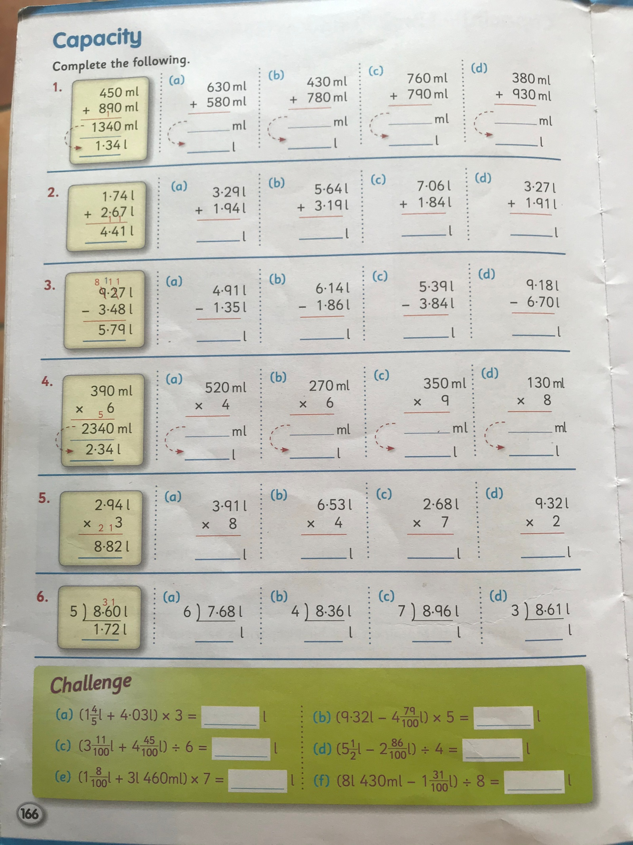

Gaeilge:
- Fuaimeanna agus Focail, Aonad 23 learn the last three words and revise all for Friday test.
- Léigh sa Bhaile, p71 ‘Ag Obair sa Ghairdín’ Léigh an scéal agus freagair na céisteanna Q4 and Q5 (sa cóipleabhar).

PE:
It’s important to be staying active even if you are just at home. If possible register for GoNoodle and choose from a variety of activities from dance/athletics etc. Ensure you’re getting at least 60 minutes exercise each day – if you don’t have access to the workouts – go for a walk or cycle, play football in the garden, use the trampoline.

SESE
Look up/think about a famous landmark e.g. Big Ben, Eiffel Tower, Statue of Liberty etc and design and build it using any materials you have around the house e.g. play-doh, lego, cardboard etc. If you like you can take a picture and send it to me by e mail.

Friday 3rd April: The holidays are near!!
English:
- Spellings: Ask an adult to call out spellings and do your best to spell it, treat the spelling test as you would as if you were in school and do the test in your text copy. When finished you can swap your copy for the book the adult is holding calling the words out for them to correct for you. Best of luck, remember, both your parents and I are always happy with your honest best effort
- Word Wizard (Unit 14) p. 82 in your copy
- Please do some reading of your choice. Perhaps a family member would enjoy listening to you reading from a novel/storybook/newspaper/internet article.
Maths:
- Master your Maths: Week 27, P92 (Friday test)
- Capacity, Chapter 33 (p167) in your Busy at maths book.
Today: p167 in a maths copy Q1, Q2, Q3, Q4
If you would like to challenge yourself attempt some of the challenges at the end of the page
Remember, there are 1,000ml in each litre therefore 330ml = 0.33L or 0.330L, 1.1L = 1L & 0.1L 100ml therefore 1.1L = 1100ml etc.
3.Challenge yourself by playing Hit The Button and try to beat your own score.
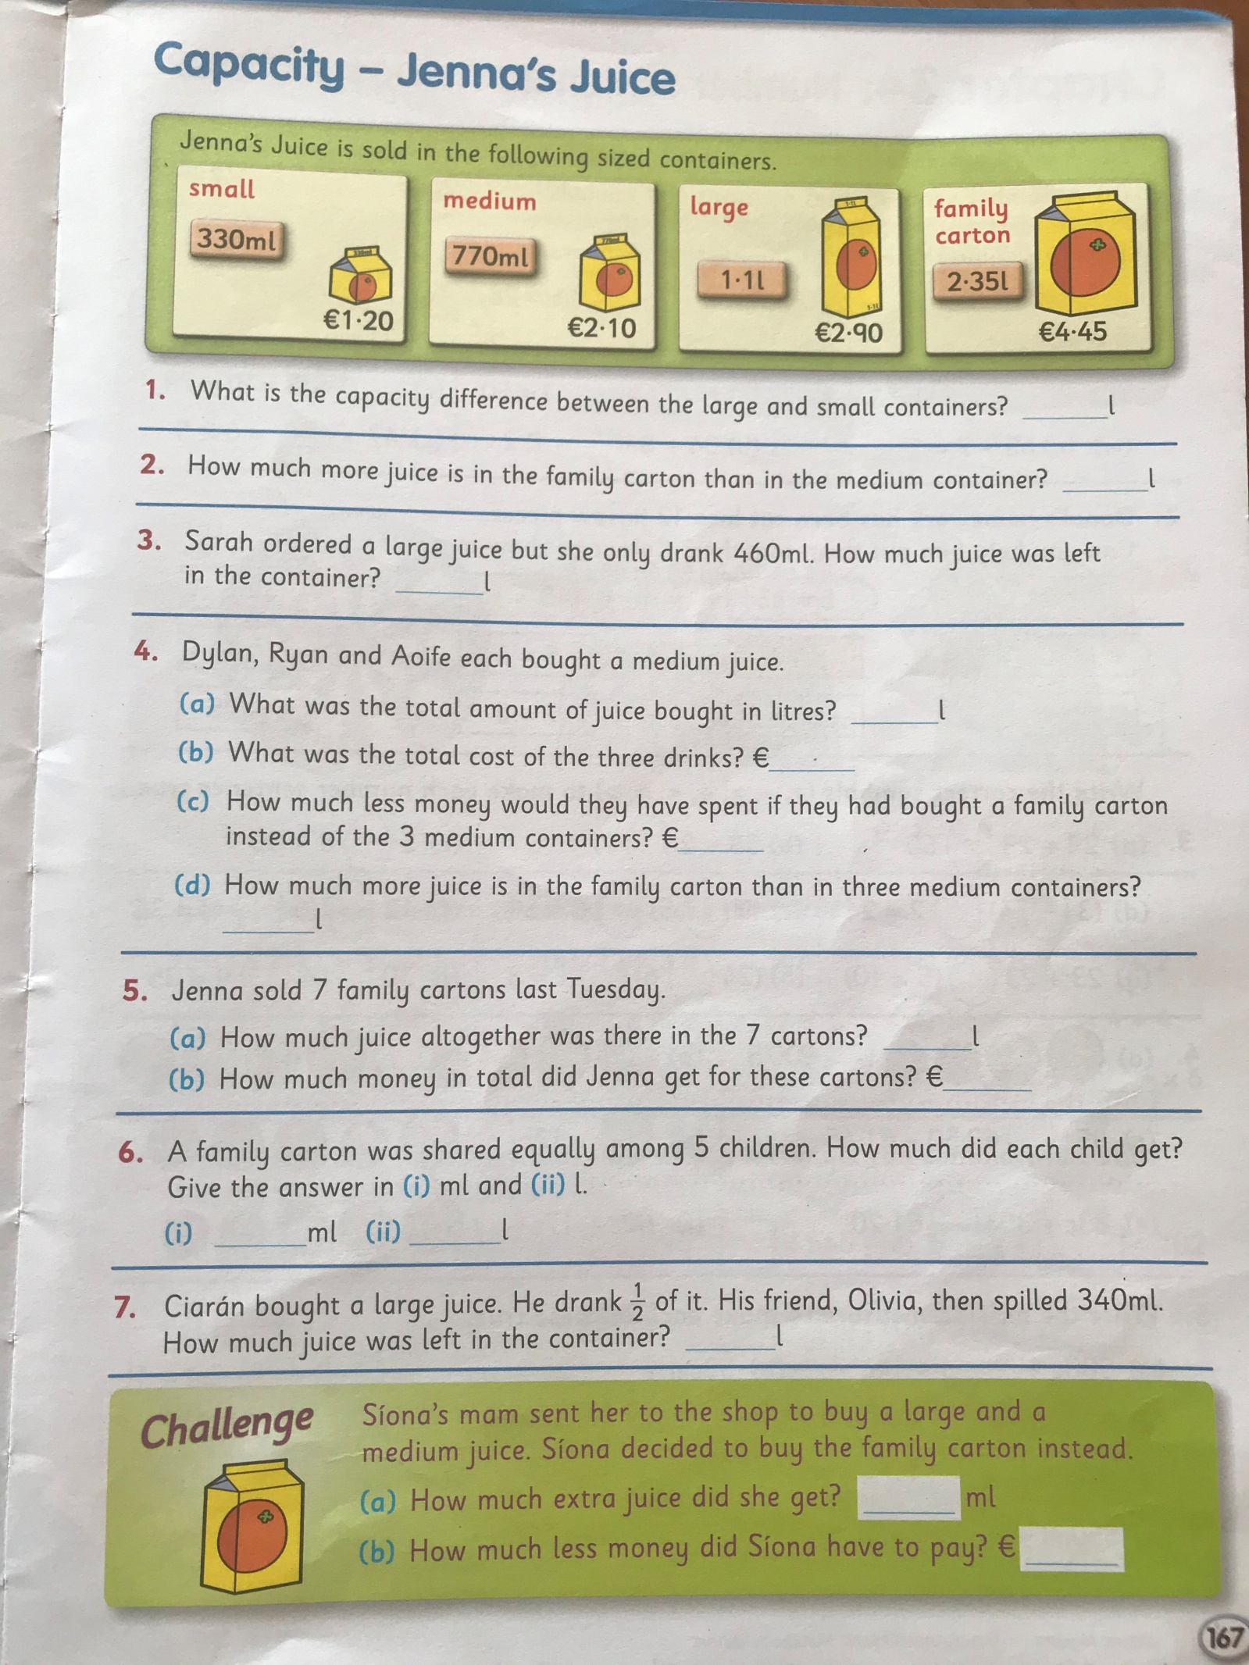

Gaeilge:
- Ask an adult to call out the words as Gaeilge for your spelling test, don’t forget to write the English beside the word. Next swap your test copy for the book and call out the words and spellings for someone else to correct, remember, just do your honest best.
- Léigh sa Bhaile, (available on cjfallon website once your parent/guardian has registered). Once your parent/guardian has emailed me at horeswoodfourthclassmsodwyer@gmail.com I can send out the answers for the comprehensions ‘Cóisir Chodalta’ agus ‘Ag Obair sa Ghairdín’ on Friday morning so you can correct your work. If you do not understand the answers you can look words up in your dictionary. Dictionary work is really important as it’s a skill you use and will continue to use throughout future studies and life.
PE:
At least 60 minutes of something you enjoy.
SESE: Small world Geography & Science:
Unit 18: Materials and Change
This week we have been studying how change can occur i.e.: a substance can take many forms based on conditions, for example water (a liquid) can change to a vapour ‘steam’ when heated or can change to a solid ‘ice’ when cooled/frozen. OR when an acid such as lemon juice is added to the surface of a dirt coin can be cleaned.
- Discuss
Can you think of anything else which can change its form when a change occurs/is applied?
- If it is convenient for your parent/guardian to supervise you and you have permission to use cupboard contents you may like to plan and prepare a dish/cake/buns? While doing this notice how ingredients change when mixed and heated.
- If baking and using bicarbonate of soda/self-raising flour/baking powder why do you think these ingredients are needed? Hypothesize, what would happen if you left one of these special ingredients out? How do you think they work? When you have finished you can google to check your reasoning.

SPHE: Healthy eating – try not eat too many Easter eggs Happy Easter!
ART: Do some virtual tours of art galleries:
https://www.theguardian.com/travel/2020/mar/23/10-of-the-worlds-best-virtual-museum-and-art-gallery-tours

https://www.mentalfloss.com/article/75809/12-world-class-museums-you-can-visit-online

