Please see the notes at the bottom of the table about accessing the Seesaw app to correct and submit work. Thank you.
Dates | Maths Activities  See notes below | Tables Champion | Gaeilge  See notes below | Jolly Grammar | Handwriting | English Reading | SESE & Art
Mon  30/03/20 | - MyM Wk. 25 -Mon  - Maths activity 1: | TC WK 24 - Mon | F&F pg. 52  - Activity A & B  - 1 sentence in copy | JG pg. 52  - Activities in the book pg. 52  - 2 words into sentences | Page 40 | Feena’s book of facts (FBOF)  Page 30 & 31  & your own books | SESE Theme: Water  These can be done through the week. We won’t assign any day to them because the science might be nice to do with siblings or as a family experiment. See notes at the bottom.  History – fact files about John Barry and John Philip Holland.  Science – Sinking and floating activities  Geography – Water conservation
Tues  31/03/20 | - MyM Wk. 25 – Tues  - Maths act. 2 | TC WK 24 - Tues | F&F pg. 52  - Activity C&D  - 1 sentence | JG pg. 52  - Next 2 words into sentences | Page 41  Don’t forget to fill in the assessment at the bottom | FBOF Page 32  & your own books
Wed  01/04/20 | - MyM Wk. 25 – Wed  - Maths act. 3 | TC WK 24 - Wed | F&F pg. 52  - Activity E&F  - 1 sentence | JG pg. 52  - Next 2 words into sentences | Page 42 | FBOF Page 33  & your own books
Thurs  02/04/20 | - MyM Wk. 25- Thurs  - Maths act. 4 | TC WK 24 - Thur | F&F pg. 52  - Activity G&H  - 1 sentence | JG pg. 52  - Next 2 words into sentences | Page 43  Don’t forget to fill in the assessment at the bottom | FBOF Page 26 & 27  & your own books
Fri  03/04/20 | - MyM Wk. 25 – Friday test | TC Check 2 & 3 (some of you may have these done ) |  | JG pg. 52  - Last 2 words into sentences | Page 44  Don’t forget to match the capital letter to the small letter | FBOF Page 28 & 29  & your own books | Art:  Design and make a poster to show how important social and physical distancing is.  Stick it up in your home to help you remember. Take a picture and send it to me.
Notes:
Online Learning App - Seesaw | I have set up an online account for our class on an app called Seesaw.  I’d like to use this tool for reviewing and correcting work, explanations of some work using voice memos or videos and also communication with 2nd class. There is no requirement to upload all work done – I might choose one or two pieces of work to send photos of or comment on or maybe read out in a voice memo super sentences etc. Just like in the classroom. Only I will hear and see the work though – not like the classroom.  To access the online app each child will have a unique password. I will e-mail you this code and instructions on how to get into the system. It is very easy and simple for the children to use. Please send me an e-mail to horeswood2ndclass@gmail.com and I can arrange this. If you have contacted this e-mail address already there is no need to re-send an e-mail. Many thanks.  If you have any questions or queries regarding the assigned school work I will be online Monday to Friday 11:00 a.m. to 1:00p.m. at this address also.
Religion | Please make sure you know all of the following prayers for the First Penance (all on page 64 of Grow in Love) – Act of Sorrow, Prayer for forgiveness, Prayer after forgiveness, Confiteor (Penitential Act A).  The children also got their lines for the drama or readings or hymns for the First Penance. Please go over these during the school closure.
PE | Outdoor adventures as much as you can. Remember to keep a safe distance from other people when you are doing your activities.
Gaeilge | Each day write one sentence in your homework copy using one of the words. Try your best. Remember your verbs from the classroom.  Bhí mé – I was, Chuir mé – I put, Chuaigh mé – I went. Cheannaigh mé – I bought.  Aonad 25  Cócó - cocoa Rópa - rope Lón - lunch Brón – sad  Dó – two Nóra - Nóra Tósta - toast Bóthar - road
Maths | Tables | Don’t forget to practice your tables. You can log into Xtramath.org at home. I will send you any codes that you might be missing. Or use some of the online games below – like the balloon challenge. Or challenge your family to a game of shotgun!
 | Maths Activities | Please do these in your homework copy or print out the sheet and complete it.  Write the date, question number and all the numbers in your copy so we will be able to correct them easily.  e.g. Activity 1: question 1  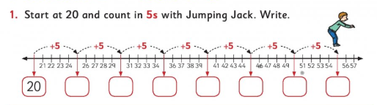  In your copy your answer would look like:  30/03/2020  Q1 - 20, 25, 30, 35, 40, 45, 50, 55  You can google a 100 square to help you if you need to or draw out your own – I don’t think you’ll need to though.  Maths Activity 1 – 30/03/2020 Maths activity 2: 31/03/2020  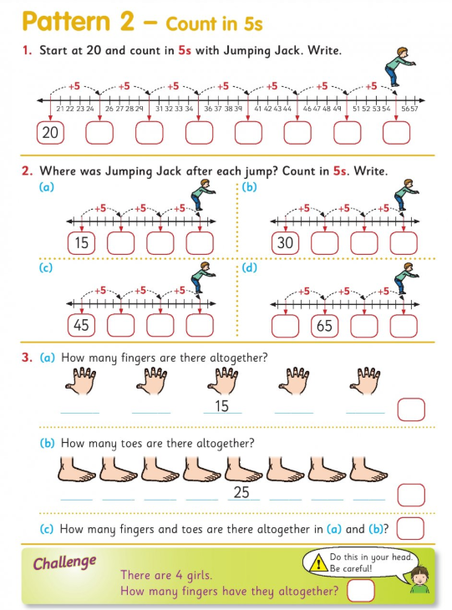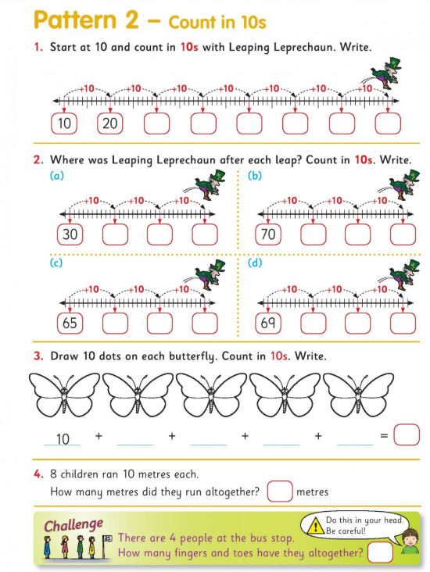  Maths activity 2: 31/03/2020 Maths activity 2: 31/03/2020  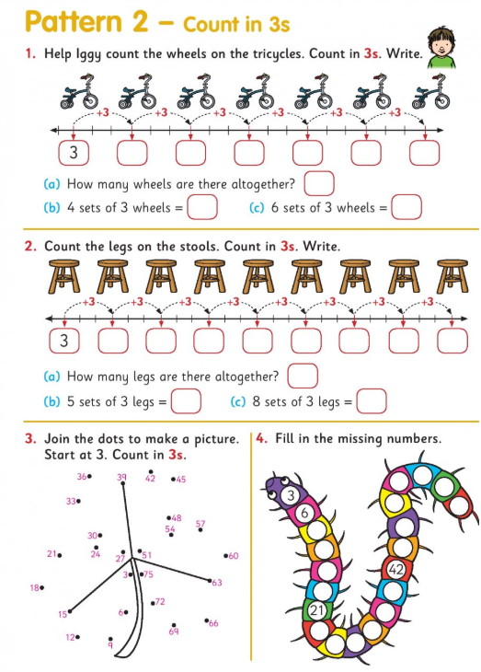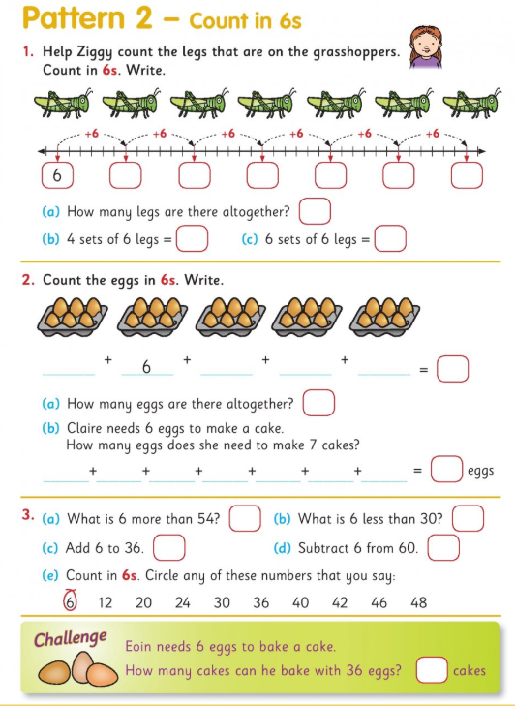
SESE | Theme: Water  History: John Barry & John Philip Holland  - Read the text below from your Small World book pg. 41.  - Read activity A aloud to a sibling or parent and tell them what the correct answer should be.  - Read more information about John Philip Holland on this link www.askaboutireland.ie/learning-zone/primary-students/5th-+-6th-class/5th-+-6th-class-environme/sea-time-story/famous-irish-mariners/john-philip-holland/index.xml  or google search ‘Ask about Ireland John Philip Holland’ will bring you to the same page.  - Let’s see what you learnt about John Philip Holland. Like the example below, please write down 3 new facts you learned. Then 2 things you found really interesting, and lastly one question that you still have about John Philip Holland. You can draw it out like the table below or you can just use the headings in your copy. When you are up and running with your seesaw app, you can take a picture of the page and upload it.  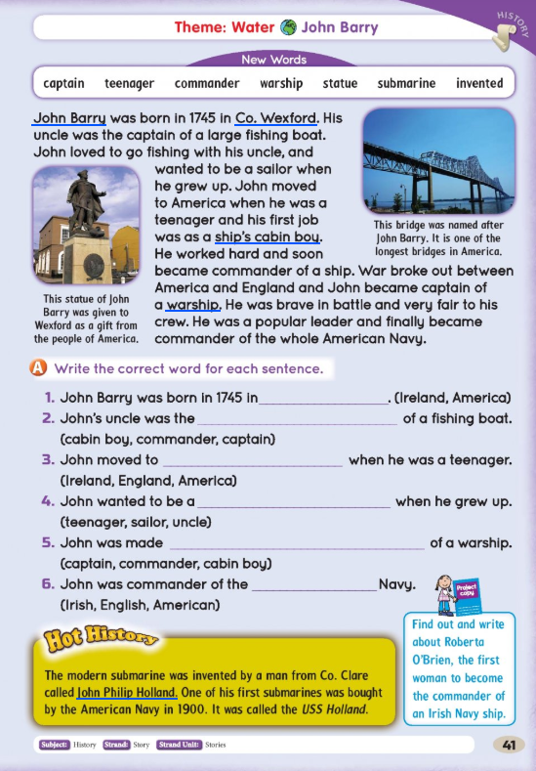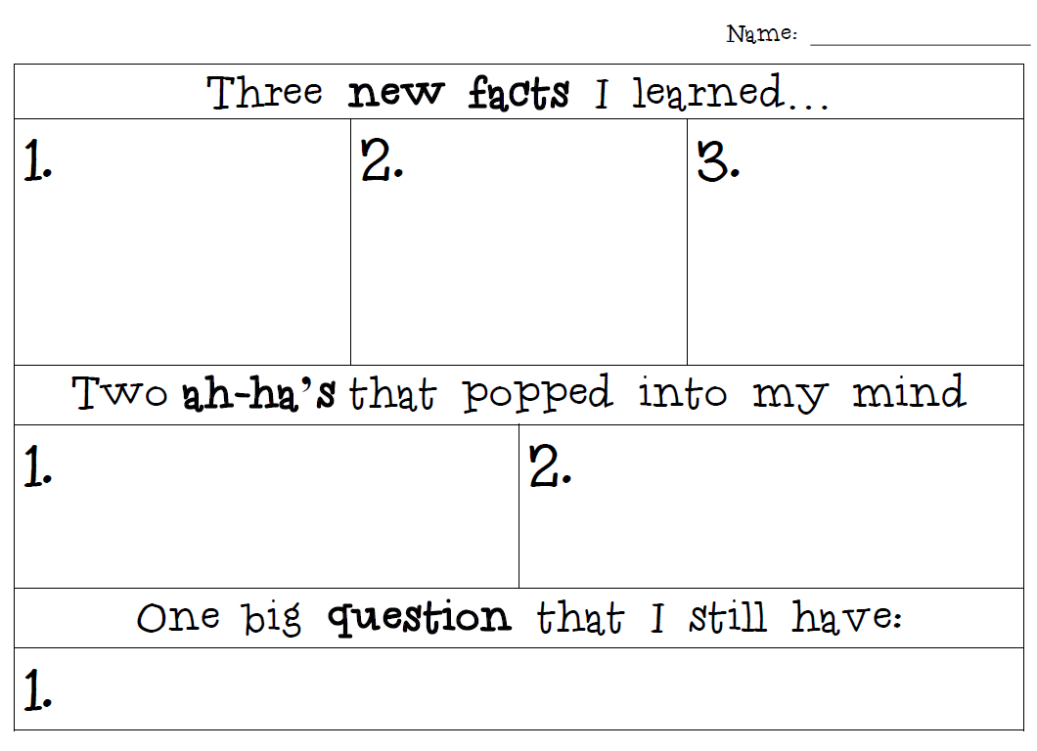  Science – Sinking and Floating  - Starting point is to watch this YouTube video ‘Thinking about sinking and floating: density’ by Caitlin Webb https://www.youtube.com/watch?v=dcQR6vV1Sqo  - Try the below experiment. Don’t worry if you do not have an orange or a banana. What else could you try with?  If you have access to the Seesaw app, I would like to see your photos and a recording of the answers to the questions below.  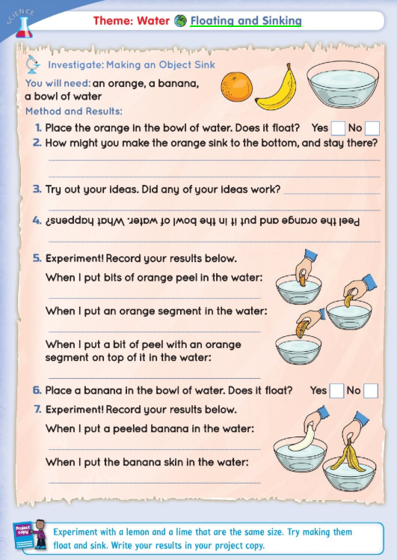  Science: Floating and Sinking Part 2  - To start, there is a great game on this website (you need to have flash player to allow it to work). It is a little complicated, but make sure to read the instructions carefully and you will be well able!  http://resources.hwb.wales.gov.uk/VTC/Phase2delivery/Wales/Science/Keystage2/Materialsandthe/Floatingandsink/Introduction/activitypop.htm  - Then try the experiment below from your Small World book. Some of these things you may not have in your house. What could you use instead? If you have access to the Seesaw app, I would like to see your photos and a recording of the answers to the questions below.  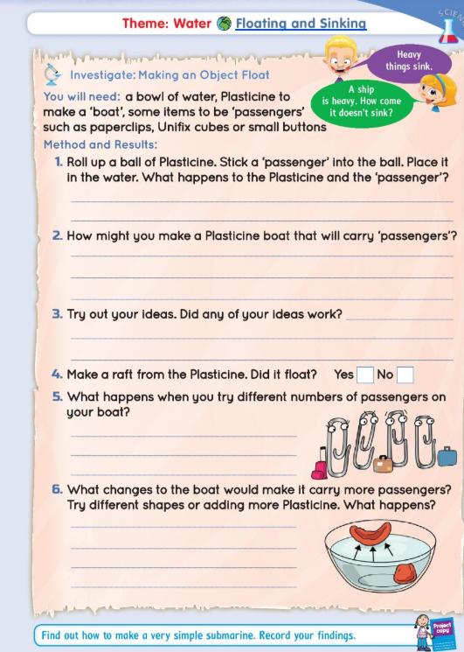  Geography: Water Conservation  - Especially now when we are all washing our hands so much, we need to think not wasting water. To start with there are some great ideas on how to conserve water on this website https://wateruseitwisely.com/kids/  - Then look at the pages from your Small World book. In your copy can you write down the estimates you think. Remember a litre is like a carton of 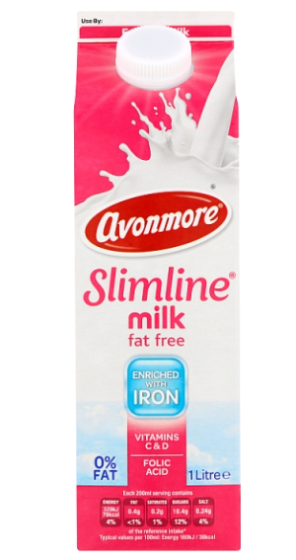. I’ll read out the answers on the Seesaw app and you can check your estimates. For the second page you can draw the picture in your copy and circle the ways to say water.  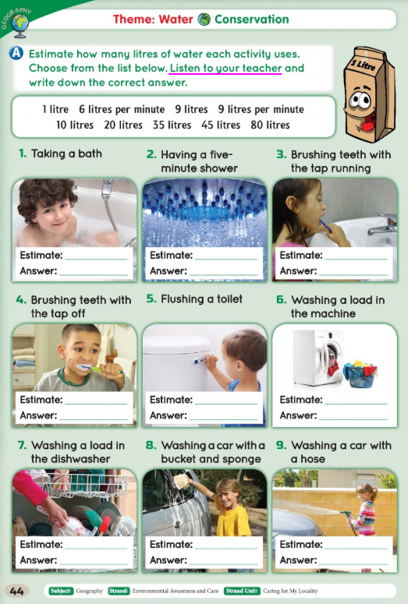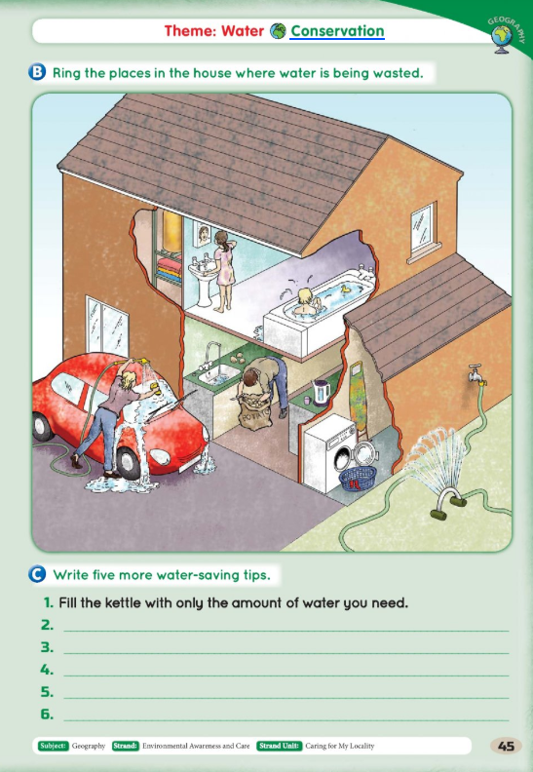
Useful websites:

IXL – https://ie.ixl.com/math/class-2 Great for practicing maths activities
Topmarks – https://www.topmarks.co.uk/maths-games/daily10
Hit the button - https://www.topmarks.co.uk/maths-games/hit-the-button
Balloon pop - https://www.theschoolhub.ie/sample.php
Mathletics: https://www.mathletics.com/uk/for-home/ Free home trial for maths

eBook library: https://www.oxfordowl.co.uk/for-home/find-a-book/library-page/
BorrowBox app – free resource from the library. Use the barcode from the back of your library card to log in. You can access eBooks and also audio books. Super resource for children and adults at this time!

Twinkl – A really useful website with lots of resources for free that they have make accessible to everyone at this time. Use the code IRLTWINKLHELPS to get free access to all resources for a month. Would be helpful for the engineer and scientist facts above or the ocean animal project.

Art PowerPoints – step by step instructions: www.mrsbrown.art/drive
LEGO Stamping: https://frugalfun4boys.com/lego-stamping-its-art-with-bricks/

Lightbot - https://lightbot.com/hour-of-code.html Coding website

Duolingo – www.duolingo.com or as a free app on the phone. Great opportunity to practice Gaeilge in a fun, interactive way.
Cula: www.cula4.com/en/

GoNoodle: www.gonoodle.com
Yoga: https://www.youtube.com/user/CosmicKidsYoga

