Dates | Maths Activities  - See notes | Tables Champion | Gaeilge  - See notes | Jolly Grammar | Matilda  -see notes | Movement Breaks | Other Subjects
Mon  30/03/20 | - MyM Wk. 26 - Tues  - Maths Activity 1 | TC WK 14 –  Mon | Chas (turned)  Chroch (hung)  Chrίochnaigh (finished) | JG pg. 52  - First 3 words into sentences  - Activity 1 pg 52 | Pg 153 - 156 | Just Dance (YouTube)  1hr outdoors | Religion (see notes)  SESE Project.  - Read about the Rose Fitzgerald Kennedy Bridge on www.visitnewross.ie/community/22523/everything-you-need-to-know-about-the-new-ross-bypass-bridge  - write down 10 interesting facts about our new local bridge.  - Using recycled material and material from nature build a replica bridge outside.  - Take a picture of your bridge and email it to  horeswoodsecondandthird@gmail.com  SPHE: Design a poster promoting social and physical distancing. Stick it up somewhere in your home to remind everyone. Take a picture and email it to me.
Tues  31/03/20 | - MyM Wk. 26 - Weds  - Maths Activity 2 | TC WK 14– Tues | Ghlan (cleaned)  Las (lit)  Léim (jumped) | JG pg. 52  - Next 3 words into a sentence in copy  - Activity 2 pg 52 | Pg 157 - 160 | Cosmic Kids Yoga (YouTube)  1 hr outdoors
Wed  01/04/20 | - MyM Wk. 26 – Thur  - Maths Activity 3 | TC WK 14 - Weds | Bhuail (hit)  Phioc (picked)  Phreab (bounced) | JG pg. 52  - Next 2 words into sentences  - Activities 3 + 4 pg 52 | Pg 161 – 163  Task 1 | Try a Go Noodle activity  1 hr outdoors
Thurs  02/04/20 | - MyM Wk. 26 – Fri  - Maths Activity 4 | TC WK 14 –  Thurs | Rith (ran)  Scuab (swept)  Sheas (stood) | JG pg. 52  - Next 2 words into sentences  - pg 53 | Pg 164 - 166 | RTE jr. 10@10  1 hr outdoors
Fri  03/04/20 | - Maths Activity 5 | TC Check Up pg 21 A + B | Shiúil (walked)  Shroich (reached)  Thit (fell)  - Ask a parent or sibling to test your spellings. | JG pg. 52  - Ask a parent or sibling to test your spellings. | Pg 167 – 170  Task 2 | Just Dance (YouTube)  1 hr outdoors
Notes:
Religion | Please make sure you know all of the following prayers for the First Penance (all on page 50 + 51 My First Holy Communion and Penance) – Act of Sorrow, Prayer for forgiveness, Prayer after forgiveness, Confiteor.  Lines for the drama or readings or hymns for the First Penance. Please go over these during the school closure.  Complete pgs 16 + 17 in My First Holy Communion and Penance
Maths | Maths Activities | Please do these in your homework copy or print out the sheet and complete it. If you are finding some of the activities tricky try using R.U.D.E.  Activity 1: 30/03/2020  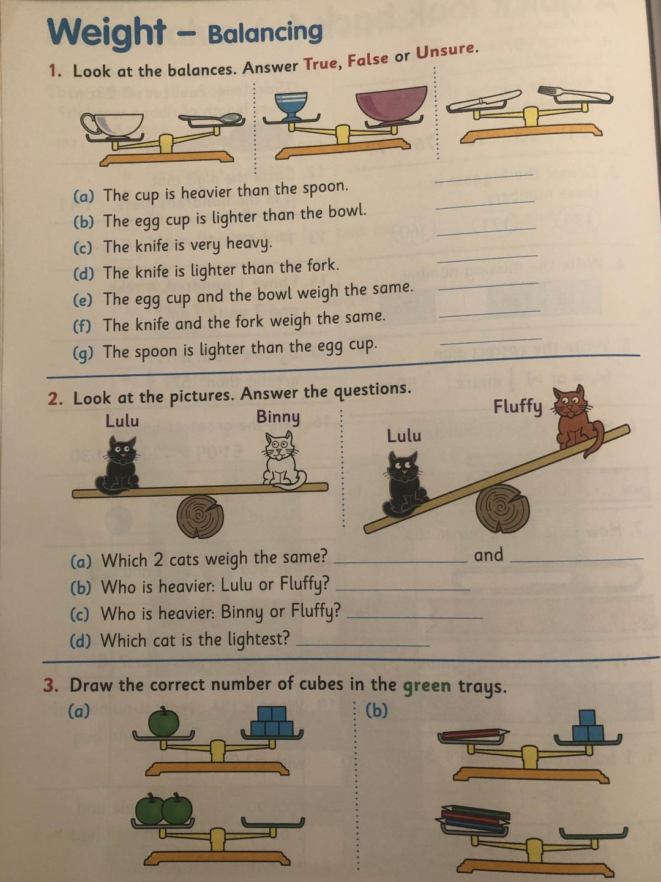  Activity 2: 31/03/2020  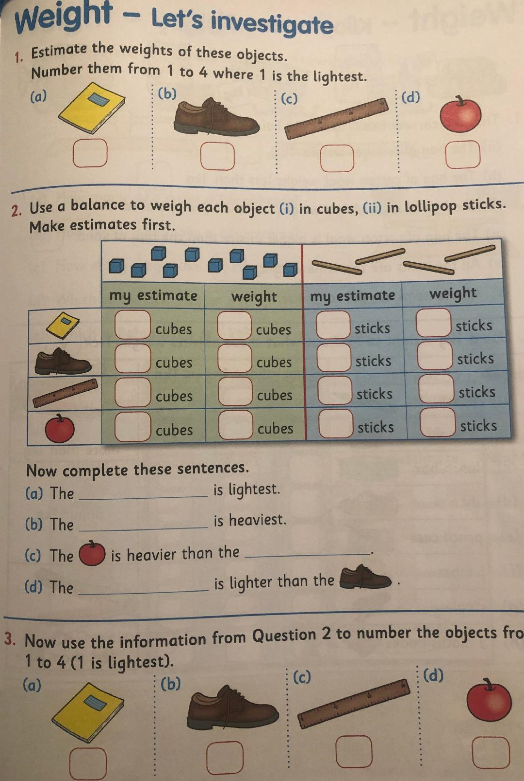  Activity 3: 01/04/2020  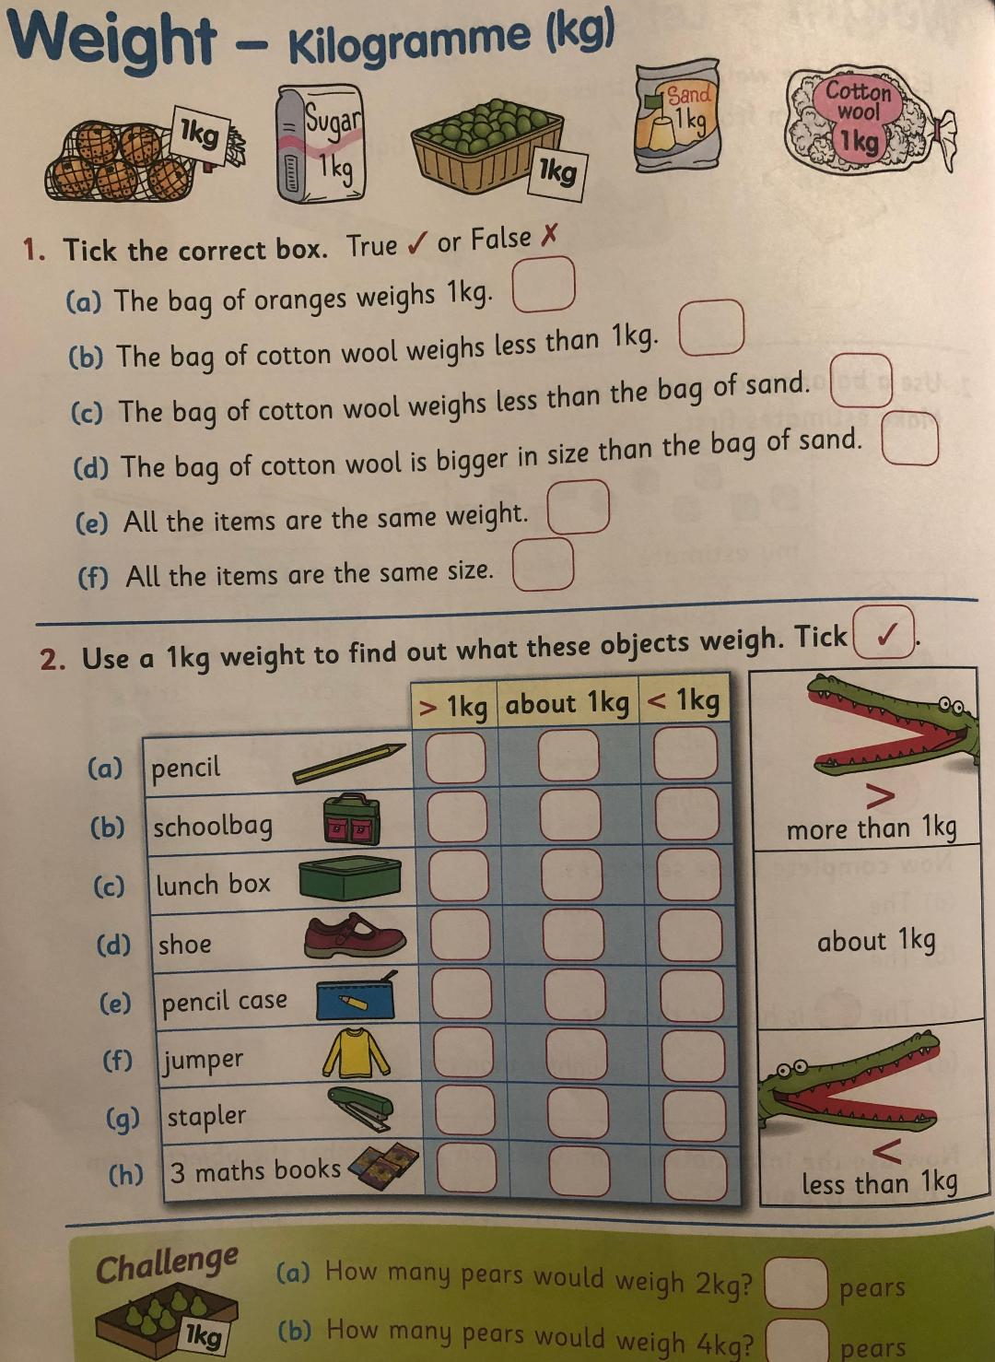  Activity 4: 02/04/2020  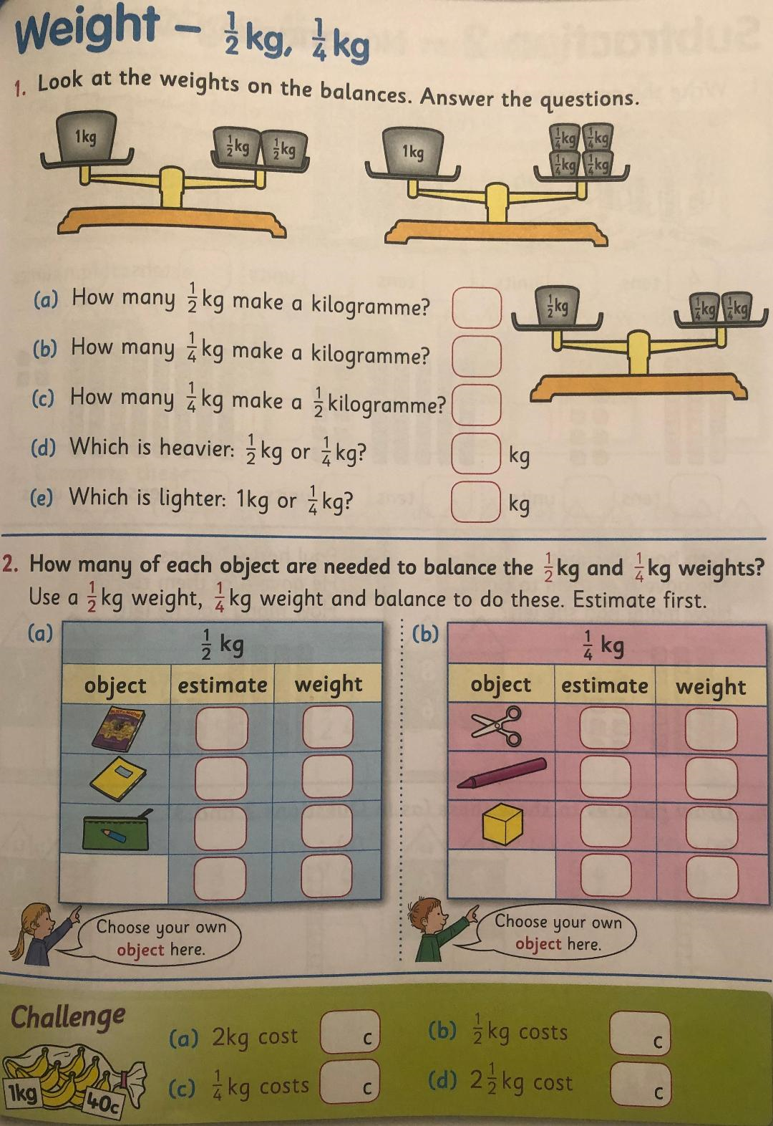  Activity 5: 03/04/2020  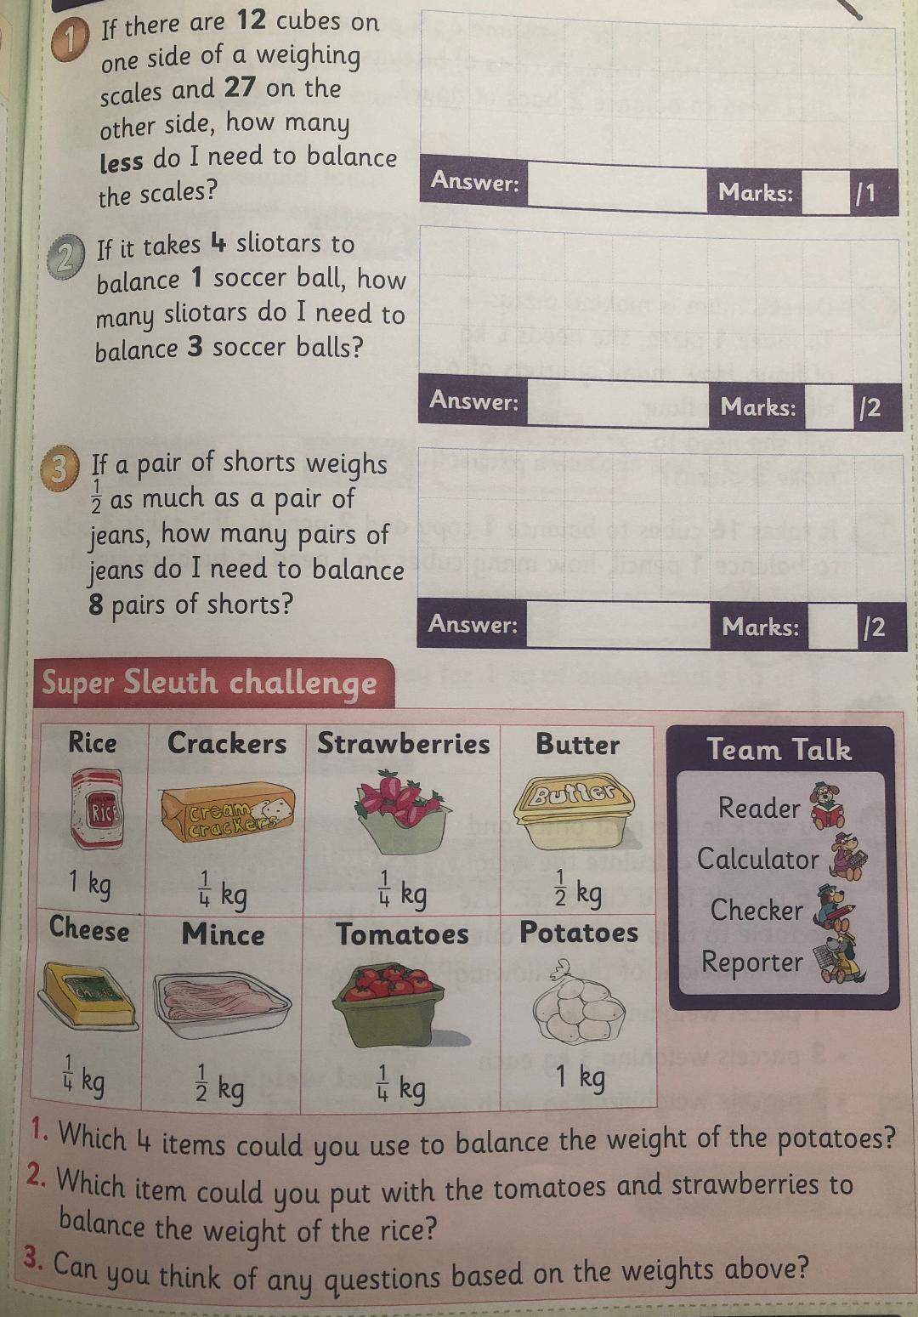
Gaeilge | Each day draw a picture for each of your 3 new Irish words, learn the spellings and meanings and put them into sentences.
Matilda | Task 1: Answer the following questions using full sentences:  - Describe the Trunchbull’s perfect school.  - What plopped into the Trunchbull’s glass?  - Who did the Trunchbull blame?  - What words did Matilda say to knock over the glass?  - In your own words describe what happened when the glass fell over.  Task 2:  Using 6 boxes create a comic strip showing the main events of Chapter 14 and 15.
Email | Please feel free to email me any completed work or pictures of your SESE projects to  horeswoodsecondandthird@gmail.com  If you have any questions or queries regarding the assigned school work I will be online Monday to Friday 11:00 to 1:00.
Useful websites:

IXL – https://ie.ixl.com/math/class-2 Great for practicing maths activities
Topmarks – https://www.topmarks.co.uk/maths-games/daily10
Hit the button - https://www.topmarks.co.uk/maths-games/hit-the-button
Balloon pop - https://www.theschoolhub.ie/sample.php
Mathletics: https://www.mathletics.com/uk/for-home/ Free home trial for maths

eBook library: https://www.oxfordowl.co.uk/for-home/find-a-book/library-page/
BorrowBox app – free resource from the library. Use the barcode from the back of your library card to log in. You can access eBooks and also audio books. Super resource for children and adults at this time!

Twinkl – A really useful website with lots of resources for free that they have make accessible to everyone at this time. Use the code IRLTWINKLHELPS to get free access to all resources for a month. Would be helpful for the engineer and scientist facts above or the ocean animal project.

Art PowerPoints – step by step instructions: www.mrsbrown.art/drive
LEGO Stamping: https://frugalfun4boys.com/lego-stamping-its-art-with-bricks/

Lightbot - https://lightbot.com/hour-of-code.html Coding website

Duolingo – www.duolingo.com or as a free app on the phone. Great opportunity to practice Gaeilge in a fun, interactive way.
Cula: www.cula4.com/en/

GoNoodle: www.gonoodle.com
Yoga: https://www.youtube.com/user/CosmicKidsYoga

