Dear Parents and Guardians,
I hope that you are all keeping safe and well at this very unusual time in our history.
Please find attached in this document your plan of work for Monday 30th March – Friday 3rd April.
I really want to stress I do not wish for any parent to feel overwhelmed with the content of this work. Please contact me should you have any queries in regards to the work. If there is work that cannot be completed for some reason that is no problem and it can always be revisited at a later date. You can select items of work that are accessible for you and your child.
I have set up an email account that you can contact me through. Please email the following address if you have any queries in regards to the work.
Email: horeswoodfirstclass@gmail.com

Ideas for motivating pupils
It is important to stay positive and get a good balance of both indoor and outdoor activities. Active breaks are very beneficial after tasks where children have been concentrating for a longer period of time. It can be a good idea to offer rewards like stickers for a reward chart (the end reward does not always have to be an actual object it could be an experience like getting to go for a walk/play a board game etc.)

It is a good idea to have structure with your child’s learning if possible. A good idea could be to write out the activities for the day on a whiteboard. Following each activity the child could tick off their completed work which will provide them with a sense of achievement.
Here are two example of reward charts that you could print off and use at home.

Days of the Week  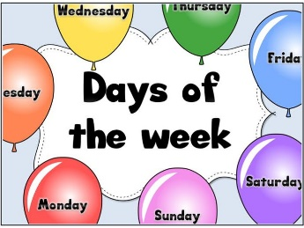 | __________________ Work Reward Chart  Task: To get a sticker you must try your very best with your work + behaviour.  I need to get _______ stickers each day to get. My reward is______________________________________. Good Luck!!
 | Morning  Part 1 | Break | Morning  Part 2 | Lunch time | Afternoon
Monday
Tuesday
Wednesday
Thursday
Friday

My Reward Chart

My name is …………………

I need to get ____ stars each day.
My reward is____________________________________________________. Good Luck

Monday
Tuesday
Wednesday
Thursday
Friday
A traffic lights system could be used to monitor behaviour. We have a system like this in the classroom. The child starts on green and if they need a few reminders they move their name along the traffic lights to yellow and so on. If the pupil ends up on red it means a consequence for the child (perhaps a time out/loss of a privilege) If the pupils are working excellently and are doing their work they can end up on multi-coloured and can earn an incentive for their positive behaviour. This incentive could be a sticker/star for their reward chart.
Weekly Planner

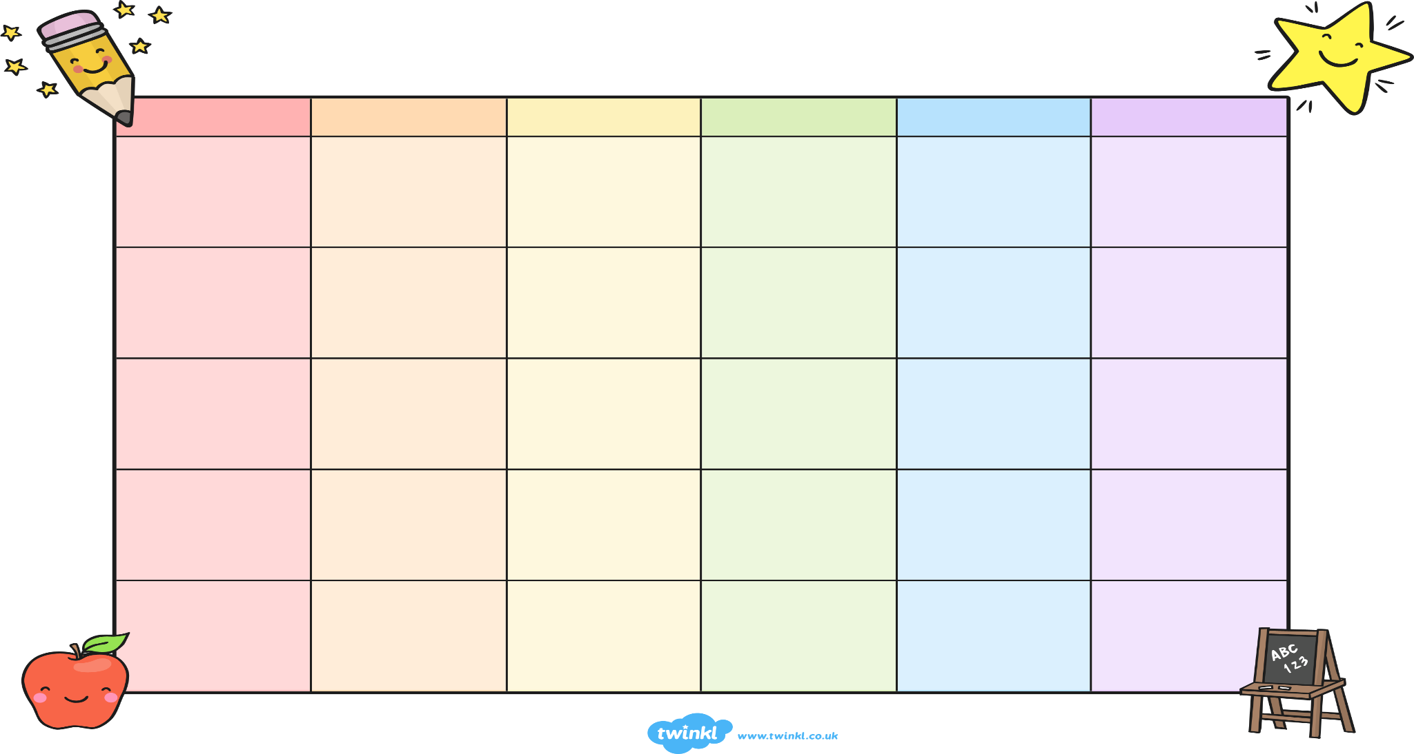
Movement Breaks
Movement Breaks are a great way in which to help to keep the children stimulated and motivated.
Body and Mind
Stick on your favourite upbeat playlist and try out these exercises one after the other. To give yourself a bigger challenge, do each circuit twice or three times or more!
Session 1 - 5 x 25 | Session 2 - legs moving | Session 3 - up and down
- 25 jumping jacks  - 25 squats  - 25 seconds run on the spot  - 25 push ups  - 25 seconds plank | - 30 seconds run on the spot  - 30 seconds high knees  - 30 seconds jumping jacks  - 30 seconds butt kicks  - 30 seconds jog on the spot | - 30 seconds jumping jacks  - 30 seconds mountain climbers  - 30 seconds run on the spot  - 30 seconds plank  - 30 seconds burpees!
OR
Have a family disco - stick on your favourite tunes and bop around the room for 20 minutes!
Get Outside
Try out as many of these exercises outside (keeping social distance!) that you can and tell your teacher which ones you’ve done.
- Cycle your bike for 10 minutes  - Go for a walk  - Ride your scooter for 10 minutes  - Draw your own hopscotch with chalk and play  - Throw a ball against a wall and catch  - Create your own obstacle course  - Run for 5 minutes  - 10 minutes of free play outside | - Jump on your trampoline  - Walk your dog  - Bubble bashing - get someone to blow bubbles for you to try and burst all of them  - Do 3 laps of your house or up and down the hall 10 times  - Keepie uppies - how many can you do in a row?  - Skip sideways up and down the garden 5 times  - Write your dolch words with chalk on cement outside

Helpful Websites: Here are a list of excellent websites for a variety of subjects.
Movement breaks websites
Mindfulness Session (peaceful and reflective music)
Go Noodle (Very good dance and movement breaks)
https://learning.gaa.ie/planner/ (Wexford GAA have posted activity cards on their website with some very good lesson ideas)
https://www.youtube.com/user/thebodycoach1 PE with Joe (Joe Wicks is offering live workouts that are specifically designed for children on Monday – Fridays)
https://www.cosmickids.com/ (Yoga activities for children)
https://m.youtube.com/ (You tube has a selection of Just Dance activities available)
https://rtejr.rte.ie/10at10/ (Fun, interactive workouts for children that last 10 minutes)
Maths websites
https://www.topmarks.co.uk/ (Excellent for a variety of maths games)
https://login.mathletics.com/ (login details _________________

www.folensonline.ie (see the image below which shows how to set up a free account to avail of the online ebooks/interactive activities)
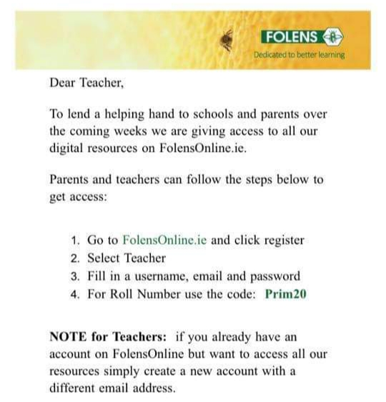

Religion websites
https://app.growinlove.ie/en (The login on to this site simply use the following email: trial@growinlove.ie + password is growinlove
Monday 30th March 2020 |  | Optional tick if  work completed
Subject | Activity
Maths  Tables | Tables: Revision of +9 tables. Recite the tables/Mix up the tables/Play x’s and o’s with the tables  9+0 9+9 9+2  9+6 9+3 9+8  9+1 9+4 9+5  You will find the tables located in your child’s homework journal.  Worksheet 1 (Monday) located at the end of this file can be completed (based on +9 tables).  Maths: Topic: Number Addition  Revise renaming of tens and units. This can be completed by giving your child some small objects  (16 objects) get your child to count the 16 objects. Following doing so get your child to rename and see if they can make a ten and have units leftover. Repeat with different 2 digit numbers.  Check out the following website. https://www.folensonline.ie There are several maths games and interactive activities on this website.  https://www.topmarks.co.uk/learning-to-count/place-value-basketball (Excellent game to reinforce tens and units)  Do worksheet that is attached and numbered p.g 140.  Maths Game:  Guess my number (1-100) –The pupils ask questions such as is your number higher than __?/lower than __ ?an odd number?/an even number? /between the numbers __ and __?
Jolly Grammar | Spelling: Jolly Phonics: page 52 (spelling sound ow) remind the children that the main ways of writing the /ow/ sound are/ow/and ou.  - Do the following activities on page 52 :  - write words that have (ow) in the owl pictures. Prior to doing so you could read through the list of ow words that I have attached.  - Go through the meanings of the spelling words.  - Put the first three spellings into a sentence in a copy.  - Learn first 3 spellings.  - Play the “roll the dice game” based on the spellings for this week.
Gaeilge | Téama “An Cháisc” Easter  Go back over the phrases “Dia duit” /”Dia is mhuire duit”. Conas atá tú? Tá/Níl mé go maith. An maith leat ____ ? Is maith liom/Ní maith liom ___.  Learn the phrase “Cháisc Shona duit”. (Happy Easter)  Learn the words “coinín” (rabbit) /”ubh” (egg) “uan” (lamb) If you would like the words pronounced type the words into the following website : foclóir.ie and click on the speaker symbol.
Other Subjects | Science: Sound  Sound Walk  Make a list of objects in your home / garden that make sounds. Feel free to use “Sound Walk” Worksheet that is attached.
Movement Breaks | Select a few movement breaks from the list of ideas and suggestions above. For example Cosmic kids yoga/Just Dance /Joe Wicks Daily Routine.  You can always create your own movement break and I would be delighted to hear all about it.
Religion | Theme: Easter  https://app.growinlove.ie/en/user/lesson-resources/154  This website grow in love are providing free access to parents. I have included details above about how to login in. Following logging in, please follow the above link and you are provided with a selection of activities for Holy Week/Easter.
Reading | Tricky Words: why/where/who/which /any/many/ more/before/other/were/because/want/saw/put (Please go through these tricky words. You could get your child to write the words on a whiteboard/copy. I have made a set of flashcards of these words. Please feel free to print these words off and you could use the words to play the roll say dice game in your child’s bag.  You could also play x’s and o’s with the words. Put the words into funny sentences.  On www.twinkl.ie read the story “Saving Easter”. To locate this book simply put the title of the story into the search box.  Get your child to read the story with your help. Have a chat about the story when you are finished. Ask each other questions about the story. Engage with the phrase “I wonder why…..”
Other | RTE Interactive Primary School Programme: Starting on Monday the 30th March there will be a daily programme for primary school pupils on RTE. It will cover a range of topics/subjects from the curriculum. The pupils will be encouraged to interact and engage with activities that are of interest to them at home.

Literacy websites
www.starfall.com
www.topmarks.co.uk

Tuesday 31st March 2020 |  | Optional tick if  work completed
Subject | Activity
Maths  Tables | Tables: Revision of +9 tables. Recite the tables/Mix up the tables/Play x’s and o’s with the tables  9+0 9+9 9+2  9+6 9+3 9+8  9+1 9+4 9+5  You will find the tables located in your child’s homework journal.  Worksheet 1 (Monday) located at the end of this file can be completed (based on +9 tables).  Maths: Topic: Number Addition  Revise renaming of tens and units. This can be completed by giving your child some small objects  (16 objects) get your child to count the 16 objects. Following doing so get your child to rename and see if they can make a ten and have units leftover. Repeat with different 2 digit numbers.  Check out the following website. https://www.folensonline.ie There are several maths games and interactive activities on this website.  https://www.topmarks.co.uk/learning-to-count/place-value-basketball (Excellent game to reinforce tens and units)  Do worksheet that is attached and numbered p.g 141.  Maths Game:  Guess my number (1-100) –The pupils ask questions such as is your number higher than __?/lower than __ ?an odd number?/an even number? /between the numbers __ and __?
Jolly Grammar | Spelling: Jolly Phonics: page 52 (spelling sound ow) remind the children that the main ways of writing the /ow/ sound are/ow/and ou.  - Do the following activities on page52 :  - write words that have (ou) in the house pictures  - Go through the meanings of the spelling words and re-read the spelling list.  - Put the next three spellings into a sentence in a copy.  - Play the “roll the dice game” based on the spellings for this week. (See attached to this document)  - Learn next three spellings .
Gaeilge | Téama “An Cháisc” Easter  Go back over the phrases “Dia duit” /”Dia is mhuire duit”. Conas atá tú? Tá/Níl mé go maith. An maith leat ____ ? Is maith liom/Ní maith liom ___.  Learn the phrase “Cháisc Shona duit”. (Happy Easter)  Go back over the words “coinín” (rabbit) /”ubh” (egg) “milseáin” (sweets)  Learn the words “sicín” (chicken)/”seacláid” (chocolate) “uan” lamb “buí” yellow  If you would like the words pronounced type the words into the following website : foclóir.ie and click on the speaker symbol. Do worksheet – cuardach focal : word search
Other Subjects | Science: Sound  Chat about sounds that you like and sounds that you dislike.  Look up David Attenborough’s youtube clip of the Lyrebird and see the amazing sounds that the Lyrebird can make.  Do page 15 in “What a wonderful World” titled “Sounds around us”.
Movement Breaks | Select a few movement breaks from the list of ideas and suggestions above. For example Cosmic kids yoga/Just Dance /Joe Wicks Daily Routine.  You can always create your own movement break and I would be delighted to hear all about it.
Religion | Theme: Easter  https://app.growinlove.ie/en/user/lesson-resources/154  This website grow in love are providing free access to parents. I have included details above about how to login in. Following logging in, please follow the above link and you are provided with a selection of activities for Holy Week/Easter. You can also read the pupils ebook and print any Easter related worksheets.
Reading  +  Writing | On www.twinkl.ie read the story “Saving Easter”. To locate this book simply put the title of the story into the search box.  Re-read the story “Saving Easter”. Write about the story in your copy and draw a picture to accompany it.
 | RTE Interactive Primary School Programme: Starting on Monday the 30th March there will be a daily programme for primary school pupils on RTE. It will cover a range of topics/subjects from the curriculum. The pupils will be encouraged to interact and engage with activities that are of interest to them at home.

Wednesday 1st April 2020 |  | Optional tick if  work completed
Subject | Activity
Maths  Tables | Tables: Revision of +9 tables. Recite the tables/Mix up the tables/Play x’s and o’s with the tables  9+0 9+9 9+2  9+6 9+3 9+8  9+1 9+4 9+5  You will find the tables located in your child’s homework journal.  Worksheet 1 (Monday) located at the end of this file can be completed (based on +9 tables).  Maths: Topic: Weight  Introduce the words heavy and light. Go on a hunt in the house and find things that are heavy/light.  Do page 93 that is attached.  Maths Game:  Guess my number (1-100) –The pupils ask questions such as is your number higher than __?/lower than __ ?an odd number?/an even number? /between the numbers __ and __?  I Spy something heavier than the cup etc/I spy something lighter than the fridge etc.
Jolly Grammar | Spelling: Jolly Phonics: page 52 (spelling sound ow) remind the children that the main ways of writing the /ow/ sound are/ow/and ou.  - Do the following activities on page52 :  - Go through the meanings of the spelling words and re-read the spelling list.  - Put the next three spellings into a sentence in a copy.  - Learn next three spellings  - Dictation: At the bottom of page 52 in the dictation section (1-9) call out the following words and sentences for your child to write down/repeat each word +sentence 3 times.  - cow 2. now 3. clown 4. howl 5. crowd 6. powder  7. Come down here.  8. They went to town on the bus.  9. She had a quick shower.
Gaeilge | Téama “An Cháisc” Easter  Go back over the phrases “Dia duit” /”Dia is mhuire duit”. Conas atá tú? Tá/Níl mé go maith. An maith leat ____ ? Is maith liom/Ní maith liom ___.  Learn the phrase “Cháisc Shona duit”. (Happy Easter)  Go back over the words “coinín” (rabbit) /”ubh” (egg) “milseáin” (sweets)“uan” lamb “buí” yellow  Learn the words “sicín” (chicken)/”seacláid” (chocolate)  If you would like the words pronounced type the words into the following website: foclóir.ie and click on the speaker symbol.  Do Irish worksheet (colour the egg by numbers)
Other Subjects | Science: Sound  Do page 16 in “What a wonderful World” titled “I have two ears”.  This also linked in with our grammar lesson this week based on action words.  Following doing the word search chat about activities that make quiet sounds and activities that make loud sounds.
Movement Breaks | Select a few movement breaks from the list of ideas and suggestions above. For example Cosmic kids yoga/Just Dance /Joe Wicks Daily Routine.  You can always create your own movement break and I would be delighted to hear all about it.
Religion | Theme: Easter  https://app.growinlove.ie/en/user/lesson-resources/154  This website grow in love are providing free access to parents. I have included details above about how to login in. Following logging in, please follow the above link and you are provided with a selection of activities for Holy Week/Easter.
Reading  +  Writing | Reading: Do pages 1+2 of worksheets titled “The Zoo”
 | RTE Interactive Primary School Programme: Starting on Monday the 30th March there will be a daily programme for primary school pupils on RTE. It will cover a range of topics/subjects from the curriculum. The pupils will be encouraged to interact and engage with activities that are of interest to them at home.

Thursday 2nd April 2020 |  | Optional tick if  work completed
Subject | Activity
Maths  Tables | Tables: Revision of +9 tables. Recite the tables/Mix up the tables/Play x’s and o’s with the tables  9+0 9+9 9+2  9+6 9+3 9+8  9+1 9+4 9+5  You will find the tables located in your child’s homework journal.  Worksheet 1 (Monday) located at the end of this file can be completed (based on +9 tables).  Maths: Topic: Weight  Go back over the words heavier and lighter.  Do Planet Maths Satellite book p.g 36  Maths Game/Activity:  I Spy something heavier than the cup etc/I spy something lighter than the fridge etc.  Find 5 things that are heavier than you.  Find 5 things that are lighter than you.  You can record/write down your answers if you wish.
Jolly Grammar | Spelling: Jolly Phonics: page 52 (spelling sound ow ) remind the children that the main ways of writing the /ow/ sound are/ow/and ou.  - Go through the meanings of the spelling words.  - Put last spelling into sentence and write down favourite spelling  - Learn last spelling  - Write your spellings out on pieces of paper. Get somebody to stick them up around the house and you have to find them.
Gaeilge | Téama “An Cháisc” Easter  Go back over the phrases “Dia duit” /”Dia is mhuire duit”. Conas atá tú? Tá/Níl mé go maith. An maith leat ____ ? Is maith liom/Ní maith liom ___.  Learn the phrase “Cháisc Shona duit”. (Happy Easter)  Go back over the words “coinín” (rabbit) /”ubh” (egg) “milseáin” (sweets)  Learn the words “sicín” (chicken)/”seacláid” (chocolate)  If you would like the words pronounced type the words into the following website : foclóir.ie and click on the speaker symbol.  Make a cárta (card) On the front get the pupils to write Cháisc Shona duit”. Ask them if they could add some images of the words that they have learned during the week.
Other Subjects | Art  Art activity challenge make an Easter rabbit or a chick using any materials of your choice. You could use paper/clay/papier machee/fabric/cardboard/ an old cd/paint/feathers/pom poms etc to make your chick or rabbit.  See below for ideas:  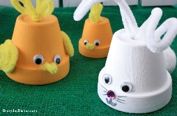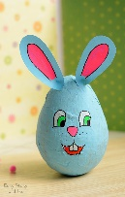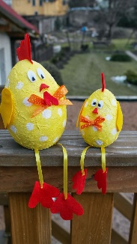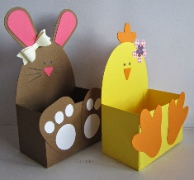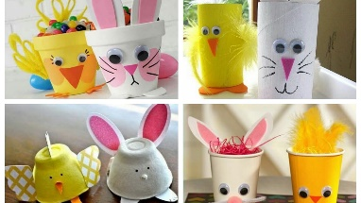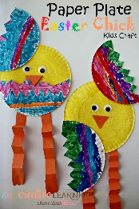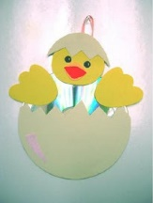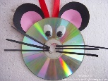
Movement Breaks | Select a few movement breaks from the list of ideas and suggestions above. For example Cosmic kids yoga/Just Dance /Joe Wicks Daily Routine.  You can always create your own movement break and I would be delighted to hear all about it.
Religion | Theme: Easter  https://app.growinlove.ie/en/user/lesson-resources/154  This website grow in love are providing free access to parents. I have included details above about how to login in. Following logging in, please follow the above link and you are provided with a selection of activities for Holy Week/Easter.
Literacy | Jolly Grammar p.g 53 (Verbs)  - Get the children to remind you that a verb is an action word. Ask them to give examples of verbs.  - On p.g 53 the children have to look at the picture and write 6 verbs for the actions they can see. Following doing so read the 4 sentences below and get the pupils to underline the verbs in red. Tell them that there can be more than one verb in the sentences.
 | RTE Interactive Primary School Programme: Starting on Monday the 30th March there will be a daily programme for primary school pupils on RTE. It will cover a range of topics/subjects from the curriculum. The pupils will be encouraged to interact and engage with activities that are of interest to them at home.

Friday 3rd April 2020 |  | Optional tick if  work completed
Subject | Activity
Maths  Tables | Tables: Revision of +9 tables. Recite the tables/Mix up the tables/Play x’s and o’s with the tables  9+0 9+9 9+2  9+6 9+3 9+8  9+1 9+4 9+5  You will find the tables located in your child’s homework journal.  Worksheet 1 (Monday) located at the end of this file can be completed (based on +9 tables).  Maths: Topic: Weight  Go back over the words heavier and lighter.  Introduce the word kilogram/kg for short.  Ask the pupils to find items in the cupboard that weigh a kg/that are heavier than a kg/that are lighter than a kg.  Maths Game:  In Planet Maths Satellite Book play snakes and ladders on page 35
Jolly Grammar | Spelling: Jolly Phonics: page 52 (spelling sound ow ) remind the children that the main ways of writing the /ow/ sound are/ow/and ou.  - Spelling Test – do at the back of the Jolly Grammar book
Gaeilge | Téama “An Cháisc” Easter  Go back over the phrases “Dia duit” /”Dia is mhuire duit”. Conas atá tú? Tá/Níl mé go maith. An maith leat ____ ? Is maith liom/Ní maith liom ___.  Learn the phrase “Cháisc Shona duit”. (Happy Easter)  Go back over the words “coinín” (rabbit) /”ubh” (egg) “milseáin” (sweets) “sicín” (chicken)/”seacláid” (chocolate)  If you would like the words pronounced type the words into the following website: foclóir.ie and click on the speaker symbol.  Do Irish Worksheet attached (colour the Easter pictures + try to read the words)
Other Subjects | Art  Art activity challenge make an Eater rabbit or a chick using any materials of your choice. You could use paper/clay/papier machee/fabric/cardboard/ an old cd/paint/feathers/pom poms etc to make your chick or rabbit.  See below for ideas:
Movement Breaks | - Select a few movement breaks from the list of ideas and suggestions above. For example Cosmic kids yoga/Just Dance /Joe Wicks Daily Routine.  - You can always create your own movement break and I would be delighted to hear all about it.
Religion | Theme: Easter  https://app.growinlove.ie/en/user/lesson-resources/154  This website grow in love are providing free access to parents. I have included details above about how to login in. Following logging in, please follow the above link and you are provided with a selection of activities for Holy Week/Easter.  www.twinkl.ie have several power points and worksheets based on Holy Week and Easter.
Reading | Reading Comprehension  Read the Comprehension story “A trip to the Zoo” that is attached. Following doing so answer the questions based on the story.

Fun Activities to try!!
Colour the activities that you try

Read a story to a pet or sibling | Learn the words to a song | Go outside an sketch something that you see | Go outside and gather leaves, wild flowers etc and make a Spring picture from it | Do something kind for somebody | Go on a walk of your garden and look for mini beasts.
Learn how to wrap a gift | Learn how to tell a few jokes | Make ice pops | Learn new dance | Look at a cartoon in Irish on TG4 | Make a monster from a box
Skype a family member | Make somebody smile | Make a sock puppet | Try something new to eat that you have never tried | Make a musical shaker using rice | Learn how to do paper weaving
Write your news | Help do 5 jobs around the house | Find 10 objects that are shapes around your house or in your garden | Look at the map of the world and pick 5 places that you would like to visit | Do finger painting  animals | Build a race track
Keep a diary of your day | Make a family tree | Make Easter buns | Build a fort | Have an Easter egg hunt | Tidy your toys

Tables worksheet: Addition + 9
Monday | Tuesday | Wednesday | Thursday | Friday
9+9= | 9+ ___ = 9 | ___ + 9= 19 | 9+ 5 = ___ | 9+ 2 = ___
9+2= | 9+ ____ = 17 | ___ + 9= 11 | 9+ 7 = ___ | 9+ 0 = ___
9+0= | 9+ _____= 10 | ___ + 9 = 17 | 9 + 10 = ___ | 9 + 1 = ___
9+8= | 9+ ____= 11 | ___ + 9 = 12 | 9 + 9 = ____ | 9 + 6 = ____
9+10 = | 9+ _____= 13 | ____ + 9 = 18 | ___ + 9 = 12 | ___ + 9 = 13
9+4= | 9+ ______= 15 | ____ + 9 = 9 | ___ + 9 = 14 | ___ + 9 = 15
9+6= | 9+ ______= 16 | ____ + 9 = 13 | ___ + 9 = 16 | ___ + 9 = 18
9+1= | 9+ ______= 18 | ____ + 9 = 16 | 9 + ___ = 9 | 9 + ___ = 10
9+7= | 9+ ______ = 17 | ____ + 9 = 14 | 9 + ___ = 13 | 9 + ___ = 18
9+5= | 9+ ______= 14 | ____ + 9 = 18 | 9+ ____ = 10 | 9+ ____ = 9

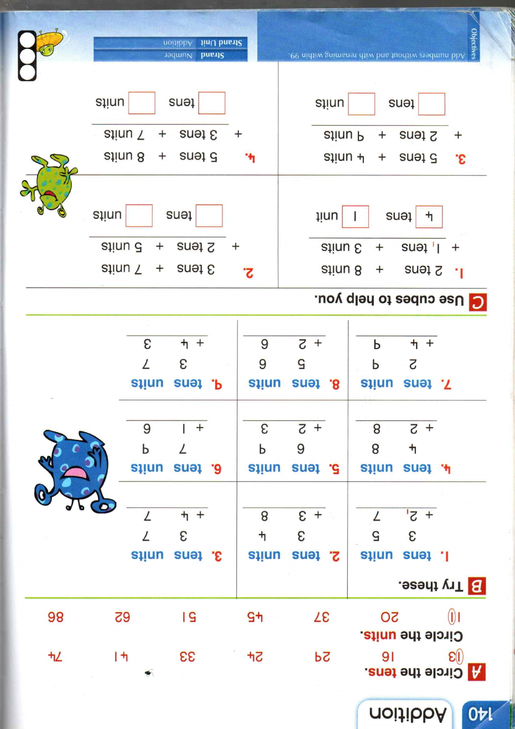
Roll the Dice

  - Say all you ow spellings
  - Put the word flowerpot into a sentence
  - My favourite spelling is ___________.
  - My least favourite spelling is ________.
  - The word town means __________.
  - Put the word should into a sentence.

My Sound Walk
Sounds I hear in the house | Sounds I hear in the garden  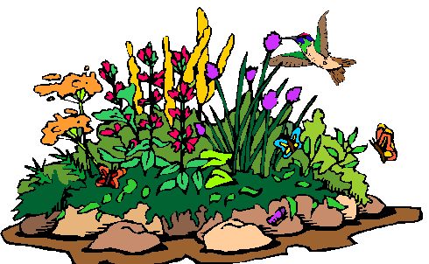
Tricky Words
put | many
why | more
where | before
who | other
which | were
any | because
want | saw

The Zoo
Before reading:

Make a list of animals that you can find at a zoo.
1___________
2___________
3___________
4___________
5___________
6___________

Draw a picture of a zoo.

Have a look at these words.
Words I see a lot | Tricky words
was  they  their  like  went  what  where  which | birthday  friends  animals  bamboo  favourite  pretty  bodies  scales
What do you want to learn about a zoo?

1_____________________________

2____________________________
A Trip to the Zoo
It was Tom’s birthday last Monday so he went to the zoo as a treat. Tom’s friends Kelly, Mark and Adam went to the zoo with Tom too. At the zoo they saw so many animals. They saw lions, tigers, pandas, zebras, snakes and many more animals. Tom loved the lions but Adam liked the pandas the most. Everyone had a great day at the zoo.
- When was Tom’s birthday?
Sunday / Friday / Minday
- Who did Tom go to the zoo with?
his friends / his brothers and sisters / his Mam and Dad
- What animals did they see at the zoo?
______________________________________
____________________________________

- Which animal did Adam like the most?
lions / pandas / snakes
- What zoo animal do you like the most?
____________________________
The Panda
There is a new baby panda at the zoo. When it is born, it is tiny and pink. But it will grow to be big, black and white. Pandas come from China. They eat bamboo. They eat lots and lots of bamboo!
- What colour is the new-born panda?
___________________________
- Where do pandas come from?
___________________________
- What do pandas eat?

Zebra at the Zoo
Amy and her family go to the zoo. Amy sees many animals. Her favourite animal is the zebra. The zebra looks like a horse with black and white stripes. Amy thinks the zebra is very pretty.

Colour the Z green if it is true.
Colour the Z red if it is not true.

1. In the story, Amy goes to the zoo.
2. Amy sees only one animal at the zoo.
3. Amy’s favourite animal at the zoo is the horse.
4. A zebra has black and white stripes.
5. Amy does not like zebras.
Snakes
Snakes have long, thin bodies. They have no arms or legs. Snakes only like to eat meat so they eat small animals. Snakes are not able to bite their food so they have to eat it all in one go. Snakes have scales on their bodies.
Try these questions:
- What do snakes look like?

______________________________
- Why do snakes eat their food all in one go?

_________________________________
- What small animals do you think snakes eat?

__________________________________Some pictures to help
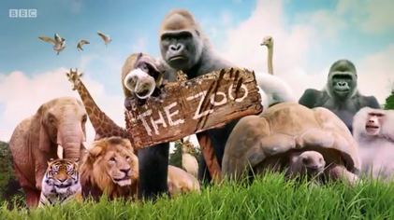
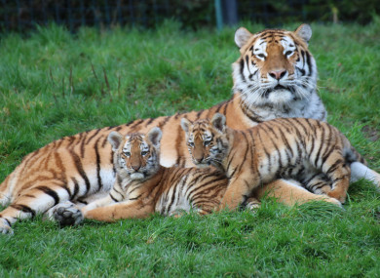
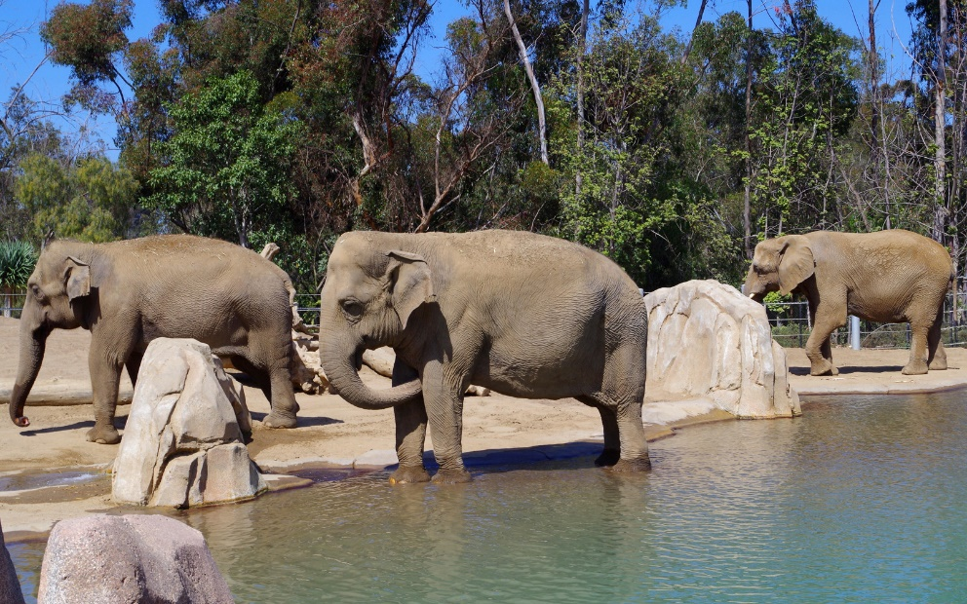
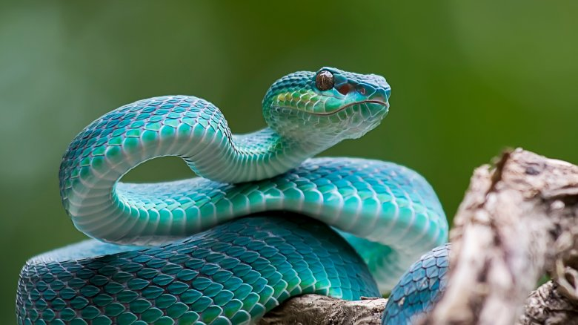
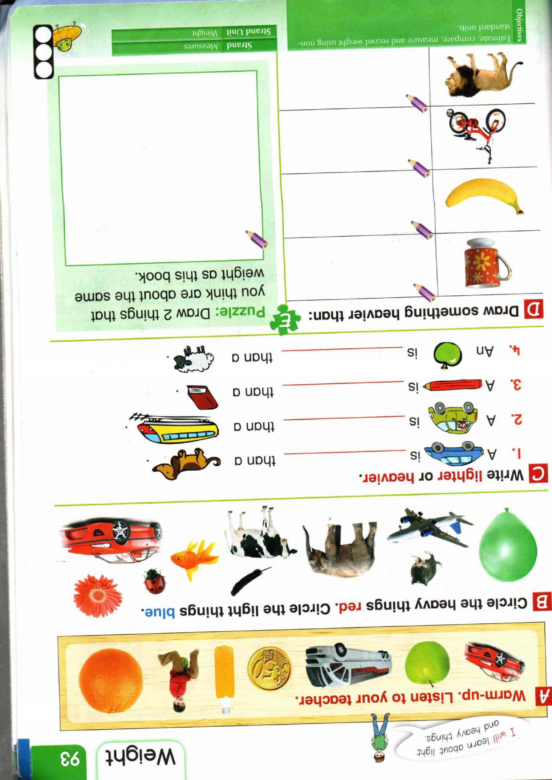
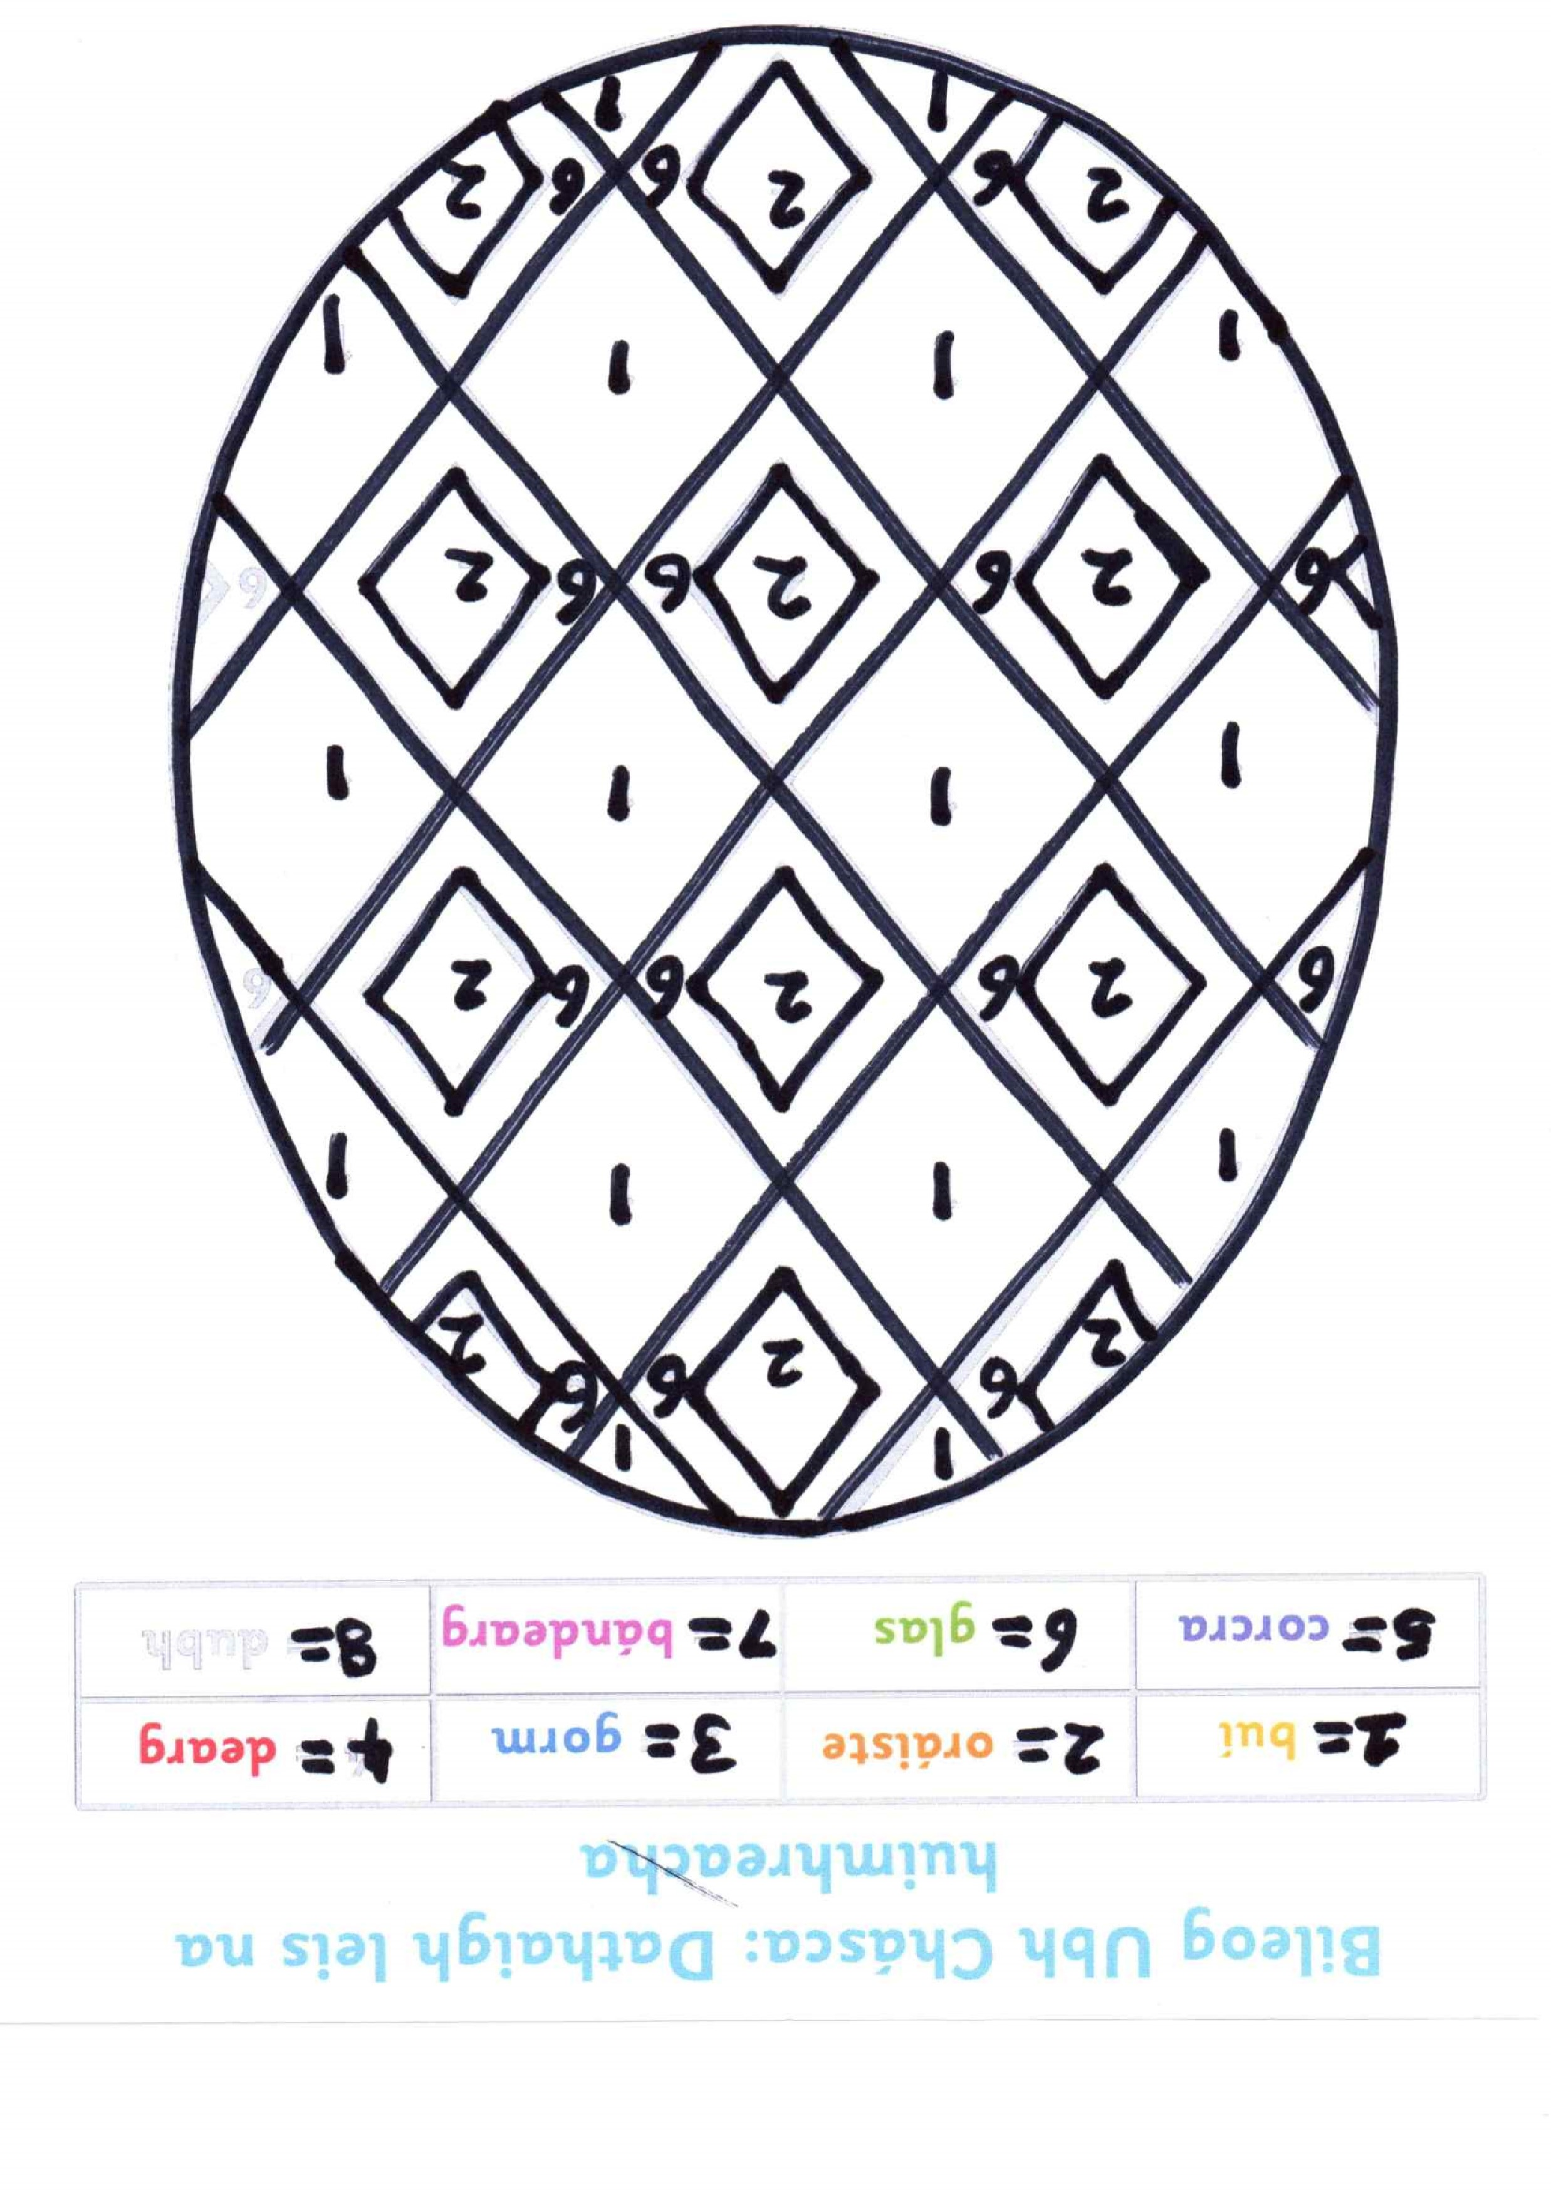
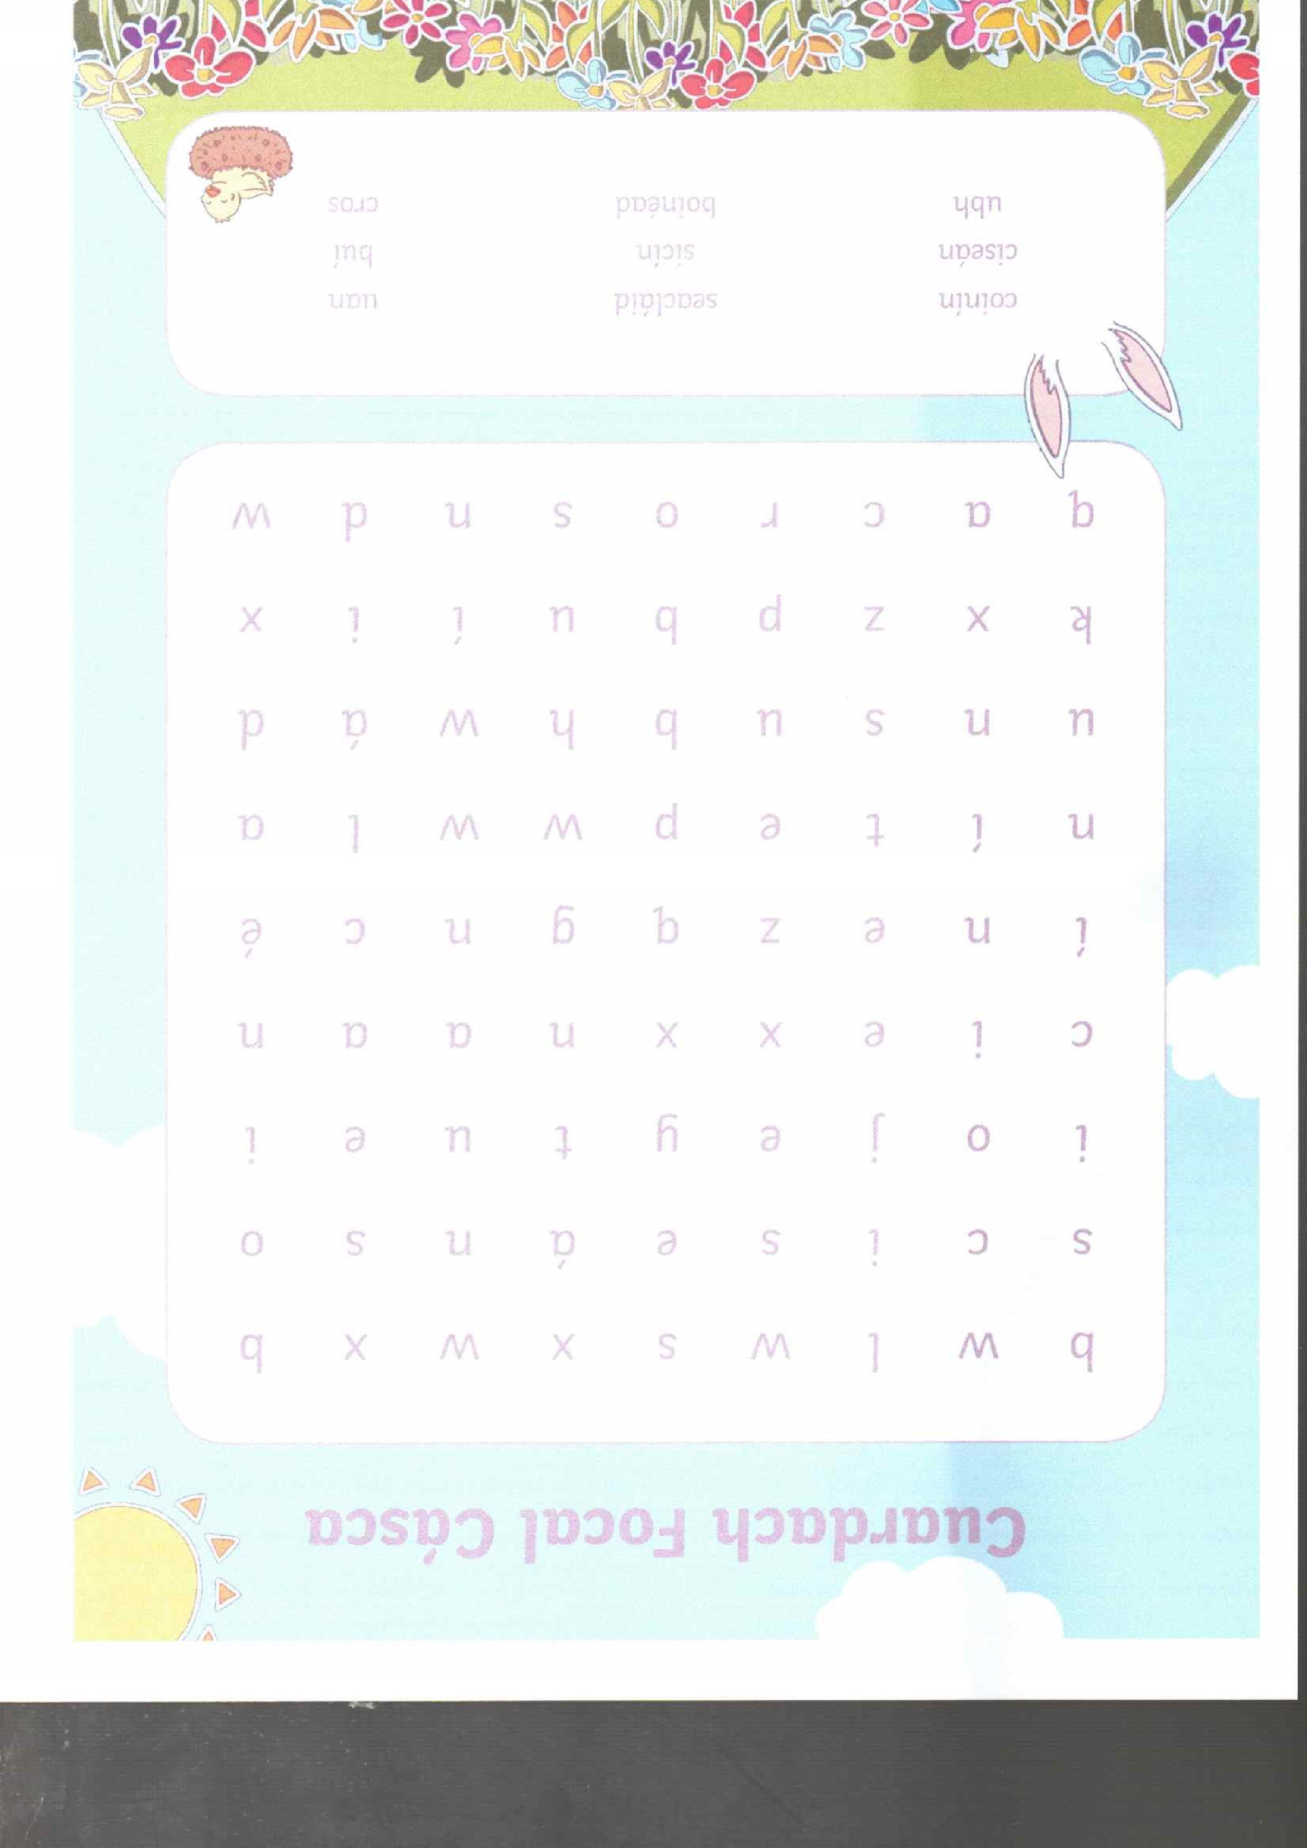
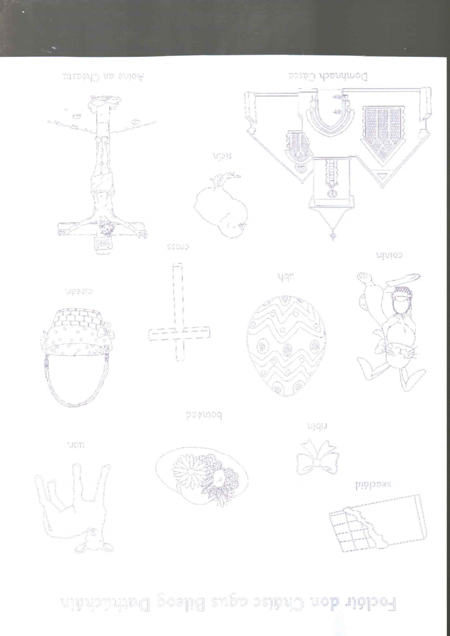
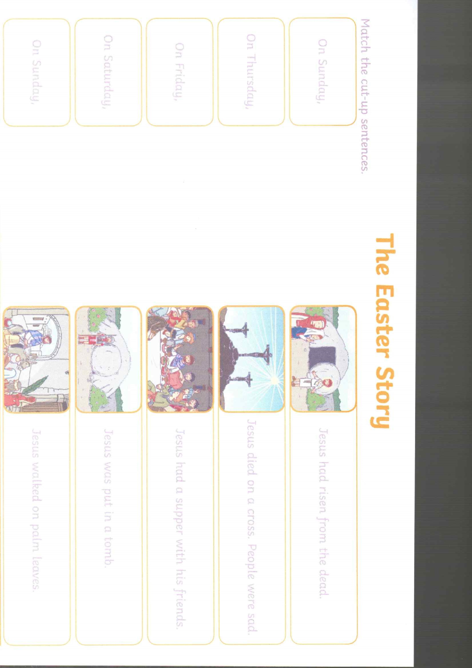
Saving Easter

____________________________________________________________________________________________________________________________________________________________________________________________________________________________________________________________________________________________________________________________________________________________________________________________________________________________________________________________________________________________________________________________________________________________________________________________________________________________________________________________________________________________________________________________________________________________________________________________________________________________________________________________________________________________________________________

Design an Easter Egg

